**Two-Energy Storage-Ring Electron Cooler for Relativistic Ion Beams \***

B. Dhital#1,2, J.R. Delayen1,2, Ya.S. Derbenev2, D. Douglas2, G.A. Krafft1,2, F. Lin2,  
V.S. Morozov2, Y. Zhang2  
1Center for Accelerator Science, Old Dominion University, Norfolk, VA, 23529, USA  
2Thomas Jefferson National Accelerator Facility, Newport News, VA, 23606, USA

*Abstract*

An electron beam based cooling system for the ion beam is one of the commonly used approaches. The proposed two–energy storage-ring electron cooler consists of damping and cooling sections at markedly different energies connected by an energy recovering superconducting RF structure. The parameters in the cooling and damping sections are adjusted for optimum cooling of a stored ion beam and for optimum damping of the electron beam respectively. This paper briefly describes a two cavities model along with a third cavity model to accelerate and decelerate the electron beam in two energy storage ring. Based on our assumed value of equilibrium emittance shows that these models give a bunch length of the order of cm and energy spread of the order of ${10}^{-5}$ in the cooling section which are required parameters for the better cooling. Numerical calculations along with elegant simulation is presented.

Introduction

Recently, in storage ring, it has been realized that several interesting topologies for the multiple beam energies may be possible [1]. Here we focus our study on two energy storage ring where one ring is at higher energy and another ring at lower energy connected by RF cavities as shown in Fig 1. Recent study shows that longitudinal stability exists in a two-energy storage ring [2]. We are interested to this type of storage ring for electron cooling. Cooling allows small transverse beam sizes at the interaction point and enhanced luminosity. Electron cooling rate will be affected by the bunched electron beam properties such as beam size, energy spread etc [3]. Hence, from the cooling requirement, we can apply two cavities model to get the longer bunch length in the cooling section. This further allows to get smaller energy spread in the cooling section as required for the better cooling.

## Two Cavities model

### Concept

The schematic diagram for such a storage ring is shown in Figure 1. We use two groups of RF cavities to accelerate (Acc cav1, Acc cav2) and decelerate (Dec cav1, Dec cav2) the electron beam in the corresponding accelerating and decelerating passes. Two cavities model is in the sense that we use two RF cavities to accelerate and another two RF cavities to decelerate the beam. This arrangement causes the beam to stretch more giving the longer bunch length in the cooling section. In this scheme, each cavity adds or subtracts energy by an equal amount in the corresponding accelerating and decelerating passes.

* Work supported by U.S. DOE Contract No. DE-AC05-06OR23177 and DE-AC02-06CH11357.

# bdhit001@odu.edu

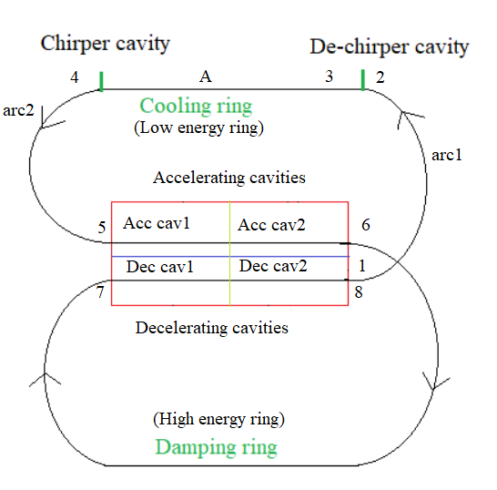 Figure 1: Schematic drawing of a two-energy storage ring with two cavities to accelerate and another two cavities to decelerate electron beam [4].

For simplicity, cooling ring is at 55 MeV and the damping ring is at 155 MeV, so the gain in energy through each cavity during acceleration is 50 MeV, and the total gain through two cavities is 100 MeV. Beam passing through the decelerating cavities lose the energy by an equal amount. We introduce a small phase shift in the accelerating phase of second accelerating cavity (Acc cav2) so that there is no cancelation of total slope in accelerating and decelerating passes.

In energy recovery linac (ERL) mode, one of the accelerating and decelerating passes is longitudinally focusing while the other is defocusing and the small phase shift introduced to second accelerating cavity provides the stability.

We study the longitudinal stability using two cavities model in ERL mode.

### Two cavities model: Phasor diagram

The RF phasor diagram is shown in Figure 2. $ϕ_{s}^{acc}\left(1\right)$ is the RF accelerating phase angle for the first accelerating cavity, $ϕ_{s}^{acc}\left(2\right)$ is the RF accelerating phase angle for second accelerating cavity. Similarly, $ϕ_{s}^{dec}(1)$ and $ϕ_{s}^{dec}(2)$ are the corresponding decelerating phase angles for first and second decelerating cavities respectively. If we apply a small phase shift $Δϕ$ for $ϕ_{s}^{acc}(2)$ then the following relations holds for RF accelerating and decelerating phase angles in ERL mode.

$ϕ_{s}^{acc}\left(2\right)= - ϕ_{s}^{acc}\left(1\right)+π+Δϕ$ (1)

$ϕ_{s}^{dec}\left(1\right)= ϕ_{s}^{acc}\left(1\right)+π$ (2)

$ϕ_{s}^{dec}\left(2\right)= ϕ_{s}^{acc} \left(2\right)+π$ (3)

The corresponding $M_{65}$ values for RF system is given by:

$M_{65}^{acc}\left(tot\right)= \frac{ΔE}{E_{2}} k (\tan{ϕ_{s}^{acc}\left(2\right)}+\tan{ϕ_{s}^{acc}\left(1\right)})$

Using equation (1) and applying the formula $\tan\left(x+y\right)=\tan{y}+ x\sec^{2}{y}+…$

$M_{65}^{acc}\left(tot\right)=\frac{ΔE}{E_{2}}k\frac{Δϕ}{\cos^{2}{(ϕ_{s}^{acc}\left(1\right) )}}$ (4)

$M_{65}^{dec}\left(tot\right)= -M_{65}^{acc}\left(tot\right).\frac{E_{2}}{E_{1}}$ (5)

where k = $\frac{2π}{λ_{rf}}, λ_{rf}=$ 0.6298 m ($f_{rf}=$ 476 MHz), $ΔE=$ 50 MeV, $E_{1}$ = 55 MeV and $E_{2}=$ 155 MeV respectively.

From equation (4), it is clear that $M_{65}^{acc}(tot)$ is inversely proportional to some higher energy $E_{2}$. It means when beam accelerates through each cavity for some higher energy, the corresponding $M_{65}^{acc}$ value decreases. This causing the bunch length stretching more.

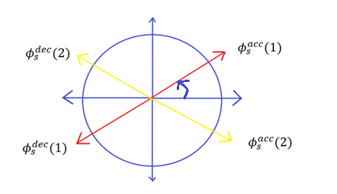

Figure 2: Phasor diagram for accelerating and decelerating cavities in ERL mode in two-energy storage ring.

## Calculations

### Numerical Calculations

We have performed numerical calculations to study the relationship among the various parameters in our system. Our assumed value of equilibrium emittance in these calculations is 1 mm-mrad which is not the real damped emittance value (damped emittance needs to be calculated).

From Fig 3, For our assumed equilibrium emittance value, the bunch length is inversely proportional to the corresponding $M_{65}(tot)$ value. For $σ_{s}$ $≈$ 2.5 cm in the cooling section, the corresponding $M_{65}(tot)$ value is $≈$ 0.0000046698 for $Δϕ={0.0001}^{0}$. It means, the value of $M_{65}(tot)$ very close to zero gives the longer bunch length in ERL mode using two groups of cavities for acceleration and deceleration respectively. In other words, you have many choices for RF accelerating phase angles $ϕ_{s}^{acc}(1)$ and phase shift $Δϕ$ given to the second accelerating cavity to get the different size of bunch in the cooling section.

From Fig 4, For our assumed value of equilibrium emittance, $σ_{s}$ is inversely proportional to $σ_{δ}$. These values of bunch length and the corresponding energy spread in the cooling section may be suitable for cooling purpose.

### Periodic Solution

For different accelerating phase angles, we calculate one turn transfer matrix starting from the point A in cooling section as shown in Fig 1 and calculate the longitudinal twiss parameters values $α_{s}, β_{s}$ and $γ_{s}$ at that point. Using these values, we create the uniform beam distribution at that point and run elegant simulations to test the periodic solution.

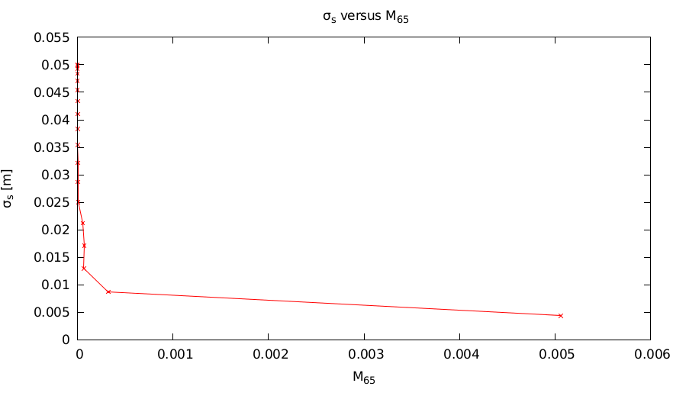

Figure 3: $σ_{s}$ versus $M_{65}(tot)$ plot for $Δϕ={0.0001}^{0}$.

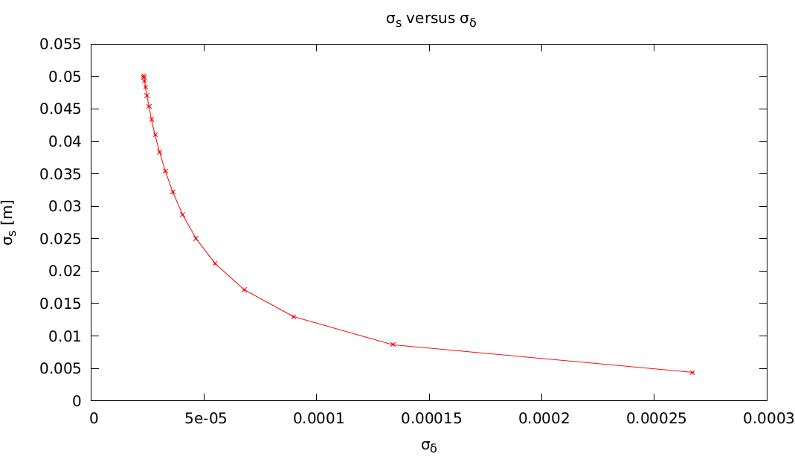

Figure 4: $σ_{s}$ versus $σ_{δ}$ plot for $Δϕ={0.0001}^{0}$.

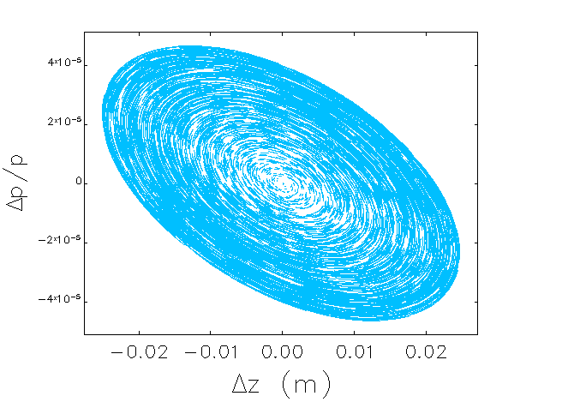Figure 5: $\frac{Δp}{p}$ versus $Δz$ plot showing that the periodic solution exists in ERL mode using two cavities model. Here, $ϕ_{s}^{acc}\left(1\right)={60}^{0}, Δϕ={0.0001}^{0}$.

Simulation shows that the periodic solution exists, and the system is longitudinally stable.

### Chirping and De-chirping

The beam phase-space in the cooling section is not perfect upright but tilted one. So, we introduce de-chirping after arc1 in cooler ring followed by chirping before arc2 as shown in Fig 1. We apply the voltage scanning method to determine the voltage required for chirping and de-chirping which gives the perfect upright beam distribution in the cooling section.

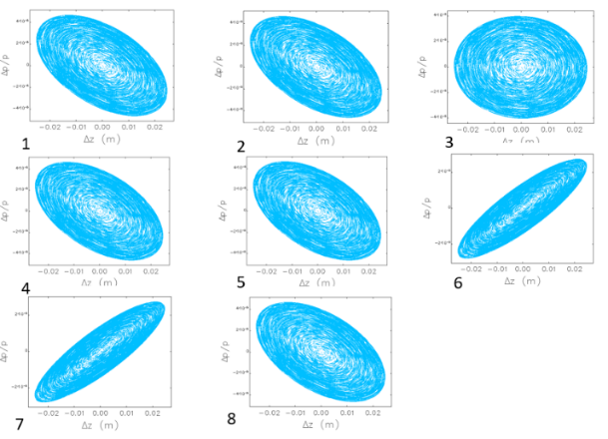

Figure 6: Periodic solution with chirping and de-chirping in two- energy storage ring in ERL mode with $ϕ_{s}^{acc}\left(1\right)={60}^{0}, Δϕ={0.0001}^{0}$. Numbers from 1 to 8 represent the corresponding location as shown in Fig 1.

|  |  |  |  |  |  |  |  |  |  |  |  |  |  |  |  |  |  |  |  |  |  |  |  |  |
| --- | --- | --- | --- | --- | --- | --- | --- | --- | --- | --- | --- | --- | --- | --- | --- | --- | --- | --- | --- | --- | --- | --- | --- | --- |
| Figure 6 shows that the periodic solution exists with chirping and de-chirping scheme. RF phases for chirping and de-chirping cavities are opposite. we do voltage scanning for some other values of accelerating phase angles and estimate the required voltage to be applied for chirping and de-chirping.   |  |  |  |  | | --- | --- | --- | --- | |  | (cm) | $$Δp/p$$ | Voltage(V) | |  | 4.93 | $$2.36×{10}^{-5}$$ | 1300.0 | |  | 4.70 | $$2.47×{10}^{-5}$$ | 1500.0 | |  | 4.34 | $$2.68×{10}^{-5}$$ | 1700.0 | |  | 3.21 | $$3.62×{10}^{-5}$$ | 4000.0 | |  | 2.50 | $$4.65×{10}^{-5}$$ | 5000.0 | |
| Table 1: RF parameters and bunch parameters in two energy storage ring.  From the Table1, longer the bunch length, lesser the RF voltage should be applied for chirping and de-chirping. third cavity model In this scheme, instead of introducing small phase shift to second accelerating cavity, we use another third cavity to provide phase shift to the beam passing after accelerating cavities. In this model, two groups of cavities work the same way as before except no phase shift in the second accelerating cavity. This third cavity is operating in passive mode (neither accelerating nor decelerating). We apply different RF voltages to the third cavity just after accelerating cavities. Different bunch length and the corresponding energy spread values for our assumed beam emittance value of 1 mm-mrad are shown in the following table.   |  |  |  |  | | --- | --- | --- | --- | | Voltage(V) | $$M_{65}^{3rd cav}$$ | $σ_{s}$ (cm) |  | | 1.0 | $$6.4×{10}^{-8}$$ | 5.23 |  | | 10.0 | $$6.4×{10}^{-7}$$ | 2.94 |  | | 100.0 | $$6.4×{10}^{-6}$$ | 1.65 |  | | 1000.0 | $$6.4×{10}^{-5}$$ | 0.93 |  | | 10000.0 | $$6.4×{10}^{-4}$$ | 0.52 | $$1.9×{10}^{-4}$$ |   Table 2: Bunch length and energy spread for different values of applied voltage in the third cavity.  Table shows that for our assumed equilibrium emittance value, the bunch length and the energy spread in the cooling section depends on RF voltage applied in the third cavity. Smaller the RF voltage applied larger the bunch length and smaller the energy spread value. Longitudinal dynamics study shows that periodic solution exists, and the beam phase space is almost upright in the cooling section as shown in the figure below.  Figure 7: Phase space distribution showing periodic solution exists in two energy storage ring using third cavity. Numbers from 1 to 8 represent the corresponding location as shown in Fig 1.  From Fig 7, beam phase space is almost upright in the cooling section. It means, third cavity model works without chirping and de-chirping scheme. This may be one of the advantages of using the third cavity model. |
|  |  |

## Conclusion

Two cavities model along with chirping and de-chirping scheme, we get the bunch length of the order of cm and energy spread of the order of ${10}^{-5}$ for our assumed equilibrium emittance value 1 mm-mrad. Periodic solution exists. It ensures that longitudinal stability exists.

Another possible solution to the problem is using third cavity. A small phase shift is introduced in the third cavity. (No phase shift to second accelerating cavity). This model also gives the similar bunch parameters in the cooling section. Periodic solution exists. Third cavity model looks better than two cavities model. It is because second model is simpler than the first one. Next, third cavity model may not require introducing chirping and de-chirping to make beam distribution upright in the cooling section. It also reduces the number of cavities in our system.

## References

[1] G. A. Krafft, B. Dhital, F. Lin, V. Morozov “Multiple energy storage rings” [arXiv:1907.13461v1](https://arxiv.org/abs/1907.13461v1)[phys ics.acc-ph]

[2] B. Dhital, J. R. Delayen, Y. S. Derbenev, D. Douglas, G. A. Krafft, F. Lin, V. S. Morozov, and Y. Zhang, “Equilibria and Synchrotron Stability in Two Energy Storage Rings”, Proc. of the 2019 Int. Part. Acc. Conf., Melbourne, Australia, 364 (2019).

[3] H. Zhang *et al*., “Simulation study on JLEIC high energy bunched electron cooling”, in *Proc. North American Particle Accelerator Conference (NAPAC'16)*, Chicago, IL, USA October 2016.

[4] F. Lin *et al*., “Storage-ring Electron Cooler for Relativistic Ion Beams”, in *Proc. 7th Int. Particle Accelerator Conf. (IPAC'16)*, Busan, Korea, May 2016, pp. 2466-2468. doi:10.18429/JACoW-IPAC2016-WEPMW020.