FIELD QUALITY ANALYSIS OF INTERACTION REGION QUADRUPOLES FOR JLEIC*

G. Sabbi†, LBNL, Berkeley, CA, USA   
B.R.P. Gamage, T. Michalski, V.S. Morozov, R. Rajput-Ghoshal, M. Wiseman, Jefferson Lab, Newport News, VA, USA  
Y. Nosochkov, M. Sullivan, SLAC, Menlo Park, CA, USA

Abstract

The JLEIC physics goals of high luminosity and a full acceptance detector result in significant design challenges for the Interaction Region quadrupoles. Key requirements include large aperture, high field, compact transverse and longitudinal dimensions, and tight control of the field errors. In this paper, we present and discuss field quality estimates for the IR Quadrupoles of both electron and ion beamlines, obtained by integrating experience from previous projects with realistic designs consistent with the specific requirements of the JLEIC collider.

INTRODUCTION

The Jefferson Lab Electron-Ion Collider (JLEIC) is a proposed next-generation facility addressing the goals of the U.S. Nuclear Physics program: CM energy of 20 to 100 GeV (upgradable to 140 GeV); luminosity of 1033 to 1034 cm-2s-1 over the full energy range; beam polarization above 70%; and a full acceptance detector [1-4].

The JLEIC design [5-6] is based on two vertically-stacked collider rings with a circumference of 2.3 km and an innovative figure-8 layout which helps preserving spin polarization. Collision energies are in the range of 3 to 12 GeV for electrons and 30 to 200 GeV for protons. The electron beam energy is limited by synchrotron radiation, and the resulting asymmetry causes a significant fraction of the collision products to be nearly collinear with the ion beam direction. A 50 mrad crossing angle is used to separate these particles from the electron beam and provide transverse space for accelerator components [7].

Due to large beam size in the Interaction Region (IR) Quadrupoles, their field quality has dominant effect on the collider dynamic aperture (DA) and needs to be carefully evaluated [8-9]. The results of these studies will generate updated magnet requirements to be incorporated in future design iterations.

MAGNET REQUIREMENTS AND DESIGN

The JLEIC IR quadrupoles must incorporate a combination of challenging features to address both experimental and accelerator physics requirements:

* Large bore to accommodate the beam optics and provide the required acceptance;
* Compact size with excellent field quality in a broad operating range, and control of magnet fringe fields to minimize perturbations on the adjacent beam.

* Work supported by the U.S. DoE under Contracts No. DE-AC05-06OR23177, DE-AC02-76SF00515, and DEAC03-76SF00098.

† GLSabbi@lbl.gov

Table 1: Quadrupole requirements: magnetic length; clear bore, good field, and outer radii; gradient (normal, skew).

|  |  |  |  |  |  |  |
| --- | --- | --- | --- | --- | --- | --- |
| **Element name** | **Lmag**  **[m]** | **Rbore [cm]** | **Rfield [cm]** | **Rout [cm]** | **Gnormal [T/m]** | **Gskew [T/m]** |
| eQDS1 | 0.6 | 4.5 | 1.7 | 8.0 | -33.75 | -4.89 |
| eQDS2 | 0.6 | 4.5 | 2.8 | 8.5 | 36.22 | 5.25 |
| eQDS3 | 0.6 | 4.5 | 2.4 | 10.0 | -18.72 | -2.71 |
| eQUS1 | 0.6 | 4.5 | 2.0 | 10.0 | -36.94 | 8.10 |
| eQUS2 | 0.6 | 4.5 | 3.2 | 11.0 | 33.66 | -7.38 |
| eQUS3 | 0.6 | 4.5 | 1.5 | 11.0 | -20.80 | 4.56 |
| iQDS1a | 2.25 | 9.2 | 4.0 | 23.1 | -37.23 | -1.23 |
| iQDS1b | 2.25 | 12.3 | 4.0 | 31.0 | -37.23 | - |
| iQDS2 | 4.50 | 17.7 | 4.0 | 44.4 | 25.96 | - |
| iQUS1a | 1.45 | 3.0 | 2.0 | 10.0 | -97.88 | -3.08 |
| iQUS1b | 1.45 | 3.0 | 2.0 | 10.0 | -97-88 | - |
| iQUS2 | 2.10 | 4.0 | 3.0 | 12.0 | 94.07 | - |

In addition, in order to reduce the magnet cost and development time, the coil peak fields are chosen to be within the operational limits of the well-established NbTi superconductor and associated magnet technologies.

The resulting parameters for the electron and ion final focusing quadrupoles are shown in Table 1. The naming convention starts with e/i for electron/ion, followed by Q for quadrupole, DS/US for downstream/upstream of the IP (based on the traveling direction of the corresponding beam), and a sequence number moving away from the IP.

The pole tip fields (product of Gnormal and Rbore) are in the range of 0.7-1.7 T for the electron quadrupoles and 3.7-4.6 T for the ion quadrupoles. These values are compatible with NbTi technology, but the design is made challenging by large forces and stored energy, stringent field quality requirements, and space constraints limiting the optimization options.

With this in mind, we assume that all magnets will be based on keystone Rutherford cables and a cos2 coil layout surrounded by a collar structure for mechanical support and pre-load. This well proven design approach provides excellent magnetic efficiency, stable operation to a high fraction of the conductor limit, tight geometric tolerances, control of large magnetic forces and reliable insulation against the internal voltages generated during a quench. The field quality analysis that follows is based on this assumption and takes advantage of past experience in conductor design, field quality optimization, material properties and positioning tolerances.

FIELD QUALITY ANALYSIS

The quadrupole field quality is represented in terms of harmonic coefficients defined by the series expansion:



where *Bx* and *By* are the transverse field components, *B*2 is the quadrupole field at *r*0 and  are the multipole coefficients, expressed in 10-4 “units” of the quadrupole component *B2*. Only the harmonic components b*4n+2* are allowed by the quadrupole symmetry. The other harmonics appear due to departures from quadrupole symmetry originating from either the magnet design or fabrication tolerances. For 3D analysis, the field components are replaced by integrals along the z-axis.

The harmonics are presented at a reference radius *r*0 of about 2/3 of the coil radius, a useful reference in accelerator magnets. However, in cases where the magnet aperture is driven by acceptance requirements, the “good field” radius (Table 1) may be significantly smaller, effectively reducing the impact of field errors on the beam dynamics, in particular for the higher order harmonics.

In order to evaluate the effect of individual error sources on the field quality, representative magnet designs were developed which meet the performance requirements and geometric constraints. Table 2 shows the main geometric and operational parameters for the electron quadrupoles and selected ion quadrupoles. The calculations were performed using ROXIE [11].

The conductor parameters were derived from previous projects: the electron quadrupole cable is based on the LHC matching quadrupole (MQY) [12] and the ion quadrupole on LHC main dipole (MB) [13]. In both cases, the keystone angle is adjusted for the JLEIC aperture range.

The coil inner radius is assumed to be 8 mm larger than the specified clear bore to provide space for an inner vessel and vacuum components. Radial space between coil and yoke is provided to house the collars.

A single coil design is assumed for the electron IR quads to decrease cost and development time [10]. The yoke size can be adjusted to the available space (Table 1).

Table 2: Design and performance parameters used for field quality analysis purposes in selected IR quadrupoles.

|  |  |  |  |  |  |
| --- | --- | --- | --- | --- | --- |
| **Parameter** | **Unit** | **eQ** | **iQDS1a** | **iQDS1b** | **iQDS2** |
| Strand diam. | mm | 0.735 | 1.065 | 1.065 | 1.065 |
| No. strands |  | 22 | 28 | 28 | 28 |
| Cable width | mm | 8.3 | 15.1 | 15.1 | 15.1 |
| Rcoil (inner) | mm | 53 | 100 | 131 | 185 |
| No. layers |  | 1 | 1 | 2 | 2 |
| No. blocks |  | 2 | 2 | 4 | 4 |
| Ryoke (inner) | mm | 70 | 135 | 187 | 245 |
| Ryoke (outer) | mm | 95±15 | 225 | 302 | 434 |
| Ref. current | kA | 3.15 | 9.5 | 7.1 | 6.5 |
| Ref. grad. | T/m | 35.5 | 38.0 | 36.7 | 26.2 |

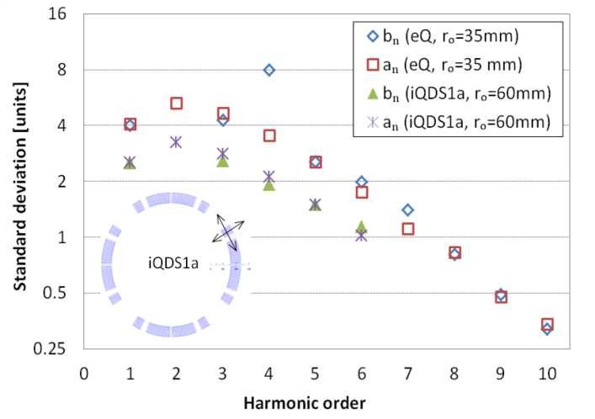

Figure 1: Random errors for conductor block positioning tolerances of ±100 m in radial and azimuthal direction.

Geometric Harmonics and Random Errors

The cross-section is optimized by adjusting the position and number of turns in the conductor blocks. Two blocks (one wedge) per layer are sufficient to achieve very small errors at a given operation point. Therefore, the straight section field quality is dominated by geometric tolerances and current dependent effects.

Field errors due to coil positioning tolerances can be estimated with a Monte Carlo simulation where the conductor blocks are randomly displaced. Fig. 1 shows the calculated standard deviations for the electron quadrupole (n=1, 10) and the first downstream ion quadrupole (n=1, 6) using 500 samples and 16 displacements for each sample (r,  for 8 blocks). This calculation may also be used to estimate the uncertainty on the systematic [14]. A flat distribution of ±100 m in radial and azimuthal direction was selected for the displacements. While conductor positioning accuracy below 50 m has been routinely demonstrated in series production, a larger value is chosen to account for a limited learning curve in JLEIC since only one (or few) units are required for each magnet. In order to improve the field quality, a correction scheme based on magnetic measurements performed after magnet assembly may be considered [15].

Iron saturation

The saturation effect is particularly relevant in the IR quadrupoles of JLEIC due to operation in a broad current range and space constraints limiting the iron yoke size.

Figure 2 shows the results for the dodecapole (b6) in the electron quadrupoles as a function of current and the yoke size. For yoke outer radius of 110 mm (or higher) no effect is observed, but the variation with current rapidly increases as the yoke size is reduced. It should be noted that a correction can be applied by adjusting the magnet cross section. Therefore, all curves may be shifted vertically by a fixed amount (assuming that the same coil design is used for all magnets) to optimize the DA. In case the saturation effect is found to be too large, a slight increase of the (still preliminary) space allocation for the innermost quadrupoles may be implemented.

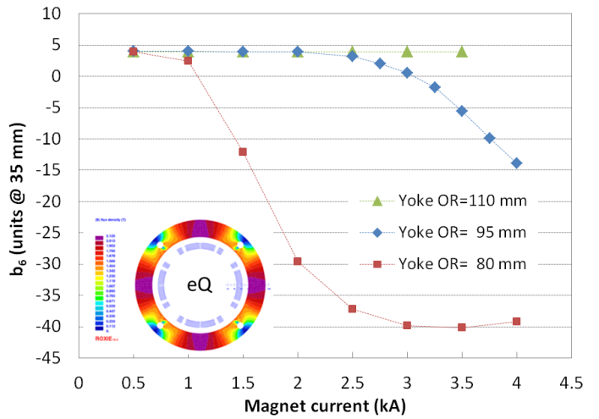

Figure 2: Saturation effect (b6 at r0=35mm) in the electron quadrupole as a function of current and yoke outer radius.

Fringe Fields

Transverse space constraints also limit the capability to return the magnetic flux. In this case the main concern is the effect of the high field, large aperture ion quadrupole fringe fields on the adjacent electron beamline. Fig. 3 shows the results for the downstream ion quadrupoles. The largest effect is found in IQDS1b due to a combination of aperture, gradient and radial yoke size. The effect on the electron beam needs to be evaluated from an optics and synchrotron radiation standpoint. Possible mitigation strategies include integrating the electron beamline in the iron yoke of the ion quadrupole, or placing an active correction coil or passive shield around the electron beam.

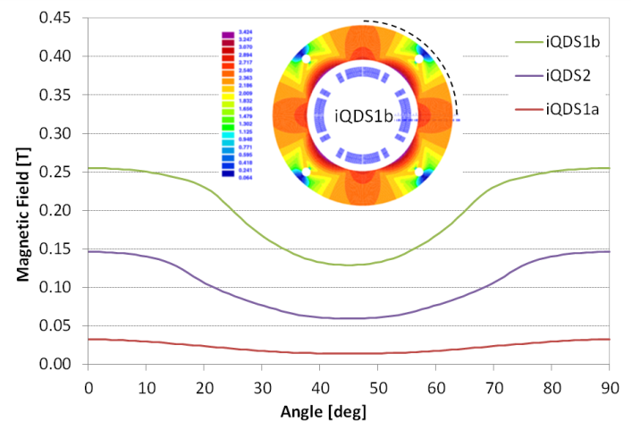

Figure 3: Fringe field at reference gradient in the downstream ion quadrupoles (field is plotted along dotted line).

Coil Ends

Large field errors are generated in the coil ends as the conductors are lifted and bent around the pole to return the current without interfering with the beam pipe. These errors may be corrected at the integral level within the end region by splitting and displacing the conductor blocks relative to each other. However, this approach comes at the cost of increased complexity and magnet physical length. Using the first downstream ion quad as a reference (Fig. 4), we show an example of this process applied to the b6 component (Fig. 5). In the case of a compact end, b6 reaches a peak of -280 units, or -43.3 units integrated over a magnetic length (straight section equivalent) of 406.3 mm. By displacing the mid-plane conductor block by 53 mm relative to the pole block, two narrower peaks appear with opposing sign and the integral is essentially zero. However, the quadrupole field decays more slowly in the optimized end. By computing the difference between physical and magnetic length in the two cases, it can be shown that an additional 17 mm per side is required to achieve the required magnetic length. The next component, b10, is essentially unaffected with a -30 unit peak, or -3.1 units integrated over 406.3 mm. In order to correct b10 the blocks need to be split at an appropriate location and additional displacements need to be introduced.

A more attractive alternative is to compensate the integrated end harmonics with opposite values in the straight section. This strategy has essentially no cost in terms of magnet design and fabrication, but should be evaluated from an accelerator physics standpoint as the correction is achieved over a much longer distance.

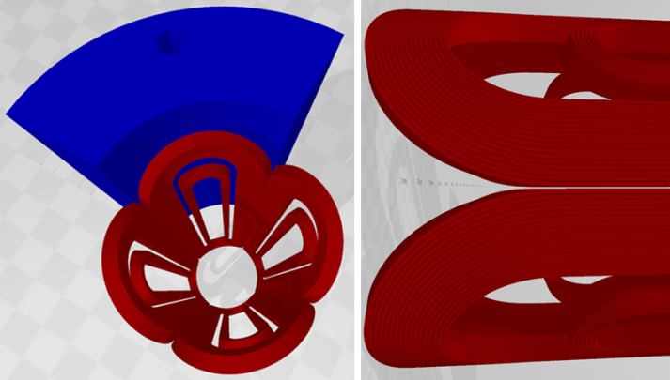

Figure 4: Coil and yoke model for iQDS1a 3D analysis.

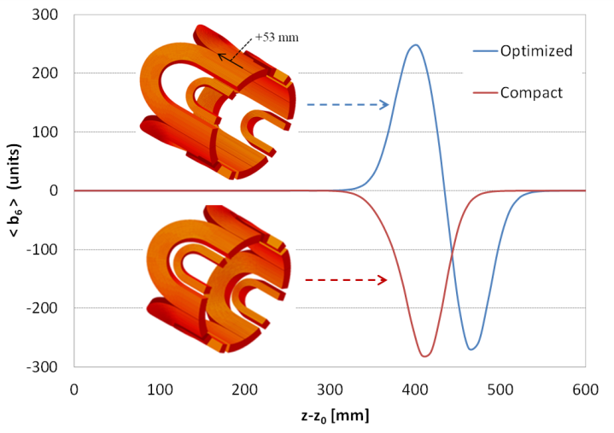

Figure 5: Comparison of b6 as a function of *z* in iQDS1a for the compact vs. field quality optimized end geometry.

SUMMARY AND NEXT STEPS

Preliminary estimates of the field harmonics for the JLEIC IR quadrupoles were presented. Feedback from the accelerator physics studies will provide guidance for further evaluation and optimization of the magnet field quality.

References

[1] DOE/NSF Nuclear Science Advisory Committee, “The Frontiers of Nuclear Science: A Long Range Plan”. AIP Conference Proceedings 972, 17 (2008)

[2] Donald Geesaman (2016) Reaching for the Horizon: The Nuclear Science Advisory Committee 2015 Long Range Plan for Nuclear Science, Nuclear Physics News, 26:1, 3-4, DOI: 10.1080/10619127.2016.1140967

[3] National Academies of Sciences, Engineering, and Medicine, “An Assessment of U.S.-Based Electron-Ion Collider Science”. Washington, DC: The National Academies Press (2018). <https://doi.org/10.17226/25171>.

[4] A. Accardi et al., “Electron-Ion collider: the next QCD frontier- understanding the glue that binds us all” eur. Phys. J. A52, p. 268 (2016).

[5] Y. Zhang, “JLEIC design update”, Proceedings of NAPAC 2019, Lansing, Michigan, September 2019.

[6] A. Seryi, F. Willeke et al., “The US electron ion collider accelerator designs,” NAPAC 2019, Lansing, Michigan, September 2019.

[7] V. Morozov et al., “Full acceptance interaction region design of JLEIC”, Proceedings of the 10th International Particle Accelerator Conference (IPAC 2019) Melbourne, Australia, May 2019.

[8] Y. Nosochkov et al., “Dynamic aperture of JLEIC electron collider ring with errors and correction”, Proceedings of the 10th International Particle Accelerator Conference (IPAC 2019) Melbourne, Australia, May 2019.

[9] B.R.P. Gamage et al., “Multipole effects on dynamic aperture in JLEIC ion collider ring”, Proceedings of NAPAC 2019, Lansing, Michigan, September 2019.

[10] R. Rajput-Ghoshal et al., “Conceptual design of the interaction region magnets for future electron-ion collider at Jefferson Lab”, *IEEE Trans. Appl. Supercond.* Vol 29, No. 5, August 2019.

[11] S. Russenschuck, “ROXIE: Routine for the optimization of magnet X-sections, inverse field calculation and coil end design,” CERN-99-01, Apr. 1999.

[12] H. Prin et al., “Production of the Superconducting Matching Quadrupoles for the LHC Insertions”, *IEEE Trans. Appl. Supercond.*, vol. 16, no. 2, June 2006.

[13] L. Rossi, “Superconducting cables and magnets for the Large Hadron Collider”, Proceedings of the 6th European Conference on Applied Superconductivity (EUCAS 2003), 14-18 September 2003, Sorrento, Italy.

[14] P. Ferracin et al., “Development of MQXF: The Nb3Sn Low-βQuadrupole for the HiLumi LHC”, *IEEE Trans. Appl. Supercond.*, vol. 64, no. 4, June 2016.

[15] G. Sabbi et al., “Correction of high gradient quadrupole harmonics with magnetic shims”, *IEEE Trans. Appl. Supercond.* Vol. 10, No. 1, March 2000.