TRANSIENT BEAM LOADING AND MITIGATION IN JLEIC COLLIDER RINGS\*

J. Guo#, R. A. Rimmer, H. Wang, S. Wang, JLAB, Newport News, VA, USA  
T. Mastoridis, CalPoly, San Luis Obispo, CA, USA  
J. Fox, Stanford University, Stanford, CA, USA

Abstract

The Jefferson Lab Electron-Ion Collider (JLEIC) is an asymmetric high luminosity ring-ring collider proposed as the next major R&D facility for the nuclear physics community. Both of JLEIC’s electron and ion collider rings have high beam current with gaps serving the purposes of beam abort, ion clearing, etc. Such a time-varying beam loading in the RF cavities would generate modulation in cavity RF phase/voltage, causing cyclic shift of collision point and potential luminosity loss. We studied a few approaches to mitigate the RF phase modulation and IP shift, such as correcting the RF phase/voltage modulation with traditional LLRF feedback, one-turn feedback (OTFB), or RF feedforward (FF); optimizing the bunch fill pattern to limit the RF phase/voltage modulation to a small fraction of the bunch trains in the collider ring; or matching the RF phase modulation in the two rings. The preliminary results are discussed in this paper.

Introduction

JLEIC is a high luminosity electron-ion collider. After a few rounds of design iteration, currently JLEIC is designed for 3-12 GeV electrons and 20-200 GeV protons (or other ions of the same maximum magnetic rigidity), with the possibility to upgrade to higher energy. The luminosity optimization strategies of JLEIC require beams with high bunch repetition rate, short bunch length, low emittance, and high current in both rings [1]. JLEIC’s beam current is up to 0.75 A for proton and 3.6 A for electron, but varies with different beam energy and ion species.

In the current design, the JLEIC electron ring will reuse the PEP-II RF system retuned to approximately 476.3 MHz with single cell normal conducting cavities of ~0.8 MV maximum voltage, and the ion ring will use a newly designed 952.6 MHz superconducting RF (SRF) system with 24 two-cell cavities of 2.4 MV maximum voltage. The short bunch length in JLEIC requires high bunching RF voltages and strong reactive beam loading, with 57.6 MV nominal voltage in the ion ring, while the RF voltage in the electron ring ranges from a few MV to 30MV, depending on beam energy.

Both JLEIC’s collider rings require beam current gaps for beam abort and other purposes. Currently the ion ring has two gaps of 267 ns each, determined by the minimum abort kicker rise time and JLEIC’s ion bunch formation process with binary splitting [2]. The electron ring gap length was initially chosen to match the ion ring gap. The missing reactive beam loading in those gaps will cause strong phase modulation in the two rings. In case of synchrotron phase *ϕs*=0, optimum detuning and constant klystron drive, the maximum RF phase modulation can be calculated as [3]:

\*Authored by Jefferson Science Associates, LLC under U.S. DOE Contract No. DE-AC05-06OR23177, with additional support from U.S. DOE Award Number DE-SC-0019287

#jguo@jlab.org

$∆φ≈\frac{ω_{0}I_{b}τ_{gap}}{V}\frac{R}{Q}$ (1)

where *Ib* is the DC beam current, and *τgap* is the time length of the gap. JLEIC’s two rings are asymmetric and usually would have different phase modulation response, resulting in cyclic longitudinal shift of the interaction point (IP). With the small β\* in JLEIC, this IP shift could cause significant luminosity loss if not corrected. Figure 1 shows different phase modulation in JLEIC’s two rings for the case of 10 GeV electron (*Ib*≈ 0.7 A*, Vc*×cos*ϕs*≈ 0.6 MV), and 100 GeV ions (*Ib*=0.75 A*, Vc*=2.4 MV). These cavity parameters were also used for the quantitative results (simulation and analytical) shown in the next section, unless specifically mentioned. For the cases with lower electron energy (higher beam current, lower cavity voltage) and possibly lower ion ring beam current (i.e. heavy ions), the two rings’ RF phase mismatch will be more significant.

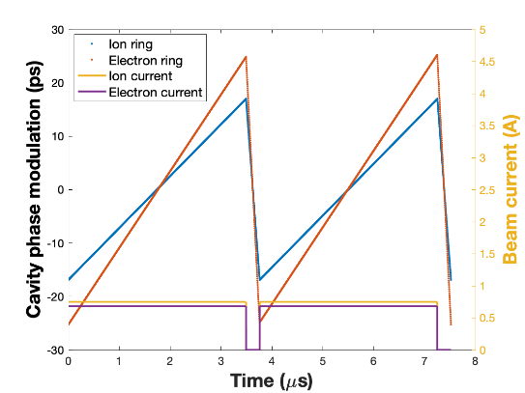

Figure 1: RF phase modulation in JLEIC bunching cavities caused by transient beam loading.

CORRECTIng THE RF PHASE MODULATION IN JLEIC

There are a few approaches to mitigate the IP shift caused by transient beam loading. The phase modulation can be corrected by the “traditional” LLRF feedback, OTFB, or feedforward; or we can use an adaptive algorithm to match the RF phase modulation in the two rings and mitigate the IP shift. The LLRF model for JLEIC with all these schemes is shown in Fig. 2. We simulated these schemes with JLEIC beam parameters of 10 GeV 0.7 A electrons and 100 GeV 0.75 A ions. We could also modify the bunch fill pattern to correct the phase modulation.

Feedback

We first consider the traditional LLRF feedback system with a digital loop (low bandwidth) and an analog loop (high bandwidth). With a realistic delay of 320 ns, the beam phase modulation is regulated well after the first 1 µs. The peak to peak IP shift is 18.7 ps (5.6 mm), which is similar to the case of constant klystron drive; however the rms IP shift is reduced to 5.1 ps (1.5 mm). The klystron power needed in the electron ring is about 425 kW per cavity, which fits to the design using each of the existing PEP-II 1.2 MW klystron to drive two cavities; the ion ring requires approximately 150 kW per cavity, or 3.6 MW total.

**Macintosh HD:Users:Themis:Dropbox:EIC:EICnotes:EIC_block_diagram.pdf**

Figure 2: Proposed JLEIC LLRF diagram.

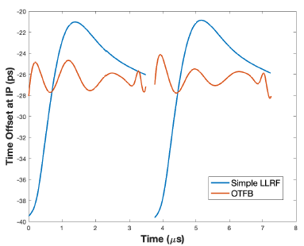a)

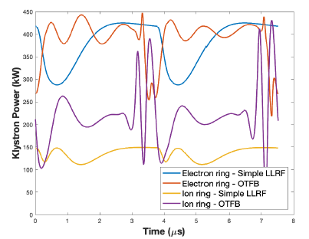b)

Figure 3: JLEIC cavity RF phase modulation (a) and klystron power (b) using “simple” LLRF feedback or OTFB, with realistic delay.

We can improve the phase modulation correction with a OTFB system reducing the peak to peak IP shift to 4.2 ps (1.3mm), or 0.85 ps (0.25mm) rms. The RF power in the electron ring increases slightly to 450 kW per cavity, and it almost tripled to 430 kW per cavity in the ion ring. Figure 3 shows the IP offset and klystron drive for both cases of the traditional LLRF feedback and OTFB.

Feedforward

Similar to the RF feedback, a feedforward system controls the klystron input. But its input is the beam position rather than the cavity voltage. It can thus measure the beam current and compensate it through the klystron.

*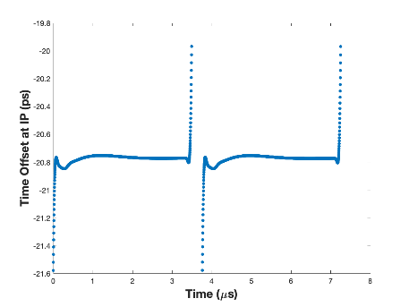*a)

*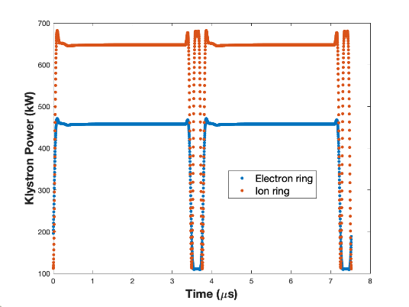*b)

Figure 4: JLEIC cavity RF phase modulation (a) and klystron power (b) using feedforward, with realistic delay.

With an ideal feedforward system, it’s possible to completely correct the RF phase modulation by switching the klystron drive phase and amplitude when the instantaneous beam current changes. With optimum steady-state detuning, the RF power needed during the gap would be very high. To minimize the peak klystron power, the detuning must be adjusted. For the ion ring, we can adopt the “Half-detuning” scheme [4], reducing the detuning angle to half of optimum detuning. In such a scheme, the klystron power needed for the beam and no-beam segments are equal

$P_{beam}=P_{no beam}=\frac{V_{c}^{2}{\left(1+β\right)}^{2}}{4R_{sh}β}+\frac{{R_{sh}I}_{b}^{2}}{16β}$ (2)

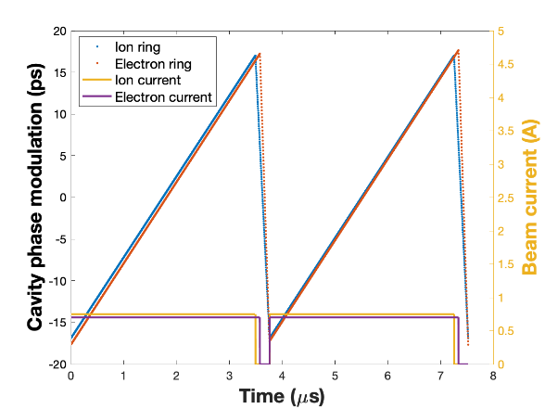

Figure 5: Matching the RF phase reference modulation in JLEIC’s electron ring and ion ring.

We can further optimize the cavity coupling to minimize the klystron power. For SRF cavities in the ion ring, the optimized loaded Q is $Q_{L}={{2V}_{c}}/{\left(I_{b}R/Q\right)}$, resulting klystron power of $P={I_{b}V_{c}}/4$. For the JLEIC ion ring with 0.75 A beam current, we would need 450 kW per cavity or 10.8 MW total, not including any overhead required by system delay, waveguide loss, etc.

Figure 4 shows the simulation results in JLEIC in a realistic system. The peak to peak IP shift is 1.6 ps (dominated by the initial and final transients) and the standard deviation is 0.07 ps. For the electron ring, the coupling of the existing PEP-II cavities is assumed to be due to the design. The RF power needed per cavity is 680 kW in the ion ring, and 480 kW in the electron ring.

RF Phase Reference Modulation

Among the previously discussed schemes for JLEIC RF transient mitigation, the simple LLRF can’t correct the phase modulation sufficiently; both the OTFB and FF schemes require more than 10 MW total RF power in the ion ring, which becomes a new cost driver. The RF power per SRF cavity is also challenging for the coupler design. Alternatively, the RF power required can be reduced significantly by letting the beam current drive the cavity voltage modulation, accepting a phase shift along the bunch train but matching it between the two rings, as demonstrated at LHC [5].

To minimize the RF power needed in one ring, the RF reference could follow the modulation in the case of an ideal ring with CW klystron drive. Using default parameters, JLEIC’s two asymmetric rings have different RF reference, as shown in Fig. 1. Such a modulation is determined by parameters including beam current, cavity R/Q and voltage, as well as gap length. Although all these parameters can be used to match the RF phase reference modulation, in reality the electron ring gap length is the only continuous free knob with a large range. Figure 5 shows that after reducing the electron ring gap from 267 ns to 183 ns (from gap of 128 bunches to 87 bunches), the two rings’ phase reference modulation can be matched. The range of IP collision time shift is ±18 ps. Initial simulation shows that the ion ring requires approximately 115 kW per cavity and 2.8 MW total, while the electron ring requires 435 kW per cavity. For low energy cases with higher electron beam current, and probably also lower electron ring RF voltage and ion beam current, the electron ring gaps will have to be further shrunk to the limit of the abort gap; the ion ring gap length can also be doubled if necessary. The ion ring cavity coupling used in this simulation was optimized to minimize the RF power for fully correcting the phase modulation with “Half-detuning”, and can be optimized further to reduce the RF power in the phase reference modulation scheme.

One concern for the phase reference modulation is the beam transverse shift at IP along the bunch train caused by coherent crabbing phase error. Attempting to correct that error by matching the crab voltage reference to the bunch voltage phase modulation requires a lot of RF power, cancelling the RF power saving of the RF phase modulation scheme. Although JLEIC’s two rings are asymmetric, they have the same crabbing angle, resulting in exactly same transverse shift at IP. However, when particles are longitudinally off from the IP, the transverse shift caused by crabbing phase modulation will be different in the two rings, potentially reducing the luminosity. A study for HL-LHC [6] showed a luminosity loss of ~2% due to coherent crabbing phase error with crabbing time offset of 100 ps. With the shorter bunch length and smaller crabbing time offset, the luminosity loss from coherent crabbing phase error in JLEIC is expected to be even smaller. Quantitative evaluation of this luminosity loss, both analytical and numerical, is still needed for JLEIC.

The matching of phase reference modulation assumes that the two rings have the same revolution time. JLEIC’s electron/ion beam synchronization scheme requires changing the harmonic number in the ion ring at very low energy (<38 GeV/u for the current baseline) to reduce the RF frequency and electron ring circumference change [7], a.k.a. “gear changing”. In this case we need to correct the phase modulation with either OTFB or FF. JLEIC can choose to install ~115 kW klystrons in the ion ring to satisfy the 0.75 A 57.6 MV operation above 38 GeV/u, and operate with reduced ion beam current and RF voltage for ion energy below 38 GeV/u. We may also relax the requirement of the maximum IP shift. Actually for most of JLEIC’s operating scenarios with ion energy below 38 GeV/u, the high beam current and short bunch length are already less attractive due to the lack of bunched beam cooling during collision and stronger IBS effect, and also constrained by the space charge limit during the bunch formation (for heavy ions) or during collision (for low energy protons).

Modifying the Bunch Train Fill Pattern

We also explored another approach to eliminate the low order driving term of the transient beam loading by modifying the bunch train fill pattern. We can increase the intensity of the bunches around the gaps to average out the missing beam loading in the gaps, so the RF phase modulation can be almost eliminated in the normal intensity segments of the bunch train. This principle has been demonstrated experimentally for electron rings at both BEPC-II and ALS [8]. For the JLEIC ion ring, the bunch formation process to generate the higher intensity segments remains a challenge, especially due to the space charge limit.

CONCLUSION

We studied a few options to either correct the RF phase modulation due to transient beam loading in JLEIC, or mitigate the IP shift by modulating the RF phase of the two rings with matched reference. The preliminary results showed that matching the RF phase reference of JLEIC’s two rings is feasible and can be the baseline for most of JLEIC’s energy range with moderate RF power. At lower ion energy (<38 GeV/u) when JLEIC’s beam synchronization scheme engages “gear changing”, we need to correct the phase modulation in both rings using the feedback or feedforward schemes, and reducing the ion beam current and RF voltage if needed. We need to repeat the studies for other beam parameter combinations, especially the cases with lower energy/higher beam current in the electron ring.

References

[1] Y. Zhang, “JLEIC: A High Luminosity Polarized Electron-Ion Collider at Jefferson Lab”, presented at the IPAC'19, Melbourne, Australia, May 2019, paper TUPRB112, this conference.

[2] J. Guo, T. Satogata, Y. Zhang and B. R. P. Gamage, “Study on JLEIC Ion Beam Formation Scheme”, presented at the IPAC'19, Melbourne, Australia, May 2019, paper TUPRB109, this conference.

[3] D. Boussard, T. Linnecar, “The LHC Superconducting RF System”, 1999 Cryogenic Engineering and International Cryogenic Materials Conference, July 12-16, 1999, Montreal, Canada.

[4] P. Baudrenghien and T. Mastoridis, “Performances and Future Plans of the LHC RF”, in *Proc. HB'12*, Beijing, China, Sep. 2012, paper THO1C04, pp. 565-569.

[5] T. Mastoridis *et al.,* “Cavity voltage phase modulation to reduce the high-luminosity Large Hadron Collider RF power requirements”, *PRAB*, 20, 101003 (2017)

[6] E. Yamakawa *et al.,* “Luminosity reduction caused by phase modulations at the HL-LHC crab cavities”, *NIM-A* 908, 2018, p. 338–346.

[7] V. Morozov *et al.,* “Study of Beam Synchronization at JLEIC”, ArXiv:1606.09117 [physics.acc-ph], June 29 2016

[8] H. Wang *et al.,* “Transient Beam Loading Due to the Bunch Train Gap and Its Compensation Experiments at BEPC-II and ALS”, in *Proc. IPAC'18*, Vancouver, Canada, Apr.-May 2018, pp. 390-393. doi:10.18429/JACoW-IPAC2018-MOPMK017