UPDATE ON THE JLEIC ELECTRON COLLIDER RING DESIGN*

F. Lin†, V.S. Morozov, Y. Zhang, Jefferson Lab, Newport News, VA 23606, USA   
Y. Cai, Y.M. Nosochkov, SLAC National Accelerator Laboratory, Menlo Park, CA USA

Abstract

The design concept of electron collider ring in the Jefferson Lab Electron-Ion Collider (JLEIC) is based on a small beam size at the interaction point (IP) to boost the luminosity. With a chosen beta-star at the IP, electron beam size is determined by the equilibrium emittance obtained from the linear optics design. In this paper, we present an update on the lattice design of the electron ring considering not only preservation of low beam emittance, but also optimization of geometric arrangement. In particular, recently development of the lattice design has been focused on incorporating the vertical dogleg, which brings the electron beam to the ion beam plane for collisions, in the spin rotator design. The vertical dogleg is designed with no horizontal emittance growth, controlled vertical emittance and no first-order effect on the electron polarization.

INTRODUCTION

The electron collider ring in the JLEIC [1] is designed for electron beams with a small beam size to collide with ion beams at the IP to reach a high luminosity. Such a small beam size is achieved by an aggressively small beta-star and small emittance, which both are determined by the linear optics. Small beta-star is obtained from a design with a few of final focusing quadrupoles (FFQs) in the IP region locally, while small equilibrium emittance is related to the linear optics design globally. In addition to reaching the desired beam parameters, a compact electron collider ring design is favorable as it is most cost effective and guaranteed to fit in the Jefferson Lab site, while the size and dimension of the ring should be sufficiently large to accommodate all machine components. The major components include spin rotator, interaction region, injection, RF system, electron polarimeter, etc. Hence, the linear optics design of the electron collider ring considers a balance between machine performance and geometry.

OPTICS DESIGN

To reduce project costs, PEP-II High Energy Ring (HER) magnets [2] are considered to be reused in the JLEIC electron collider ring. Specifically, these magnets are mainly operated in both arcs and straights within their magnet specification. The lattice is a FODO lattice in both arcs and straights. Machine sections with special functions, such as spin rotator and detector region, are designed as modules and inserted into the lattice with proper optics matching.

* Work supported Jefferson Science Associates, LLC under U.S. DOE Contract No. DE-AC05-06OR23177 and DE-AC02-76SF00515

† fanglei@jlab.org

The normal arc FODO cell is 15.2-m long, with two PEP-II 5.4-m long normal conducting dipole magnets. The filling factor is 71%. The dipole has a field of 0.363 T at the 12 GeV electron beam energy, with a bending angle of 2.81° resulting in a sagitta of 3.3 cm. This sagitta is about 1 cm larger than the PEP-II dipole sagitta of 2.2 cm, but it is still within the dipole good field region of 5 cm. Optics, shown in Fig. 1, has reused PEP-II quadrupole strengths within their specifications below 17 T/m [2]. Each quadrupole is followed by a sextupole for chromaticity compensation and a focusing-plane corrector and BPM for closed orbit measurement and correction.

Due to the natural synchrotron radiation effect, the electron beam in a storage ring reaches an equilibrium emittance that is primarily determined by the linear optics design. In the JLEIC electron collider ring, two arcs, consisting of regular FODO cells, spin rotators and matching sections between them, contribute up to 94% of the natural horizontal emittance. The phase advance of a regular arc FODO cell is chosen to be 108°, close to 137° that gives the minimum emittance for an FODO cell optics [3]. Such a phase advance creats a 3π phase advance between sextupoles every 5 cells so that the sextupole induced geometric resonance driving terms can be cancelled.

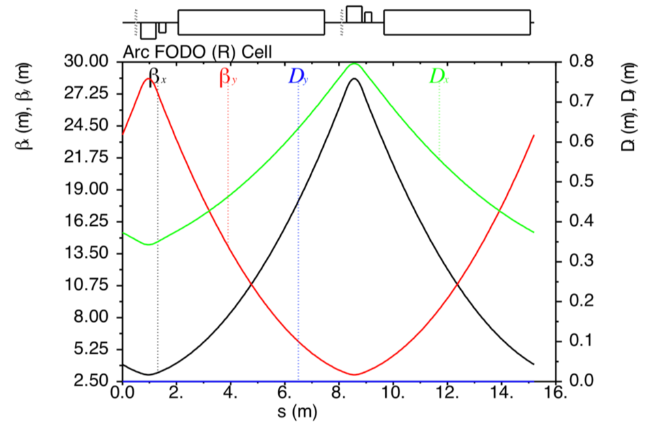

Figure 1: Electron collider ring arc FODO optics.

The spin rotator is designed with interleaved solenoids and dipoles, quadrupoles in between for the optics, to rotate the electron polarization between the vertical (in arcs) and longitudinal (at IP) directions in the whole energy range of 3 to 12 GeV [4, 5, 6]. Spin rotator is part of the arc optics, providing a horizontal bending angle of 13.2°. In addition to the spin manipulation, the spin rotator is also designed to transport the electron beam, through a vertical-dogleg design, from the electron collider ring plane to the ion collider ring plane for collisions at the IP. The advantages of doing this are twofold. First, the dipole fields used to transport the electron beam are much weaker than those used to transport the ion beam since the electron beam energy is much lower than the ion beam energy. Second, space is tighter in the ion collider ring because more machine components, such as an electron cooling section, accelerating and bunching cavities, dedicated region for far-forward ion detection after collisions, etc., are required. Placing the vertical dogleg into the electron collider ring provides sufficient space for all required machine components in the ion collider ring.

The radial dipole fields that bend the electron beam vertically in the dogleg are not interleaved with the vertical dipole fields that are required for the spin manipulation. Therefore, the dogleg has zero net effect on the spin rotation in the first order. However, the depolarization caused by the spin-orbit coupling effect might be enhanced due to the radial dipole fields in the dogleg. Spin tracking simulations will be performed to provide a quantitative estimate of how much the polarization lifetime is affected.

The longitudinal fields in the solenoids cause coupling between the horizontal and vertical motions. Although such transverse coupling may be a benefit in the operation of synchrotrons to adjust the vertical emittance and increase the Touschek lifetime, the accompanying coupling resonances may reduce the available dynamic aperture for the particle motion and accordingly decrease the beam lifetime. Therefore, transverse orbital coupling is usually undesirable and should be compensated in a storage ring. Two solutions of coupling compensation have been studied. One is to use normal quadrupoles [7]. In this scheme, a solenoid is divided into two equal parts and an insert composed of normal quadrupoles is placed between them. The quadrupole strengths are chosen so that for the whole combination (half solenoid, quadrupole insert, and half solenoid), the 4 × 4 transport matrix is block-diagonal. Then the transverse coupling due to the solenoids is neutralized. In this scheme, the quadrupole strengths are independent of the solenoid fields, however, they are relatively strong. A relatively large longitudinal space for the compensating quadrupoles is also needed to create this block-diagonal transport matrix. Another solution that is being applied in the JLEIC spin rotator for the coupling compensation is to use skew quadrupoles. Each solenoid is divided into four equal parts and skew quadrupoles are inserted in between. The coupling effect induced by skew quadrupoles cancels that due to the solenoids, with a block-diagonal 4 × 4 transport matrix of the whole insertion. Splitting a long solenoid into four parts makes the optics straightforward to control. This scheme places no requirements on the strengths and lengths of different solenoids. The skew quadrupole strengths depend on the solenoid strengths, and vary with the beam energy.

The optics of spin rotator is shown in Fig. 2, with the beam line shifted by 1.2 m in the vertical direction as shown in Fig. 3. This spin rotator does not change the design orbit over the entire range of designed electron beam energy. Dipole bending angles and optics are chosen and designed to control the emittance contribution in both horizontal and vertical planes. Zero dispersion in the solenoids avoids synchrotron sideband spin resonances.

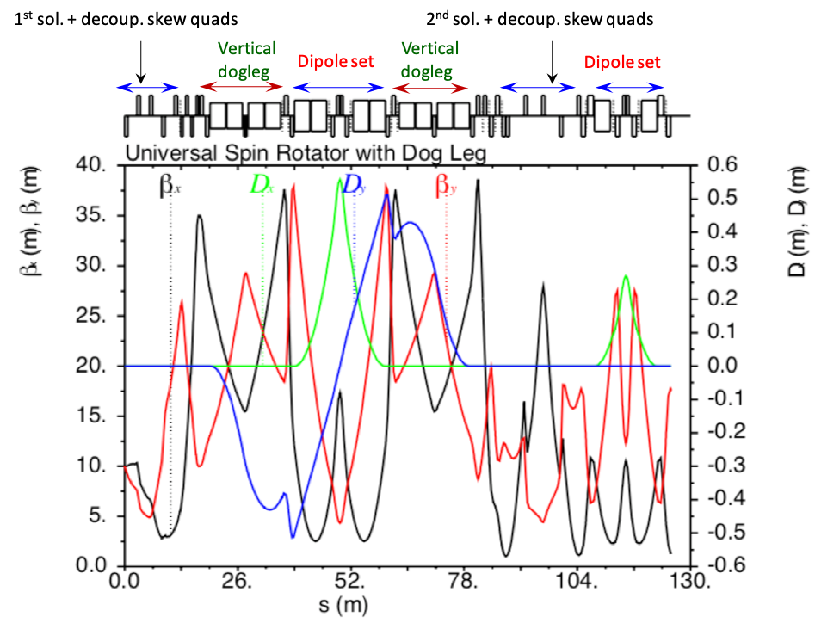

Figure 2: Spin rotator optics in the electron collider ring.

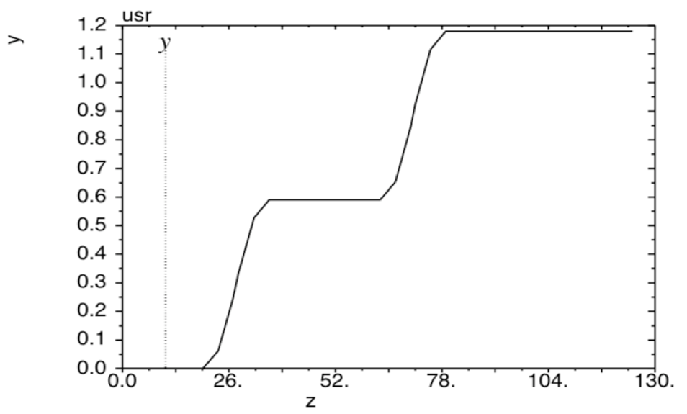

Figure 3: Vertical dogleg in the spin rotator transports the electron beam by 1.2 m in the vertical direction.

The interaction region is designed with small beta-star to provide electron beams with a small beam size at the IP for collisions with ion beams to reach a desired high luminosity. Two triplets are used in both up- and downstream of the IP to guarantee the desired beta-star and control the maximum beta functions. The detector space is made asymmetric to create sufficient space for electron low-Q2 tagging and minimum chromaticity contribution. Special attention is paid to sizes and positions of machine elements to avoid them interfering with ion detector region elements, considering engineering fabrication. The downstream optics is designed to focus the beam again to allow close placement of detectors at those locations, in combination with relatively large dispersion values, which enhances the momentum resolutions of the forward detector. The dispersion generated by the spectrometer dipoles is suppressed by a dipole chicane whose parameters are chosen to avoid a significant impact on the equilibrium emittance. In addition to two anti-solenoids, skew windings up to ~10 T/m on the FFQs are sufficient to compensate the detector solenoid induced coupling at the IP. Space is reserved in both up- and downstream of the IP for crab cavities with large horizontal beta functions and (n+1)π/2 phase advance relative to the IP to reduce the cavity voltages. The optics of interaction region is shown in Fig. 4.

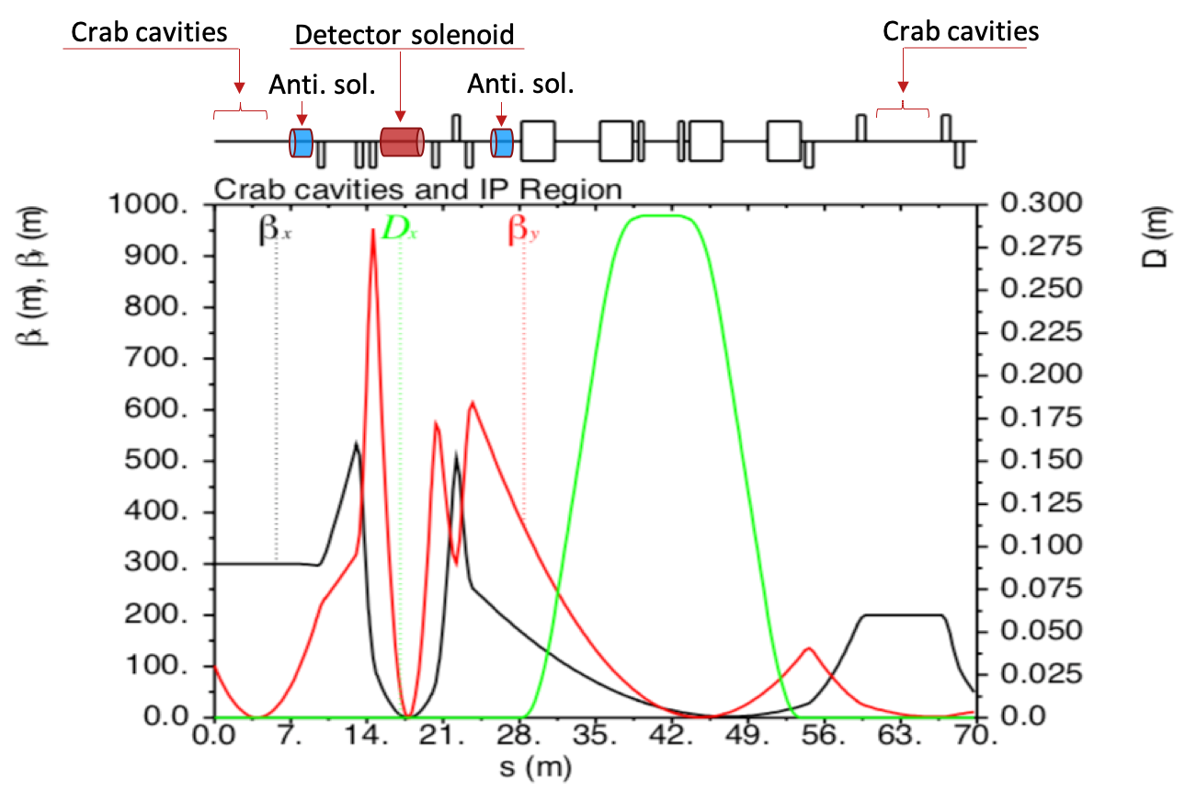

Figure 4: Electron collider ring interaction region optics.

The linear optics of JLEIC electron collider ring has one IP integrated. The rest of the IP straight is occupied by FODO cells and necessary matching sections. The second straight is presently filled with FODO cells and space is reserved for a second IP. Some of these FODO cells are used as a tune trombone for the betatron tune adjustment. RF cavities are placed in the straight between quadrupoles in FODO cells. The beta functions in the RF locations are controlled to be relatively small to improve the coupled beam instability thresholds.

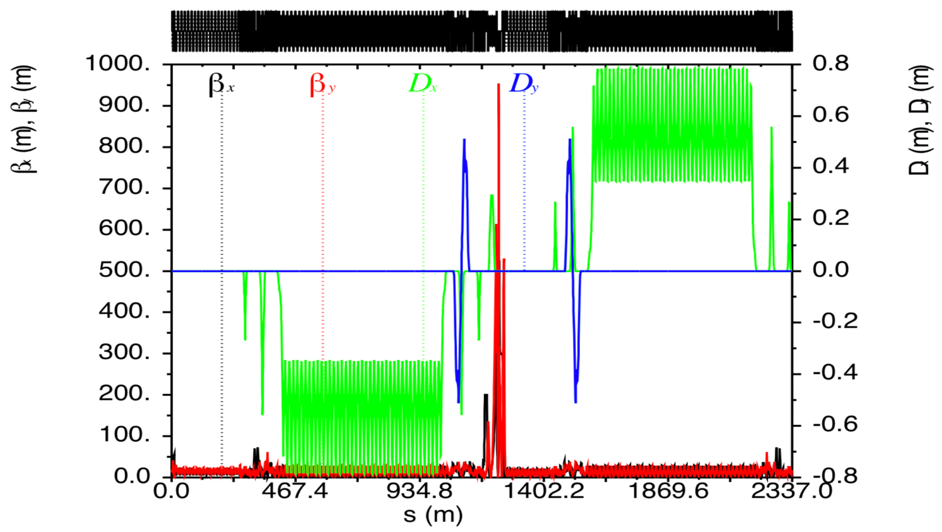

Figure 5: Complete electron collider ring optics.

Figure 5 plots the complete electron collider ring optics. Figure 6 and 7 show the top-view and side-view layouts of the electron collider ring. Table 1 presents high-level optics parameters of the design of JLEIC electron collider ring.

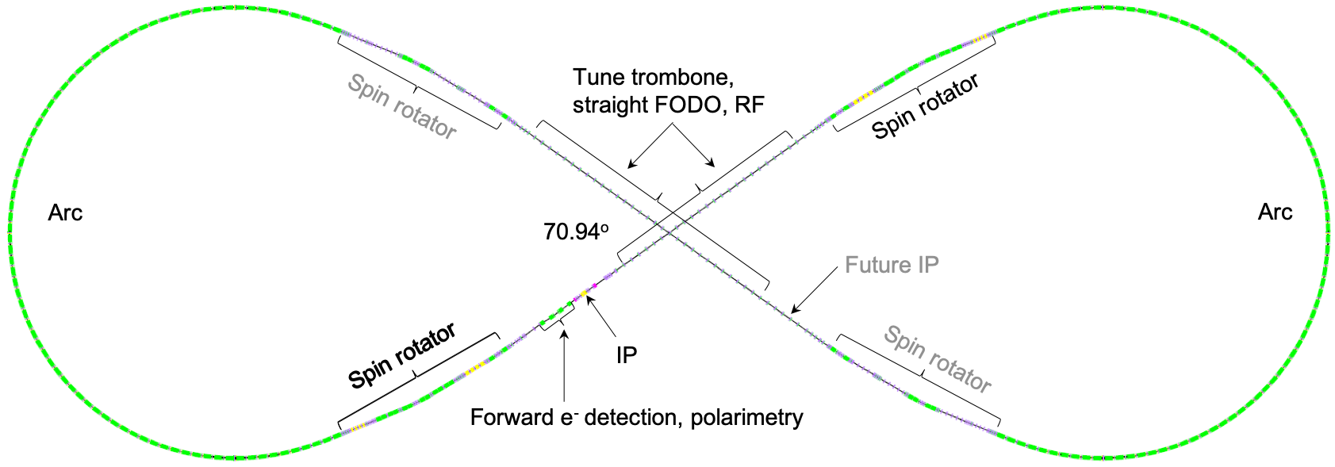

Figure 6: Electron collider ring top-view layout.

CONCLUSION

The JLEIC electron collider ring is designed to deliver an electron beam with high current and high polarization for collisions with an ion beam at the IP. The luminosity is boosted by a small beam size that is achieved by small beta-

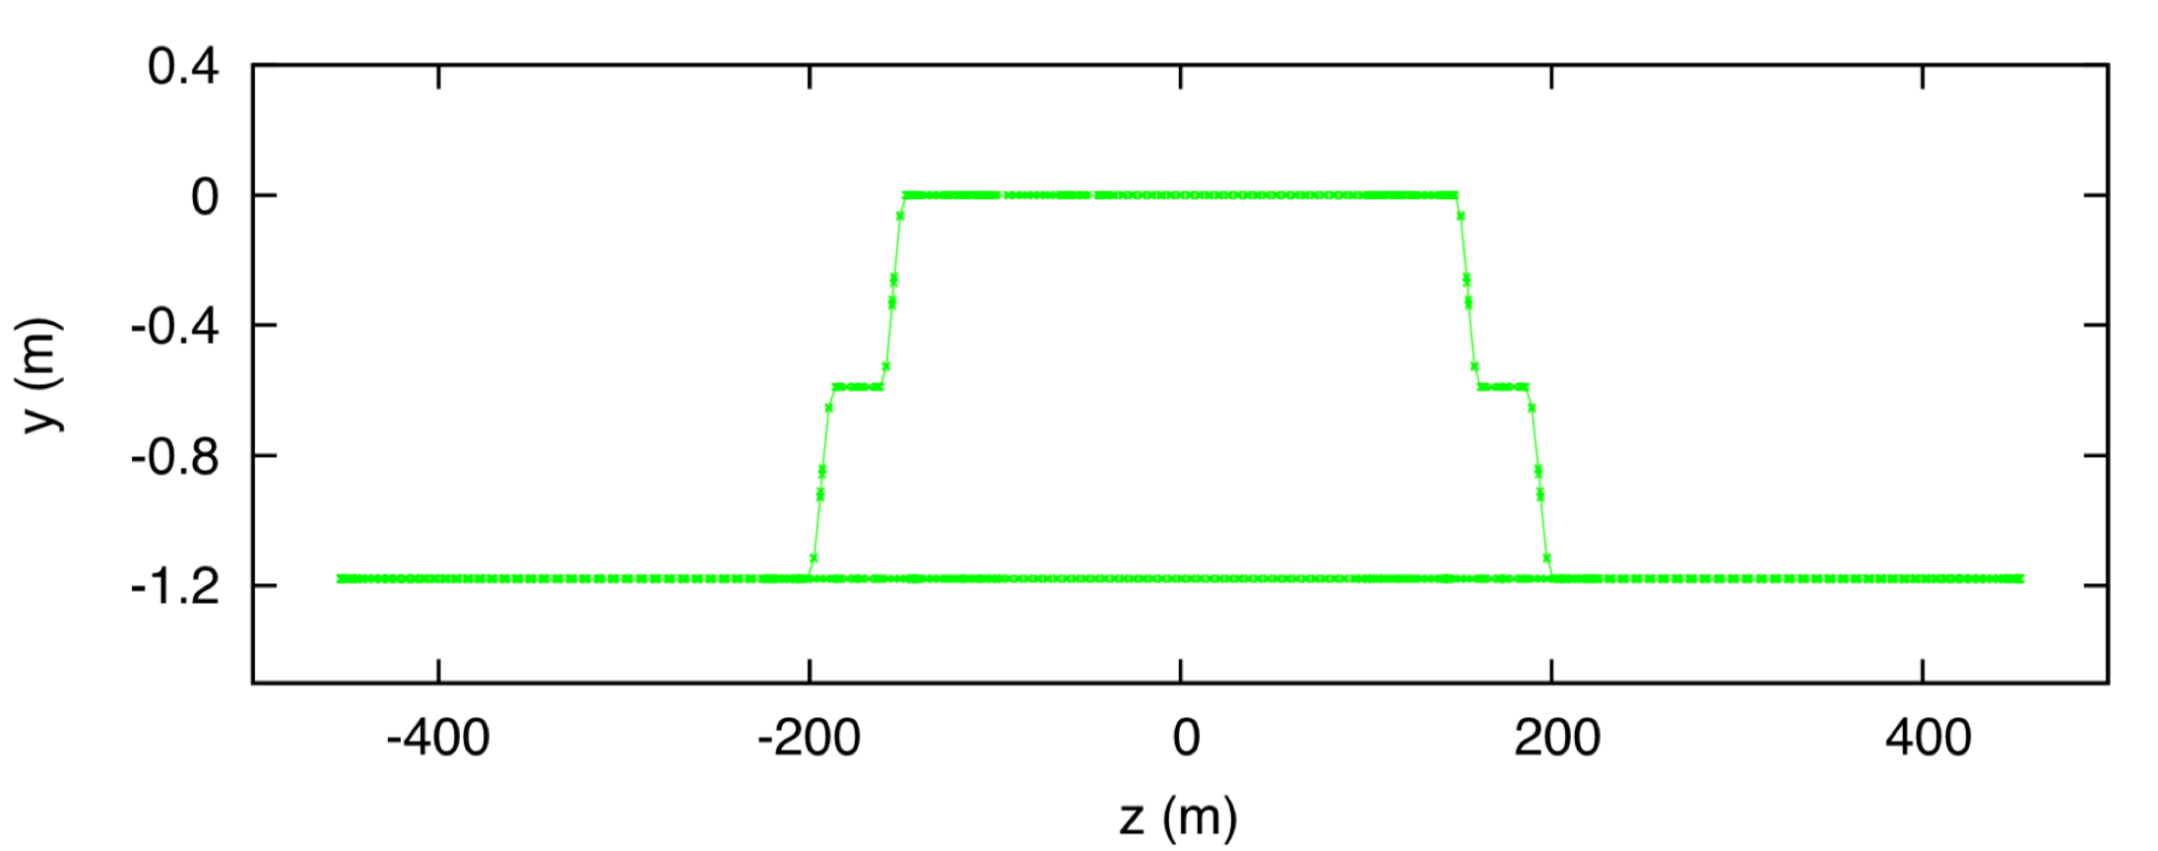

Figure 7: Electron collider ring side-view layout.

Table 1: JLEIC Electron Collider Ring Lattice Parameter

|  |  |  |
| --- | --- | --- |
| **Parameter** | **Unites** | **Value** |
| Circumference | m | 2336.00 |
| Figure-8 crossing angle | deg | 70.94 |
| Total ring bending angle | deg | 501.88 |
| β*x | cm | 10 |
| β*y | cm | 1 |
| βx,max | m | 532 |
| βy,max | m | 873 |
| Dx,max | m | 0.78 |
| Dy,max | m | 0.51 |
| ςx | - | -110 |
| ςy | - | -144 |
| αc | 10-3 | 1.71 |
| γT | - | 24.21 |
| εNx,y at 5 GeV | μm | 85 / 6 |

star at the IP and small emittance through the linear optics design. Considering the project cost, the electron collider ring reuses the PEP-II magnets and RF cavities. In addition, a compact design is adopted to further reduce the cost and guarantee to fit in the Jefferson Lab site, while the size and dimension are large enough to accommodate all machine components. Nonlinear dynamics study will be performed to evaluate the momentum acceptance and dynamic aperture in the electron collider ring.

References

[1] S. Abeyratne et al., MEIC Design Summary, edited by G. A. Krafft, arXiv:1504.07961 (2015).

[2] M. Bona et al., SuperB CDR, INFN/AE– 7/2, SLAC-R-856, LAL 07-15, March 2007.

[3] S.Y. Lee, Accelerator Physics, published by World Scientific Publishing Co. Pte. Ltd.

[4] P. Chevtsov, et al., Jlab-TN-10-026 (2010).

[5] H. Sayed, et al., in Proc. of IPAC’10, Kyoto, Japan, TUPEB044 (2010).

[6] F. Lin, et al., in Proc. of PSTP’13, PoS(PSTP2013)025 (2013).

[7] A. Zholents, et al., BINP (Novosibirsk) Preprint 81-80 (1981). English translation: DESY Report L-Trans 289 (1984).