Tunnel Diameters of Colliders

The Tevatron has an internal diameter of 8’ 4”

The SSC had an internal diameter of 12’

The LEP/LHC tunnel has an internal diameter of 3.8m (12’ 6”) in the arcs and 4.4m (14’ 5”) or 5.5m (18’ 1”) in the straights

The HERA tunnel had an internal diameter of 5.2m (17’ 1”) (had both proton and electron rings)

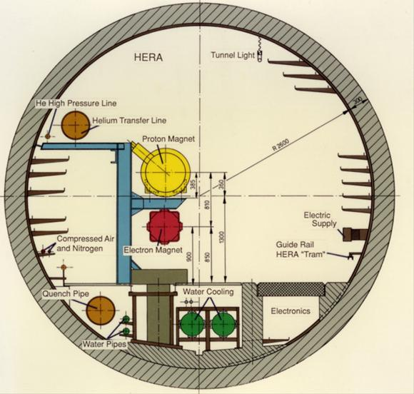

The VHC had a proposed internal diameter of 12’

The JLEIC tunnel internal diameter is proposed to be 25’ (boring) or 21’ x 11’2” cut and cover).