**Optimization of an electron spin rotator with vertical bends**

A.M. Kondratenko1, M.A. Kondratenko1, and Yu.N. Filatov2

*1Science and Technique Laboratory “Zaryad”, Novosibirsk 630090, Russia*

*2Moscow Institute of Physics and Technology, Dolgoprudny 141700, Russia*

Translated by V.S. Morozov, *Jefferson Lab, Newport News, VA 23606, USA*

When vertical doglegs for stacking the electron and ion collider arcs are placed in the ion ring, they occupy about 200 m of the experimental straights. Since the ion energy is an order of magnitude higher than the electron one, the doglegs in the ion collider ring require significantly higher field integrals and higher element setup and alignment accuracy to maintain the beam collision mode. This report presents an optimized design of an electron ring section combining the functions of a dogleg and a Universal Spin Rotator (USR) rotating the spin from the vertical to the longitudinal direction.

To have the capability of setting not only the longitudinal but the vertical electron polarization at the interaction point as well, we choose a scheme, which does not violate the spin transparency of the electron ring with the USR solenoids off, i.e. any spin direction is repeated after passing around the ring (Fig. 1). The dogleg is arranged using a pair of dipoles with radial fields of opposite sign. The USR uses two arc dipoles rotating the spins by the angles $φ_{y1}$ and $φ_{y2}$ and two solenoids rotating the spin by the angles $φ_{z1}$ and $φ_{z2}$. Compared to the original design, the only required additional space is for placement of the radial field dipoles along with optics for suppression of the vertical dispersion excited by them.

$$φ_{z2}$$

$$φ_{y2}$$

$$φ_{z1}$$

$$φ_{y1}$$

$${-φ}_{x}$$

$$φ_{x}$$

Fig. 1. Schematic of a universal spin rotator.

Figure 2 shows the dependencies of the spin angles and the corresponding longitudinal field integrals of the spin rotator solenoids on the electron beam energy for the optimized spin rotator design. Since the spin angles of the solenoids change in a narrow range, the orbital characteristics of the betatron motion only weakly depend on the energy.

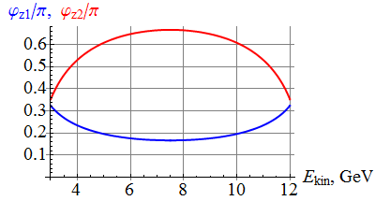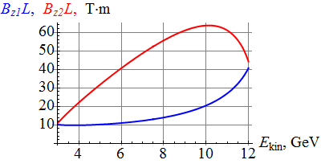

Fig. 2. Dependencies of the spin angles (left) and the longitudinal field integrals of the spin rotator solenoids (right) on the electron beam energy.

The optimized orbital angles of the arc dipoles are $α_{y1}≈{10.6}^{∘}$ and $α_{y2}≈{5.3}^{∘}$. The maximum field integrals of the solenoids are ${BL}_{1sol}≈40.7$ T $⋅$ m and $BL_{2sol}≈63,7$ T $⋅$ m. When using 6 T solenoids, their magnetic lengths are $L_{1sol}≈6.8$ m and $L_{2sol}≈10.6$ m.

To minimize the space occupied by the solenoids, we developed a new compact scheme for compensation of betatron coupling, which minimizes the fraction of space occupied by compensating quadrupoles (less than 30%) (Fig. 3). In the original coupling compensation scheme, the fraction of space occupied by the compensating quadrupoles is $≈60\%$.

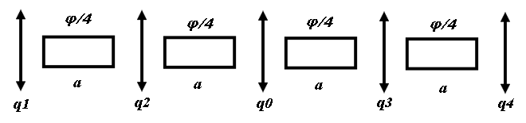

**Fig. 3.** Coupling compensation scheme.

In the new scheme, a solenoid rotating the spin by an angle $φ$ is split into four equal parts of length $a$ and five compensating quadrupoles are placed between and next to the solenoid segments as shown in Fig. 3. The central quadrupoles $q_{0}$ is straight (aligned vertically) while the quadrupoles $q_{1}={-q}_{4}$ and $q_{2}=-q_{3}$ are skew (rotated by $± {45}^{∘}$). The optics of the original and new decoupling schemes are compared in Figs. 4(left) and 4(right), respectively. We assume that dispersion is suppressed inside the solenoids. Figure 4 shows that the new scheme saves about 8 m of space per solenoid.

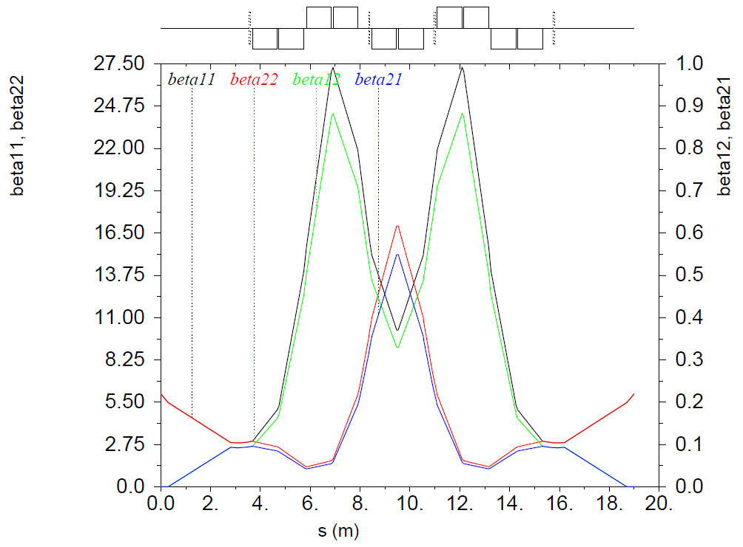 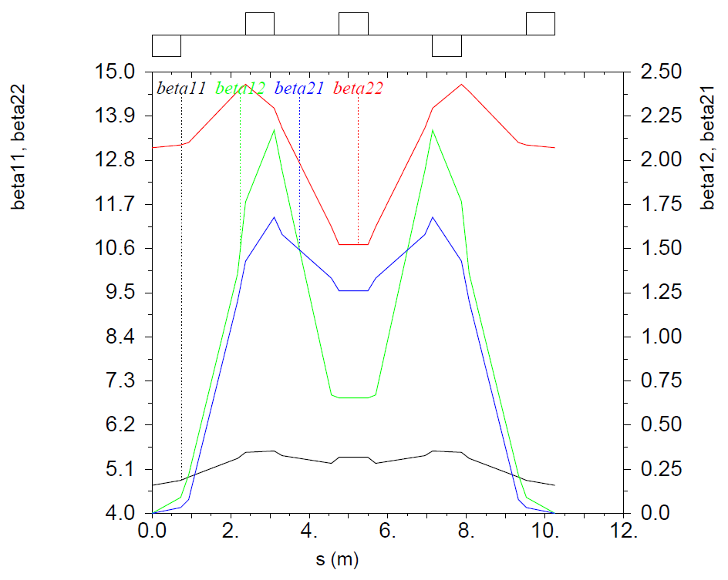

**Fig. 4.** Optics of the original (left) and new (right) decoupling schemes

***Milestones reached***

* Design and optimization of an electron spin rotator with vertical bends to improve ion polarization performance and reduce ion collider ring circumference by keeping the ion ring flat