ANALYSIS OF SPIN RESPONSE FUNCTION AT BEAM INTERACTION POINT IN JLEIC*

A. M. Kondratenko, M. A. Kondratenko, Sci. & Tech. Laboratory Zaryad, Novosibirsk, Russia  
Yu. N. Filatov, MIPT, Dolgoprudny, Moscow Region, Russia  
Ya. S. Derbenev, F. Lin, V. S. Morozov, Y. Zhang, Jefferson Lab, Newport News, VA, USA

Abstract

The spin response function is determined by a collider’s magnetic lattice and allows one to account for contributions of perturbing fields to spin resonance strengths. The depolarizing effect of an incoming beam depends significantly on the response function value at the interaction point (IP). We present an analytic calculation of the response function for protons and deuterons at the IP of Jefferson Lab Electron Ion Collider (JLEIC) over its whole momentum range. We find a good agreement of the analytic calculation with our numerical modeling results obtained using a spin tracking code, Zgoubi.

## Spin response function in figure-8 accelerators

The response function technique allows one to efficiently solve problems concerning the impact of magnetic field perturbations on the spin dynamics. For example, the response function was used to calculate the spin resonance strengths in the Nuclotron (JINR) [1]. This function was used to explain the “unexpectedly large” strength of a deuteron resonance induced by an RF dipole in the COSY accelerator [2].

The response function in figure-8 colliders was used to calculate the coherent part of the resonance strength in the JLEIC ion collider ring [3]. We achieved a good agreement [4] of this analytic calculation with numerical modeling results obtained using a spin tracking code, Zgoubi [5].

The figure-8-shaped ion collider ring of Jefferson Lab Electron-Ion Collider (JLEIC) is transparent to the spin: the combined effect of arc fields on the spin in an ideal collider lattice reduces to zero after one particle turn on the design orbit, i.e. any orientation of the particle spin at any orbital location repeats from turn to turn [6-8]. Particles are in the region of a zero-integer spin resonance and the spin tune is zero. To stabilize the spin direction, one must introduce a 3D spin rotator based on “weak” magnetic fields, which “shifts” the spin tune by a small value $ν≪1$  
 and sets the necessary orientation of the polarization [9-11]. The “weak” magnetic fields have essentially no effect on the beam’s orbital characteristics.

For polarization stability, one must ensure that the spin tune ν induced by the 3D spin rotator significantly exceeds the strength of the zero-integer spin resonance $ω$: $ν≫ω$. The resonance strength consists of two parts: a coherent part $ω_{coh}$ arising due to additional transverse and longitudinal fields on the beam trajectory deviating from the design orbit and an incoherent part $ω_{emitt}$ associated with the particles’ betatron and synchrotron oscillations (beam emittances) [12, 13]. In practice, the coherent part significantly exceeds the incoherent one.

* This material is based upon work supported by the U.S. Department of Energy, Office of Science, Office of Nuclear Physics under contracts DE-AC05-06OR23177 and DE-AC02-06CH11357.

A local field perturbation introduced at a single place in a collider causes closed orbit excursion along the whole collider ring. As a result, particle spins experience additional influence of the whole ring while moving along the distorted orbit. The spin response function accounts for contribution to the resonance strength of the “response” of the whole collider ring to a field perturbation $δB$:

|  |  |
| --- | --- |
| $$w=\frac{γG}{2π} \oint{\frac{δB F e^{iΨ}}{Bρ} dz} ,$$ | (1) |

where $Ψ=γG\int_{0}^{θ}{K_{y}dθ}$ is the spin rotation angle in the collider’s bending dipoles and $G$ is the anomalous magnetic moment.

The response function is a periodic function of the distance along the orbit *z*: $F\left(z\right)=F\left(z+L\right)$, where $L$ is the collider’s circumference. At a high momentum ($γG≫1$), assuming a flat figure-8 design orbit without coupling of radial and vertical betatron oscillations, the response function can be expressed through the Floquet function of vertical betatron oscillations $f_{y}(z)$ with a property $f_{y}\left(z+L\right)={e^{2πiν_{b}}f}_{y}\left(L\right)$  
, where $ν_{b}$ is the vertical betatron tune [12, 14]:

|  |  |
| --- | --- |
| $$F=\frac{e^{-iΨ}}{2i}\left[f_{y}^{*}\int_{-∞ }^{z}{\left(f_{y}^{'} \frac{d}{dz}{ e}^{i Ψ}\right) dz}\right.- \\ \left. f_{y}\int_{-∞ }^{z}{\left(f_{y}^{*'}\frac{d}{dz}{ e}^{i Ψ}\right)dz }\right] .$$ | (2) |

In the limit of ultra-high energies, the response function goes to unity.

Spin response function AT IP OF Jleic

Contribution of the incoming beam to the zero-integer spin resonance strength can be estimated as

|  |  |
| --- | --- |
|  | (3) |

where $B_{bunch}$ is the average radial field of the incoming beam and $F_{IP}$ is the response function at the IP. Therefore, in principle, one can significantly reduce the impact of collisions on the beam polarization by adjusting the response function value at the IP to zero ($F_{IP}=0$).

Let us present our calculations of the response function at JLEIC’s IP. Figures 1 and 2 show the $β$-functions and dispersions, respectively, of the ion collider ring. The origin of the coordinate system is located at the collider’s IP. Figures 3 and 4 plot the dependence of the absolute value of the response function $|F_{IP}|$ at JLEIC’s IP on the beam momentum for protons and deuterons, respectively. Due to the small value of the deuteron anomalous magnetic moment, the deuteron response function changes smoothly. To the contrary, the dependence of the proton response function on the beam momentum has oscillatory behavior.

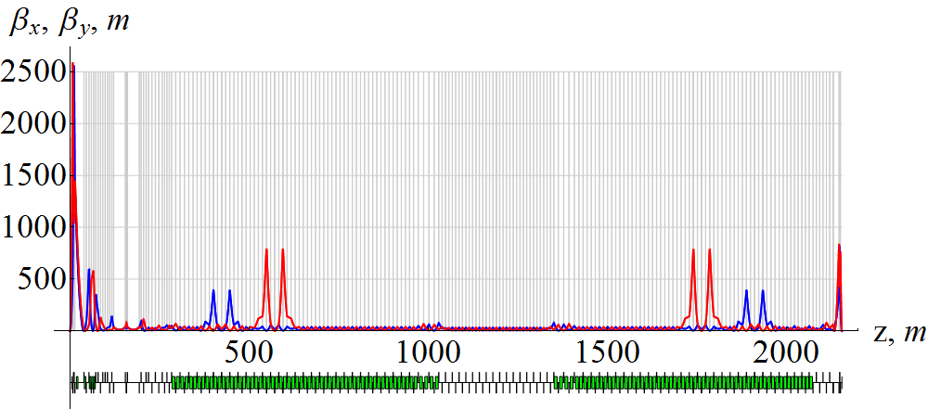

Figure 1: Horizontal (blue) and vertical (red) $β$ functions of the ion collider ring.

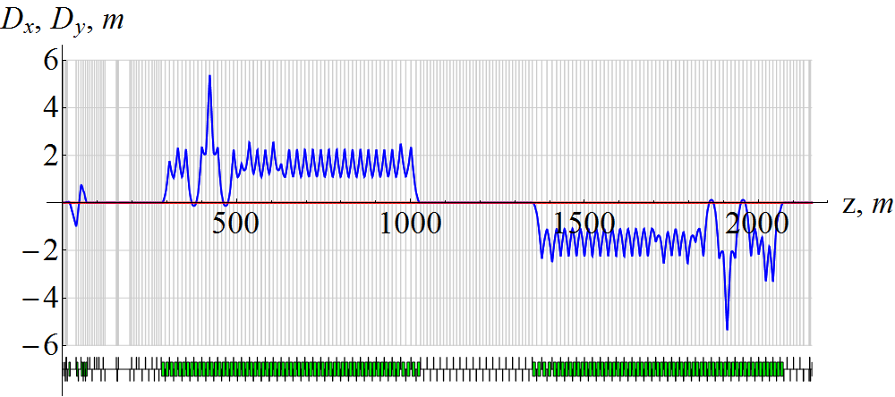

Figure 2: Horizontal (blue) and vertical (red) dispersions of the ion collider ring.

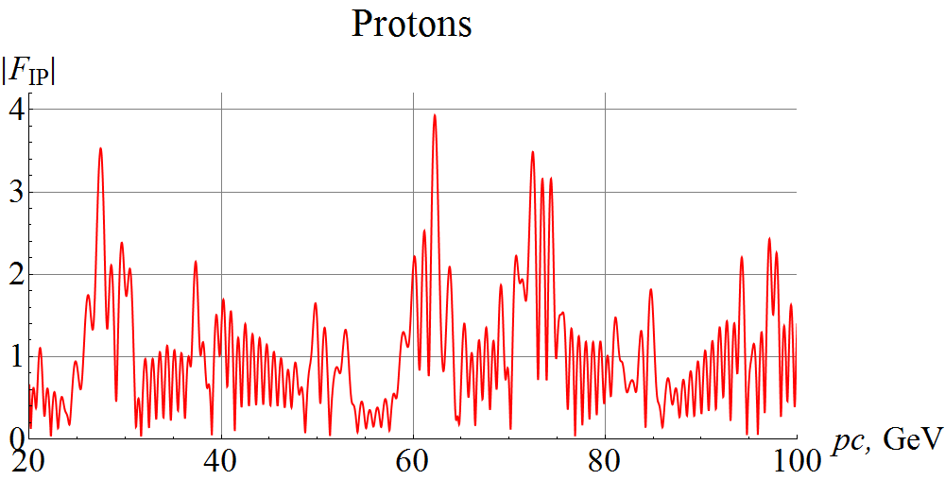

Figure 3: Proton response function at the IP versus the beam momentum in the JLEIC ion collider ring.

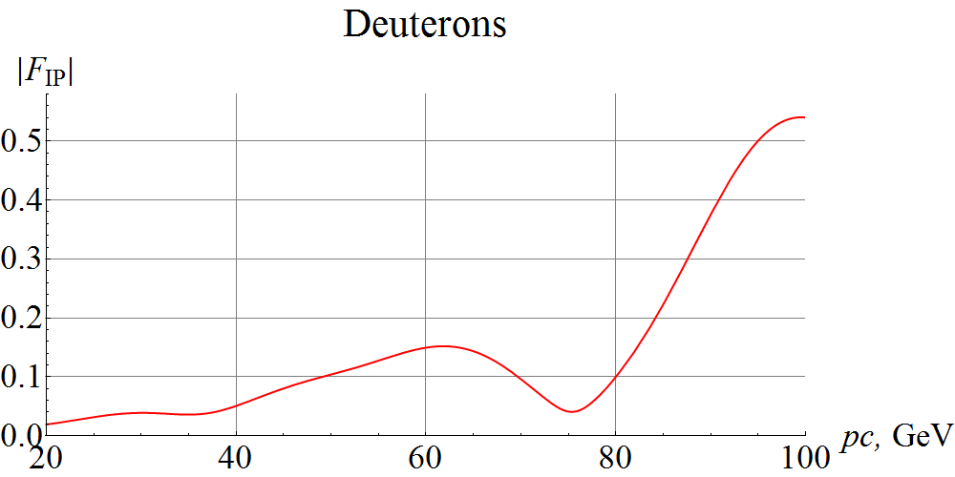

Figure 4: Deuteron response function at the IP versus the beam momentum in the JLEIC ion collider ring.

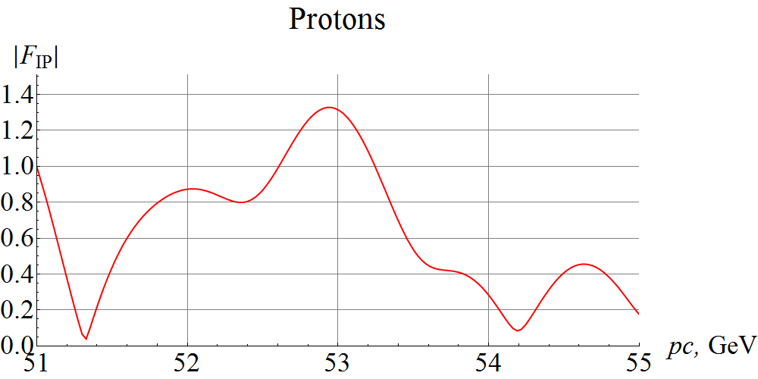

Figure 5: Graph of the proton response function in Fig. 3 zoomed on a momentum range of 51 to 55 GeV/c.

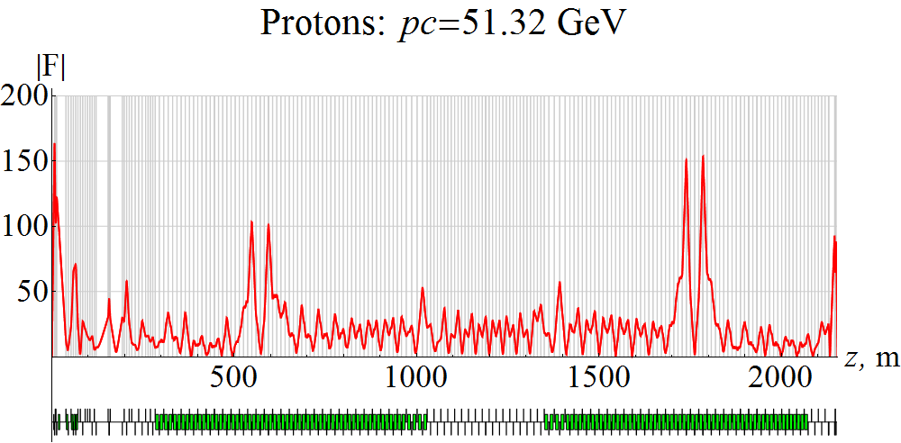

Figure 6: Proton response function along the obit at a momentum of 51.32 GeV/c.

To provide more detailed information, Fig. 5 expands a segment of the graph of the proton response function in a momentum range of 51 to 55 GeV/c. As an example, Fig. 6 shows the proton response function along the design orbit at a beam momentum of 51.32 GeV/c, which corresponds to a local minimum of $\left|F_{IP}\right|.$

As can be seen, the response function has maxima at the same locations as the maxima of the vertical $β$-function. The response function value is close to zero at the IP. However, by the choice of lattice optics, one can zero out not only the value of the response function at the IP but its slope as well. This will allow one to significantly suppress the impact of the incoming bunch on the beam polarization. This problem is similar to that of designing an IP with zero dispersion and dispersion slope (see Fig. 2).

IMPACT OF FIELD NONLINEARITIES

The response function can be used to estimate the contribution to the zero-integer resonance strength coming from the multipoles of a field perturbation:

|  |  |
| --- | --- |
| $$δB_{x}/Bρ=δh_{dip}+δh_{quad}+δh_{sext}+δh_{oct}+…$$ | (4) |

Equation (1) gives that the contribution to the resonance strength of the quadrupole and octupole field components is zero. In JLEIC, phase $Ψ(z)$ similarly to the response function is a periodic function. Therefore, the averages $〈δh_{quad} F e^{iΨ}〉=0$ and $〈δh_{oct} F e^{iΨ}〉=0$.

Besides the dipole component, a source of a contribution to the resonance strength may be the sextupole component

|  |  |
| --- | --- |
| $$δh_{sext}=\frac{1}{Bρ}\frac{∂^{2}B_{x}}{∂x^{2}}\frac{{(x}^{2}-y^{2})}{2}+\frac{1}{Bρ}\frac{∂^{2}B_{y}}{∂x^{2}}xy ,$$ | (5) |

where the first term corresponds to a skew sextupole while the second one corresponds to a normal sextupole.

Thus, in the absence of betatron oscillation coupling, the contribution of normal sextupole components to the resonance strength in JLEIC is zero, since the average

|  |  |
| --- | --- |
| $$〈\frac{F}{Bρ}\frac{∂^{2}B_{y}}{∂x^{2}}xye^{iΨ}〉=0$$ | (6) |

due to the difference of the radial and vertical betatron tunes.

The contribution of a skew sextupole to the resonance strength can be estimated using

|  |  |
| --- | --- |
|  | (7) |

where $ϵ_{x}$ and $ϵ_{y}$ are the normalized betatron beam emittances. Depending on the energy and their locations, skew sextupoles can give a significant contribution to the resonance strength. However, skew sextupoles are not used in the JLEIC ion collider ring lattice.

SPiN tracking simulaton

Let us use a spin tracking code Zgoubi [5] to demonstrate that the impact of transverse magnetic field perturbations on the polarization is proportional to the response function. We consider an example of a 2 cm long radial-field dipole located at the collider’s IP. We complete numerical modeling for two momentum values of 51.32 and 52.94 GeV/c, which correspond to the points of local minimum and maximum of $\left|F_{IP}\right|$ with the values of 0.0322 and 1.329 (see Fig. 5). To obtain the resonance strength due to this dipole, we observe revolution of an initially vertical spin. The resonance strength is determined by the number of particle turns $N_{flip}$ that it takes the spin to flip

|  |  |
| --- | --- |
| $$w=\frac{1}{2N_{flip}} .$$ | (8) |

Figure 7 shows the vertical spin components versus the number of particle turns for the selected momenta. In the calculations, we set the field strength of the radial dipole to $2⋅{10}^{-3} m^{-1}$ in units of the magnetic rigidity. The particle is launched along the distorted closed orbit.

The spin makes a complete revolution in about 54 thousand particle turns at 51.32 GeV/c and in about 1.17 thousand turns at 52.94 GeV/c, which correspond to resonance strengths values of $w_{1}≈1.85⋅{10}^{-5}$ and $w_{2}≈8.54⋅{10}^{-4}$, respectively. A calculation using the response function gives resonance strengths of $w_{1}≈2.01⋅{10}^{-5}$ and $w_{2}≈8.56⋅{10}^{-4}$, which is in a good agreement with our numerical modeling.

The discrepancy in the simulated and analytic resonance strengths at the small value of the response function is about 8%. This discrepancy may be due to the fact that the resonance strength in this case is already determined by higher orders of expansion of the spin motion. Another reason may be the closed orbit distortion caused by the radial-field dipole leading to a “shift” of the interaction point.

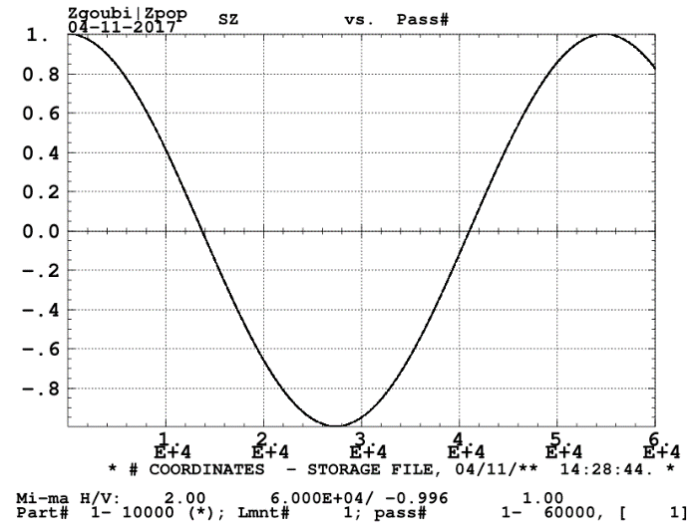

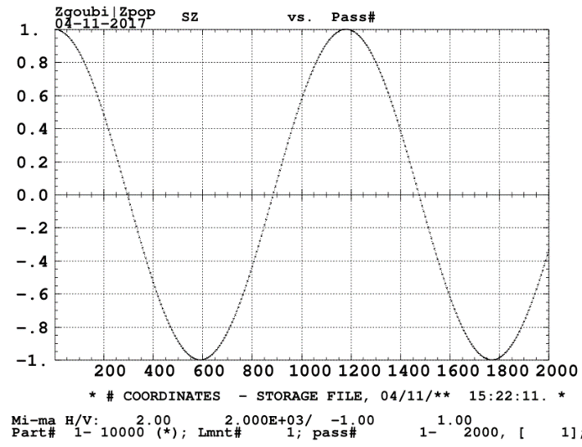

Figure 7: Vertical proton spin components versus the number of particle turns at momenta of 51.32 GeV/c (up) and 52.94 GeV/c (down).

Our numerical modeling confirms our analytic prediction that the resonance strength is proportional to the response function value. In the above example, we are able to reduce the spin resonance strength by a factor of about 40 by choosing the momentum with a minimum value of the response function.

CONCLUSION

The response function can be used to calculate the effect of perturbing fields at the IP on the beam polarization. We demonstrated the possibility of suppressing the impact of perturbing fields at the IP on the beam polarization by a few orders of magnitude by reducing the response function value at the IP. Thus, by choosing a lattice with zero response function at the IP, one can significantly improve polarization stability of the colliding beams.

References

[1] I. B. Issinskii *et al*. “Deuterons resonance depolarization degree in JINR Nuclotron”, in *Proc.* *VI Workshop on High Energy Spin Physics*, Protvino, 1996, pp. 207–211.

[2] A. M. Kondratenko, M. A. Kondratenko and Yu. N. Filatov, “Calculation of Spin Resonance Strength at COSY Accelerator”, Pepan, v.5 (6), pp. 538–547, 2008.

[3] A. M. Kondratenko *et al*., “Numerical Calculation of the Ion Polarization in MEIC”, in *Proc. IPAC’15*, Richmond, VA, USA, May 2015, paper TUPWI030, pp. 2304–2306.

[4] A. M. Kondratenko *et al*., “Acceleration of polarized protons and deuterons in the ion collider ring of JLEIC”, in *Proc. IPAC’17*, Copenhagen, Denmark, May 2017, paper WEPIK038.

[5] F. Méot, “The Ray-Tracing Code Zgoubi”, *Nucl. Instr. Meth A*, vol. 427, pp. 353–356, 1999.

[6] S. Abeyratne *et al*., “MEIC Design Summary”, arXiv:1504.07961 [physics.acc-ph], 2015.

[7] Ya. S. Derbenev, “The Twisted Spin Synchrotron”, University of Michigan report, UM HE 96-05, 1996.

[8] Ya. S. Derbenev *et al.*, “Polarized Ion Beams in Figure-8 Rings of JLab’s MEIC”, in *Proc. IPAC’14*, Dresden, Germany, June 2014, paper MOPRO004, pp. 68–70.

[9] Ya. S. Derbenev *et al.*, “Ion Polarization Control in MEIC Rings Using Small Magnetic Field Integrals”, in *Proc. Science*, PoS (PSTP 2013) 026.

[10] Ya. S. Derbenev *et al.*, “Polarization Preservation and Control in a Figure-8 Ring”, *Int. J. Mod. Phys. Conf. Ser.* 40, 1660090 (2016).

[11] A. M. Kondratenko *et al*., “Baseline Scheme for Polarization Preservation and Control in the MEIC Ion Complex”, in *Proc. IPAC’15*, Richmond, VA, USA, May 2015, paper TUPWI029, pp. 2301–2303.

[12] A. M. Kondratenko *et al*., “Ion Polarization Scheme for MEIC”, arXiv:1604.05632 [physics.acc-ph], 2016.

[13] A. M. Kondratenko *et al*., “Ion Beam Polarization Dynamics in the 8 GeV Booster of the JLEIC Project at JLab”, in *Proc. IPAC’16*, Busan, Korea, May 2016, paper WEPMW017, pp. 2460–2462.

[14] A. M. Kondratenko, “Polarized beams”, Ph.D. thesis, (Budker) Institute of Nuclear Physics, Siberian Br. USSR Academy of Sciences, Novosibirsk, 1982 (in Russian).