**Small Project Quarterly Report**

DOE Office of Nuclear Physics (NP)

Facilities and Project Management Division

**Proposal Name:**

Critical Accelerator R&D for Achieving High Performance of a Polarized Medium Energy Electron Ion Collider (***FY14***)

**Report Date:**

April 23, 2018

**Principal Investigator:**

Yuhong Zhang (***FY14***)

**Work-scope Highlights:**

In this quarterly report, we summarize the R&D work completed during the second quarter of FY18 at Jefferson Lab with funds carried over from FY14. The remaining FY14 funding is used to support A.M. Kondratenko of Novosibirsk, Russia and his colleagues for polarization design of JLEIC (formerly MEIC). In the past quarter, this team evaluated the impact of the crab cavities on the ion polarization in JLEIC.

**Brief summary of activity issues, concerns, successes:**

Work continues on schedule and on budget.

**Task 3 (FY14): Ion Beam Polarization**

**Milestones**

1. *Milestone description*

Evaluation of crab crossing effect on *ion and electron* polarizations

1. *Milestone forecast versus actual date*

This task is completed on schedule and on budget.

1. *Milestone result*

To obtain a high luminosity of the colliding electron and ion bunches, the JLEIC interaction region design has a crossing angle of 50 mrad. It allows one to rapidly separate the colliding beams near the interaction point (IP) to eliminate harmful parasitic collisions under a high (476 MHz) bunch repetition frequency. To avoid loss of the luminosity associated with non-head-on collisions, a scheme of crab crossing utilizing SRF crab cavities is employed for restoring head-on collisions [1, 2]. This report provides the results of analysis of the crab cavity impact on the proton and deuteron polarizations in JLEIC.

Figure 1 shows a schematic of the crab cavity placement in the ion collider ring of JLEIC. The radial electric field of the 1st resonator causes radial deflection of the longitudinally-offset ions at the IP. This deflection is compensated by a 2nd crab resonator separated from the 1st resonator by a betatron phase advance of $14 π$ rad and located at a place with the same value of the radial $β$-function. Thus, the radial excursion of the closed orbit is localized between the two crab resonators in the IP area.

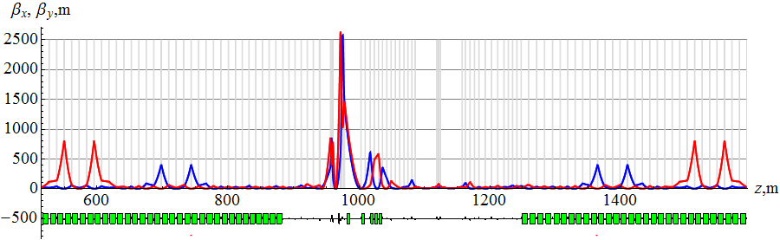

**CRAB1**

**CRAB2**

**IP**

Figure 1: Schematic of the crab cavity placement in the ion collider ring of JLEIC.

The effect of the radial electric field on the spin comes down to the effect of the vertical magnetic field. For the above betatron phase advance between the crab resonators, the spin transparency condition is automatically satisfied: $ν_{crab}=$ 0. However, even with the spin transparency condition satisfied, the crab resonators cause dynamic beam depolarization at the IP due to the difference of the rotation angles about the vertical direction for particles with different longitudinal offsets from the bunch center. The degree of the dynamic depolarization is maximum for polarization lying in the collider’s plane. In practice, it is small and does not exceed a value of $3⋅{10}^{-5}$ for protons and ${5⋅10}^{-8}$ for deuterons for a bunch length of 1 cm.

Similar conclusions are also valid for the impact of crab cavities on the electron polarization.

***References***

[1] R. Palmer, SLAC Report No. SLAC-PUB-4707 (1988)

[2] K. Oide and K. Yokoya, Phys. Rev. A 40, 315 (1989)

**Budget**

Summary of expenditures:

**Details on, or further, issues/concerns**

None.