**Spin Response Function method for suppression of depolarization in the interaction region including the beam-beam influence on the ion and electron spins**

A.M. Kondratenko1, M.A. Kondratenko1, and Yu.N. Filatov2

*1Science and Technique Laboratory “Zaryad”, Novosibirsk 630090, Russia*

*2Moscow Institute of Physics and Technology, Dolgoprudny 141700, Russia*

Translated by V.S. Morozov, *Jefferson Lab, Newport News, VA 23606, USA*

A real collider structure always contains additional perturbing radial fields ${δB}_{x}$, which cause distortion of the particle vertical motion. Therefore, even with a local perturbation of the radial field, the particle spins experience an additional effect of the whole ring when moving along the distorted orbit. For a figure-8 ring, the periodic spin response function $F\left(z\right)=F\left(z+L\right)$ is determined by the ideal linear ring lattice and accounts for the resonance strength contribution due to a “response” of the whole collider ring to a periodic radial field perturbation [1]. Below we provide an example of how the response function technique allows one to account for the impact on the polarization of the dipole component of the opposing beam, which we model as a 2 cm long dipole field located at the interaction point.

Figure 1 shows the absolute value of the proton response function at the interaction point of the JLEIC ion collider ring versus momentum in the range from 45 to 55 GeV/c.

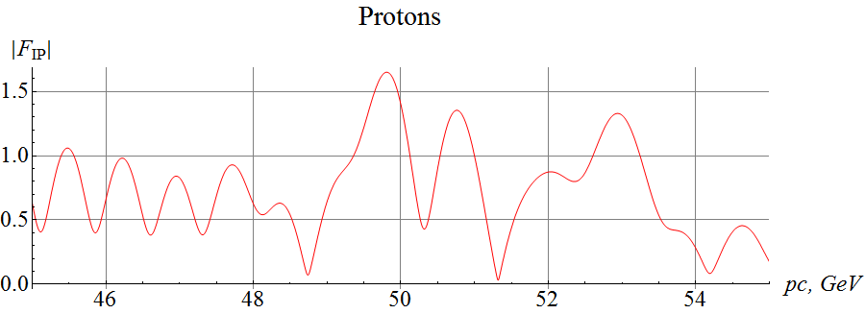

Figure 1: Proton response function at the interaction point versus momentum in the JLEIC ion collider ring.

We next use a spin tracking code Zgoubi [2] to calculate the resonance strengths for the two momenta of 51.32 and 52.94 GeV/c, which correspond to the points of local minimum and maximum of $\left|F_{IP}\right|$ with the values of 0.0322 and 1.329, respectively. The resonance strength is determined by the number of particle turns $N_{flip}$ that it takes an initially vertical spin to flip

$$w=\frac{1}{2N_{flip}}.$$

Figure 2 shows the vertical spin components versus the number of particle turns for the selected momenta. In the calculations, we set the field strength of the radial dipole to $2⋅{10}^{-3} m^{-1}$ in units of magnetic rigidity. The spin makes a complete revolution in about 54 thousand particle turns at 51.32 GeV/c and in about 1.17 thousand turns at 52.94 GeV/c, which correspond to resonance strengths values of $w_{1}≈1.85⋅{10}^{-5}$ and $w_{2}≈8.54⋅{10}^{-4}.$ A calculation using the response function gives resonance strengths of $w_{1}≈2.01⋅{10}^{-5}$ and $w_{2}≈8.56⋅{10}^{-4}$, which is in good agreement with the numerical modeling.

The discrepancy in the resonance strengths at the small value of the response function is about 8%. This discrepancy may be due to the fact that the resonance strength in this case is already determined by higher orders of the spin motion expansion. Another reason is related to excursion of the closed orbit due to the radial dipole, which leads to a “shift” of the interaction point.

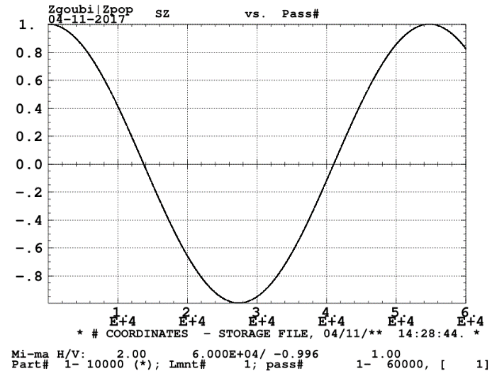 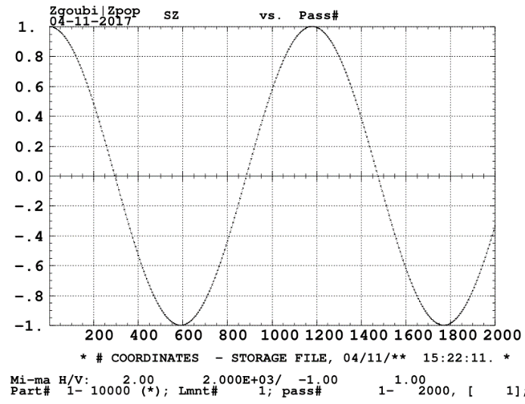

Figure 2: Vertical proton spin components versus the number of particle turns at momenta of 51.32 GeV/c (left) and 52.94 GeV/c (right).

The numerical modeling confirms the analytic calculation that the resonance strength is proportional to the response function. In the above example, we are able to reduce the spin resonance strength by a factor of about 40 by choosing momentum with a minimum response function. The above example demonstrates the possibility of reducing the impact of the opposing bunches on the beam polarization by a few orders of magnitude by adjusting the response function and its derivative to zero at the interaction point by the choice of the collider’s magnetic lattice. This problem is similar to designing an interaction point with a zero dispersion function.

The same conclusion is valid when analyzing the depolarizing effect of the incoming ion beam on the electron polarization at the interaction point.

***Milestone reached***

* Investigate implementation of the Spin Response Function method for suppression of depolarization in the interaction region including the beam-beam influence on the ion and electron spins

***References***

[1] A.M. Kondratenko *et al.*, *Ion Polarization Scheme for MEIC*, arXiv:1604.05632 [physics.acc-ph], (2016)

[2] F. Méot, *The Ray-Tracing Code Zgoubi*, Nucl. Instr. Meth A, vol. 427, p. 353, (1999)