**Ion Polarization in the JLEIC Collider**

**(annual report for the period of June 16, 2016 – June 15, 2017)**

A.M. Kondratenko1, M.A. Kondratenko1, and Yu.N. Filatov2

*1Science and Technique Laboratory “Zaryad”, Novosibirsk 630090, Russia*

*2Moscow Institute of Physics and Technology, Dolgoprudny 141700, Russia*

Translated by V.S. Morozov, *Jefferson Lab*

**table of CONTENTS**

Introduction 4

1. Verification of the proton and deuteron polarization control schemes in the collider ring at the beam momentum of 100 GeV/c 6

1.1 Proton and deuteron polarization in an ideal lattice of the JLEIC ion collider ring 6

1.1.1 Obtaining transverse polarization at the collider’s interaction point 8

1.1.2 Obtaining longitudinal polarization at the collider’s interaction point 8

1.2 Impact of lattice imperfections on polarization in the JLEIC ion collider ring 9

1.2.1 Coherent component of the resonance strength in a non-ideal collider lattice 9

1.2.2 Compensation of the depolarization caused by imperfections 11

1.3 Spin flipping in the ion collider ring 12

2. Numerical simulations of proton and deuteron beam polarization dynamics during transition energy crossing in the collider JLEIC 15

3. Acceleration of polarized protons and deuterons in the collider ring of JLEIC 17

3.1 Preservation of ion polarization in figure-8 accelerators 17

3.2 Calculation of zero-integer spin resonance strength in JLEIC 17

3.2.1 Incoherent part of the spin resonance strength 18

3.2.2 Coherent part of the spin resonance strength 19

3.3 Acceleration of polarized ions in the JLEIC collider 19

3.4 Crossing the transition energy 21

4. Effect of detector solenoid on the spin dynamics in the JLEIC ion collider ring 22

4.1 Design orbit and description of the spin dynamics in the detector solenoid 22

4.2 Calculation of the proton and deuteron spin dynamics in the JLEIC ion collider ring including the detector solenoid 23

4.3 Compensation of the detector solenoid effect on the ion polarization 27

5. Analysis of nonlinear effects and the influence of betatron oscillation coupling on the spin dynamics 28

5.1 Spin response function for calculating the contribution of field nonlinearity to the resonance strength 28

5.2 Influence of betatron oscillation coupling on the incoherent part of the spin resonance strength 28

5.3 Compensation of the incoherent part of the spin resonance strength due to the collider’s arcs 30

6. Numerical modeling of the spin dynamics in the JLEIC collider including nonlinear effects 30

6.1 Calculation of the sextupole and octupole components of field nonlinearity 30

6.2 Calculation of the incoherent part due to betatron oscillations 32

6.3 Demonstration of nonlinear effects on the spin dynamics using Zgoubi 33

Conclusion 36

Acknowledgements 37

References 37

The contract agreement from June 16, 2016 through June 15, 2017 specifies the following work plan.

* First and second quarters of the year revised scope
  + Spin tracking simulations using verified existing codes
  + Verification of the proton and deuteron polarization control schemes in the collider ring at the beam momentum of 100 GeV/c
    - Obtaining longitudinal and transverse polarizations at the interaction point using 3D spin rotators
    - Compensation of the coherent part of the spin resonance strength
    - Spin flipping
  + Acceleration of polarized protons and deuterons in the collider ring
  + Development and optimization of a transition energy crossing scheme compatible with stable spin dynamics
  + Numerical simulations of proton and deuteron beam polarization dynamics during transition energy crossing in the collider
* Third and fourth quarters of the year revised scope
  + Spin tracking simulations using verified existing codes
  + Evaluation and compensation of the spin effect of the detector solenoid
  + Analysis of the betatron oscillation coupling effect on the polarization control scheme in the collider
  + Study of 1st-order effects of non-linear fields and higher-order spin resonances

# Introduction

Jefferson Lab Electron Ion Collider (JLEIC) is a figure-8 collider “transparent” to the spin. This allows one to control the ion polarization using a universal 3D spin rotator based on weak solenoids. A 3D spin rotator allows one to set any polarization orientation of any ion species at any location in the collider. Moreover, a 3D rotator allows one to flip the spins during experiments (a Spin Flipping system) [1-10].

The field strengths of the control solenoids are determined by the requirement that the spin tune induced by the 3D rotator must significantly exceed the incoherent part of the zero-integer spin resonance strength, which is determined by the beam emittances.

The main contribution to the coherent part of the resonance strength is related to the closed orbit excursion. The coherent part of the resonance strength can be measured and then either compensated using an additional 3D rotator or accounted for in the process of ion polarization control.

Besides the 3D spin rotator, a coherent effect on the spin is produced as a result of the ion beam crossing the detector solenoid at a 50 mrad angle. It comes from the angled field of the detector solenoid in combination with additional transverse fields of the dipole kickers used for correction of the ion beam orbit at the interaction point.

The incoherent part of the resonance strength depends on betatron oscillation coupling. Weak coupling of betatron oscillations exists due to the use of weak control solenoids in the 3D rotators as well as due to random rolls of the collider’s quadrupoles. Local coupling is also introduced by the detector solenoid. In principle, strong coupling of betatron oscillations can be intentionally introduced in the collider to provide the required parameters of the beam orbital motion. An additional contribution to the incoherent part of the resonance strength can come from magnetic elements with nonlinear field components: sextupoles, octupoles, etc.

In this report, we present the results of verification of the ion polarization control scheme up to 100 GeV/c. Using the spin tracking code ZGOUBI [11], we model the spin dynamics of protons and deuterons during their acceleration in the JLEIC ion collider ring from 8 GeV/c to 100 GeV/c including crossing of the transition energy. The report also contains analysis of the depolarizing effects associated with the detector solenoid and the presence of betatron oscillation coupling in the ion collider ring. We analyze the 1st-order effects of non-linear fields and higher-order spin resonances.

The report consists of six main parts. In the first part, we use spin tracking to calculate the strengths of the zero-integer spin resonance for protons and deuterons at the beam momentum of 100 GeV/*c*, which determines stability of the beam polarization in the ion collider ring. The coherent part of the zero-integer spin resonance strength is calculated using the statistical model of random quadrupole misalignments, which cause distortion of the closed orbit. We demonstrate compensation of the depolarization caused by imperfections. We present the results of numerical modeling of a spin flipping system.

In the second part, we model crossing of the transition energy in the JLEIC ion collider ring during acceleration of polarized proton and deuteron beams. We show that, if the beam’s orbital motion is not significantly perturbed at the moment of transition energy crossing, practically no change in the ion polarization occurs as a result of the crossing.

In the third part, we present the results of our theoretical analysis and numerical modeling of the spin dynamics during acceleration of protons and deuterons in the JLEIC ion collider ring in the whole momentum range of the beam. To stabilize the polarizations of protons and deuterons during their acceleration, we use a solenoid with a maximum field integral of 7.5 T $⋅$ m. When modeling the coherent part of the resonance strength, we use a model with random quadrupole shifts leading to an rms closed orbit excursion of 100 $μm$. Using numerical modeling, we demonstrate that synchrotron energy modulation has practically no effect on the proton and deuteron polarization in the JLEIC ion collider ring.

In the fourth part, we analyze the influence of the detector solenoid on the ion polarization. The detector solenoid is located at a 50 mrad angle to the design orbit of the ion beam, which leads to the presence of longitudinal as well as radial magnetic field components. We provide analysis of the orbital and spin motions of ions accounting for the fact that the beam is moving in a spiral in the detector solenoid. The presented calculations show that the spin tune induced by the detector solenoid insertion does not exceed values of $2⋅{10}^{-2}$ for protons and $4⋅{10}^{-5}$ for deuterons when changing the field in the detector solenoid from 0 to 3 T in the whole momentum range of the JLEIC ion collider ring. Influence of the detector solenoid insertion on the proton and deuteron polarizations can be compensated using an additional 3D rotator.

In the fifth part, we analyze nonlinear effects and influence of betatron oscillation coupling on the ion polarization in the JLEIC ion collider ring. Nonlinear effects are separated into two kinds: nonlinearities related to the expansion of magnetic field in multipoles (sextupoles, octupoles, and so on) and nonlinear effects due to inclusion of the spin perturbations in the second and subsequent orders of the Bogoliubov averaging method. The contribution of field nonlinearities to the incoherent part of the resonance strength is considered using a periodic spin response function. The incoherent part of the resonance strength due to betatron oscillations is determined by the second order of the method of averaging over spin perturbations.

In the absence of betatron oscillation coupling, the incoherent part of the resonance strength in the JLEIC ion collider ring depends only on the emittance of vertical oscillations and points along the vertical. The completed analysis shows that coupling of betatron oscillations results in the incoherent part of the resonance strength acquiring a component in the plane of the collider. The strength itself then depends not only on the emittances of the two independent modes of betatron oscillations but on the longitudinal emittance as well. In the acceleration mode, when the normalized emittances of radial and vertical betatron oscillations are1 $μm$ each, the presence of coupling does not generally lead to a significant increase in the incoherent part of the resonance strength as a result of redistribution of the betatron oscillation modes. However, in the collider mode, when, in the absence of coupling, the vertical emittance is significantly smaller than the radial one, depending on the specific structure of coupling, betatron oscillation coupling can significantly increase the incoherent part of the resonance strength. As a rough estimate, one can expect that the strength increases by a factor of the emittance ratio of the two betatron oscillation modes.

At the end of the fifth part, we specify the conditions on compensation of the incoherent part of the resonance strength in the collider, which allows one to do experiments with polarized ions at an even higher precision level.

In the sixth part, we provide the results of numerical modeling, which demonstrate the influence of nonlinear effects on the spin dynamics. We show that straight sextupoles and octupoles in the JLEIC collider do not give a substantial contribution to the resonance strength. We present a calculation of a contribution to the resonance strength due to skew sextupoles. We demonstrate the influence of the beam emittances on the spin dynamics in the JLEIC collider.

# Verification of the proton and deuteron polarization control schemes in the collider ring at the beam momentum of 100 GeV/c

This chapter presents the results of verification of the proton and deuteron polarization control scheme in the JLEIC ion collider ring using the Zgoubi spin tracking code [11]. We first model the spin motion at the beam interaction point when the 3D spin rotators are used to set the transverse and longitudinal orientations of the proton and deuteron polarizations. We when calculate the coherent component of the resonance strength caused by misalignments of the collider quadrupoles. We next demonstrate compensation of the coherent resonance strength component by a second 3D spin rotator that allows one to significantly improve the spin characteristics of the beam and to reduce the requirement on the fields of the control solenoids in the 3D spin rotator. Finally, we model spin flipping implemented using a 3D spin rotator.

## 1.1 Proton and deuteron polarization in an ideal lattice of the JLEIC ion collider ring

Figures 1.1a and 1.1b show graphs of the spin components in an ideal lattice of the collider ring for proton and deuteron beams. The beam momentum is 100 GeV/c. The particle was launched along the closed orbit with vertically (Fig.  1.1a) and longitudinally (Fig. 1.1b) oriented spin.

|  |  |
| --- | --- |
|  |  |
| **Figure 1.1a:** Proton spin components in an ideal collider lattice. The initial conditions are: *Sy*=1, *x*0=*y*0=0 μm, *x*’0= *y*’0=0 mrad. | **Figure 1.1b:** Deuteron spin components in an ideal collider lattice. The initial conditions are: *Sz*=1, *x*0=*y*0=0 μm, *x*’0 = *y*’0=0 mrad. |
|  |  |
| **Figure 1.2a:** Proton vertical spin component in an ideal collider lattice when including betatron oscillations (the initial condition is: *Sy* = 1). | **Figure 1.2b:** Proton spin components in an ideal collider lattice when including betatron oscillations (the initial condition is: *Sz* = 1). |

As can be seen from Figs. 1.1a and 1.1b, when a particle is launched along the ideal closed orbit, the spin does not change at all, which means that the coherent component of the spin resonance strength equals zero in an ideal collider lattice.

Figures 1.2a and 1.2b show calculations of the proton spin dynamics for the transverse beam size at the interaction point of 19.4×3.9 μm2. The spin was started in vertical (Fig. 1.2a) and longitudinal (Fig. 1.2b) directions. The graphs in Figs. 1.2a and 1.2b yield that the incoherent resonance strength component is directed vertically and its value for protons is about  
*w*incoh = 1.3 10-4.

Note that, for the particle offset from the closed orbit, the modulation of its vertical spin component occurs at a doubled frequency. This confirms that the average spin field due to betatron oscillations is determined by the second order of the averaging method (compare Figs. 1.2a and 1.2b).

Similar calculations for deuterons show that their incoherent resonance strength component is also directed vertically and its value is about *w*incoh = 4 10-10.

|  |  |  |  |  |
| --- | --- | --- | --- | --- |
|  | |  | | |
| **Figure 1.3a:** Proton spin components in an ideal collider with a 3D rotator setting of *nx*=1, νsol=0.01. The initial conditions are: *Sx*=1, *x*0=*y*0=0 μm,  *x*’0= *y*’0=0 mrad. | | **Figure 1.3b:** Proton spin components in an ideal collider with a 3D spin rotator setting of *nx*=1, νsol=0.01. The initial conditions are: *Sz*=1,  *x*0=*y*0=0 μm, *x*’0 = *y*’0= 0 mrad. | | |
|  | |  | | |
| **Figure 1.3c:** Proton radial spin component in the presence of betatron motion with a 3D rotator setting of *nx*=1, νsol=0.01. The initial conditions are: *Sx*=1, *x*0=19.3 μm, *y*0=3.9 μm, *x*’0= *y*’0=0 mrad. | | **Figure 1.3d:** Proton spin components in the presence of betatron motion with a 3D rotator setting of *nx*=1, νsol=0.01. The initial conditions are: *Sz*=1, *x*0=19.3 μm, *y*0=3.9 μm, *x*’0= *y*’0=0 mrad | | |
|  |  | | |
| **Figure 1.4a:** Deuteron spin vector in an ideal collider with a 3D rotator setting of *nz*=1, νsol=10-4. The initial conditions are: *Sz*=1, *x*0=*y*0=0 μm,  *x*’0 = *y*’0 = 0 mrad. | **Figure 1.4b:** Deuteron spin vector in an ideal 3D collider with a 3D rotator setting of *nz*=1, νsol=10-4. The initial conditions are: *Sy*=1,  *x*0=*y*0=0 μm, *x*’0 = *y*’0 = 0 mrad | | |
|  | | |  | |
| **Figure 1.4c:** Deuteron longitudinal spin component in the presence of betatron motion with a 3D rotator setting of *nz*=1, νsol=10-4. The initial conditions are: *Sy*=1, *x*0=19.4 μm, *y*0=3.9 μm, *x*’0= *y*’0=0 mrad | | | **Figure 1.4d:** Deuteron spin components in the presence of betatron motion with a 3D rotator setting of *nz*=1, νsol=10-4. The initial  conditions are: *Sy*=1, *x*0=19.4 μm, *y*0=3.9 μm, *x*’0= *y*’0=0 mrad | |

### 1.1.1 Obtaining transverse polarization at the collider’s interaction point

As an example let us consider obtaining radial proton polarization at the collider’s interaction point. Figures 1.3a-1.3d show graphs of changes in the spin components in an ideal collider lattice. The 3D rotator parameters are: *nx*=1, νsol=0.01. The beam momentum is 100 GeV/c. The particle is launched along the closed orbit with radial (Fig. 1.3a) and longitudinal (Fig. 1.3b) spin directions. Figures 1.3c and 1.3d show similar calculations for the transverse beam size at the interaction point of 19.4×3.9 μm2. As can be seen from Figs. 1.3b and 1.3d, the proton spin tune value induced by the 3D rotator is practically independent of betatron oscillations and remains equal to 10-2. Our calculations show that, when setting vertical polarization at the collider’s interaction point, the spin dynamics is similar to the case of the radial polarization setting considered above.

### 1.1.2 Obtaining longitudinal polarization at the collider’s interaction point

As an example, let us consider obtaining longitudinal deuteron polarization at the collider’s interaction point. Graphs of change in the spin components in an ideal collider lattice are shown in Figs. 1.4a-1.4d. Parameters of the 3D rotator are: *nz*=1, νsol=10-4. The beam momentum is 100 GeV/c. The particle is launched along the closed orbit with longitudinal (Fig. 1.4a) and vertical (Fig. 1.4b) spin directions. Similar calculations for the transverse beam size at the interaction point of 19.4×3.9 μm2 are shown in Fig. 1.4c and 1.4d. As can be seen from Figs. 1.4b and 1.4d, the deuteron spin tune value induced by the 3D rotator is practically independent of betatron oscillations and remains equal to 10-4.

Note the exceptional stability of deuterons in regard to the incoherent spin resonance strength: the longitudinal component changed by only 5⋅10-6 in the presence of betatron oscillations.

The presented calculations confirm the stability of polarization in the ion collider ring when using a 3D spin rotator, which provides the spin tune values of 10-2 for protons and 10-4 for deuterons.

## 1.2 Impact of lattice imperfections on polarization in the JLEIC ion collider ring

In real conditions, there are always errors in the manufacture of collider magnetic lattice elements as well as errors in alignment of these elements along the collider’s design orbit. These lattice imperfections lead to a change in the collider’s closed orbit. As a result, particle spins experience additional coherent rotations caused by perturbing magnetic field when the particles are moving along the distorted periodic closed orbit. The combined effect of these magnetic fields on the spin determines the coherent component of the resonance strength.

### 1.2.1 Coherent component of the resonance strength in a non-ideal collider lattice

One of the main reasons for appearance of the coherent resonance strength component are random quadrupole shifts resulting in a change in the collider’s closed orbit.

Figures 1.5 and 1.6 show diagrams of random quadrupole shifts, which are used in calculations of the proton spin motion in the collider. The sizes of the quadrupole shifts in the vertical and radial directions are given in units of their rms deviation equal to 5 µm. The diagrams also indicate the locations of the control 3D rotator (1st 3D-rotator) and of the compensating 3D rotator (2nd 3D-rotator). The indicated quadrupole alignment errors result in a closed orbit distortion in the arcs of a few hundred µm (see Fig. 1.7).

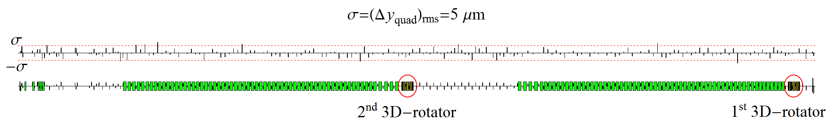

**Figure 1.5:** Diagram of vertical quadrupole alignment errors in the collider ring distributed normally   
with $σ_{rms}= Δy_{quad}=5 μm$.

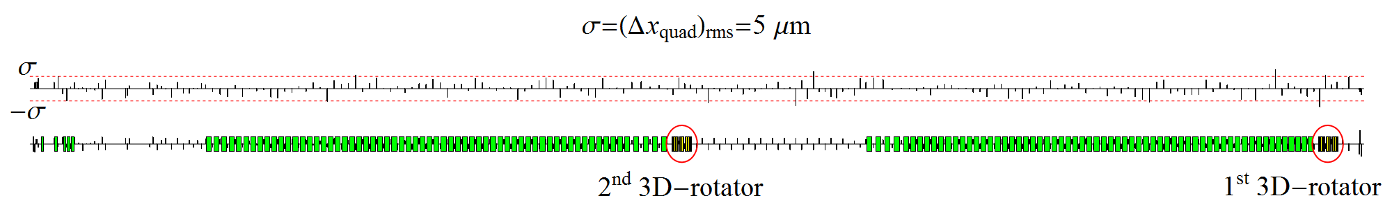

**Figure 1.6:** Diagram of radial quadrupole alignment errors in the collider ring distributed normally   
with $σ_{rsm}=Δx_{quad}=5 μm$.

|  |  |
| --- | --- |
|  |  |

**Figure 1.7:**Radial and vertical orbit excursions with random misalignments of all quads in the collider.

|  |  |
| --- | --- |
|  |  |
| **Figure 1.8a:** Proton spin components at the interaction point in an non-ideal collider lattice with the 3D rotators off. | **Figure 1.8b:** Deuteron spin components at the interaction point in an non-ideal collider lattice with the 3D rotators off. |

To determine the coherent resonance strength component, Fig. 1.8 demonstrates graphs of the proton and deuteron spin components versus the number of particle turns in the collider with the random quadrupole shifts as per the diagrams in Figs. 1.5 and 1.6. The particle is launched from the beam interaction point along the closed orbit with longitudinal spin.

The proton spin completes 9 oscillations in 985 particle turns. The coherent strength component is then about $w_{coh}^{prot}≈9.14⋅{10}^{-3}$. The deuteron spin completes 1 oscillation in ${10}^{4}$ particles turns, which gives the coherent strength component equal to about $w_{coh}^{deut}≈{10}^{-4}$.

As noted above, the coherent resonance strength component itself does not cause beam depolarization. On the contrary, by finding the unknown direction of the coherent component, which is determined by random quadrupole misalignments, one can stabilize the particle’s spin.

To find the direction of the precession axis $\vec{n}$ induced by the coherent resonance strength component, one can also use the graphs in Fig. 8. Since the spin component along the $\vec{n}$ axis is an invariant of the spin motion, the average spin value $〈\vec{S}〉$ is directed along the $\vec{n}$ axis:

$$〈\vec{S}〉=S_{n} \vec{n} .$$

Thus, by calculating the average spin components as half sums of the maximum and minimum values of the corresponding spin components:

$$〈S_{x}〉=\frac{{{(S}_{x})}_{min}+⁡{{(S}_{x})}_{max}}{2} , 〈S_{y}〉=\frac{{{(S}_{y})}_{min}+⁡{{(S}_{y})}_{max}}{2} , 〈S_{z}〉=\frac{{{(S}_{z})}_{min}+⁡{{(S}_{z})}_{max}}{2} ,$$

we get the  axis components:

$$n_{x}=±\frac{〈S_{x}〉}{S_{n}} , n_{y}=±\frac{〈S_{y}〉}{S_{n}} , n_{z}=±\frac{〈S_{z}〉}{S_{n}} , S_{n}=\sqrt{{〈S_{x}〉}^{2}+{〈S_{y}〉}^{2}+{〈S_{z}〉}^{2}} .$$

The sign of the $\vec{n}$ vector is determined from the condition that the spin vector rotates about $\vec{n}$ counterclockwise. Calculations of the proton and deuteron precession axes at the interaction point give:

$${\vec{n}}_{IP}^{prot}=\left( 0.330,-0.020, 0.944 \right), {\vec{n}}_{IP}^{deut}=\left( -0.536, 0.0015, 0.844\right).$$

If a particle is launched along the closed orbit with its initial spin direction being along ${\vec{n}}_{IP}$ at the interaction point, then the polarization will be stable from turn to turn of the particle, which is completely confirmed by the calculations presented in Fig. 1.9.

|  |  |
| --- | --- |
|  |  |
| **Figure 1.9a:** Stable proton polarization at the interaction point in a collider lattice with errors with the 3D rotators off. | **Figure 1.9b:** Stable deuteron polarization at the interaction point in a collider lattice with errors with the 3D rotators off. |

### 1.2.2 Compensation of the depolarization caused by imperfections

Below we consider compensation of the coherent resonance strength component using protons as example. The deuteron case can be considered similarly.

The calculation of the coherent resonance strength component in the collider ring shows that its value for protons is $ω_{coh}^{prot}≈9.14⋅{10}^{-3}$. This means that using a 3D rotator with a spin tune of 10-2 to control the proton polarization already becomes, at least, inconvenient, since, during a spin manipulation process, one should always make a “correction” of the spin field for the coherent resonance strength component. Besides, the coherent component grows with increase in energy along with the fields required for its compensation. Nevertheless, the solenoid fields of the control 3D rotator can be left at the same level if one compensates the coherent resonance strength component using a second 3D rotator with static field located in the opposite straight (see Fig. 1.5).

To determine the direction of the precession axis induced by the coherent resonance strength component near the 2nd 3D rotator, Fig. 1.10a shows graphs of the proton spin components versus the number of particle turns in the collider ring with the random quadrupole shifts according to the diagrams presented in Fig. 1.5 and 1.6. The particle is launched from the interaction point along the closed orbit with longitudinal spin. The spin is observed near the 2nd 3D rotator in a section opposite to the interaction point. The graph yields that the direction of the spin precession axis ${\vec{n}}_{2}$ near the second 3D rotator is

$${\vec{n}}_{2}=\left( -0.845, -0.001, -0.534\right).$$

|  |  |
| --- | --- |
|  |  |
| **(a)** | **(b)** |
| **Figure 1.10:** Proton spin components in a section opposite to the interaction point in a non-ideal collider lattice with the 3D rotators off before (a) and after (b) compensation of the coherent resonance strength component. | |

Figure 1.10b shows the spin components after compensation of the coherent resonance strength component. The parameters of the compensating 3D rotator were chosen as

$${\vec{n}}_{comp}={\vec{n}}_{2}=\left( -0.845, -0.001, -0.534\right), ν_{comp}=-ω_{coh}=-9.14 {10}^{-3}.$$

The graph in Fig. 1.10b yields that, after compensation, the coherent resonance strength component, became $2.1⋅{10}^{-4}$, i.e. decreased practically to the value of the incoherent resonance strength components.

Since we set the 3D rotator parameters using formulae derived in the linear approximation in the spin tune $ν$, the accuracy of compensation in an ideal collider lattice is determined by the square of the spin tune $ν^{2}\sim {10}^{-4}$. One can further improve the compensation by specifying the 3D rotator parameters up to the second order including the non-commutativity of the spin rotations about the different axes in the 3D rotator modules. One should also analyze the effect on the 3D rotator of additional fields arising inside the rotator due to random quadrupole misalignments.

Figure 1.11a shows a graph of the spin component evolution in a non-deal collider lattice when setting vertical proton polarization at the interaction point with compensation of the coherent resonance strength component. The parameters of the control 3D rotator are: *ny*=1, νsol=0.01. The beam momentum is 100 GeV/c. The particle is launched along the closed orbit with vertical spin. For comparison, Fig. 1.11b shows a similar graph without compensation of the coherent resonance strength component.

The provided example shows that a non-ideal collider with compensation of the coherent resonance strength component becomes equivalent to an ideal one in terms of polarization control.

## 1.3 Spin flipping in the ion collider ring

A 3D spin rotator allows one to make reversals of the particle spins during an experiment by slowly (adiabatically) changing the solenoid fields of the 3D spin rotator to rearrange the spin motion [12]. To preserve the polarization degree, one must meet the condition of adiabatic change in the spin direction, which has the following form for the number of particle turns $N_{flip}$ necessary to flip the spin:

$$N_{flip}≫\frac{1}{ν} .$$

|  |  |
| --- | --- |
|  |  |
| **(a)** | **(b)** |
| **Figure 1.11:** Setting vertical polarization in a non-ideal collider lattice with **(a)** and without **(b)** compensation of the coherent resonance strength component. | |

We get a limit on the number of turns for a spin flip of $N_{flip}^{prot}≫{10}^{2}$ for protons and $N_{flip}^{deut}≫{10}^{4}$ for deuterons, which, in terms of the flip time, means $τ_{flip}^{prot}≫1 ms$ for protons and $τ_{flip}^{deut}≫0.1 s$ for deuterons. In practice, the adiabaticity condition is automatically satisfied, since the spin reversal time is limited by the field ramp rate in the super-conducting solenoids.

Let us provide the results of our calculation of the proton spin reversals in the vertical (*yz*) plane of the collider. The pattern of spin field change with the number of turns when making spin reversals is shown in Fig. 1.12. The number of turns is indicated in units of $N_{0}$, which is the number of turns for rotation of the spin from vertical to longitudinal direction. The vertical *hy* (green line) and longitudinal *hz* (red line) components of the spin field are set using the solenoids of the vertical *ny*- and longitudinal *nz*-modules of the 3D spin rotator. The magnitude of the spin field sets the spin tune value. Change in the spin tune in units of the maximum field $h_{max}$ is shown in Fig. 1.13.

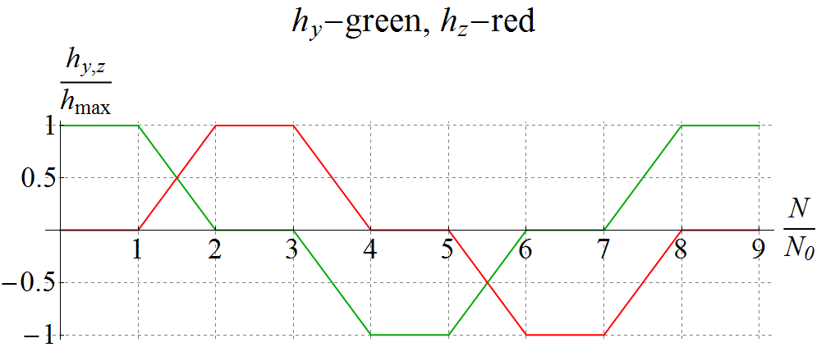

**Figure 1.12:** Pattern of change in the vertical *hy* and longitudinal *hz* spin field components when making spin reversals in the collider ring.

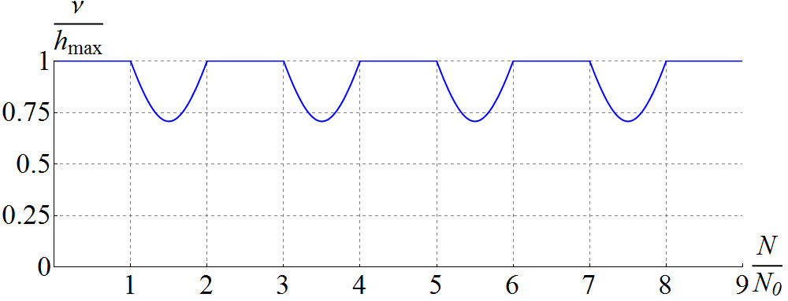

**Figure 1.13:** Change in the spin tune in units of the maximum spin field *h*max when producing rotations of the spin in the collider.

Figure 1.14 shows the change in the proton spin components as a function of the number of turns for the indicated change in the spin field using the 3D rotator. Rotation from vertical to longitudinal direction and back is done in 50 thousand turns. The maximum spin tune value is 10-2. The spin components then follow the shape of the spin filed pattern practically everywhere, as it should be in case of adiabatic motion. Exceptions are small regions where the spin field has sharp breaks, in which the adiabaticity condition is violated. The spin is directed vertically up. Then a spin rotation takes place in 50 thousand turns. As we can see, the spin undergoes sequential rotations from the vertical-up direction to the longitudinal direction along the particle velocity, then to the vertical-down direction and finally to the longitudinal direction opposite to the particle velocity.

To demonstrate a violation of the adiabatic condition of the spin motion during its rotations, Fig. 1.15 shows a similar graph for a deuteron when rotation from vertical to longitudinal direction is done in 50 thousand turns with a maximum spin tune value of 10-4. As we can see from the graphs, there appears an additional modulation of the spin components at the spin frequency, which gradually grows with increase in the number of turns.

To meet the adiabatic condition of the spin motion at the spin tune of 10-4, it is sufficient to complete the rotation from vertical to longitudinal direction in 300 thousand turns. A graph of the spin components when making deuteron spin rotations in this case are shown in Fig. 1.16. As we can see, now, as in the proton case, the spin practically everywhere follows the spin field according to the pattern in Fig. 1.12.

The presented calculations demonstrate the capability of implementing a spin-flipping system using a 3D rotator. Thus, the figure-8 JLEIC ion collider provides a unique capability of doing high-precision experiments with polarized ion beams.

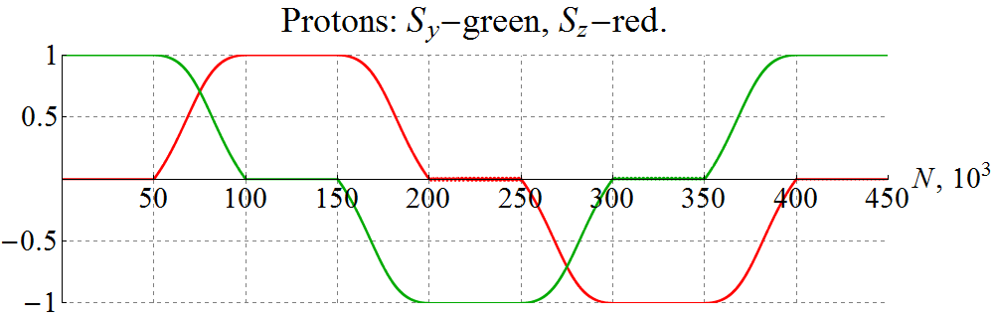

**Figure 1.14:** Producing rotations of the proton spin in an ideal collider lattice.

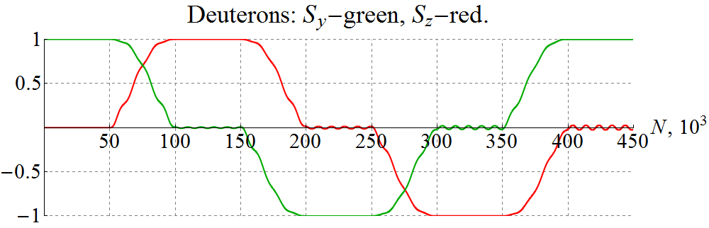

**Figure 1.15:** Producing rotations of the deuteron spin in an ideal collider lattice with violation of the adiabaticity condition of the spin motion.

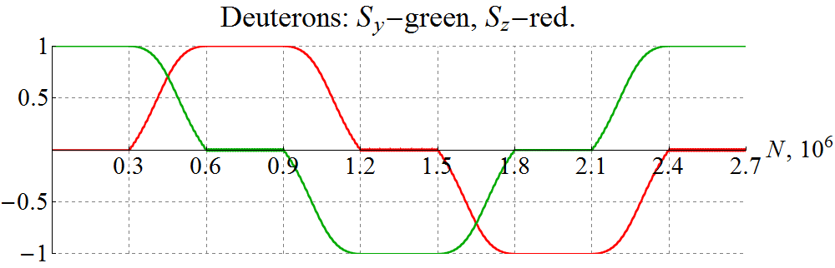

**Figure 1.16:** Producing rotations of the deuteron spin in an ideal collider lattice with the adiabatic condition of the spin motion satisfied.

# Numerical simulations of proton and deuteron beam polarization dynamics during transition energy crossing in the collider JLEIC

When accelerating polarized protons and deuterons in the JLEIC ion collider ring in the momentum range from 8 GeV/c to 100 GeV/c, one has to consider the question of preserving the beam polarization during transition energy crossing. The relativistic Lorentz factor of the transition energy in the ion collider ring equals $γ_{tr}=12.453$, which corresponds to a momentum of 11.65 GeV/c for protons and 23.3 GeV/c for deuterons.

Below we present our calculations of proton and deuteron beam depolarizations in the process of crossing the transition energy completed using the spin tracking program Zgoubi [11].

For our calculations, we chose a conventional model, in which crossing of the transition energy is done by a fast jump of the RF cavity phase at the exact moment of the crossing from the value $φ_{s}$ to the value $φ_{s}^{*}= π- φ_{s}$ at a given field ramp rate [13]. To attain such a phase jump, one must satisfy the condition on the cavity frequency change ${δω}_{RF}$ during the jump time $τ$ :

$$\int_{-τ/2}^{τ/2}{{δω}_{RF}\left(t\right)dt}=π-2 φ_{s} .$$

Let us demonstrate an example of calculating transition energy crossing for protons with a fairly short jump time ( $τ≪60$ ms). Figure 2.1 shows the synchrotron oscillation phase of the synchronous particle as a function of the turn number *N* (RF field phase at the times the particle passed the cavity). The calculation assumes that a particle accelerates from the initial momentum of 11.18 GeV/c to the final one of 12.12 GeV/c in 84⋅103 turns, which corresponds to a field ramp rate of 3 T/min. The jump of the synchronous phase from $φ_{s}≈0.3$ rad to $φ_{s}^{*}≈2.84$ rad occurs at the synchronous particle’s momentum of 11.65 GeV/c.

Figure 2.2 shows the synchrotron oscillation phases of five particles uniformly distributed on a phase space ellipse with an initial amplitude of the momentum deviation of Δp/p=10-3.

|  |  |
| --- | --- |
|  |  |
| **Figure 2.1:** Synchrotron oscillation phase of the synchronous particle. | **Figure 2.2:** Synchrotron oscillation phases of five particles uniformly distributed on a phase space ellipse with an amplitude of Δp/p = 10-3. |

The phase space trajectories of the five indicated particles is shown in Fig. 2.3. As the energy approaches transition ( $N_{tr}≈42⋅{10}^{3}$ turns), the amplitude of the synchrotron phase deviation from the equilibrium value of $φ_{s}≈0.3$ rad reduces while the amplitude of the momentum deviation grows. After crossing the transition energy, the particles are captured inside a new separatrix and undergo oscillations about a new equilibrium phase of rad. The amplitude of the momentum deviations damps as the energy gets further away from transition. Our calculations indicate that no significant change of the transverse beam size occurs at the transition energy crossing.

|  |  |
| --- | --- |
|  |  |
| **Figure 2.3:** Longitudinal phase space trajectories of five particles uniformly distributed on a phase space ellipse with an amplitude of Δp/p=10-3. | **Figure 2.4:** Longitudinal spin components of five particles uniformly distributed on a phase space ellipse with an amplitude of Δp/p=10-3. |

Figure 2.4 shows a graph of the longitudinal spin components during transition energy crossing for five particles uniformly distributed on a phase-space ellipse. The graph demonstrates that the initial phases of the synchrotron oscillations have practically no effect on the beam polarization. The longitudinal proton polarization was stabilized in the calculations by a weak solenoid. The normalized emittances in the radial and vertical directions were equal to 1 mm mrad. Depolarization of the proton beam after crossing of the transition energy does not exceed a few hundredth of a percent.

The completed numerical calculations show that the proton and deuteron polarizations practically do not change in the process of transition energy crossing in the JLEIC ion collider ring. To preserve proton and deuteron polarizations when accelerating a beam from 8 GeV/c to 100 GeV/c, it is sufficient to use a solenoid with a maximum field integral of 7.5 T m.

# Acceleration of polarized protons and deuterons in the collider ring of JLEIC

## 3.1 Preservation of ion polarization in figure-8 accelerators

A characteristic feature of JLEIC [1] is its figure-8-shaped rings [2]. Such a ring topology is transparent to the spin: the combined effect of arc fields on the spin in an ideal collider lattice reduces to zero after one particle turn on the design orbit, i.e. any orientation of the particle spin at any orbital location repeats from turn to turn. To preserve the polarizations of the proton and deuteron beams during acceleration from 8 GeV/c to 100 GeV/c in the ion collider ring, it is sufficient to use a weak solenoid with a field integral of 1.2 T⋅m, which does not perturb the design orbit and has practically no effect on the beam’s orbital parameters [3-10]. The solenoid then stabilizes longitudinal spin polarization at its location. A solenoid with the indicated field integral allows one to induce a spin tune of 10-2 for protons and 3⋅10-3 for deuterons, i.e., when a particle with a vertical spin makes one turn on the design orbit, its spin tilts by an angle of $2πν$ from its initial orientation.

For polarization stability, one must ensure that the spin tune $ν$ induced by the solenoid significantly exceeds [3-6] the strength of the zero-integer spin resonance $ω$: $ν≫ω$.

The resonance strength is the average spin field $\vec{ω}$ (the zero-integer Fourier harmonic of the spin perturbation without a stabilizing solenoid) determined by deviation of the trajectory from the design orbit due to machine element errors and beam emittances. In the absence of a solenoid, the spin precesses by an angle of $2πω$ about the $\vec{ω}$ direction in one particle turn. The resonance strength consists of two parts: a coherent part arising due to additional transverse and longitudinal fields on a trajectory deviating from the design orbit and an incoherent part associated with the particles’ betatron and synchrotron oscillations (beam emittances) [8, 9]

$$\vec{ω}={\vec{ω}}_{coh}+{\vec{ω}}_{emitt} , ω_{coh}≫ω_{emitt .}$$

In practice, the coherent part $ω_{coh}$ significantly exceeds the incoherent one $ω_{emitt}$. The coherent part does not cause beam depolarization and only results in a simultaneous rotation of the polarization about the field determined by the strength and alignment errors of collider elements. In principle, the direction and size of the coherent part of the resonance strength can be measured and taken into account for polarization control. To preserve the polarization, it is then sufficient to satisfy a weaker condition: $ν≫ω_{emitt}$.

## 3.2 Calculation of zero-integer spin resonance strength in JLEIC

Figure 3.1 shows β functions of the JLEIC collider lattice in the acceleration mode [14] used in our spin dynamics calculations. The origin of the coordinate frame is located at the collider's IP. Figure 3.1 also indicates the location of the solenoid stabilizing the spin during acceleration. The difference from the collision mode [15] where $β$ functions in the IP region reach 2.5 km is that, in the acceleration mode, the $β$ functions in the detector section do not exceed 150 m.

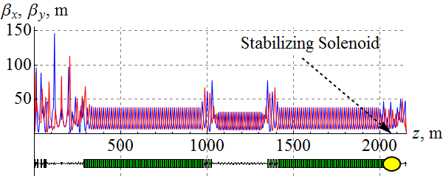

**Figure 3.1: $β$** functions of the ion collider ring.

### 3.2.1 Incoherent part of the spin resonance strength

Figure 3.2 shows the incoherent part of the proton resonance strength for normalized emittance values of 1 mm⋅mrad in both radial and vertical directions. As we can see, the value of the incoherent part does not exceed 2⋅10-4 practically in the whole momentum range of the collider with the exception of narrow “interference” peaks where spin perturbations add up coherently in the arc magnets. The presented calculation confirms that the spin tune value of 10-2 induced by the solenoid field is sufficient to stabilize the spin with normalized emittances of the betatron motion equal to 1 mm⋅mrad.

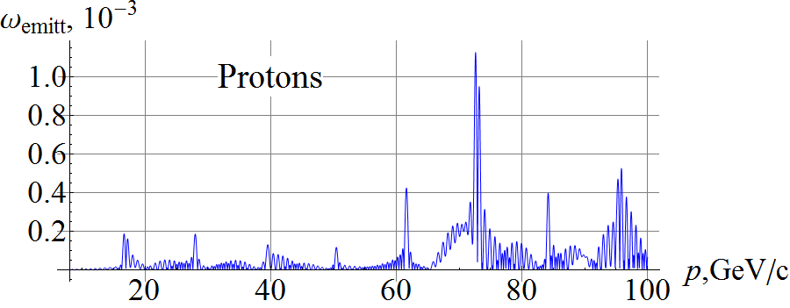

**Figure 3.2:** Incoherent part of the proton resonance strength in the JLEIC ion collider ring.

Figure 3.3 shows a similar graph of the dependence of the incoherent part of the deuteron resonance strength on momentum. Our calculations assumed that the transverse size of the deuteron beam was equal to the proton beam size, i.e. the transverse beam emittances were 0.5 μm.

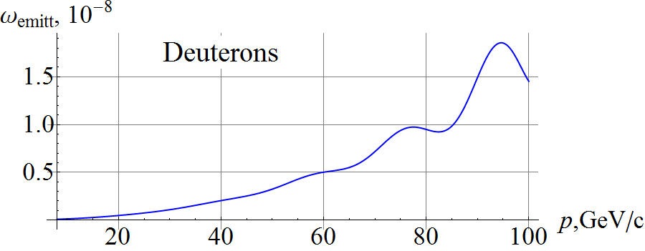

**Figure 3.3:** Incoherent part of the deuteron resonance strength in the JLEIC ion collider ring.

In contrast to protons, due to the small value of the deuteron anomalous magnetic moment, deuterons have only one interference peak at the momentum of 93 GeV/c whose value does not exceed 2⋅10-8. Thus, a deuteron spin tune of 3⋅10-3 induced by a solenoid significantly exceeds the incoherent part of the resonance strength.

### 3.2.2 Coherent part of the spin resonance strength

Let us calculate the resonance strength for a proton beam using a model with random shifts of all quadrupoles in the transverse directions. Figure 3.4 shows the coherent part of the proton resonance strength in the ion collider ring with random quadrupole misalignments resulting in a transverse closed orbit distortion of about 100 μm rms.

The statistical model calculates the most probable magnitude of the coherent part of the resonance strength not specifying its direction, which lies in the collider’s plane.

As in the case of the incoherent part, the coherent part of the resonance strength has interference peaks whose maximum values do not exceed 1.5⋅10-2, which has an order of magnitude comparable to the field induced by the stabilizing solenoid.

Figure 3.5 shows a graph of the coherent part of the deuteron resonance strength calculated using the statistical model of random quadrupole misalignments.

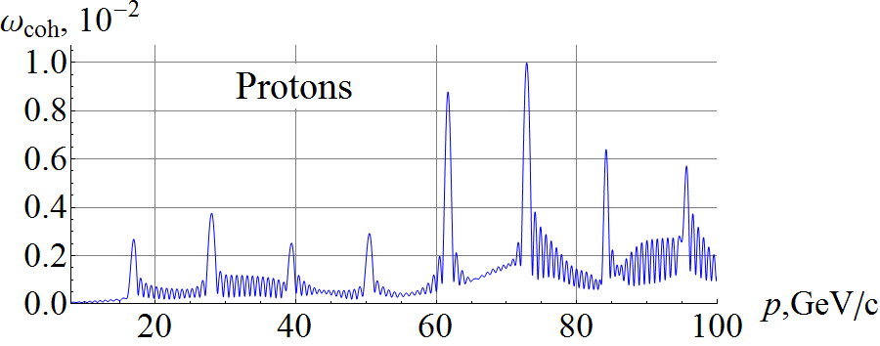

**Figure 3.4:** Coherent part of the proton resonance strength in the ion collider ring.

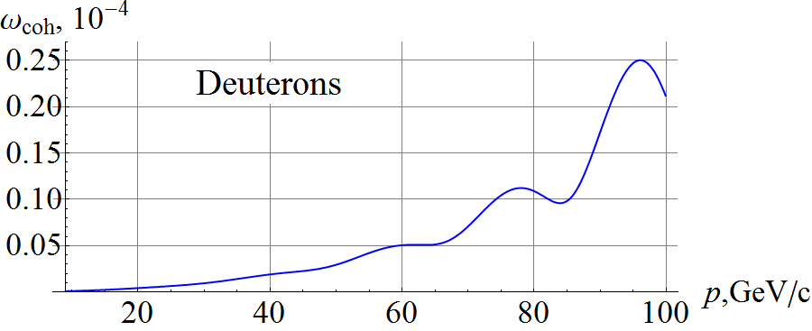

**Figure 3.5:** Coherent part of the deuteron resonance strength in the ion collider ring.

## 3.3 Acceleration of polarized ions in the JLEIC collider

The spin dynamics during acceleration in the ion collider ring is a precession about the spin field $\vec{h}$, which consists of the field ${\vec{h}}_{sol}$ induced by the stabilizing solenoid and the resonance strength $\vec{ω}$: $\vec{h}= {\vec{h}}_{sol}+ \vec{ω}$ [8]. During acceleration the field ${\vec{h}}_{sol}$ is maintained constant while the resonance strength $\vec{ω}(t)$ experiences significant changes in the regions of interference peaks.

The beam polarization substantially depends on the field ramp rate in the arc magnets. When using superconducting magnets with a field ramp rate of ~3 T/min, acceleration happens adiabatically, which means that, in a characteristic time of change in the spin field, the spin makes a large number of turns. During adiabatic acceleration, the spin follows the $\vec{h}$ field direction, which can significantly deviate from the longitudinal direction at the locations of the interference peaks of the coherent part of the resonance strength. However, this does not signify polarization loss, the beam polarization restores its longitudinal direction in places where $h_{sol}≫ω_{coh}$  
.

Let us present calculations of the spin dynamics during acceleration of protons and deuterons in the JLEIC ion collider ring made using a spin tracking code Zgoubi [11].

Figure 3.6 shows the longitudinal spin components in the ion collider ring during acceleration of 3 protons with $Δp/p=0$ (green line), $Δp/p={10}^{-3}$ (red line) and $Δp/p={-10}^{-3}$  
 (blue line). As we can see, the graphs of the longitudinal spin components practically do not differ from each other (the red line covers up the blue and green lines), i.e. synchrotron energy modulation does not give a noticeable contribution to the ion spin motion when stabilizing the polarization by a weak solenoid in the JLEIC ion collider ring. All particles were launched with the same initial conditions: $S_{z0}=1$, $x_{0}=0.61$ mm, $x_{0}^{'}=0$ rad, $y_{0}=0.27$ mm, $y_{0}^{'}=0$ rad. The field ramp rate was ~3 T/min (the particles were accelerated in 8.3 million turns). During acceleration, the spin preserves its component along the spin field, which lies in the orbit plane and noticeably deviates from the longitudinal direction in the regions of the “interference” peaks of the coherent part of the resonance strength at momenta of about 60 GeV/c and 75 GeV/c, where the resonance strength becomes approximately equal to the size of the solenoid spin field. The spin tune induced by the solenoid during acceleration is 10-2.

The simulation in Fig. 3.6 is done with a closed orbit excursion of 100 μm rms. If needed tolerances to alignment of the lattice elements can be relaxed. The strength of the stabilizing solenoid can be increased. One then has to account for the fact that the solenoid itself gives a contribution to the spin resonance strength due to an angle between the distorted closed orbit and solenoid axis. This results in a transverse magnetic field component, which has practically no effect on the orbital motion but can have a strong effect on the spin motion especially for a proton beam at high energies ($γG≫1$). This contribution can be minimized either by a more precise alignment of the solenoid axis or by choosing such a collider lattice, which has a sufficiently small value of the spin response function at the solenoid location. The response function is the spin Green’s function determined and controlled by the linear lattice. It describes the effect of the ring as a whole on the spin due to a $δ$-function-like radial field [8]. Another option is to compensate the coherent part of the spin resonance strength at the experimental energy using a 3D spin rotator [4-8, 10].

Similar graphs for the longitudinal components of the deuteron spin are shown in Fig. 3.7. The initial conditions and solenoid field strength during acceleration were chosen the same as in the proton case.

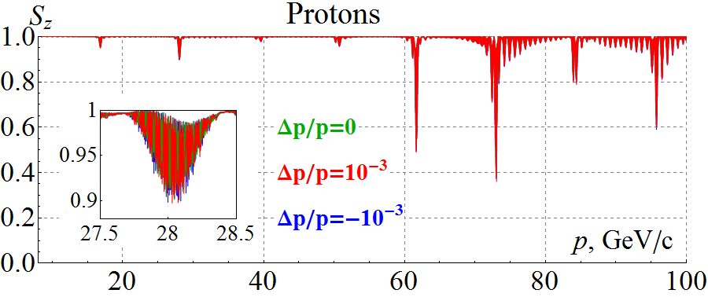

**Figure 3.6:** Longitudinal spin component during acceleration of three protons in the ion collider ring.

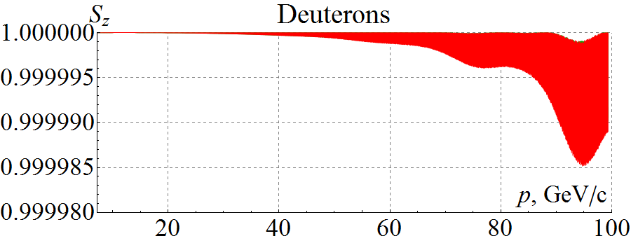

**Figure 3.7:** Longitudinal spin component during acceleration of three deuterons in the ion collider ring.

In contrast to protons, the change in the deuteron longitudinal polarization during acceleration does not exceed $2⋅{10}^{-5}$ even in the interference peak. This example demonstrates a high stability of the deuteron polarization in figure-8 rings, which can be used for high-precision experiments. To the contrary, in conventional accelerators with preferred periodic spin orientation, control of the deuteron polarization and its preservation during acceleration to 100 GeV/c is a practically unrealistic task.

## 3.4 Crossing the transition energy

The relativistic Lorentz factor of the transition energy in the ion collider ring equals 12.453, which corresponds to a momentum of 11.65 GeV/c for protons and 23.3 GeV/c for deuterons.

For our calculations, we chose a conventional model, in which crossing of the transition energy is done by a fast jump of the RF cavity phase at the exact moment of the crossing from the value $φ_{s}$ to the value $φ_{s}^{*}= π- φ_{s}$ at a constant field ramp rate.

The phase space trajectories of two protons with the initial momentum offsets of $Δp/p={10}^{3}$  
 (red line) and $Δp/p={-10}^{3}$ (blue line) are shown in Fig. 3.8. As the energy approaches transition, the amplitude of the synchrotron phase deviation from the equilibrium value of $φ_{s}≈0.3$ rad reduces while the amplitude of the momentum deviation grows. After crossing the transition energy, the particles are captured inside a new separatrix and undergo oscillations about a new equilibrium phase of  rad. The amplitude of the momentum deviations damps as the energy gets further away from transition. Our calculations indicate that, if transition energy crossing is organized without significant excitation of the emittances, its effect on the polarization is negligible. Further studies with a more representative particle distribution and a more realistic model of transition energy crossing are needed.

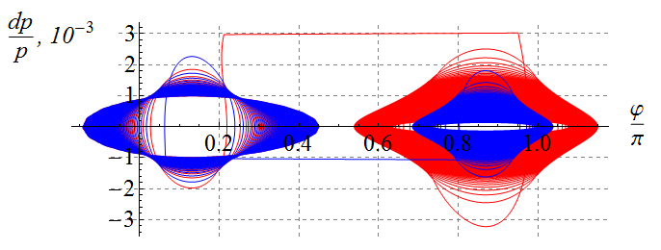

**Figure 3.8:** Proton phase space trajectories.

Figure-8 rings with weak solenoids provide an elegant solution to preservation of the polarization when accelerating particles of any kind. Our calculations made using a spin tracking code Zgoubi verify the validity of our scheme for preserving the polarization during acceleration of protons and deuterons in the JLEIC ion collider ring with transition energy crossing.

# Effect of detector solenoid on the spin dynamics in the JLEIC ion collider ring

## 4.1 Design orbit and description of the spin dynamics in the detector solenoid

The reference frame in a collider is defined using the design closed orbit ${\vec{r}}_{0}\left(z\right)$ specified as a function of the distance *z* along this orbit [13]. In a conventional collider, the design orbit is composed of straights and arcs matched at the connection points. The longitudinal basis vector ${d {\vec{r}}_{0}}/{dz}={\vec{e}}_{z}\left(z\right)$ becomes a continuous function of the distance z along such an orbit and is a periodic function of z: ${\vec{e}}_{z}\left(z+L\right)={\vec{e}}_{z}\left(z\right)$.

The three basis vectors ${\vec{e}}_{x},{\vec{e}}_{y},{\vec{e}}_{z}$ form an accelerator coordinate system for description of trajectory deviations. Change in the basis vectors along the design orbit is determined by the angular velocity vector $\vec{K}\left(z\right)$ and is found from the rotation equations:

$$\frac{d{\vec{e}}_{i}}{dz}=\vec{K}×{\vec{e}}_{i} .$$

In a conventional collider, the basis vectors connected to the straights and arcs satisfy this equation where the angular velocity vector only has components transverse to the particle trajectory: $\vec{K}\left(z\right){=\vec{K}}_{⊥}\left(z\right)$. A regular solenoid whose axis is oriented along the particle trajectory does not change the accelerator frame basis vectors.

The detector solenoid in the JLEIC collider is oriented at an angle to the ion trajectory and has both transverse and longitudinal magnetic field components. The ion motion in such a field is a spiral, which can be only roughly approximated by many arcs. Therefore, to improve the calculation accuracy, one must determine the design orbit in the detector solenoid.

Let us find a solution of this equation with $\vec{K}=const$ inside the solenoid. Since the angular velocity components remain constant during motion:

$$\frac{dK_{i}}{dz}=\frac{d}{dz}\left(\vec{K}{\vec{e}}_{i}\right)=\vec{K}\frac{d}{dz}{\vec{e}}_{i}=\vec{K}×\left(\vec{K}×{\vec{e}}_{i}\right)=0 ,$$

the equation of motion in the matrix form becomes:

$$\frac{d\vec{e}}{dz}=K\hat{n}\vec{e} ,$$

where $K=\sqrt{K_{x}^{2}+K_{y}^{2}+K_{z}^{2}}$ and the matrix

$$\hat{n}=\left(\begin{matrix}0 & n_{z} & {-n}_{y} \\ -n_{z} & 0 & n_{x} \\ n_{y} & {-n}_{x} & 0\end{matrix}\right)$$

is composed of the direction vector components $n_{x}=\frac{K_{x}}{K}$, $n_{y}=\frac{K_{y}}{K}$, $n_{z}=\frac{K_{z}}{K}$.

The solution of this equation in the general form $\vec{e}\left(z\right)=Λ\left(\vec{K},z\right)\vec{e}\left(0\right)$ is determined by a rotation matrix $Λ$ with a dimensionality of 3×3:

$Λ\left(\vec{K},z\right)=I+\left(1-\cos\left(Kz\right)\right){\hat{n}}^{2}+\sin\left(Kz\right)\hat{n}$*,*

with the initial condition $\vec{e}\left(z\right)=\vec{e}\left(0\right)$ at $z=0$.

The design trajectory inside the solenoid becomes:

$${\vec{r}}_{0}\left(z\right)=\int_{0}^{z}{{\vec{e}}_{z}\left(z\right)dz}=\int_{0}^{z}{Λ_{31}\left(z\right)dz}{\vec{e}}_{x}\left(0\right)+\int_{0}^{z}{Λ_{32}\left(z\right)dz}{\vec{e}}_{y}\left(0\right)+\int_{0}^{z}{Λ_{33}\left(z\right)dz}{\vec{e}}_{z}\left(0\right) .$$

Thus, using a fixed reference frame at the entrance into the solenoid, the design trajectory can be written as:

$$X\left(z\right)=\left(z-\frac{\sin\left(Kz\right)}{K}\right)n_{x}n_{z}+\frac{\left(1-\cos\left(Kz\right)\right)}{K}n_{y},$$

$$Y\left(z\right)=\left(z-\frac{\sin\left(Kz\right)}{K}\right)n_{y}n_{z}-\frac{\left(1-\cos\left(Kz\right)\right)}{K}n_{x},$$

$$Z\left(z\right)=z-\left(z-\frac{\sin\left(Kz\right)}{K}\right)\left(1-n_{z}^{2}\right).$$

The trajectory length $z_{max}$ inside the solenoid of a length $L_{sol}$ is determined by the relation

$\vec{n}{\vec{r}}_{0}\left(z_{max}\right)=z_{max}n_{z}=L_{sol}$,

which gives that

$z_{max}=\frac{L_{sol}}{n_{z}}>L_{sol}$.

When the solenoid is tilted in the plane of the collider (when $n_{y}=0$), the design orbit curves mainly in the vertical direction:

$$X\left(z\right)=\left(z-\frac{\sin\left(Kz\right)}{K}\right)n_{x}n_{z},$$

$$Y\left(z\right)=-\frac{\left(1-\cos\left(Kz\right)\right)}{K}n_{x},$$

$$Z\left(z\right)=z-\left(z-\frac{\sin\left(Kz\right)}{K}\right)\left(1-n_{z}^{2}\right).$$

Description of the spin dynamics along the design orbit is done similarly with the following replacements in dipole magnets and solenoids:

$$K_{x}→{γGK}_{x}, K_{y}→{γGK}_{y}, K_{z}→{\left(1+G\right)K}_{z}.$$

## 4.2 Calculation of the proton and deuteron spin dynamics in the JLEIC ion collider ring including the detector solenoid

Figure 4.1 shows a scheme of the detector solenoid placement in the JLEIC ion collider ring [16].



**Detector   
Solenoid**

**Final Focus   
Quads**

**Final Focus   
Quads**

**Detector   
Dipole**

**Kickers**

**1**

**2**

**3**

**4**

**Compens.   
Solenoid**

**Compens.   
Solenoid**

**IP**

**Figure 4.1:** Schematic of the detector solenoid placement in the JLEIC ion collider ring.

A 4 m detector solenoid is located along a straight section of the electron ring and makes a 50 mrad horizontal angle with a straight section of the ion ring. The interaction point divides the solenoid at a length ratio of $1.6 m :2.4 m=2 :3$ and lies at the crossing point of the electron and ion straight sections when the solenoid is off.

When the field of the detector solenoid is on, the ions are affected not only by the longitudinal field component but by the radial field component as well, which shifts the ions vertically away from the interaction point. To stabilize the interaction point and correct the ion orbit at the exit and entrance of the Final Focusing Quadrupole (FFQ) triplets, there are a pair of kickers on each side of the detector solenoid: the first and second kickers are directly to the left of the solenoid, the third and fourth kickers on the right of the solenoid are separated by a detector dipole with vertical field. Each kicker has vertical $K_{yi}$ and radial $K_{xi}$ components of the transverse field.

To compensate coupling introduced by the detector solenoid, 1.6 m and 2.4 m anti-solenoids are placed on the two sides of the detector solenoid. The axes of the anti-solenoids are aligned with the axis of the ion straight section.

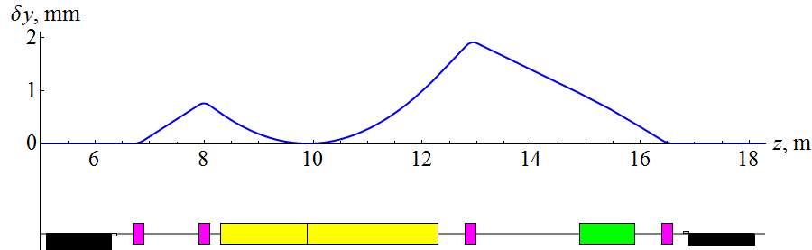

$$K_{x1 }$$

$$K_{y1}$$

$$K_{x2}$$

$$K_{y2}$$

$$K_{y3}$$

$$K_{x3 }$$

$$K_{x4 }$$

$$K_{y4}$$

$$K_{y}$$

**IP**

$K_{z},$ $α=0.05$

**Figure 4.2:** Vertical excursion of the ion beam from the axis of the ion straight section. The field of the detector solenoid is 3 T. The beam momentum is 100 GeV/c.

Figure 4.2 shows the vertical excursion of the ion beam trajectory caused the detector solenoid field of 3 T at the beam momentum of 100 GeV/c. As we can see, the new orbit is completely restored at the exit and entrance of the FFQ triplets. To stabilize the interaction point, the transverse components of the kickers in units of the magnetic rigidity must take the following values:

$$K_{x1}=-0.0033 m^{-1}, K_{y1}≈2.9⋅{10}^{-5}{ m}^{-1}, K_{x2}≈0.0069 { m}^{-1}, K_{y2}≈-5.5 ⋅{10}^{-5}{ m}^{-1},$$

$$K_{x3}= 0.0079 m^{-1}, K_{y3}≈9.2⋅{10}^{-5}{ m}^{-1}, K_{x4}≈-0.0031 { m}^{-1}, K_{y4}≈-4. ⋅{10}^{-5}{ m}^{-1}.$$

Figure 4.3 shows the influence of the detector solenoid insertion on the proton spin dynamics as a function of momentum. The calculations assume that the beam orbit is stable and corresponds to the beam parameters shown in Fig. 4.2.

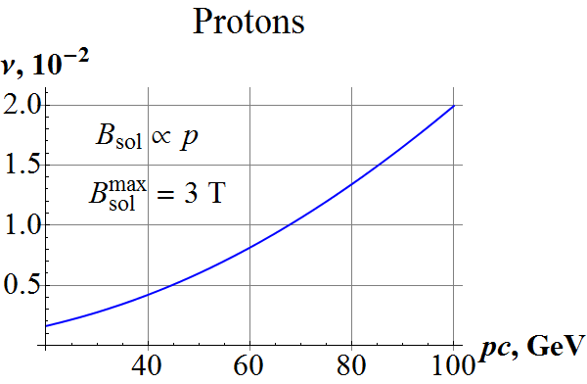 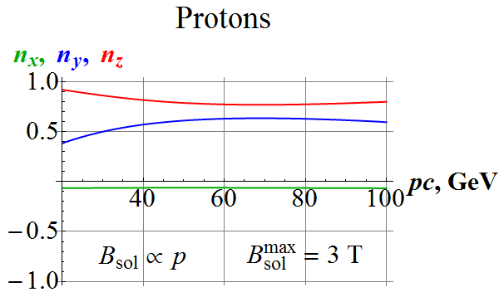

**Figure 4.3:** Momentum dependence of the proton spin tune and $\vec{n}$– axis components caused by insertion of the detector solenoid. In the calculations, the solenoid field scales proportionally to the beam momentum and reaches 3 T at the maximum momentum of 100 GeV/c.

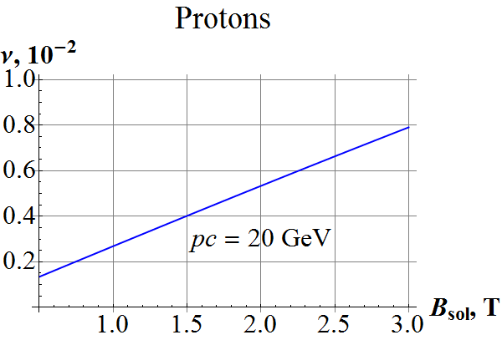 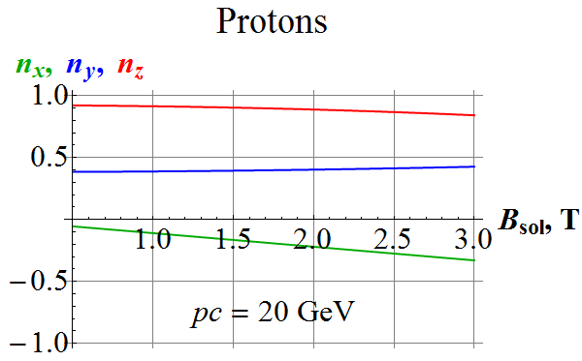

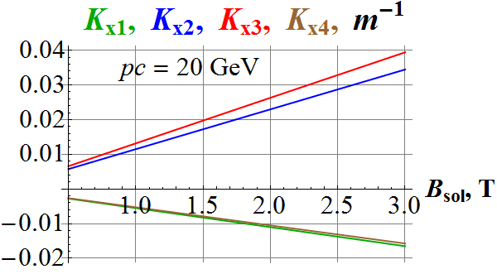 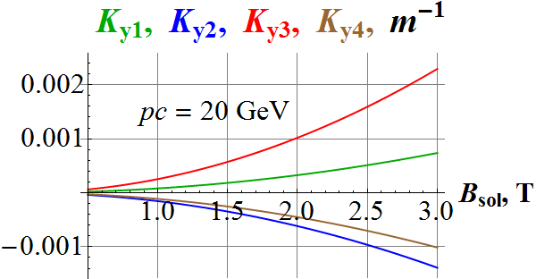

**Figure 4.4:** Dependencies of the proton spin tune and $\vec{n}$– axis components (top) and of the kicker transverse fields in units of the magnetic rigidity (bottom) on the field of the detector solenoid at the beam momentum of 20 GeV/с.

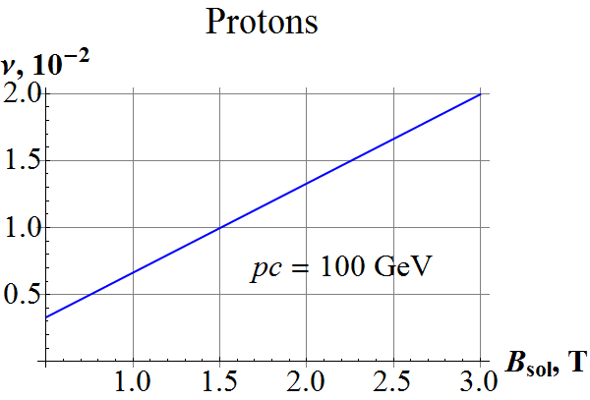 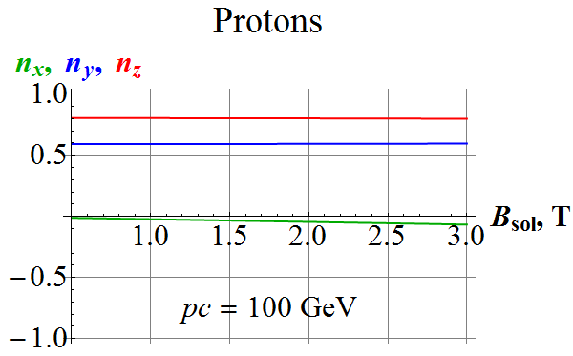

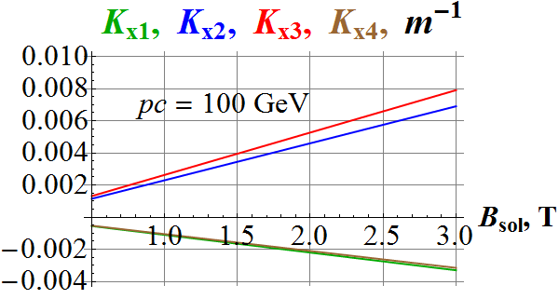 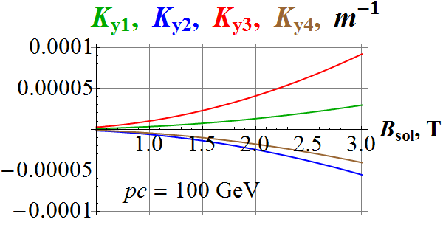

**Figure 4.5:** Dependencies of the proton spin tune and $\vec{n}$– axis components (top) and of the kicker transverse fields in units of the magnetic rigidity (bottom) on the field of the detector solenoid at the beam momentum of 100 GeV/с.

Figures 4.4 and 4.5 show the dependences of the proton spin tune and $\vec{n}$– axis components on the field of the detector solenoid at the beam momenta of 20 GeV/c and 100 GeV/c, respectively. These figures also show the transverse magnetic field components in the kickers necessary for stabilization of the interaction point as functions of the detector solenoid field.

Figure 4.6 shows the influence of the detector solenoid insertion on the deuteron spin dynamics as a function of the beam momentum. The calculations assume that the beam orbit is stable and corresponds to the beam parameters shown in Fig. 4.2.

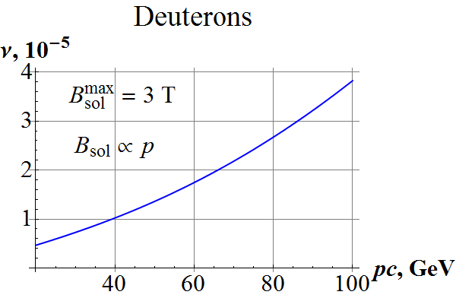 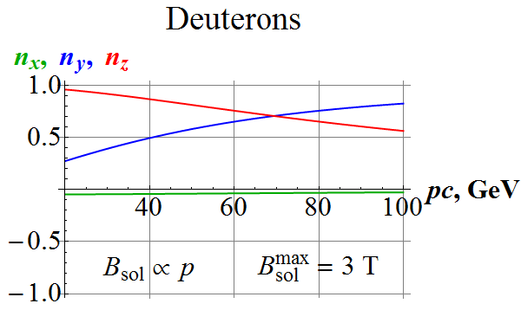

**Figure 4.6:** Momentum dependence of the deuteron spin tune and $\vec{n}$– axis components caused by insertion of the detector solenoid. In the calculations, the solenoid field scales proportionally to the beam momentum and reaches 3 T at the maximum beam momentum of 100 GeV/c.

Figures 4.7 and 4.8 show the dependencies of the deuteron spin tune and $\vec{n}$– axis components on the field of the detector solenoid at the beam momenta of 20 GeV/c and 100 GeV/c, respectively.

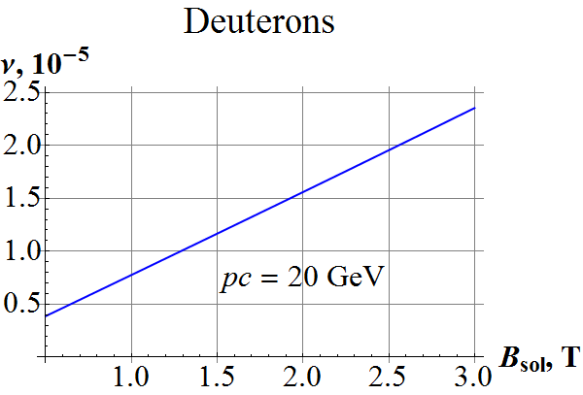 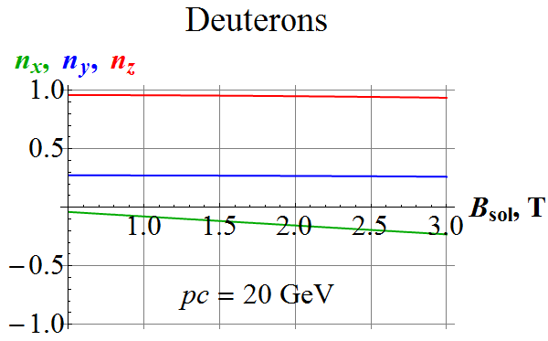

**Figure 4.7:** Dependence of the deuteron spin tune and $\vec{n}$– axis components on the field of the detector solenoid at the beam momentum of 20 GeV/с.

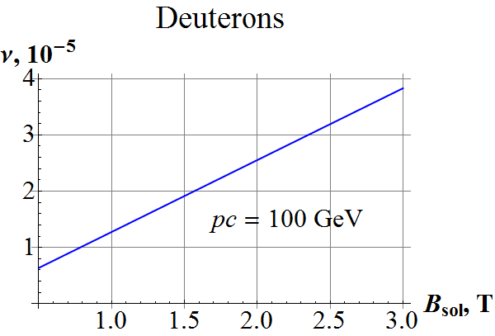 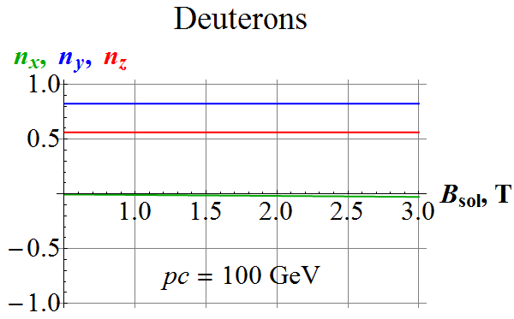

**Figure 4.8:** Dependence of the deuteron spin tune and $\vec{n}$– axis components on the field of the detector solenoid at the beam momentum of 100 GeV/с.

## 4.3 Compensation of the detector solenoid effect on the ion polarization

The calculations presented above show that the spin tune induced by the detector solenoid insertion does not exceed the value of $2⋅{10}^{-2}$ for protons and $4⋅{10}^{-5}$ for deuterons when the field of the detector solenoid changes from 0 to 3 T in the whole momentum range of the JLEIC collider. From the calculations, it also follows that the directions of the proton and deuteron spin precession axes induced by the detector solenoid insertion do not change significantly in the whole momentum range of the collider.

The control 3D spin rotators allow one to induce spin tunes of ${10}^{-2}$ for protons and ${10}^{-4}$ for deuterons.

Thus, the influence of the detector solenoid insertion on the deuteron polarization is weaker than on the proton polarization and can be compensated using a single additional 3D rotator. Compensation of the influence of the detector solenoid insertion on the proton polarization requires using two such rotators, which can be placed in any available space in a straight section of the collider.

# Analysis of nonlinear effects and the influence of betatron oscillation coupling on the spin dynamics

Contribution of the arcs to the zero-integer spin resonance strength is dominant due to a large number of spin turns in the collider’s arcs at high energies. When moving on the design trajectory, the spin precesses with an angular frequency:

$\vec{W}=γGK_{y} {\vec{e}}_{y}$.

For deviations from the design trajectory, the perturbing spin field becomes [17]:

$\vec{w}=w_{x}{\vec{e}}_{x}+w_{y}{\vec{e}}_{y}$.

$w_{x}=-γGτ_{y}^{'},{ w}_{y}=γGτ_{x}^{'}$.

where $τ_{x}$ and $τ_{y}$ are the components of the particle velocity direction $\vec{τ}={\vec{\text{v}}}/{\text{v}}$, ${\vec{τ}}^{'}={d\vec{τ}}/{dz}$.

We describe the spin dynamics in a figure-8 collider using a system of periodic basis vectors, which rotates about the vertical direction:

$${\vec{l}}_{1}=\cos{Ψ_{y}}{\vec{e}}_{x}-\sin{Ψ_{y}}{\vec{e}}_{z} , {\vec{l}}_{2}={\vec{e}}_{y} , {\vec{l}}_{3}=\sin{Ψ_{y}}{\vec{e}}_{x}+\cos{Ψ_{y}}{\vec{e}}_{z} ,$$

where $Ψ_{y}=γG\int_{0}^{z}{K_{y}dz}$ is the spin rotation phase in the arcs of a figure-8 collider. The spin field components in this system become:

$w_{1}=\vec{w}⋅{\vec{l}}_{1}=w_{x}\cos{Ψ_{y}}$; $w_{2}=\vec{w}⋅{\vec{l}}_{2}=w_{y}$; $w_{3}=\vec{w}⋅{\vec{l}}_{3}=w_{x}\sin{Ψ_{y}}$.

In the linear approximation, the spin field components near the zero-integer resonance are determined by averaged expressions lying in the orbital plane:

$ω_{1}=\frac{L}{2π}〈w_{1}〉=\frac{L}{2π}〈w_{x} cos{Ψ_{y}}〉$, $ω_{2}=\frac{L}{2π}〈w_{y}〉=0$, $ω_{3}=\frac{L}{2π}〈w_{z}〉=\frac{L}{2π}〈w_{x}\sin{Ψ_{y}}〉$,

where *L* is the orbit length and the angle brackets denote averaging along the orbit.

## 5.1 Spin response function for calculating the contribution of field nonlinearity to the resonance strength

In the linear approximation, the resonance strength is determined by the radial component of the perturbing field $h_{x}=B_{x}/Bρ$ and can be calculated using the spin response function $F$ [18]:

$$ω_{1}+iω_{3}=\frac{L}{2π}〈h_{x}F〉,$$

where the periodic function $F\left(z\right)=F(z+L)$ is determined by the expression:

$$F=\frac{1}{2i}\left[f_{y}^{*}\int_{-∞}^{z}{f_{y}^{'}\left(\frac{d}{dz}e^{iΨ_{y}}\right)dz}-f_{y}\int_{-∞}^{z}{f_{y}^{*}'\left(\frac{d}{dz}e^{iΨ_{y}}\right)dz}\right].$$

As we can see, contribution to the response function is determined by the regions with vertical field where spin rotation occurs.

The response function allows one to calculate contribution to the resonance strength due to field nonlinearities (sextupoles, octupoles, and so on).

## 5.2. Influence of betatron oscillation coupling on the incoherent part of the spin resonance strength

In an ideal collider lattice, in the linear approximation, the average values of all spin field components due to betatron oscillations become zero. The spin field components are determined by the strength and alignment errors of the elements of the collider’s magnetic lattice. The coherent part of the spin field can be compensated by correcting elements, for example, by the local 3D spin rotators. In the absence of betatron oscillation coupling, the incoherent part of the spin field in the linear approximation is determined by synchrotron energy oscillations of the beam particles, which, according to the given equation, is:

$w_{x}=-γGD_{y}^{''}\frac{Δp}{p}$,

where $D_{y}$ is the vertical dispersion function in the arcs and ${Δp}/p$ is the relative momentum offset of the particle.

Thus, when the condition of the coherent part compensation is satisfied, the spin field components in the linear approximation are determined by the vertical dispersion function in the arcs. The condition of the absence of the synchrotron field modulation near the zero-integer spin resonance can be written as:

$$〈{e^{iΨ_{y}}D}_{y}^{''}〉=-〈\left(\frac{d}{dz}D_{y}\right)\left(\frac{d}{dz}e^{iΨ_{y}}\right)〉=0 .$$

In conventional colliders, there is no dispersion function in the arcs and the above condition is automatically satisfied.

In a collider with conventional arcs, the incoherent part of the spin resonance strength is determined by higher-order approximations. With a precision of up to the second order of the averaging method, we get the following expression for calculating the averaged spin field:

$$\vec{ω}=\frac{L}{2π}〈\vec{w}〉+\frac{L}{4π}〈\left[\vec{w}×\int_{-∞}^{z}{\vec{w}dz}\right]〉$$

Thus, for each component of the incoherent part of the averaged spin field, we get:

$$ω_{1}+iω_{3}=-\frac{L}{2π}\left(γG〈τ_{y}^{'}e^{iΨ_{y}}〉+i γ^{2}G^{2}〈τ_{y}^{'}τ_{x}e^{iΨ_{y}}〉\right)$$

$$ω_{2}=\frac{L}{4π}γ^{2}G^{2}Im〈τ_{y}^{'}e^{iΨ_{y}}\int_{-∞}^{z}{τ_{y}^{'}e^{-iΨ_{y}}dz}〉$$

The spin field components in the orbital plane are caused by coupling of the radial and vertical betatron oscillations in the collider’s arcs. The vertical field component is related to vertical particle oscillations in the collider’s arcs and, using integration by parts, is reduced to the following form:

$$ω_{2}=\frac{L}{4π}γ^{2}G^{2}Im〈τ_{y}\left(z\right)\left(\frac{d}{dz}e^{-iΨ_{y}}\right)\int_{-∞}^{z}{τ_{y}\left(ξ\right)\left(\frac{d}{dξ}e^{iΨ_{y}}\right)dξ+2i\frac{dΨ_{y}}{dz}τ_{y}^{2}\left(z\right)}〉.$$

Thus, in the absence of betatron oscillation coupling, in the second order of the averaging method, the spin field depends only on the vertical emittance, is directed along the vertical (with the control solenoids off) and grows with energy due to large values of $γG$ with appearance of interference maxima at certain energy values.

The presence of betatron oscillation coupling leads to appearance of a spin field component in the orbital plane and also to the fact that the incoherent part of the resonance strength is determined not only by the emittance of both beam betatron oscillation modes but by the longitudinal emittance as well.

## 5.3 Compensation of the incoherent part of the spin resonance strength due to the collider’s arcs

In the absence of coupling of the radial and vertical oscillations, the spin field rotates the particle spin about the vertical direction. The vertical deviation of the velocity direction $τ_{y}\left(z\right)$ can be expressed through the derivative of the Floquet function $f_{y}\left(z\right)$:

$$τ_{y}=C_{y}f_{y}^{'}+C_{y}^{*}f_{y}^{*}'$$

with a constant amplitude $C_{y}$. The Floquet function of the vertical betatron oscillations transforms after one particle turn in the following way:

$f_{y}\left(z+L\right)=e^{2πiν_{y}}f_{y}\left(z\right)$.

If the magnets in the arcs are located symmetrically

$K_{y}\left(z\right)=-K_{y}\left(z+\frac{L}{2}\right)$,

it is convenient to reduce the averaging over the ring to integrals over the half rings of the figure 8.

$$ω=γ^{2}G^{2}\frac{ε_{y}}{16π^{2}}\int_{0}^{L/2}{dz} \left\{2\frac{dΨ_{y}}{dz}\left({\left|f_{y}^{'}\left(z\right)\right|}^{2}-{\left|f_{y}^{'}\left(z+\frac{L}{2} \right)\right|}^{2}\right)+\right.$$

$\left. + Im\int_{-∞}^{z}{dξ\left(\frac{d}{dz}e^{iΨ_{y}\left(z\right)}\right)\left(\frac{d}{dξ}e^{-iΨ_{y}\left(ξ\right)}\right)} 2Re\left[f_{y}^{'}\left(z\right)f_{y}^{*}'\left(ξ\right)-f_{y}^{'}\left(z+\frac{L}{2}\right)f_{y}^{*}'\left(ξ+\frac{L}{2}\right)\right]\right\}$.

Here we use the relation of the amplitude $C_{y}$ to the emittance $ε_{y}$: $ε_{y}={4π\left|C_{y}\right|}^{2}$.

From the presented analysis, it follows that, in a figure-8 collider, one can completely compensate the incoherent part of the spin resonance strength by choosing a certain symmetry of the optical structure. For a structure with an even number of super-periods where the phase advance of the betatron oscillations between the half rings is ${πν}_{y}$, complete compensation of the incoherent part of the spin resonance strength occurs up to the forth order for all collider energies. As it follows from the above expression, the compensation conditions are:

$$K_{y}\left(z+\frac{L}{2}\right)=-K_{y}\left(z\right), f_{y}\left(z+\frac{L}{2}\right)=e^{iπν_{y}}f_{y}\left(z\right).$$

# Numerical modeling of the spin dynamics in the JLEIC collider including nonlinear effects

## 6.1 Calculation of the sextupole and octupole components of field nonlinearity

Contribution of field nonlinearity the zero-integer spin resonance strength can be accounted for using the response function $F$:

$$ω=\frac{L}{2π}γG〈Fh_{x}〉 .$$

The sextupole component of radial magnetic field is:

$$h_{x}=\frac{1}{Bρ}\frac{∂^{2}B_{x}}{∂x^{2}}\frac{{(x}^{2}-y^{2})}{2}+\frac{1}{Bρ}\frac{∂^{2}B_{y}}{∂x^{2}}xy .$$

The term including the derivative ${∂^{2}B_{x}}/{∂x^{2}}$ corresponds to skew sextupoles while the term including the derivative ${∂^{2}B_{y}}/{∂x^{2}}$ corresponds to straight sextupoles. In the JLEIC collider, there are no magnetic elements with the derivative ${∂^{2}B_{x}}/{∂x^{2}}≠0$ noticeably different from zero and the radial field becomes:

$$h_{x}=\frac{1}{Bρ}\frac{∂^{2}B_{y}}{∂x^{2}}xy.$$

In the absence of betatron oscillation coupling, the average value is

$$〈Fh_{x}〉=〈\frac{F}{Bρ}\frac{∂^{2}B_{y}}{∂x^{2}}xy〉=0$$

due to the difference of the radial and vertical betatron oscillation tunes. Thus, contribution of straight sextupoles components to the resonance strength in the JLEIC collider is zero.

As an example, let us estimate contribution of a skew sextupole to the resonance strength. Figure 6.1 shows the dependence of the absolute value of the response function on the distance along the ring at the beam momentum of 100 GeV/c.

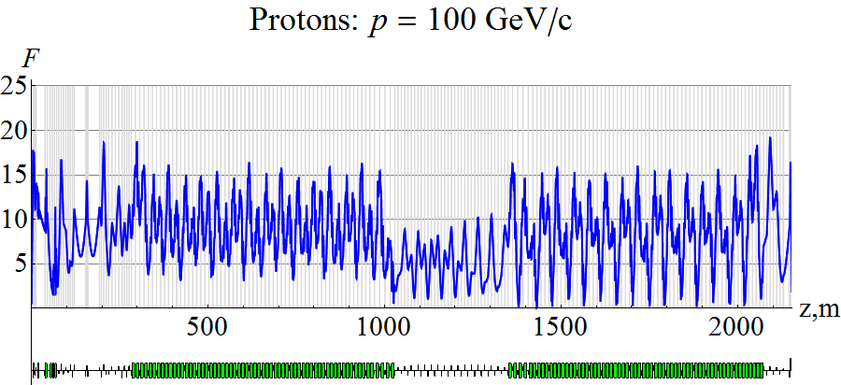

**Figure 6.1:** Proton response function at 100 GeV/c.

Figure 6.2 shows the dependence of the absolute value of the response function on momentum averaged over the sextupole locations in the JLEIC collider. The response function has interference maxima due to correlated addition of the betatron and spin motions in the arc magnets.

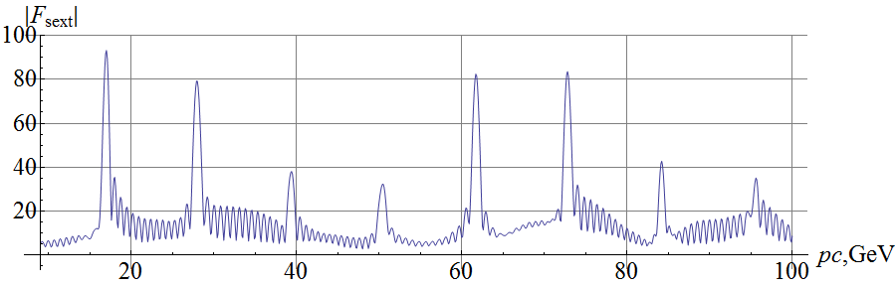

**Figure 6.2:** Dependence of the absolute value of the response function averaged over the sextupole locations on the proton beam momentum.

The maximum contribution to the resonance strength of a skew sextupole of length $L_{s}=0.5$  
 m with a normalized gradient of $({∂^{2}B_{x}}/{∂x^{2}})/Bρ=1 m^{-3}$ at ~60 GeV/c is:

$$ω_{sext}=γG\frac{L}{2π}〈\frac{F}{Bρ}\frac{∂^{2}B_{x}}{∂x^{2}}\frac{{(x}^{2}-y^{2})}{2}〉=\frac{γG}{2π} \frac{|F|}{Bρ}\frac{∂^{2}B_{x}}{∂x^{2}}\frac{\left(ε_{x}β_{x}-ε_{y}β_{y}\right)L_{s}}{2}≈ \frac{G}{2π } \frac{\left|F\right|}{Bρ}\frac{∂^{2}B_{x}}{∂x^{2}}\frac{\left(ϵ_{x}β_{x}-ϵ_{y}β_{y}\right)L_{s}}{2}≈{1.7⋅10}^{-5} .$$

Here we assume that the normalized emittances $ϵ_{x,y}$ are $1 μm$ for both directions of the betatron oscillations and the difference of the beta functions at the sextupole location is about 30 m. Note that, with increase in momentum, contribution to the resonance strength of a skew sextupole does not depend on momentum.

For a few skew sextupoles, one must add their contributions to the resonance strength including the phase of the response function. In principle, by choosing the phase of the response function, on one hand, one can add up the sextupole contributions coherently thus increasing the sextupole effect on the spin but, on the other hand, one can completely compensate the sextupole effect on the spin. When using a large number of skew sextupoles $N_{sext}$, since, at large momenta ($γG≫1)$, the phase of the responses function changes significantly from one sextupole location to another, one can estimate the total sextupole contribution using the statistical model with random phases of the response function:

$$ω_{tot}=\sqrt{N_{sext}} ω_{sext}.$$

Contribution to the resonance strength of the octupole components of field nonlinearities, which are proportional to the third power of particle deviation from the design orbit, is zero as in the case of straight sextupoles since one must detune from 3rd order betatron resonances for beam stability.

## 6.2 Calculation of the incoherent part due to betatron oscillations

As shown earlier, betatron motion gives contribution to the incoherent part of the resonance strength, which is determined by the second order of the Bogoliubov averaging method. At high energies $(γG≫1)$, the incoherent part of the resonance strength is directed vertically and is determined by vertical betatron motion:

$$ω_{2}=\frac{L}{4π}γ^{2}G^{2}Im〈τ_{y}^{'}e^{iΨ_{y}}\int_{-∞}^{z}{τ_{y}^{'}e^{-iΨ_{y}}dz}〉.$$

As we can see, the incoherent part of the resonance strength is proportional to the vertical emittance and to the square of the beam energy and therefore, with increase in energy, changes directly proportionally to energy.

Figure 6.3 shows the dependence of the incoherent part of the proton resonance strength on momentum. The calculation assumes that the normalized vertical emittance is 1 $μm$ . As in the case of the response function, the incoherent part also has interference maxima.

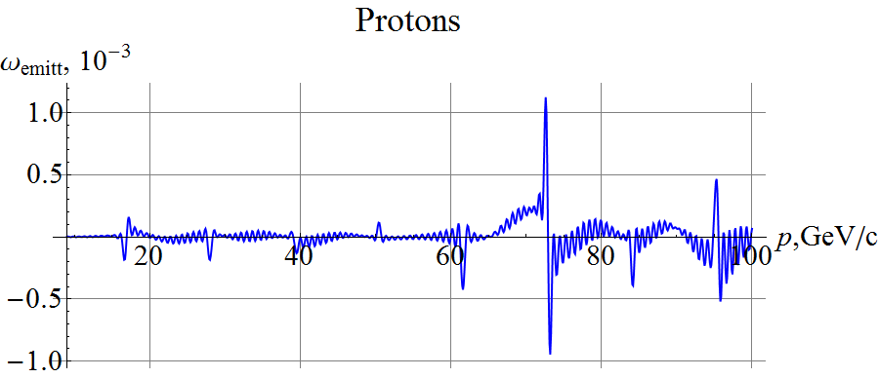

**Figure 6.3:** Incoherent part of the proton resonance strength in the JLEIC collider.

## 6.3 Demonstration of nonlinear effects on the spin dynamics using Zgoubi

In Fig. 6.4, we use Zgoubi to demonstrate that the main influence on the spin dynamics is caused by vertical betatron oscillations. A particle is launched in the ideal collider lattice at 100 GeV/c with longitudinal spin and vertical ($a_{x}=0, a_{y}=a_{y0}$) and radial ($a_{x}=a_{x0}, a_{y}=0$) offsets. Here and below, the offsets $a_{x0}$ and $a_{y0}$ correspond to the normalized radial and vertical emittance values of $ϵ_{x}=ϵ_{y}=1 μm$.

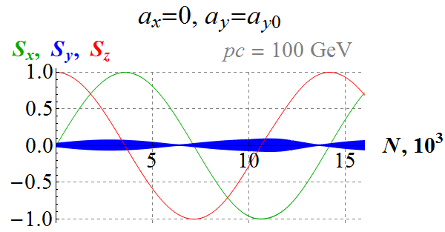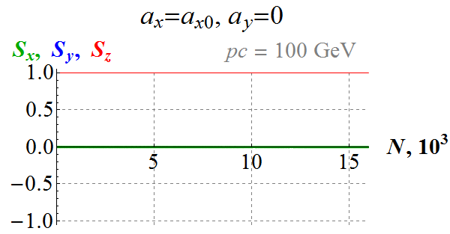

**Figure 6.4:** Influence of the vertical and radial emittances on the proton spin dynamics.

As we can see, in the case of vertical oscillations, the spin makes a full turn about the vertical axis (the average value of the vertical component is zero) in 14 thousand particle turns. This corresponds to a value of the incoherent part of the resonance strength of $7⋅{10}^{-5}$. When launching a particle only with a radial offset, the particle spin practically does not change during this time.

Figure 6.5 shows the influence of the betatron emittances on the proton spins in the JLEIC collider. A particle with longitudinal spin is first launched with betatron oscillation amplitudes corresponding to the normalized emittances (Fig. 6.5A) and then with those doubled (Fig. 6.5B) and tripled (Fig. 6.5C). By comparing the periods of the spin oscillations, one can conclude that the incoherent part of the resonance strength is proportional to the amplitudes squared (emittances), which is consistent with the fact that it is determined by the second order of the averaging method.

|  |  |  |  |  |
| --- | --- | --- | --- | --- |
| **(A)** |  | | **(B)** |  |
| **(C)** | |  | | |

**Figure 6.5:** Influence of the betatron emittances on the proton spin dynamics in the JLEIC collider. The initial amplitudes are $a_{x}=a_{x0}$, $a_{y}=a_{y0}$ (A), $a_{x}={2a}_{x0}$, $a_{y}={2a}_{y0}$ (B), and $a_{x}={3a}_{x0}$, $a_{y}={3a}_{y0}$  
 (C).

Figures 6.6-6.8 demonstrate influence of straight sextupoles on the spin dynamics in the JLEIC collider at the momentum of 61.7 GeV/c, which corresponds to a peak of the response function. Figure 6.6 shows the spin dynamics in a collider lattice without sextupoles. A particle is launched with longitudinal spin and with the betatron oscillations amplitudes corresponding to the normalized emittances of 1 $μ$ m. The graphs indicate that the spin makes two revolutions in 5115 turns, which corresponds to a value of the incoherent part of the resonance strength of $ω_{0}≈3.91⋅{10}^{-4}.$ As we can see, the span of oscillations of the radial and vertical spin components is $±1$, which corresponds to the vertical direction of the resonance strength.

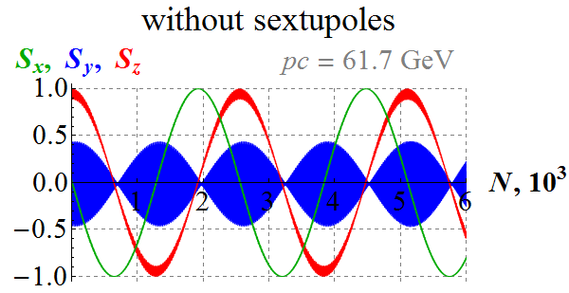 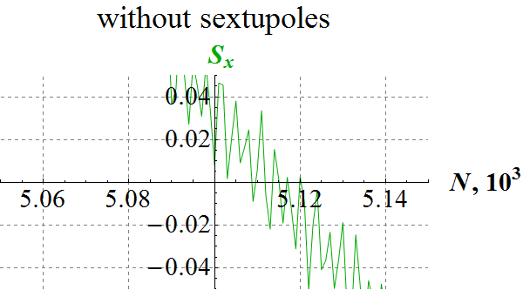

**Figure 6.6:** Proton spin dynamics in the JLEIC collider without sextupoles. The initial amplitudes are $a_{x}=a_{x0}, a_{y}=a_{y0}$.

Figure 6.7 shows the spin dynamics in the collider lattice with straight sextupoles. Figure 6.8 shows the spin dynamics when the field values are doubled in all sextupoles. The calculations include families of 48 straight sextupoles with field gradient values of about $0.6 m^{-3}$ and $1.1 m^{-3}$, which are used in the collider. From a comparison to Fig. 6.6, one can conclude that there is no noticeable influence of the straight sextupoles on the spin dynamics.

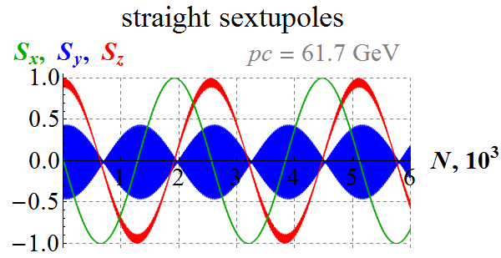 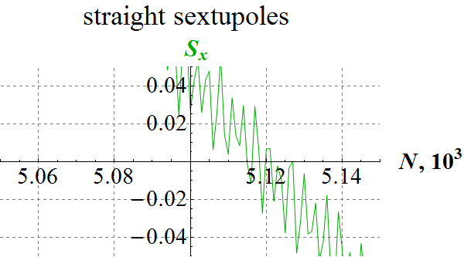

**Figure 6.7:** Proton spin dynamics in the JLEIC collider with straight sextupoles. The initial betatron amplitudes are $a_{x}=a_{x0}, a_{y}=a_{y0}$.

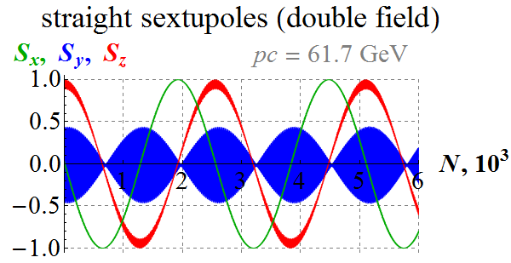 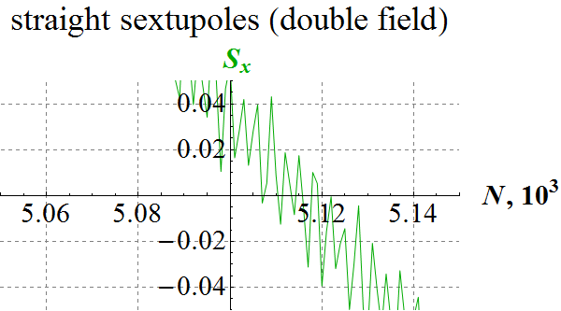

**Figure 6.8:** Proton spin dynamics in the JLEIC collider with straight sextupoles. The initial betatron amplitudes are $a_{x}=a_{x0}, a_{y}=a_{y0}$. The field values of all sextupoles are doubled.

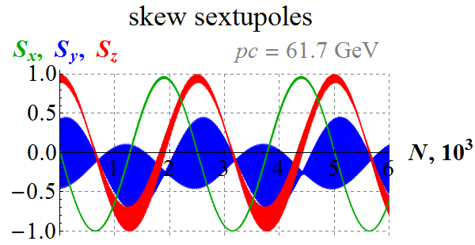 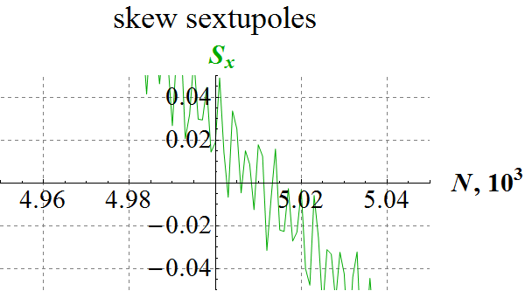

**Figure 6.9:** Proton spin dynamics in the JLEIC collider with skew sextupoles. The initial betatron amplitudes are $a_{x}=a_{x0}, a_{y}=a_{y0}$.

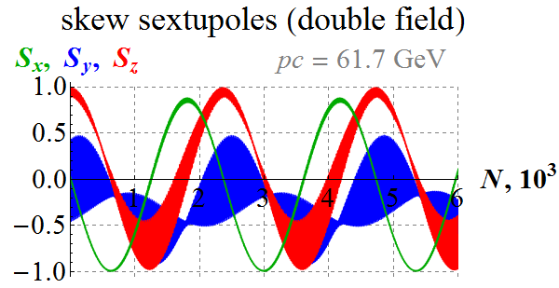 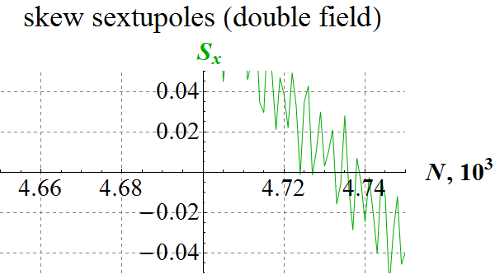

**Figure 6.10:** Proton spin dynamics in the JLEIC collider with skew sextupoles. The initial betatron amplitudes are $a_{x}=a_{x0}, a_{y}=a_{y0}$. The field values of all sextupoles are doubled.

Figure 6.9 shows the influence of skew sextupoles on the spin dynamics in the JLEIC collider at the beam momentum of 61.7 GeV/c. Figure 6.10 shows the spin dynamics when the field values of all skew sextupoles are doubled. For these calculations, all straight sextupoles in the collider are rotated by 30° about the longitudinal axis.

The graphs give that the spin makes two revolutions in 5010 turns (Fig. 6.9) and 4735 turns (Fig. 6.10), which correspond to the coherent parts of the resonance strengths of $ω_{1}≈4.0⋅{10}^{-4}$ (Fig. 6.9) and $ω_{2}≈4.22⋅{10}^{-4}$ (Fig. 6.10). The respective changes in the coherent part of the resonance strength due to the skew sextupoles are ${Δω}_{1}=0.9⋅{10}^{-5}$ (all sextupoles are skew) and ${Δω}_{2}=3.1⋅{10}^{-5}$ (all sextupoles are skew with doubled field values), i.e. the change in the strength is proportional to the sextupole field squared. This is, indeed, how it should be. In the absence of sextupoles the incoherent part $ω_{0}$ is determined by betatron motion and points vertically. The contribution of a skew sextupole is proportional to the sextupole field and the response function at its location and lies in the plane of the collider. The total strength $ω_{tot}$ is determined by the expression:

$$ω_{tot}=\sqrt{{ω_{0}^{2}+ω}_{sext}^{2}}≈ω_{0}+\frac{ω_{sext }^{2}}{2ω_{0}}, Δω=\frac{ω_{sext }^{2}}{2ω_{0}}∝B_{sext .}^{2}$$

Thus, we get the following estimate for the contribution of skew sextupoles to the resonance strength:

$$ω_{sqew}= \sqrt{2ω_{0}Δω}≈8.4⋅{10}^{-5},$$

which agrees well with the estimate made using the response function with the statistical addition of sextupoles:

$$ω_{all}=\sqrt{N_{sext}} ω_{single }≈7⋅1.7⋅{10}^{-5}⋅0.85≈{10}^{-4},$$

which takes into account that the average value of the sextupole field gradient is $0.85 m^{-3}$.

Figures 6.9 and 6.10 also demonstrate that the resonance strength acquired a transverse component, sine the maximum deviation of the radial spin component becomes less than one: $S_{x}^{max}<1$.

# Conclusion

Let us summarize the main results presented in this report.

We use Zgoubi for spin tracking simulations of the ion polarization control in the JLEIC collider by means of 3D spin rotators at the beam momentum of 100 GeV/c. We were able to

* verify the ability of a 3D spin rotator to obtain longitudinal and transverse polarizations of protons and deuterons at the interaction point of the JLEIC collider,
* numerically demonstrate compensation of the coherent part of the resonance strength, which significantly reduces the requirements on the strengths of the control solenoids in a 3D rotator,
* numerically model a spin flipping system implemented using a 3D rotator for protons and deuterons.

Start-to-end simulation of acceleration of polarized proton and deuteron beams from 8 GeV/c to 100 GeV/c lead us to draw the following conclusions:

* the proton and deuteron polarizations practically do not change in the process of transition energy crossing in the JLEIC ion collider ring,
* it is sufficient to use a solenoid with a maximum field integral of 7.5 T m to preserve the proton and deuteron polarizations during acceleration of the beam.

Analysis of the influence of the detector solenoid on the spin dynamics allows us to draw the following conclusions:

* the spin tune induced by the detector solenoid insertion does not exceed values of $2⋅{10}^{-2}$  
   for protons and $4⋅{10}^{-5}$ for deuterons when changing the solenoid field from 0 to 3 T in the whole momentum rage of the JLEIC collider,
* influence of the detector solenoid insertion on the proton and deuteron polarizations can be compensated using a 3D rotator.

Analysis of the influence of betatron oscillation coupling on the spin dynamics allows us to draw the following conclusions:

* in the absence of betatron oscillation coupling, the incoherent part of the resonance strength in the JLEIC collider depends only on the emittance of vertical oscillations and is directed vertically,
* betatron oscillation coupling leads to the incoherent part of the resonance strength acquiring a component lying in the plane of the collider and its size depends not only the emittances of the two independent modes of betatron oscillations but on the longitudinal emittance as well.

Numerical analysis of nonlinear effects on the spin dynamics allows us to draw the following conclusions:

* straight sextupoles and octupoles in the JLEIC collider do not give a significant contribution to the resonance strength,
* the contribution of skew sextupoles to the incoherent part of the resonance strength does not grow with increase in the beam momentum and can be calculated using the spin response function,
* the contribution of betatron oscillations to the incoherent part of the resonance strength grows with increase in the beam momentum and is determined by the second order of the method of averaging over spin perturbations,
* the incoherent part of the resonance strength can be compensated in the second order of the averaging method by a certain choice of the collider’s optics in the whole beam momentum range.

The results of this work have been presented at SPIN’2016 [19], NAPAC’16 [10] and at IPAC’2017 [20] conferences. The obtained results were regularly discussed at teleconferences with JLab’s CASA staff and provided as reports [21-24].

# Acknowledgements

This material is based upon work supported by the U.S. Department of Energy, Office of Science, Office of Nuclear Physics under contracts DE-AC05-06OR23177 and DE-AC02-06CH11357.

# References

[1] S. Abeyratne *et al*., “MEIC Design Summary”, arXiv:1504.07961 [physics.acc-ph], 2015.

[2] Ya.S. Derbenev, “The Twisted Spin Synchrotron”, University of Michigan report, UM HE 96-05 (1996).

[3] Ya.S. Derbenev *et al.*, “Ion Polarization Control in MEIC Rings Using Small Magnetic Field Integrals”, PoS (PSTP 2013) 026.

[4] Ya.S. Derbenev *et al.*, “Polarization Preservation and Control in a Figure-8 Ring”, *Int. J. Mod. Phys. Conf. Ser.* 40, 1660090 (2016).

[5] Ya.S. Derbenev *et al.*, “Polarized Ion Beams in Figure-8 Rings of JLab’s MEIC”, in *Proc. IPAC’14*, Dresden, Germany, June 2014, paper MOPRO004, pp. 68-70.

[6] A.M. Kondratenko *et al*., “Baseline Scheme for Polarization Preservation and Control in the MEIC Ion Complex”, in *Proc. IPAC’15*, Richmond, VA, USA, May 2015, paper TUPWI029, pp. 2301-2303.

[7] A.M. Kondratenko *et al*., “Numerical Calculation of the Ion Polarization in MEIC”, in *Proc. IPAC’15*, Richmond, VA, USA, May 2015, paper TUPWI030, pp. 2304-2306.

[8] A.M. Kondratenko *et al*., “Ion Polarization Scheme for MEIC”, arXiv:1604.05632 [physics.acc-ph], 2016.

[9] A.M. Kondratenko *et al*., “Ion Beam Polarization Dynamics in the 8 GeV Booster of the JLEIC Project at JLab”, in *Proc. IPAC’16*, Busan, Korea, May 2016, paper WEPMW017, pp. 2460-2462.

[10] A.M. Kondratenko *et al*., “Spin Flipping System in the JLEIC Collider Ring”, in *Proc. NAPAC’16*, Chicago, IL, USA, October 2016, paper TUPOB30.

[11] F. Méot, “The Ray-Tracing Code Zgoubi”, *Nucl. Instr. Meth A*, vol. 427, pp. 353-356, 1999.

[12] Quarterly report “Manipulation of the proton and deuteron polarizations in the MEIC ion collider and spin-flipping systems”, October 13, 2014.

[13] E. Courant and H. Snyder, “Theory of the Alternating-Gradient Synchrotron”; Annals of Physics 3, 1-48 (1958).

[14] V.S. Morozov *et al*., “Injection Optics for the JLEIC Ion Collider Ring”, in *Proc. IPAC’16*, Busan, Korea, May 2016, paper WEPMW012, pp. 2445-2447.

[15] Y. Nosochkov *et al.*, in *Proc. IPAC’15*, Richmond, VA, USA, May 2015, paper TUPWI032, pp. 2311-2314.

[16] G.H. Wei *et al*., in Proc. of IPAC’16, Busan, Korea, paper WEPMW015, p. 2454;   
G.H. Wei *et al*., in Proc. of NAPAC’16, Chicago, IL, paper MOA4CO03, p. 57.

[17] Close out report “Ion Polarization Scheme for MEIC”, June 12, 2015.

[18] I.B.Issinskii et al., “Deuterons resonance depolarization degree in JINR Nuclotron”, Proceedings of VI Workshop on High Energy Spin Physics, Protvino, pp. 207-211 (1996).

[19] F. Lin *et al.*, “Spin Dynamics in Jeﬀerson Lab Electron Ion Collider”, in *Proc. SPIN 2016*, 2016.

[20] A.M. Kondratenko *et al.*, “Acceleration of polarized protons and deuterons in the ion collider ring of JLEIC”, in *Proc. IPAC’17*, Copenhagen, Denmark, 2017 May 14-19, paper WEPIK038.

[21] Quarterly report “Compensation of the coherent part of the zero-integer spin resonance strength”, July 29, 2016.

[22] Quarterly report “Ion polarization control in JLEIC at 100 GeV/c”, October 17, 2016.

[23] Quarterly report “Calculation of proton and deuteron depolarizations when crossing the transition energy in the JLEIC ion collider ring”, January 23, 2017.

[24] Quarterly report “Start-to-end simulation of polarized proton and deuteron beam acceleration with transition energy crossing in the JLEIC ion collider ring”, April 13, 2017.