**Impact of the tilted detector solenoid on the ion polarization at JLIEC**

A.M. Kondratenko1, M.A. Kondratenko1, and Yu.N. Filatov2

*1Science and Technique Laboratory “Zaryad”, Novosibirsk 630090, Russia*

*2Moscow Institute of Physics and Technology, Dolgoprudny 141700, Russia*

Translated by V.S. Morozov, *Jefferson Lab, Newport News, VA 23606, USA*

Jefferson Lab Electron Ion Collider (JLEIC) is a figure-8 collider transparent to the spin. This allows one to control the ion polarization using a universal 3D spin rotator based on weak solenoids [1]. Besides the 3D spin rotator, a coherent effect on the spin is produced by a detector solenoid together with the kickers compensating coherent orbit excursion caused by the main solenoid and anti-solenoids compensating betatron oscillation coupling. This report provides the results of our numerical analysis of the detector solenoid effect on the proton and deuteron polarizations.

Figure 1 shows a scheme of the detector solenoid placement in the JLEIC ion collider ring [2,3].



**Detector   
Solenoid**

**Final Focus   
Quads**

**Final Focus   
Quads**

**Detector   
Dipole**

**Kickers**

**1**

**2**

**3**

**4**

**Compens.   
Solenoid**

**Compens.   
Solenoid**

**IP**

**Figure 1:** Scheme of the detector solenoid placement in the JLEIC ion collider ring.

The detector solenoid is 4 m long. It is located along a straight section of the electron ring and makes a 50 mrad horizontal angle with a straight section of the ion ring. The interaction point divides the solenoid length at a ratio of $1.6 m/2.4 m=2/3$ and lies at the crossing point of the straight sections of the electron and ion rings with the solenoid off. Coupling introduced by the detector solenoid is compensated by anti-solenoids placed on both of its sides. The anti-solenoids have lengths of 1.6 m and 2.4 m. Their axis are aligned with the axis of the ion straight section.

When the field of the detector solenoid is turned on, besides the longitudinal field component, the ions are also affected by the radial field component, which shifts the ions vertically away from the interaction point. To stabilize the interaction point and correct the ion orbit at the exit and entrance of the final focusing quadrupole triplets, a pair of kickers is placed on each side of the detector solenoid. The first and second kickers are directly on the left of the solenoid. The third and fourth kickers on the right of the solenoid are separated by a detector dipole with vertical field.

Figure 2 shows influence of the detector solenoid insertion on the proton and deuteron spin dynamics as a function of momentum. In the calculations, the solenoid field is changed proportionally to momentum and equals 3 T at the maximum momentum of 100 GeV/c.

Figure 3 shows the dependences of the proton and deuteron spin tunes on the field of the detector solenoid at the beam momentum of 100 GeV/c. The presented calculations show that the spin tune induced by insertion of the detector solenoid does not exceed values of $2⋅{10}^{-2}$ for protons and $4⋅{10}^{-5}$ for deuterons when changing the field of the detector solenoid from 0 to 3 T in the whole momentum range of the JLEIC ion collider ring.

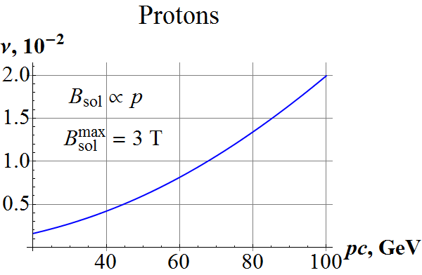 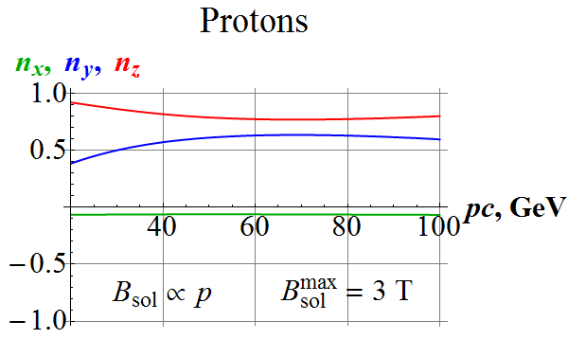

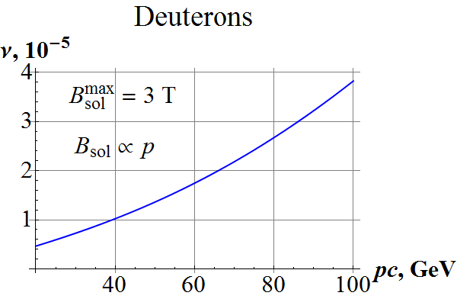 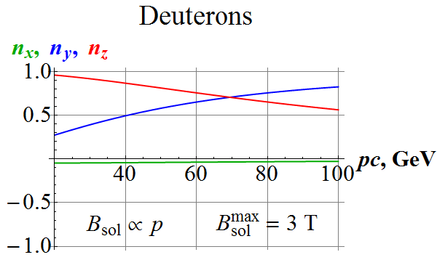

**Figure 2:** Dependence of the spin tune and $\vec{n}$–axis components on the proton and deuteron momenta induced by insertion of the detector solenoid at the interaction point.

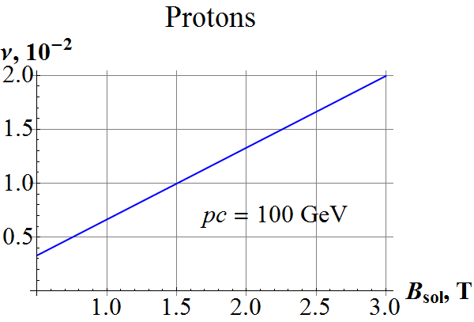 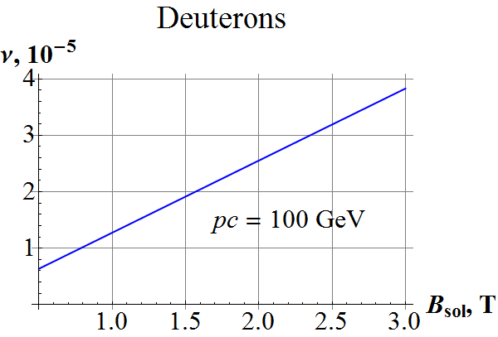

**Figure 3:** Dependence of the proton and deuteron spin tune on the detector solenoid field.

The baseline 3D rotators allow one to induce spin tunes of ${10}^{-2}$ for protons and ${10}^{-4}$ for deuterons. Thus, effect of the detector solenoid insertion on the deuteron and proton polarizations can be compensated using an additional 3D rotator, which can be located at any place in the collider [4].

***Milestone reached***

* Spin tracking simulations using verified existing codes
* Evaluation and compensation of the spin effect of the detector solenoid

***References***

[1] S. Abeyratne *et al*., arXiv:1504.07961 [physics.acc-ph], 2015.

[2] G.H. Wei *et al*., in Proc. of IPAC’16, Busan, Korea, paper WEPMW015, p. 2454.

[3] G.H. Wei *et al*., in Proc. of NAPAC’16, Chicago, IL, paper MOA4CO03, p. 57.

[4] A.M. Kondratenko *et al*., arXiv:1604.05632 [physics.acc-ph], 2016.