Acceleration of polarized protons and deuterons in the ion collider ring of JLEIC
A M Kondratenko¹, M A Kondratenko¹, Yu N Filatov², Ya S Derbenev³,
F Lin³, V S Morozov³, and Y Zhang³
¹ Science & Technique Laboratory Zaryad, Novosibirsk, Russia
² Moscow Institute of Physics and Technology, Dolgoprudny, Moscow Region, Russia
³ Jefferson Lab, Newport News, VA, USA
E-mail: morozov@jlab.org
Abstract. The figure-8-shaped ion collider ring of Jefferson Lab Electron-Ion Collider (JLEIC) is transparent to the spin. It allows one to preserve proton and deuteron polarizations using weak stabilizing solenoids when accelerating the beam up to 100 GeV/c. When the stabilizing solenoids are introduced into the collider’s lattice, the particle spins precess about a spin field, which consists of the field induced by the stabilizing solenoids and the zero-integer spin resonance strength. During acceleration of the beam, the induced spin field is maintained constant while the resonance strength experiences significant changes in the regions of “interference peaks”. The beam polarization depends on the field ramp rate of the arc magnets. Its component along the spin field is preserved if acceleration is adiabatic. We present the results of our theoretical analysis and numerical modeling of the spin dynamics during acceleration of protons and deuterons in the JLEIC ion collider ring. We demonstrate high stability of the deuteron polarization in figure-8 accelerators. We analyze a change in the beam polarization when crossing the transition energy.
- Preservation of ion polarization in figure-8 accelerators
A characteristic feature of JLEIC [1] is its figure-8-shaped rings [2]. Such a ring topology is transparent to the spin: the combined effect of arc fields on the spin in an ideal collider lattice reduces to zero after one particle turn on the design orbit, i.e. any orientation of the particle spin at any orbital location repeats from turn to turn. To preserve the polarizations of the proton and deuteron beams during acceleration from 8 GeV/c to 100 GeV/c in the ion collider ring, it is sufficient to use a weak solenoid with a field integral of 1.2 T⋅m, which does not perturb the design orbit and has practically no effect on the beam’s orbital parameters [3-10]. The solenoid then stabilizes longitudinal spin polarization at its location. A solenoid with the indicated field integral allows one to induce a spin tune $ν$ of 10⁻² for protons and 3⋅10⁻³ for deuterons, i.e., when a particle with a vertical spin makes one turn on the design orbit, its spin tilts by an angle of $2πν$ from its initial orientation.
For polarization stability, one must ensure that the spin tune $ν$ induced by the solenoid significantly exceeds [3-6] the strength of the zero-integer spin resonance $ω$: $ν≫ω$. The resonance strength is the average spin field $\vec{ω}$ (the zero-integer Fourier harmonic of the spin perturbation without a stabilizing solenoid) determined by deviation of the trajectory from the design orbit due to machine element errors and beam emittances. In the absence of a solenoid, the spin precesses by an angle of $2πω$ about the $\vec{ω}$ direction in one particle turn. The resonance strength consists of two parts: a coherent part arising due to additional transverse and longitudinal fields on a trajectory deviating from the design orbit and an incoherent part associated with the particles’ betatron and synchrotron oscillations (beam emittances) [8, 9]
$\vec{ω}={\vec{ω}}_{coh}+{\vec{ω}}_{emitt} , ω_{coh}≫ω_{emitt}$
In practice, the coherent part $ω_{coh}$ significantly exceeds the incoherent one $ω_{emitt}$. The coherent part does not cause beam depolarization and only results in a simultaneous rotation of the polarization about the field determined by the strength and alignment errors of collider elements. In principle, the direction and size of the coherent part of the resonance strength can be measured and taken into account for polarization control. To preserve the polarization, it is then sufficient to satisfy a weaker condition: $ν≫ω_{emitt}$.
- Calculation of zero-integer spin resonance strength in JLEIC
Figure 1 shows β functions of the JLEIC collider lattice in the acceleration mode [11] used in our spin dynamics calculations. The origin of the coordinate frame is located at the collider's IP. Figure 1 also indicates the location of the solenoid stabilizing the spin during acceleration. The difference from the collision mode [12] where $β$ functions in the IP region reach 2.5 km is that, in the acceleration mode, the $β$ functions in the detector section do not exceed 150 m.

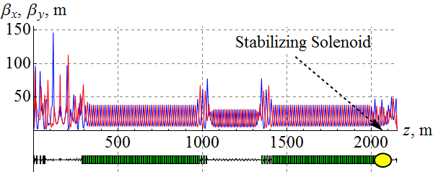
Figure 1. $β$ functions of the ion collider ring.

Incoherent part of the spin resonance strength
Figure 2 shows the incoherent part of the proton resonance strength for normalized emittance values of 1 mm⋅mrad in both radial and vertical directions. As we can see, the value of the incoherent part does not exceed 2⋅10⁻⁴ practically in the whole momentum range of the collider with the exception of narrow “interference” peaks where spin perturbations add up coherently in the arc magnets. The presented calculation confirms that the spin tune value of 10⁻² induced by the solenoid field is sufficient to stabilize the spin with normalized emittances of the betatron motion equal to 1 mm⋅mrad.
Figure 3 shows a similar graph of the dependence of the incoherent part of the deuteron resonance strength on momentum. Our calculations assumed that the transverse size of the deuteron beam was equal to the proton beam size, i.e. the transverse beam emittances were 0.5 μm.

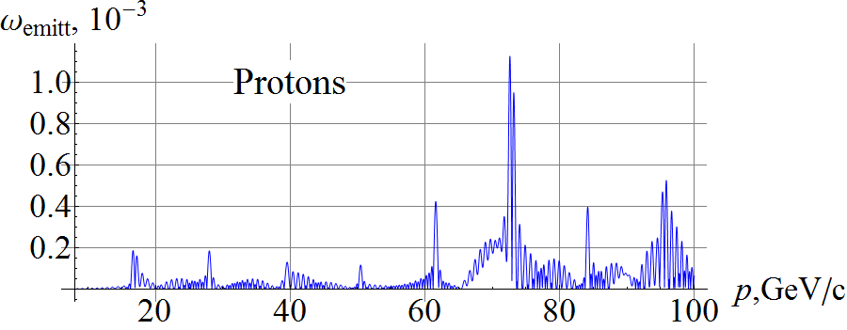
Figure 2. Incoherent part of the proton resonance strength in the JLEIC ion collider ring.

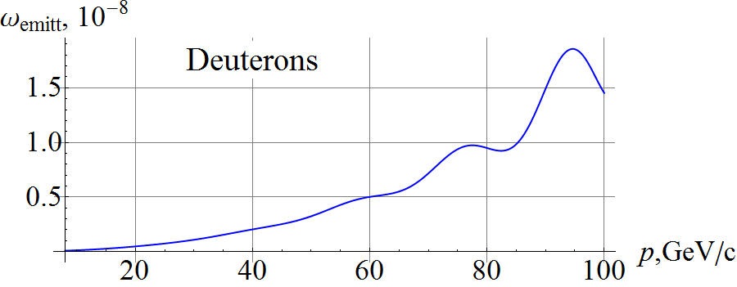
Figure 3. Incoherent part of the deuteron resonance strength in the JLEIC ion collider ring.

In contrast to protons, due to the small value of the deuteron anomalous magnetic moment, deuterons have only one interference peak at the momentum of 93 GeV/c whose value does not exceed 2⋅10⁻⁸. Thus, a deuteron spin tune of 3⋅10⁻³ induced by a solenoid significantly exceeds the incoherent part of the resonance strength.

Coherent part of the spin resonance strength
Let us calculate the resonance strength for a proton beam using a model with random shifts of all quadrupoles in the transverse directions. Figure 4 shows the coherent part of the proton resonance strength in the ion collider ring with random quadrupole misalignments resulting in a transverse closed orbit distortion of about 100 μm rms.
The statistical model calculates the most probable magnitude of the coherent part of the resonance strength not specifying its direction, which lies in the collider’s plane. As in the case of the incoherent part, the coherent part of the resonance strength has interference peaks whose maximum values do not exceed 1.5⋅10⁻², which has an order of magnitude comparable to the field induced by the stabilizing solenoid. Figure 5 shows a graph of the coherent part of the deuteron resonance strength calculated using the statistical model of random quadrupole misalignments.

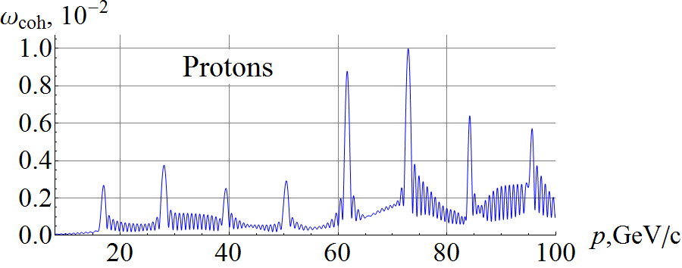
Figure 4. Coherent part of the proton resonance strength in the ion collider ring.

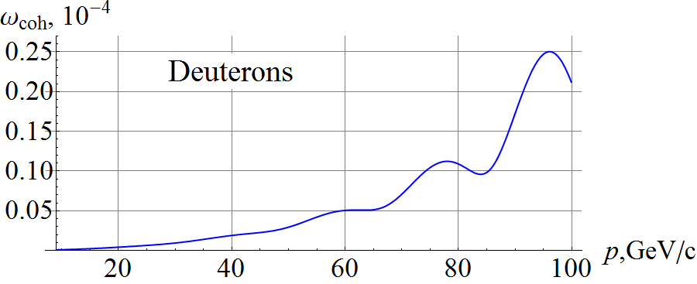
Figure 5. Coherent part of the deuteron resonance strength in the ion collider ring.

- Acceleration of polarized ions in the JLEIC collider
The spin dynamics during acceleration in the ion collider ring is a precession about the spin field $\vec{h}$, which consists of the field ${\vec{h}}_{sol}$ induced by the stabilizing solenoid and the resonance strength $\vec{ω}$:
$\vec{h}= {\vec{h}}_{sol}+ \vec{ω}$ [8]. During acceleration the field ${\vec{h}}_{sol}$ is maintained constant while the resonance strength $\vec{ω}(t)$ experiences significant changes in the regions of interference peaks.
The beam polarization substantially depends on the field ramp rate in the arc magnets. When using superconducting magnets with a field ramp rate of ~3 T/min, acceleration happens adiabatically, which means that, in a characteristic time of change in the spin field, the spin makes a large number of turns. During adiabatic acceleration, the spin follows the $\vec{h}$ field direction, which can significantly deviate from the longitudinal direction at the locations of the interference peaks of the coherent part of the resonance strength. However, this does not signify polarization loss, the beam polarization restores its longitudinal direction in places where $h_{sol}≫ω_{coh}$.
Let us present calculations of the spin dynamics during acceleration of protons and deuterons in the JLEIC ion collider ring made using a spin tracking code Zgoubi [13]. Figure 6 shows the longitudinal spin components in the ion collider ring during acceleration of 3 protons with $Δp/p=0$ (green line), $Δp/p={10}^{-3}$ (red line) and $Δp/p={-10}^{-3}$ (blue line). As we can see, the graphs of the longitudinal spin components practically do not differ from each other (the red line covers up the blue and green lines), i.e. synchrotron energy modulation does not give a noticeable contribution to the ion spin motion when stabilizing the polarization by a weak solenoid in the JLEIC ion collider ring. All particles were launched with the same initial conditions: $S_{z0}=1$, $x_{0}=0.61$mm, $x_{0}^{'}=0$ rad,
$y_{0}=0.27$mm, $y_{0}^{'}=0$ rad. The field ramp rate was ~3 T/min (the particles were accelerated in 8.3 million turns). During acceleration, the spin preserves its component along the spin field, which lies in the orbit plane and noticeably deviates from the longitudinal direction in the regions of the “interference” peaks of the coherent part of the resonance strength at momenta of about 60 GeV/c and 75 GeV/c, where the resonance strength becomes approximately equal to the size of the solenoid spin field. The spin tune induced by the solenoid during acceleration is 10⁻².
The simulation in Figure 6 is done with a closed orbit excursion of 100 μm rms. If needed tolerances to alignment of the lattice elements can be relaxed. The strength of the stabilizing solenoid can be increased. One then has to account for the fact that the solenoid itself gives a contribution to the spin resonance strength due to an angle between the distorted closed orbit and solenoid axis. This results in a transverse magnetic field component, which has practically no effect on the orbital motion but can have a strong effect on the spin motion especially for a proton beam at high energies ($γG≫1$). This contribution can be minimized either by a more precise alignment of the solenoid axis or by choosing such a collider lattice, which has a sufficiently small value of the spin response function at the solenoid location. The response function is the spin Green’s function determined and controlled by the linear lattice. It describes the effect of the ring as a whole on the spin due to a $δ$-function-like radial field [8]. Another option is to compensate the coherent part of the spin resonance strength at the experimental energy using a 3D spin rotator [4-8, 10].

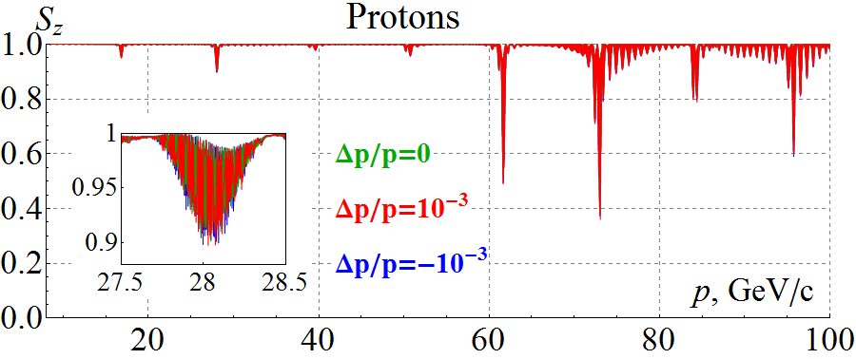
Figure 6. Longitudinal spin component during acceleration of three protons in the ion collider ring.

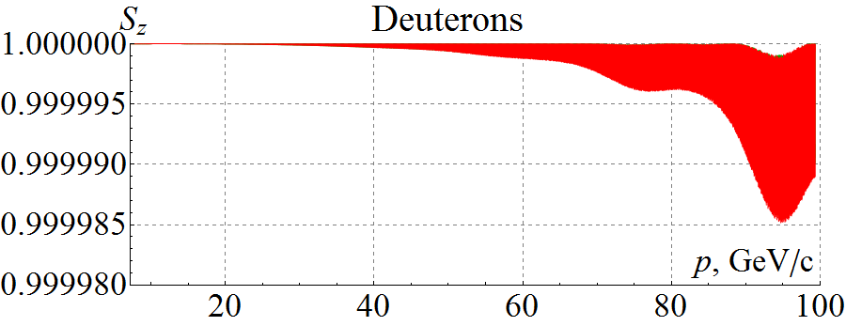
Figure 7. Longitudinal spin component during acceleration of three deuterons in the ion collider ring.

Similar graphs for the longitudinal components of the deuteron spin are shown in Figure 7. The initial conditions and solenoid field strength during acceleration were chosen the same as in the proton case. In contrast to protons, the change in the deuteron longitudinal polarization during acceleration does not exceed $2⋅{10}^{-5}$ even in the interference peak. This example demonstrates a high stability of the deuteron polarization in figure-8 rings, which can be used for high-precision experiments. To the contrary, in conventional accelerators with preferred periodic spin orientation, control of the deuteron polarization and its preservation during acceleration to 100 GeV/c is a practically unrealistic task.

Crossing the transition energy
When accelerating polarized protons and deuterons in the JLEIC ion collider ring in the momentum range from 8 GeV/c to 100 GeV/c, one has to consider the question of preserving the beam polarization during transition energy crossing. The relativistic Lorentz factor of the transition energy in the ion collider ring equals 12.453, which corresponds to a momentum of 11.65 GeV/c for protons and 23.3 GeV/c for deuterons.
For our calculations, we chose a conventional model, in which crossing of the transition energy is done by a fast jump of the RF cavity phase at the exact moment of the crossing from the value $φ_{s}$ to the value $φ_{s}^{*}= π- φ_{s}$ at a constant field ramp rate.
The phase space trajectories of two protons with the initial momentum offsets of $Δp/p={10}^{-3}$ (red line) and $Δp/p={-10}^{3}$ (blue line) are shown in Figure 8. As the energy approaches transition, the amplitude of the synchrotron phase deviation from the equilibrium value of $φ_{s}≈0.3$ rad reduces while the amplitude of the momentum deviation grows. After crossing the transition energy, the particles are captured inside a new separatrix and undergo oscillations about a new equilibrium phase of $φ_{s}^{*}≈2.84$ rad. The amplitude of the momentum deviations damps as the energy gets further away from transition. Our calculations indicate that, if transition energy crossing is organized without significant excitation of the emittances, its effect on the polarization is negligible. Further studies with a more representative particle distribution and a more realistic model of transition energy crossing are needed.

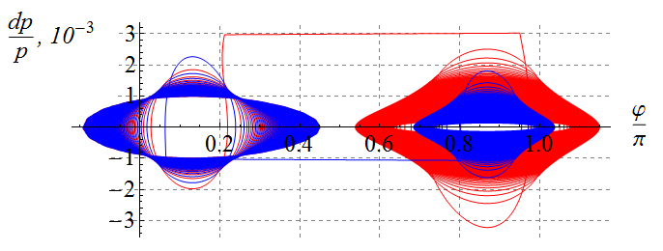
Figure 8. Proton phase space trajectories.
- Conclusion
Figure-8 rings with weak solenoids provide an elegant solution to preservation of the polarization when accelerating particles of any kind. Our calculations made using a spin tracking code Zgoubi verify the validity of our scheme for preserving the polarization during acceleration of protons and deuterons in the JLEIC ion collider ring with transition energy crossing.
Acknowledgments
This material is based upon work supported by the U.S. Department of Energy, Office of Science, Office of Nuclear Physics under contracts DE-AC05-06OR23177 and DE-AC02-06CH11357.
References
- Abeyratne S et al. 2015 MEIC Design Summary arXiv:1504.07961 [physics.acc-ph]
- Derbenev Ya S 1996 The Twisted Spin Synchrotron University of Michigan report UM HE 96-05
- Derbenev Ya S et al. 2013 Ion Polarization Control in MEIC Rings Using Small Magnetic Field Integrals PoS (PSTP 2013) 026
- Derbenev Ya S et al. 2016 Polarization Preservation and Control in a Figure-8 Ring Int. J. Mod. Phys. Conf. Ser. 40 1660090
- Derbenev Ya S et al. 2014 Polarized Ion Beams in Figure-8 Rings of JLab’s MEIC Proc. Int. Part. Accel. Conf. 14 (Dresden) paper MOPRO004 pp 68-70
- Kondratenko A M et al. 2015 Baseline Scheme for Polarization Preservation and Control in the MEIC Ion Complex Proc. Int. Part. Accel. Conf. 2015 (Richmond) paper TUPWI029 pp 2301-2303
- Kondratenko A M et al. 2015 Numerical Calculation of the Ion Polarization in MEIC Proc. Int. Part. Accel. Conf. 2015 (Richmond) paper TUPWI030 pp 2304-2306
- Kondratenko A M et al. 2016 Ion Polarization Scheme for MEIC arXiv:1604.05632 [physics.acc-ph]
- Kondratenko A M et al. 2016 Ion Beam Polarization Dynamics in the 8 GeV Booster of the JLEIC Project at JLab Proc. Int. Part. Accel. Conf. 2016 (Busan) paper WEPMW017 pp 2460-2462
- Kondratenko A M et al. 2016 Spin Flipping System in the JLEIC Collider Ring Proc. North-American Part. Accel. Conf. 2016 (Chicago) paper TUPOB30
- Morozov V S et al. 2016 Injection Optics for the JLEIC Ion Collider Ring Proc. Int. Part. Accel. Conf. 2016 (Busan) paper WEPMW012 pp 2445-2447
- Nosochkov Y et al. 2015 Progress on Optimization of the Nonlinear Beam Dynamics in the MEIC Collider Rings Proc. Int. Part. Accel. Conf. 2015 (Richmond) paper TUPWI032 pp 2311-2314
- Méot F 1999 The Ray-Tracing Code Zgoubi Nucl. Instr. Meth. A 427 353

