Start-to-end simulation of polarized proton and deuteron beam acceleration
with transition energy crossing in the JLEIC ion collider ring
A.M. Kondratenko¹, M.A. Kondratenko¹, and Yu.N. Filatov²
¹Science and Technique Laboratory “Zaryad”, Novosibirsk 630090, Russia
²Moscow Institute of Physics and Technology, Dolgoprudny 141700, Russia
Translated by V.S. Morozov, Jefferson Lab, Newport News, VA 23606, USA

The figure-8-shaped ion collider ring of Jefferson Lab Electron-Ion Collider (JLEIC) is transparent to the spin. It allows one to preserve proton and deuteron polarizations using weak stabilizing solenoids when accelerating the beam in the momentum range from 8 GeV/c to 100 GeV/c [1,2]. When the stabilizing solenoids are introduced into the collider’s lattice, the particle spins precess about a spin field, which consists of the field induced by the stabilizing solenoids and the zero-integer spin resonance strength. For polarization stability, one must ensure that the spin tune induced by the solenoid significantly exceeds the strength of the zero-integer spin resonance. In the ion collider ring, the resonance strength is mainly determined by its coherent part.
Figure 1 shows the coherent part of the proton resonance strength in the ion collider ring with random quadrupole misalignments resulting in a transverse closed orbit distortion of about 100 μm rms. The coherent part of the resonance strength has interference peaks whose maximum values do not exceed 1.5⋅10⁻², which has an order of magnitude comparable to the field induced by the stabilizing solenoid. Similar graph for the deuteron resonance strength is shown in Fig. 2.
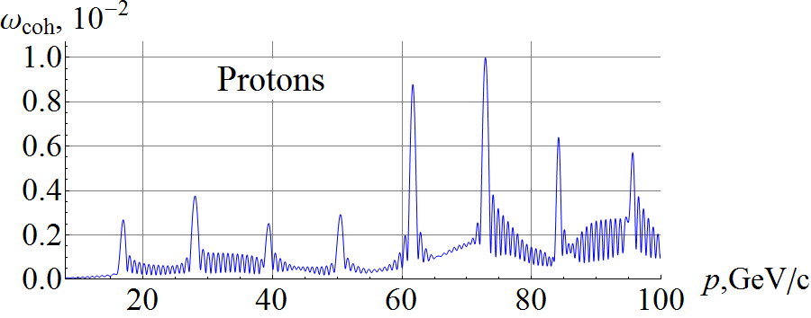  Figure 1: Coherent part of the proton resonance strength in the ion collider ring. | 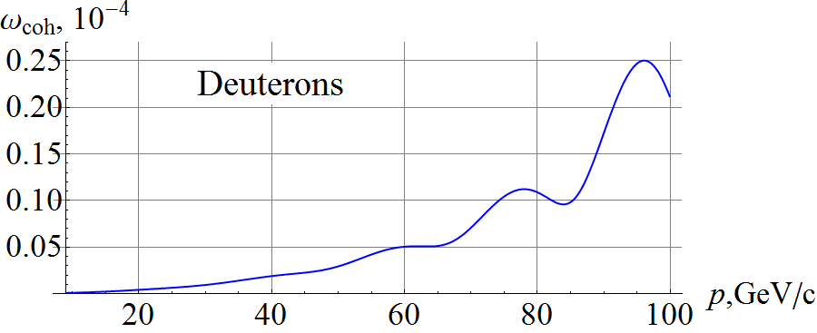  Figure 2: Coherent part of the deuteron resonance strength in the JLEIC ion collider ring.

During acceleration of the beam, the induced spin field is maintained constant while the resonance strength experiences significant changes in the regions of “interference peaks”. The beam polarization depends on the field ramp rate of the arc magnets. Its component along the spin field is preserved if acceleration is adiabatic.
Figure 3 shows the longitudinal spin components in the ion collider ring during acceleration of 3 protons with $Δp/p=0$ (green line), $Δp/p={10}^{-3}$ (red line) and $Δp/p={-10}^{-3}$ (blue line). As we can see, the graphs of the longitudinal spin components practically do not differ from each other (the red line covers up the blue and green lines), i.e. synchrotron energy modulation does not give a noticeable contribution to the ion spin motion when stabilizing the polarization by a weak solenoid in the JLEIC ion collider ring. All particles were launched with the same initial conditions: $S_{z0}=1$, $x_{0}=0.61$mm, $x_{0}^{'}=0$ rad, $y_{0}=0.27$mm, $y_{0}^{'}=0$ rad. The field ramp rate was 3 T/min.
During acceleration, the spin preserves its component along the spin field, which lies in the orbit plane and noticeably deviates from the longitudinal direction in the regions of the “interference” peaks of the coherent part of the resonance strength at momenta of about 60 GeV/c and 75 GeV/c, where the resonance strength becomes approximately equal to the size of the solenoid spin field. The spin tune induced by the solenoid during acceleration is 10⁻². Similar graphs for the longitudinal components of the deuteron spin are shown in Fig. 4. The initial conditions and solenoid field strength during acceleration were chosen the same as in the proton case.
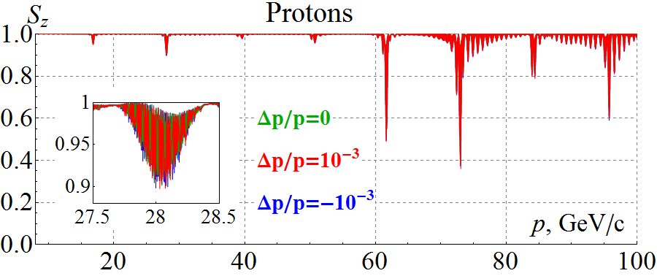  Figure 3: Longitudinal spin component during acceleration of three protons in the ion collider ring. | 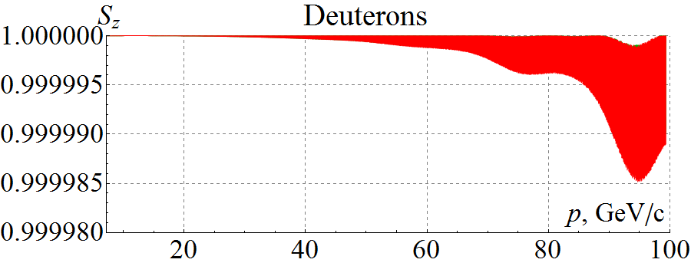  Figure 4: Longitudinal spin component during acceleration of three deuterons in the ion collider ring.
In contrast to protons, the change in the deuteron longitudinal polarization during acceleration does not exceed $2⋅{10}^{-5}$ even in the interference peak. This example demonstrates a high stability of the deuteron polarization in figure-8 rings, which can be used for high-precision experiments.
When accelerating polarized protons and deuterons in the JLEIC ion collider ring one has to consider the question of preserving the beam polarization during transition energy crossing [3]. For our calculations, we chose a conventional model, in which crossing of the transition energy is done by a fast jump of the RF cavity phase at the exact moment of the crossing [4].
Our calculations made using a spin tracking code Zgoubi [5] demonstrate preservation of the polarization during acceleration of protons and deuterons in the JLEIC ion collider ring with a closed orbit excursion of 100 μm rms. However, tolerances to alignment of the lattice elements can be relaxed by increasing the field of the stabilizing solenoid. Another option is to compensate the coherent part of the spin resonance strength at the experimental energy using a 3D spin rotator [6].

Milestone reached
- Spin tracking simulations using verified existing codes
- Acceleration of polarized protons and deuterons in the collider ring
- Development and optimization of a transition energy crossing scheme compatible with stable spin dynamics
- Numerical simulations of proton deuteron beam polarization dynamics during transition energy crossing in the collider

References
[1] S. Abeyratne et al., arXiv:1504.07961 [physics.acc-ph], 2015.
[2] A.M. Kondratenko et al., in Proc. IPAC’15, Richmond, VA, USA, May 2015, paper TUPWI029, pp. 2301-2303.
[3] Квартальный отчет “Calculation of proton and deuteron depolarizations when crossing the transition energy in the JLEIC ion collider ring” от 23.01.2017
[4] E.D. Courant and H.S. Snyder, Annals of physics, vol. 3, no. 1, pp. 1-48, 1958.
[5] F. Méot, Nucl. Instr. Meth A, vol. 427, pp. 353-356, 1999.
[6] A.M. Kondratenko et al., arXiv:1604.05632 [physics.acc-ph], 2016.

