Calculation of proton and deuteron depolarizations when crossing the transition energy in the JLEIC ion collider ring
A.M. Kondratenko¹, M.A. Kondratenko¹, and Yu.N. Filatov²
¹Science and Technique Laboratory “Zaryad”, Novosibirsk 630090, Russia
²Moscow Institute of Physics and Technology, Dolgoprudny 141700, Russia
Translated by V.S. Morozov, Jefferson Lab, Newport News, VA 23606, USA

When accelerating polarized protons and deuterons in the JLEIC ion collider ring in the momentum range from 8 GeV/c to 100 GeV/c, one has to consider the question of preserving the beam polarization during transition energy crossing. The relativistic Lorentz factor of the transition energy in the ion collider ring equals $γ_{tr}=12.453$, which corresponds to a momentum of 11.65 GeV/c for protons and 23.3 GeV/c for deuterons. It was shown that, to preserve the beam polarization in the process of accelerating protons and deuterons to the transition energy and above it, it suffices to use a weak stabilizing solenoid [1]. In this report, we present our calculations of proton and deuteron beam depolarizations in the process of crossing the transition energy completed using the spin tracking program Zgoubi [2].
For our calculations, we chose a conventional model, in which crossing of the transition energy is done by a fast jump of the RF cavity phase at the exact moment of the crossing from the value $φ_{s}$ to the value $φ_{s}^{*}= π- φ_{s}$ at a given field ramp rate [3]. To attain such a phase jump, one must satisfy the condition on the cavity frequency change ${δω}_{RF}$ during the jump time $τ$:
$$\int_{-τ/2}^{τ/2}{{δω}_{RF}\left(t\right)dt}=π-2 φ_{s}.$$
Let us demonstrate an example of calculating transition energy crossing for protons with a fairly short jump time ($τ≪60$ ms). Figure 1 shows the synchrotron oscillation phase of the synchronous particle as a function of the turn number N (RF field phase at the times the particle passed the cavity). The calculation assumes that a particle accelerates from the initial momentum of 11.18 GeV/c to the final one of 12.12 GeV/c in 84⋅10³ turns, which corresponds to a field ramp rate of 3 T/min. The jump of the synchronous phase from $φ_{s}≈0.3$ rad to $φ_{s}^{*}≈2.84$ rad occurs at the synchronous particle’s momentum of 11.65 GeV/c.
Figure 2 shows the synchrotron oscillation phases of five particles uniformly distributed on a phase space ellipse with an initial amplitude of the momentum deviation of Δp/p=10⁻³.
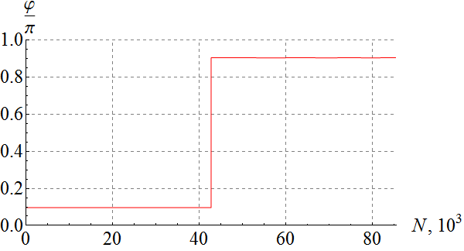 | 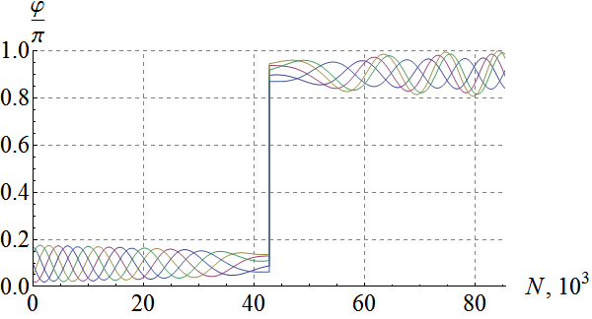
Figure 1: Synchrotron oscillation phase of the synchronous particle. | Figure 2: Synchrotron oscillation phases of five particles uniformly distributed on a phase space ellipse with an amplitude of Δp/p = 10⁻³.
The phase space trajectories of the five indicated particles is shown in Fig. 3. As the energy approaches transition ($N_{tr}≈42⋅{10}^{3}$ turns), the amplitude of the synchrotron phase deviation from the equilibrium value of $φ_{s}≈0.3$ rad reduces while the amplitude of the momentum deviation grows. After crossing the transition energy, the particles are captured inside a new separatrix and undergo oscillations about a new equilibrium phase of $φ_{s}^{*}≈2.84$ rad. The amplitude of the momentum deviations damps as the energy gets further away from transition. Our calculations indicate that no significant change of the transverse beam size occurs at the transition energy crossing.
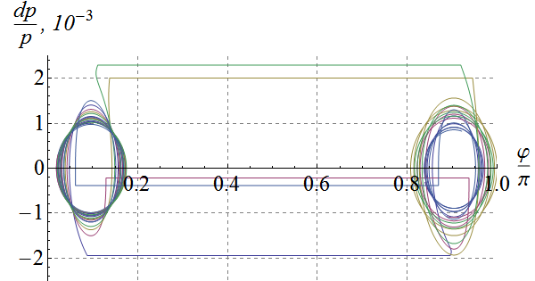 | 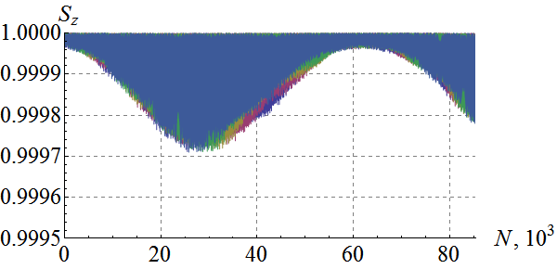
Figure 3: Longitudinal phase space trajectories of five particles uniformly distributed on a phase space ellipse with an amplitude of Δp/p=10⁻³. | Figure 4: Longitudinal spin components of five particles uniformly distributed on a phase space ellipse with an amplitude of Δp/p=10⁻³.
Figure 4 shows a graph of the longitudinal spin components during transition energy crossing for five particles uniformly distributed on a phase-space ellipse. The graph demonstrates that the initial phases of the synchrotron oscillations have practically no effect on the beam polarization. The longitudinal proton polarization was stabilized in the calculations by a weak solenoid. The normalized emittances in the radial and vertical directions were equal to 1 mm mrad. Depolarization of the proton beam after crossing of the transition energy does not exceed a few hundredth of a percent.
The completed numerical calculations show that the proton and deuteron polarizations practically do not change in the process of transition energy crossing in the JLEIC ion collider ring. To preserve proton and deuteron polarizations when accelerating a beam from 8 GeV/c to 100 GeV/c, it is sufficient to use a solenoid with a maximum field integral of 7.5 T m.
Milestone reached
- Spin tracking simulations using verified existing codes
- Acceleration of polarized protons and deuterons in the collider ring
- Development and optimization of a transition energy crossing scheme compatible with stable spin dynamics
- Numerical simulations of proton deuteron beam polarization dynamics during transition energy crossing in the collider

References
[1] “Acceleration of polarized protons in JLEIC in the momentum range of up to 100 GeV/c”, report for the teleconference on the ion polarization of November 3, 2016.
[2] F. Méot, The ray-tracing code Zgoubi, NIM-A 427 (1999) 353-356; http://sourceforge.net/projects/zgoubi/
[3] E.D. Courant and H.S. Snyder, Ann. Phys. 3, 1, 1958.

