**Acceleration of polarized protons in JLEIC in the momentum range of up to 100 GeV/c**

A.M. Kondratenko1, M.A. Kondratenko1, and Yu.N. Filatov2

*1Science and Technique Laboratory “Zaryad”, Novosibirsk 630090, Russia*

*2Moscow Institute of Physics and Technology, Dolgoprudny 141700, Russia*

Translated by V.S. Morozov, *Jefferson Lab, Newport News, VA 23606, USA*

This paper considers the problem of polarization preservation in the JLEIC ion collider ring when accelerating a proton beam in the momentum range from 12 GeV/c to 100 GeV/c. We do not consider depolarizing effects during transition energy crossing and also do not estimate the depolarizing impact of the beam cooling process.

The transition energy corresponds to a momentum of 11.65 GeV/c.

***Analytic calculation of the resonance strength using the statistical model of quadrupole misalignments in the JLEIC ion collider ring***

Our calculations use a model with random quadrupole misalignments, which give the main contribution to the coherent part of the zero-integer spin resonance strength. The incoherent part of the resonance strength is determined by normalized emittances of the betatron motion. Stabilization of the spin motion during acceleration is done by introducing a longitudinal field (*nz* module of the 3D spin rotator), which sets a spin tune value of 10-2 in the ideal collider lattice.

Figure 1 shows the incoherent part of the resonance strength for normalized emittance values of 1 mm⋅mrad in both radial and vertical directions. As we can see, the value of the incoherent part does not exceed 2⋅10-4 practically in the whole energy range of the collider with exception of narrow “resonant” regions where spin perturbations add up coherently in the arc magnets. The presented calculation confirms that the spin tune value of 10-2 induced by the solenoid field is sufficient to stabilize the spin with normalized emittances of the betatron motion equal to 1 mm⋅mrad.

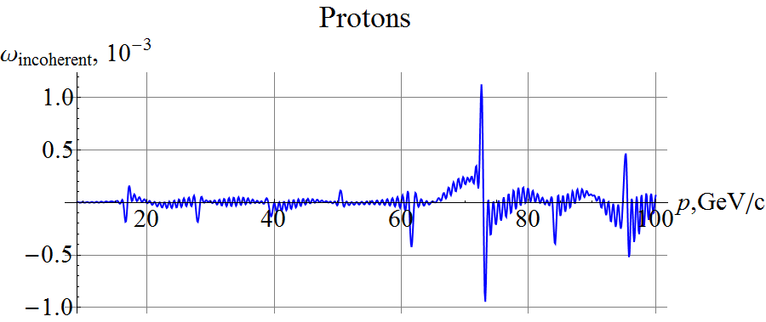

**Figure 1:**  An analytic calculation of the incoherent part of the resonance strength in the JLEIC ion collider ring. The vertical normalized emittance equals 1 mm⋅mrad.

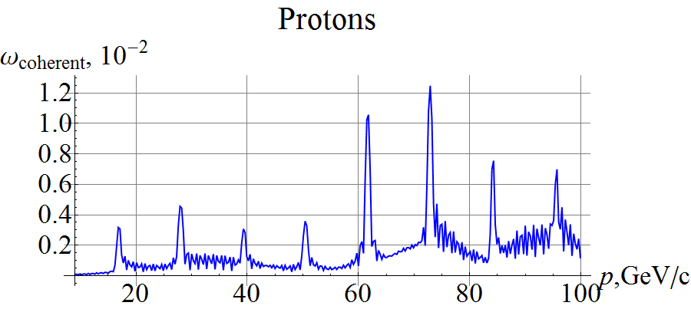

**Figure 2:**  Analytic calculation of the coherent part of the resonance strength in the JLEIC ion collider ring with random quadrupole misalignments.

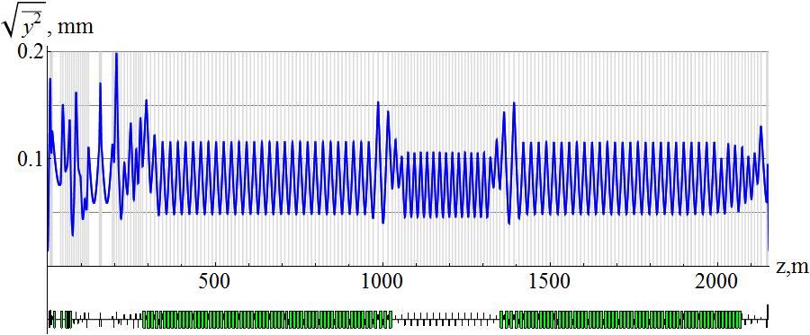

**Figure 3:**  Analytic calculation of the vertical distortion of the closed orbit in the JLEIC ion collider ring with random quadrupole misalignments.

Figure 2 shows the coherent part of the resonance strength obtained in the statistical model of random quadrupole shifts in the JLEIC ion collider ring with rms quadrupole misalignment equal to 2.5 μm. Figure 3 shows the vertical component of the closed orbit distortion, which is about 100 μm for the specified random quadrupole misalignments.

As we can see, the value of the coherent part of the resonance strength in the “resonant” regions becomes of the same order of magnitude as the spin tune value induced by the solenoid. The statistical model calculates the most probable magnitude of the coherent part of the resonance strength while leaving its direction, which lies in the collider’s plane, undefined.

The proton spin dynamics in the JLEIC collider will be a precession about the spin field $\vec{h}$, which consists of the field ${\vec{h}}_{sol}$ induced by the stabilizing solenoid and the resonance strength $\vec{ω}={\vec{ω}}_{coherent}+{\vec{ω}}_{incoherent}$:

$\vec{h}= {\vec{h}}_{sol}+ \vec{ω}$.

During proton acceleration, the field ${\vec{h}}_{sol}$ is maintained constant while the resonance strength $\vec{ω}(t)$ experiences noticeable changes in the “resonant” regions. The beam polarization will significantly depend on the field ramp rate of the arc magnets. When using super-conducting magnets, it is the most suitable to use an adiabatic acceleration rate, which means that, during a characteristic time of spin field change, the spin can make a large number of turns.

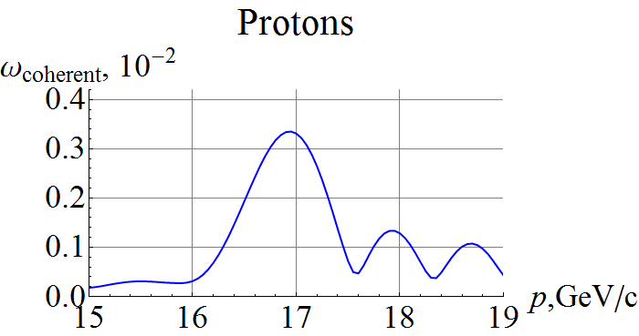

**Figure 4:**  Expanded graph of the coherent part of the resonance strength.

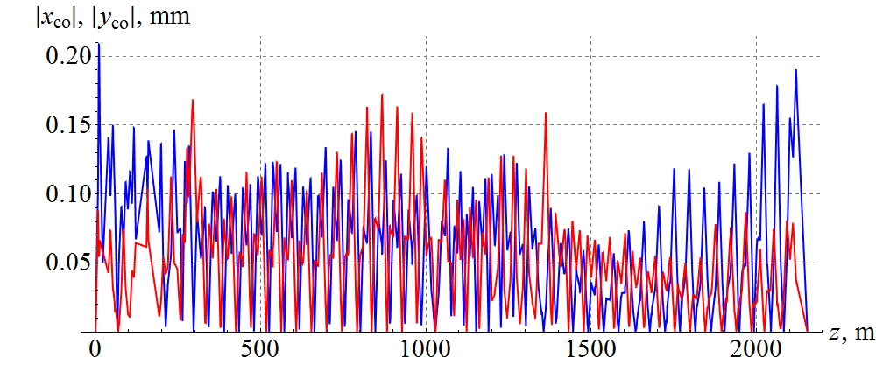

**Figure 5:**  Closed orbit distortion in the JLEIC ion collider ring with random quadrupole misalignments.

In the considered model of beam acceleration, the main change in the spin field occurs in the “resonant” regions of the coherent part of the resonance strength. To numerically estimate the width of a “resonant” region in the coherent part of the resonance strength, we show its expanded graph in the first “resonant” region of the collider in Fig. 4. As we can see from the graph, this width is about 1 GeV/c.

The adiabatic acceleration condition means that, during the characteristic time of crossing a resonant energy region, the spin can make a significant number of turns. In this case, the polarization will be preserved and its direction will follow the change in the spin field.

***Numerical calculation of spin motion during proton acceleration in the JLEIC ion collider ring with random quadrupole misalignments* (*ZGOUBI*)**

Let us calculate the spin dynamics during proton acceleration in the JLEIC ion collider ring with random quadrupole misalignments using the computer program Zgoubi. A stabilizing solenoid with $h_{sol}={10}^{-2}$ is located in a straight section near the collider’s interaction point.

Figure 5 shows the absolute values of the vertical and radial components of the closed orbit distortion caused by the random quadrupole misalignments ($Δy_{rms}=2.5 μm, Δx_{rms}=2.5 μm$). As we can see, on the average, the orbit excursion is on the order of 100 $μm$.

Figure 6 shows changes in the spin components during acceleration of a proton beam in the JLEIC ion collider ring. The particle is launched along the closed orbit with longitudinally oriented spin. The field ramp rate is 1 T/s (the particle is accelerated in 380 thousand turns). As one can see from the graphs, proton acceleration occurs adiabatically. During acceleration, the spin maintains its component along the spin field, which lies in the orbit plane, and noticeably deviates from the longitudinal direction in the “resonant” regions of the coherent part of the resonance strength (see Fig. 2). The spin experiences the greatest deviation from the longitudinal direction in the momentum regions of about 60 GeV/c and 75 GeV/c, where the resonance strength becomes approximately equal to the spin field magnitude of the stabilizing solenoid.

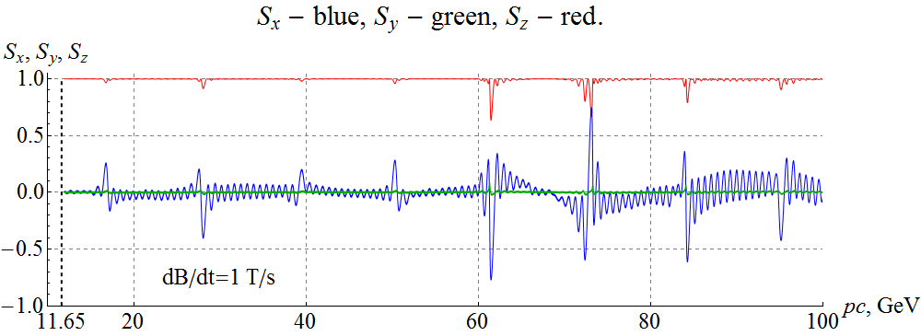

**Figure 6:**  Spin components during proton acceleration in the JLEIC ion collider ring with random quadrupole misalignments. The particle is launched along the closed orbit. A stabilizing solenoid sets a spin tune of 10-2. The field ramp rate is **1 T/s**.

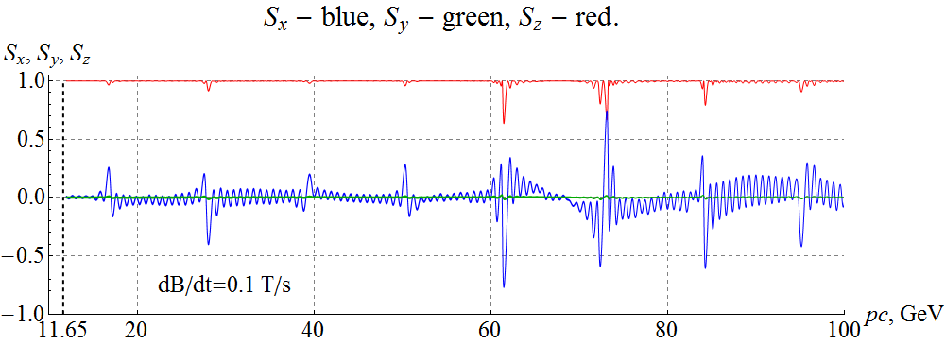

**Figure 7:**  Spin components during proton acceleration in the JLEIC ion collider ring with random quadrupole misalignments. The particle is launched along the closed orbit. A stabilizing solenoid sets a spin tune of 10-2. The field ramp rate is **0.1 T/s**.

Figure 7 shows similar graphs of changes in the spin components during proton acceleration at a field ramp rate of 0.1 T/s. As one can see, reduction in the field ramp rate already has no effect on the spin dynamics, since acceleration then remains adiabatic.

To demonstrate the effect of the incoherent part of the resonance strength (the beam emittances) on the proton polarization, Fig. 8 shows a graph of changes in the spin components during acceleration of a beam with normalized vertical and radial emittances of 1 mm⋅mrad. The field ramp rate is 1 T/s. The momentum deviation is $Δp/p=0$. As expected, the influence of the incoherent part of the resonance strength is significantly smaller than that of the coherent one. The main deviation of the spin from the longitudinal direction occurs in the “resonant energy regions (see Fig. 1).

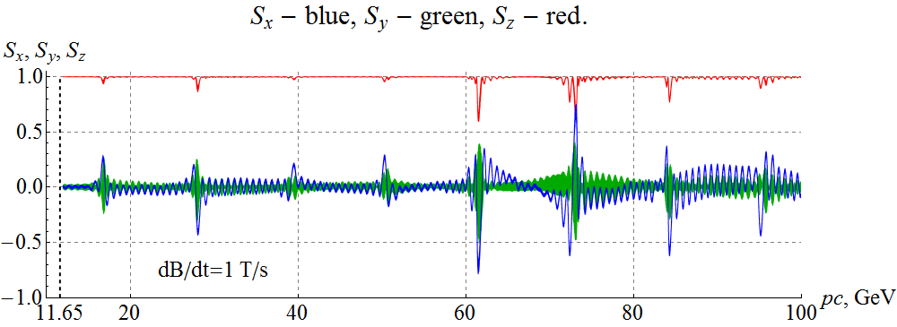

**Figure 8:**  Spin components during proton acceleration in the JLEIC ion collider ring with random quadrupole misalignments. The normalized beam emittances equal 1 mm⋅mrad in both direction. A stabilizing solenoid sets a spin tune of 10-2. The field ramp rate is 1 T/s.

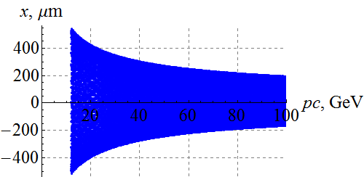 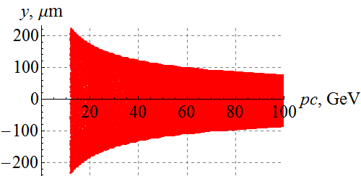

**Figure 9:**  Betatron oscillations in the JLEIC ion collider ring. The normalized beam emittances are 1 mm⋅mrad in both directions.

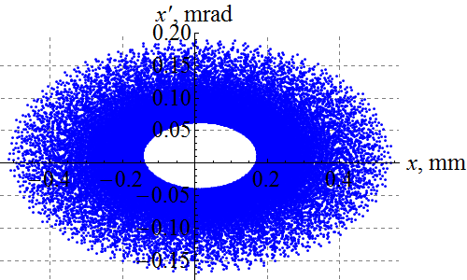 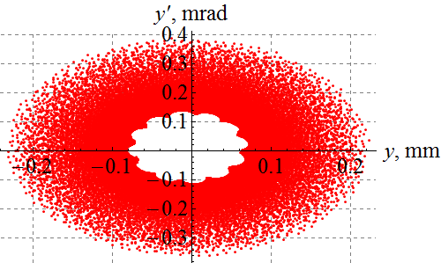

**Figure 10:**  Phase-space motion of the betatron oscillations in the JLEIC ion collider ring. The normalized beam emittances are 1 mm⋅mrad in both directions.

Figures 9-11 show changes in the orbital characteristics of the beam during acceleration. As we can see from Figs. 9-10, the betatron oscillation amplitudes experience adiabatic damping inversely proportionally to the square root of the particle momentum.

Figure 11 shows “capture” of the particle in the longitudinal dimension during proton acceleration: the momentum value changes slightly due a change in the closed orbit length.

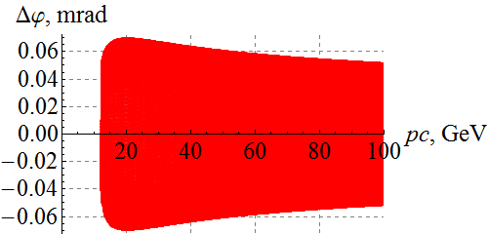 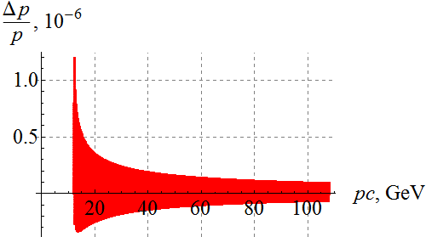 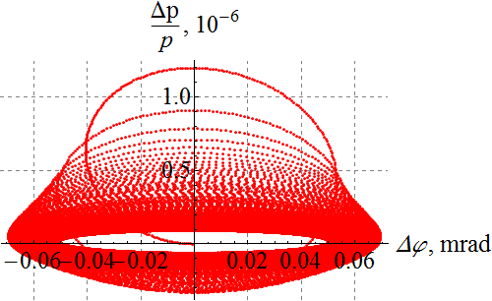

**Figure 11:**  Synchrotron oscillations in the JLEIC ion collider ring. The particle is launched along the perturbed closed orbit.

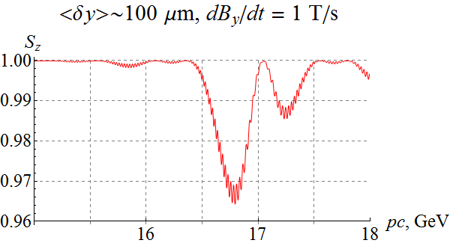 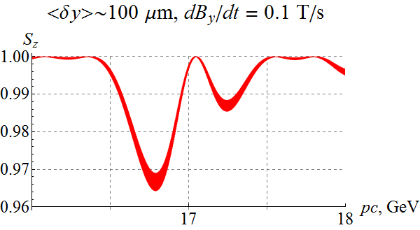

**Figure 10:**  Adiabatic acceleration of protons at field ramp rates of 1 T/s and 0.1T/s.

***Adiabatic acceleration of protons in the JLEIC ion collider ring***

Let us give an example of accelerating protons in the JLEIC ion collider ring that demonstrates a violation of the adiabatic condition.

Figure 10 shows expanded graphs of change in the longitudinal spin component in the first “resonant” region of the resonance strength for **adiabatic** acceleration of protons (parts of the above graphs in Fig. 6-7). The rms deviation of the closed orbit in the vertical direction was then about 100 $μm$.

If one increases tolerances to quadrupole alignment in the transverse directions, the coherent part of the resonance strength is then increased proportionally, which may lead to a violation of the adiabatic acceleration condition.

Figure 11 shows expanded graphs of change in the longitudinal spin component in the first resonant region of the resonance strength for **non-adiabatic** acceleration of protons with a four-fold increase in all random quadrupole misalignments. The rms orbit deviation is then about 500 $μm$ .

As we can see from the graphs, at a field ramp rate of 1 T/s, the spin does not restore its longitudinal direction after crossing the “resonant” region. The situation improves with reduction of the crossing rate to 0.1 T/s but a complete restoration of the longitudinal direction still does not take place.

The presented example demonstrates the importance of the choice of quadrupole alignment tolerances and field ramp rate when accelerating protons in the JLEIC ion collider ring.

For a significant reduction of the field ramp rate, due to increase in the acceleration time, one should pay attention to more subtle effects related, for example, to crossing of higher-order spin resonances and synchrotron energy oscillations.

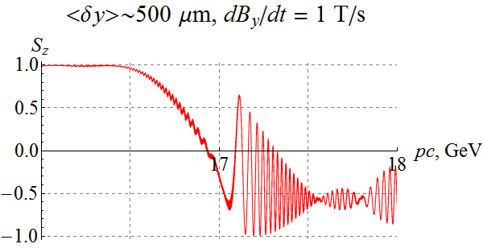 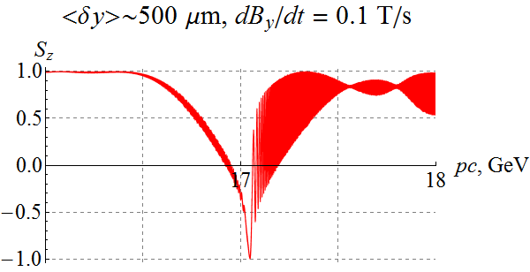

**Figure 11:**  Non-adiabatic acceleration of protons at field ramp rates 1 T/s and 0.1T/s.