Ion polarization control in JLEIC at 100 GeV/c
A.M. Kondratenko¹, M.A. Kondratenko¹, and Yu.N. Filatov²
¹Science and Technique Laboratory “Zaryad”, Novosibirsk 630090, Russia
²Moscow Institute of Physics and Technology, Dolgoprudny 141700, Russia

Translated by V.S. Morozov, Jefferson Lab, Newport News, VA 23606, USA

In the report of July 11, 2016 [1], we used the spin tracking code Zgoubi [2] to verify the ion polarization control scheme based on 3D spin rotators in the JLEIC collider. As an example, we calculated the proton and deuteron spin dynamics for the transverse and longitudinal polarization settings at the collider’s interaction point (IP) at a beam momentum of 60 GeV/c. The numerical analysis confirmed that, with the transverse beam sizes of 25×5 μm² at the IP, to control the polarization, it is sufficient to use two 3D spin rotators allowing one to induce spin tune values of 10⁻² for protons and 10⁻⁴ for deuterons. The first rotator is then used directly to control the polarization at the IP while the second one is used to compensate the coherent part the zero-integer spin resonance strength caused by manufacturing and setup errors of the collider’s magnetic elements. After compensation of the coherent part of the resonance strength, the beam polarization stability is determined by the incoherent part of the resonance strength arising to the beam emittances.
Our analytic calculations show that increase in energy leads to increase in the coherent part of the resonance strength as well as in the incoherent part of the resonance [2]. This report presents calculations of the ion polarization at the collider’s maximum momentum of 100 GeV/c.
Figure 1 shows β-functions of the JLEIC collider lattice used in our spin dynamics calculations. The origin of the coordinate frame is located at the collider’s IP. Figure 1 also indicates locations of the two 3D rotators. Calculations of the coherent part of the resonance strength used a model with random shifts of all quadrupoles in the transverse directions. The deviations of the closed orbit x_{co}, y_{co} caused by the random quadrupole shifts are shown in Fig. 2.
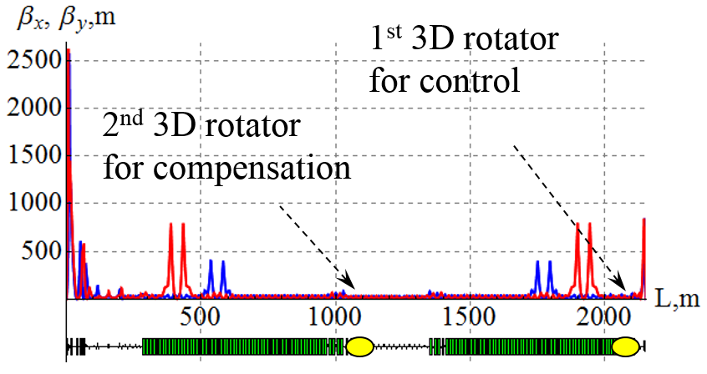 | 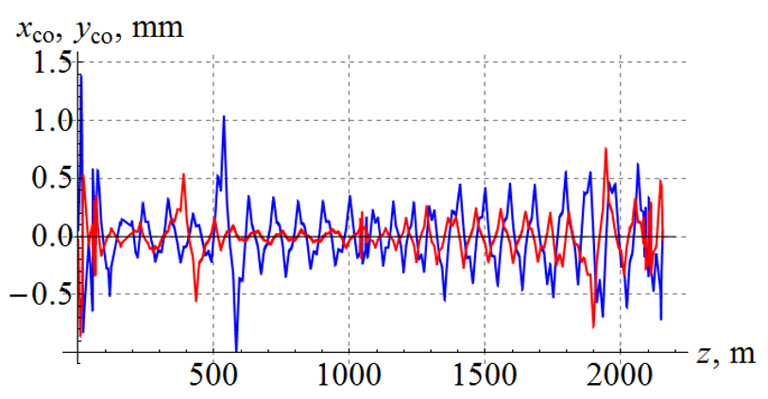
Figure 1: β-function of the ion collider ring. | Figure 2: Closed orbit deviation in the ion collider ring with random quadrupole shifts.
Our calculations showed that, with the beam size at the IP of 19.4×3.9 μm² at the beam momentum of 100 GeV/c (which corresponds to the size of 25×5 μm² at 60 GeV/c), the incoherent part of the resonance strength is about 1.3⋅10⁻⁴ for protons and 5⋅10⁻¹⁰ for deuterons. This means that a 3D spin rotator, which provides a spin tune value of 10⁻² for protons and 10⁻⁴ for deuterons, is sufficient to control the polarization at the IP.
Our calculations of the coherent part of the resonance strength at the beam momentum of 100 GeV/c showed that its size is about 9⋅10⁻³ for protons and 10⁻⁴ for deuterons, which is comparable to the spin tune value, which can be set by a 3D rotator. This means that use of a single control 3D rotator becomes insufficient to control the polarization at the IP and therefore it is necessary to use a second 3D spin rotator for compensation of the coherent part of the resonance strength.
Figure 3 shows an example of setting a vertical polarization at the IP of an imperfect collider lattice with random quadrupole shifts for two cases: (a) without compensation and (b) with compensation of the coherent part of the resonance strength. The parameters of the control 3D rotator are: n_{y}=1, ν_{sol}=0.01. The beam momentum is 100 GeV/c. The particle is launched along the closed orbit with a vertical spin. As one can see from the graphs, without compensation of the coherent part of the resonance strength, the vertical spin component experiences significant deviations from the vertical: the spin rotates in a combined spin field created by the 3D rotator and the spin resonance strength. On the contrary, after compensation of the coherent part of the resonance strength by a second 3D rotator, the vertical spin component practically does not change: the spin motion, as in the ideal collider lattice, is determined by only the first control 3D rotator.
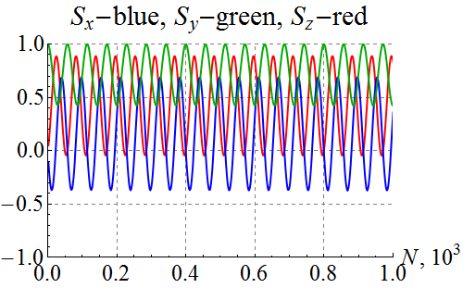 | 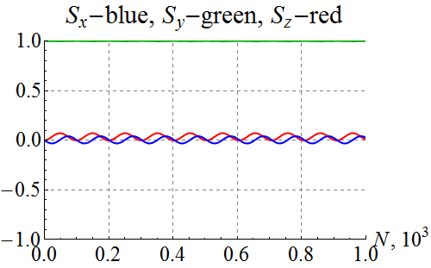
(a) (b)
Figure 3: Setting vertical polarization in a non-ideal collider lattice without (a) and
with (b) compensation of the coherent resonance strength component.

The completed numerical calculation of the proton and deuteron polarizations at the maximum ion momentum of 100 GeV/c confirms the validity of the chosen scheme for the ion polarization control in the JLEIC ion collider ring with two 3D rotators in the whole energy range.

Milestone reached
- Spin tracking continued
- Study of spin dynamics and compensation of the depolarization caused by imperfections and non-linear fields

References
[1] Annual report “Control of Ion Polarization in JLEIC”, July 16, 2016.
[2] F. Méot, The ray-tracing code Zgoubi, NIM-A 427 (1999) 353-356; http://sourceforge.net/projects/zgoubi/
[3] Close out report “Ion Polarization Scheme for MEIC”, June 12, 2015.

