Spin Flipping System in the JLEIC Collider Ring*
A.M. Kondratenko, M.A. Kondratenko, Science and Technique Laboratory Zaryad, Novosibirsk
Yu.N. Filatov, MIPT, Dolgoprudny, Moscow Region
V.S. Morozov, Ya.S. Derbenev, F. Lin, Y. Zhang, Jefferson Lab, Newport News, VA 23606, USA

Abstract
The figure-8 JLEIC collider ring opens wide possibilities for manipulating proton and deuteron spin directions during an experiment. Using 3D spin rotators, one can, at the same time, efficiently control the polarization direction as well as the spin tune value. The 3D spin rotators allow one to arrange a system for reversals of the spin direction in all beam bunches during an experiment, i.e. a spin-flipping system. To preserve the polarization, one has to satisfy the condition of adiabatic change of the spin direction. When adjusting the polarization direction, one can stabilize the spin tune value, which completely eliminates resonant beam depolarization during the spin manipulation process. We provide the results of numerical modeling of a spin-flipping system in the JLEIC ion collider ring. The presented results demonstrate the feasibility of organizing a spin-flipping system using a 3D rotator. The figure-8 JLEIC collider provides a unique capability of doing high-precision experiments with polarized ion beams.

INTRODUCTION
Using Spin-Flipping systems (SF systems) in colliders allows one to raise experiments with polarized beams to a new precision level. There are many papers on spin-ﬂipping systems (see, for instance, [1–5]). Reference [6] specified the main requirements to building long-term stable SF systems by introducing small magnetic field integrals into the collider lattice. SF systems can be divided into two classes based on how the spin reversals are organized. The first class involved single-turn SF systems, which allow one to flip the spin every particle turn. Natural representatives of this class are colliders with Siberian snakes whose spin tune equals a half. Stable polarization reversals are realized by introduction into the collider of rf ﬁelds at a frequency twice lower than the particle circulation frequency. The second class includes multi-turn SF systems, which flip the spin over a large number of particle turns. A natural representative of this class is a figure-8 collider whosse spin tune equals zero, An advantage of a multi-turn SF system in a figure-8 collider is the possibility of flipping the spin using quasi-static fields instead of RF ones.

* Authored by Jefferson Science Associates, LLC under U.S. DOE Contracts No. DE-AC05-06OR23177 and DE-AC02-06CH11357. The U.S. Government retains a non-exclusive, paid-up, irrevocable, world-wide license to publish or reproduce this manuscript for U.S. Government purposes.
Let us demonstrate how one can organize a multi-turn SF system in the JLEIC collider by introduction into its lattice of quazi-static solenoids with small field integrals.

ION POLARIZATION CONTROL IN THE JLEIC COLLIDER
Using figure-8 ring geometry [7] is an elegant way to preserve and control the polarization of a beam of any particle species (p, d, ³He, …) during its acceleration and storage at any energy. The ideal lattice of a figure-8 ring is transparent to the spin. The resulting effect of the “strong” arc dipoles on the spin dynamics is reduced to zero over one particle turn. Any spin orientation at any orbital location repeats every turn. In other words, in a figure-8 accelerator, the spin tune is zero, and there is no preferred polarization orientation because the particle is in the zero-integer spin resonance region. To stabilize the beam polarization direction at the interaction point, it is sufficient to use compact insertions for polarization control, which utilize already existing collider magnets and solenoids with small field integrals (“weak” solenoids) [8-10]. The spin tune and the polarization direction are then determined not by the “strong” structural fields of the collider but by the introduced weak solenoids. The weak solenoids do not affect the closed orbit at all and do not essentially change the beam orbital parameters. This property is universal and does not depend on the particle type. Figure-8 colliders provide a real opportunity for obtaining intense polarized deuteron beams with energies greater than a few tens of GeV.
To control the ion polarization in an ideal lattice of the JLEIC collider ring, it is sufficient to use a single 3D rotator, which consists of three modules for control of the radial n_{x}, vertical n_{y}, and longitudinal n_{z} beam polarization components (see Fig. 1).
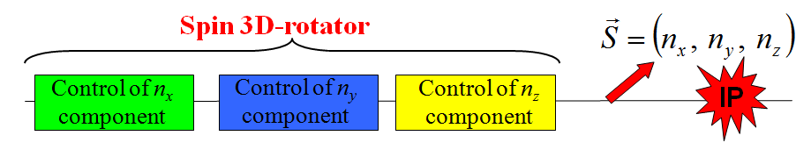
Figure 1: 3D spin rotator schematic.
Figure 2a shows the module for control of the radial polarization component n_{x}, which consists of two pairs of opposite-field solenoids and three vertical-field dipoles producing a fixed orbit bump. The control module for the vertical polarization component n_{y} is the same as that for the radial component except that the vertical-field dipoles are replaced with radial-field ones (Fig. 2b). To keep the orbit bumps fixed, the fields of the vertical- and radial-field dipoles must be ramped proportionally to the beam momentum. The module for control of the longitudinal polarization component n_{z} consists of a single weak solenoid (Fig. 2c).
(a) | 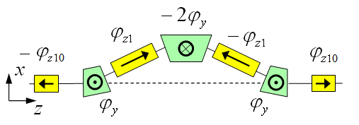
(b) | 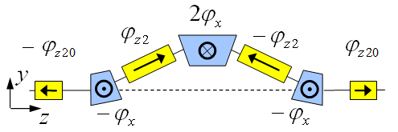
(c) | 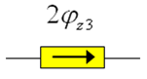
Figure 2: Modules for control of the radial (a), vertical (b), and longitudinal (c) spin components.
Below we give the formulae for calculating the spin rotation angles $ϕ_{\text{zi}}$ in the control solenoids for a given polarization direction $\vec{n}$ at the 3D spin rotator location and a given value of the spin tune ν (linear approximation in ν):
$$\begin{aligned}n_{x} \text{module}: ϕ_{z1}=\text{πν}\frac{n_{x}}{\text{sin}ϕ_{y}}, ϕ_{z\text{10}}=\frac{\text{πν}}{2}\frac{n_{x}}{\text{tan}ϕ_{y}}, ϕ_{y}=γ {Gα}_{\text{orb}}, \\ n_{y} \text{module}: ϕ_{z2}=\text{πν}\frac{n_{y}}{\text{sin}ϕ_{x}}, ϕ_{z\text{20}}=\frac{\text{πν}}{2}\frac{n_{y}}{\text{tan}ϕ_{x}}, ϕ_{x}=γ {Gα}_{\text{orb}}, \\ n_{z} \text{module}: ϕ_{z3}=\text{πν} n_{z} \text{.}\end{aligned}$$
Here G is the anomalous part of the particle’s gyromagnetic ratio, $γ$ is the Lorenz factor, and $α_{\text{orb}}$ is the orbital bending angle of the dipole.
The field $B_{\text{zi}}$ of a control solenoid of length $L_{\text{zi}}$ can be calculated using the formula:
$$B_{\text{zi}}=\frac{ϕ_{\text{zi}}}{(1+G) L_{\text{zi}}}\text{.}$$
Schematic placement of the 3D rotator elements in the collider ring’s experimental straight is shown in Fig. 3. The lattice quadrupoles are shown in black, the vertical-field dipoles are green, the radial-field dipoles are blue, and the control solenoids are yellow. With each module’s length of ~7 m, the fixed orbit deviation in the bumps is ~15 mm in the whole momentum range of the collider. The maximum dipole field is 3 T while the field of the control solenoids does not exceed 2 T. This allows one to set the spin tune to ν_{p} = 0.01 for protons and ν_{d} = 10⁻⁴ for deuterons and to also stabilize any polarization direction at any location in the collider during an experiment essentially with no perturbation to the collider’s orbital properties.
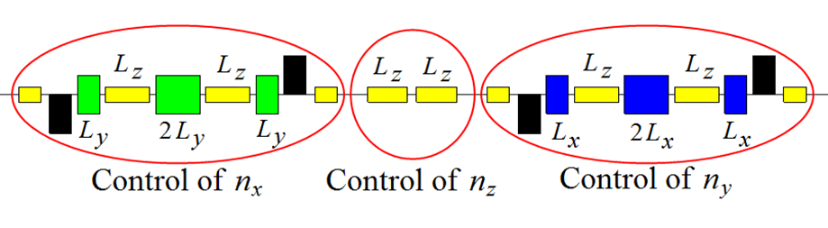
Figure 3: Placement of the 3D spin rotator elements.

Spin flipping in JLEIC collider
A 3D spin rotator allows one to make reversals of the particle spins during an experiment by slowly (adiabatically) changing the solenoid fields of the 3D spin rotator to rearrange the spin motion. To preserve the polarization degree, one must meet the condition of adiabatic change in the spin direction, which has the following form for the number of particle turns $N_{\text{flip}}$ necessary to flip the spin:
$N_{\text{flip}}\text{>>}1/ν$.
We get a limit on the number of turns for a spin flip of $N_{\text{flip}}^{P}\text{>>}{\text{10}}^{2}$ for protons and for deuterons, which, in terms of the flip time, means for protons and for deuterons. In practice, the adiabaticity condition is automatically satisfied, since the spin reversal time is limited by the field ramp rate in the super-conducting solenoids.
Let us provide the results of our calculation of the proton spin reversals in the vertical (yz) plane of the collider. We use Zgoubi [11] for spin tracking simulations. As an example, let us consider an idealized model of a piecewise linear field pattern with sharp breaks at its change points. The pattern of change in the spin field, when making spin reversals, is shown versus the number of turns in Fig. 4. The number of turns is indicated in units of $N_{0}$, which is the number of turns for rotating the spin from vertical to longitudinal direction. The vertical h_{y} (green line) and longitudinal h_{z} (red line) components of the spin field are set using the solenoids of the vertical n_{y}- and longitudinal n_{z}-modules of the 3D spin rotator.
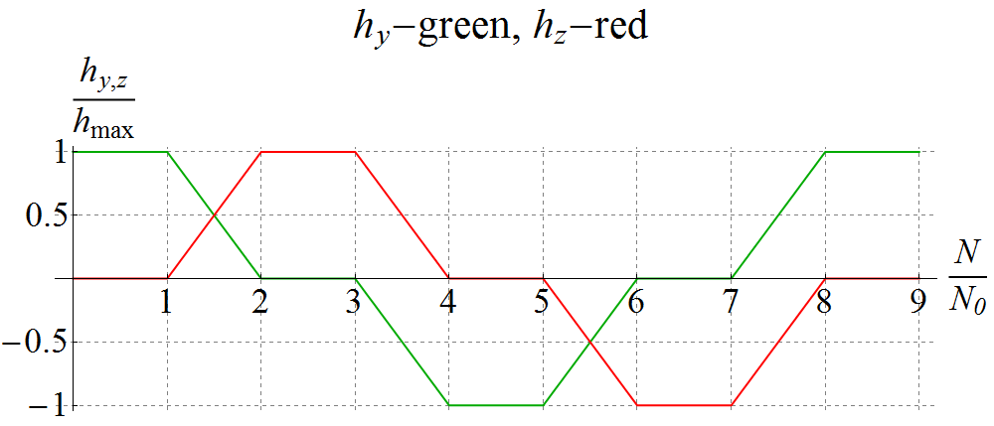
Figure 4: Pattern of change in the vertical h_{y} and longitudinal h_{z} spin field components when making spin reversals in the collider ring.
The magnitude of the spin field sets the spin tune value. Change in the spin tune in units of the maximum field $h_{\text{max}}$ is shown in Fig. 5.
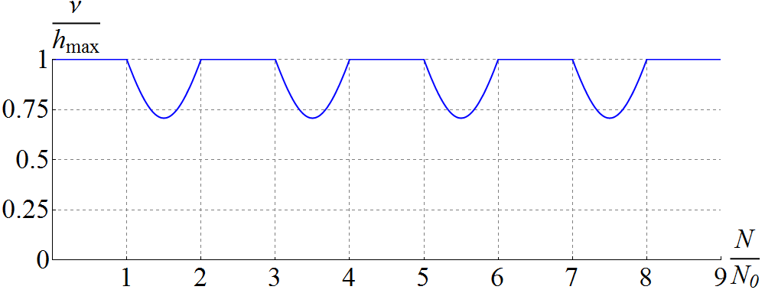
Figure 5: Change in the spin tune in units of the maximum spin field h_{max} when rotating the spin in the collider.
Figure 6 shows the change in the proton spin components as a function of the number of turns for the indicated change in the spin field using the 3D rotator. Rotation from vertical to longitudinal direction and back is done in 50 thousand turns. The maximum spin tune value is 10⁻². The spin components then follow the shape of the spin field pattern practically everywhere, as it should be in case of adiabatic motion. Exceptions are small regions where the spin field has sharp breaks, in which the adiabaticity condition is violated.
The spin is directed vertically up. Then a spin rotation takes place in 50 thousand turns. As we can see, the spin undergoes sequential rotations from the vertical-up direction to the longitudinal direction along the particle velocity, then to the vertical-down direction and finally to the longitudinal direction opposite to the particle velocity.
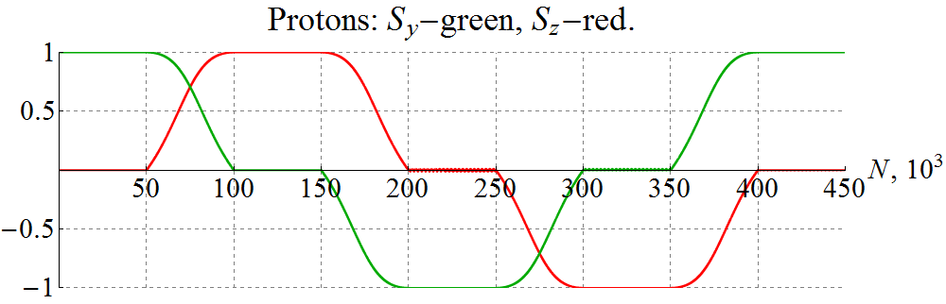
Figure 6: Rotating the proton spin in an ideal collider lattice.
To demonstrate a violation of the adiabatic condition of the spin motion during polarization rotations, we show a similar graph in Fig. 7 for a deuteron when rotation from vertical to longitudinal direction is done in 50 thousand turns with a maximum spin tune value of 10⁻⁴.
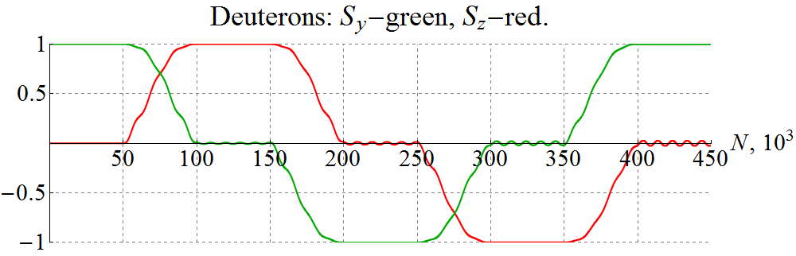
Figure 7: Rotating the deuteron spin in an ideal collider lattice with violation of the adiabaticity condition of the spin motion.
As we can see from the graphs, there appears an additional modulation of the spin components at the spin frequency, which gradually grows with increase in the number of turns.
To meet the adiabatic condition of the spin motion at the spin tune of 10⁻⁴, it is sufficient to complete the rotation from vertical to longitudinal direction in 300 thousand turns. A graph of the spin components, when rotating the deuteron spin in this case, is shown in Fig. 8. As we can see, now, as in the proton case, the spin follows the spin field practically everywhere according to the pattern in Fig. 4.
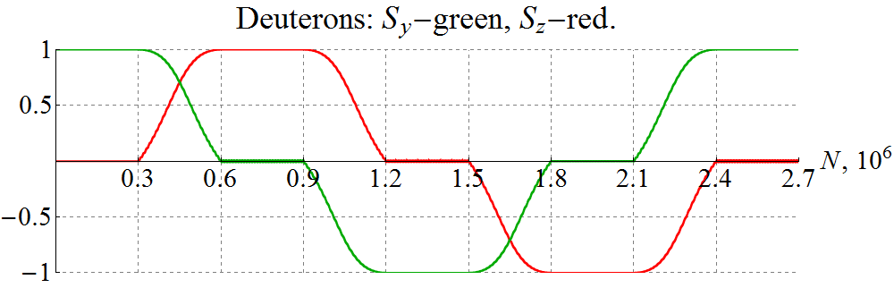
Figure 8: Rotating the deuteron spin in an ideal collider lattice with the adiabatic condition of the spin motion satisfied.
In a real situation, superconducting fields switch on smoothly and the adiabaticity condition can be met during the whole cycle of the field change. Moreover, to ensure polarization stability over a long time period, one can stabilize the spin tune during the spin reversal as well that will allow one to eliminate crossing of spin resonances during an experiment. We do not discuss impact of imperfections in this paper but the usual criterion of the spin tune being much greater than the error spin effect (the zero-integer spin resonance strength) applies here as well and was earlier shown to be satisfied for the above conditions [12].
CONCLUSION
The presented calculations demonstrate the feasibility of implementing a spin-flipping system using a 3D rotator. Thus, the figure-8 JLEIC ion collider provides a unique opportunity for doing high-precision experiments with polarized ion beams.
References
[1] D.D. Caussyn et al., PRL 73, 2857 (1994).
[2] B.B. Blinov et al., PRL 81, 2906 (1998).
[3] M.A. Leonova et al., AIP Conf. Proc. 1149 (2009), pp. 168-173.
[4] M. Bai et al., PAC’11, New York, NY, USA (2011).
[5] Ya.S. Derbenev and V. A. Anferov, Phys. Rev. ST Accel. Beams 3, 094001 (2000).
[6] A.M. Kondratenko et al., DSPIN’2011(2011).
[7] Ya.S. Derbenev, University of Michigan report UM HE 96-05 (1996)
[8] Ya.S. Derbenev et al., PoS (PSTP 2013) 026.
[9] Ya.S. Derbenev et al., IPAC’14, MOPRO004, p. 68.
[10] V.S. Morozov et al., IPAC’15, TUPWI029.
[11] F. Méot, NIM-A 427, 353-356 (1999).
[12] A.M. Kondratenko et al., arXiv:1604.05632 (2016).

