**Compensation of the coherent** **part of the zero-integer spin resonance strength**

Stability of the ion polarization in the JLEIC collider ring is determined by the incoherent part of the resonance strength, which is related to the beam emittances [1]. With the transverse beam size at the collider’s interaction point of 25×5 μm2, the incoherent part of the resonance strength is about $1.8⋅{10}^{-5}$  
 for protons and $0.7⋅{10}^{-9}$ for deuterons. Our calculations using the spin tracking code Zgoubi [2] confirm polarization stability in an ideal lattice of the collider ring when using a 3D spin rotator [3,4], which provides the spin tune values of ${10}^{-2}$ for protons and ${10}^{-4}$ for deuterons. In real conditions, manufacturing errors in the elements of the collider’s magnetic lattice as well as misalignments of these elements along the collider’s ideal design orbit result in appearance of the coherent part of the resonance strength. Our calculations show that the coherent part of the resonance strength significantly exceeds the incoherent part and lies in the range of ${10}^{-3}-{10}^{-2}$ for protons and ${10}^{-5}-{10}^{-4}$ for deuterons. This means that using the aforementioned 3D rotator to control the ion polarization already becomes, at least, inconvenient, since, during a spin manipulation process, one should always make a “correction” of the spin field for the coherent part of the resonance strength. Besides, the coherent part grows with increase in energy along with the fields required for its compensation. Nevertheless, the solenoid fields of the control 3D rotator can be left at the same level if one compensates the coherent part of the resonance strength using a second 3D rotator with static fields located in the opposite straight.

Below we consider compensation of the coherent part of the resonance strength using protons as example. The deuteron case can be considered similarly.

Figures 1 and 2 show diagrams of random quadrupole shifts, which are used in our calculations of the proton spin motion in the collider. The sizes of the quadrupole shifts in the vertical and radial directions are given in units of their rms deviation equal to 5 µm. The diagrams also indicate the locations of the control 3D rotator (1st 3D-rotator) and of the compensating 3D rotator (2nd 3D-rotator). The indicated quadrupole alignment errors result in a closed orbit distortion in the arcs of a few hundred µm   
(see Fig. 3).

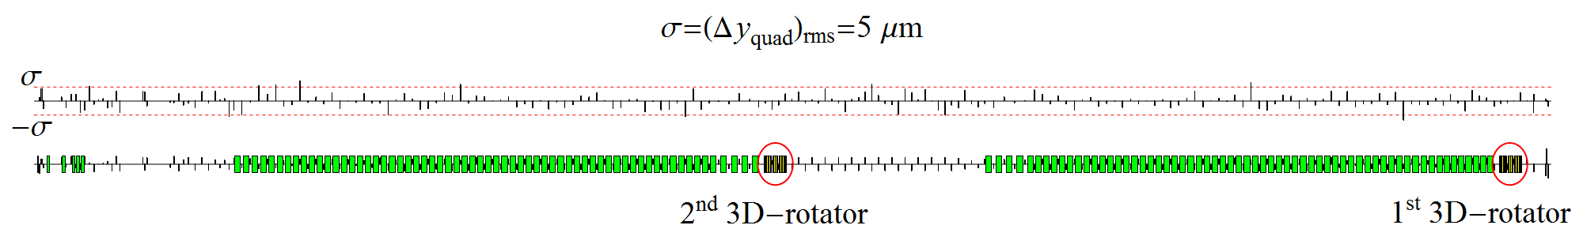

**Figure 1:** Diagram of vertical quadrupole alignment errors in the collider ring distributed normally with $σ_{rms}= Δy_{quad}=5 μm$  
.

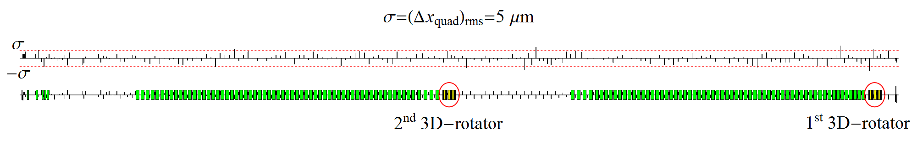

**Figure 2:** Diagram of radial quadrupole alignment errors in the collider ring distributed normally with $σ_{rsm}=Δx_{quad}=5 μm$  
.

|  |  |
| --- | --- |
|  |  |

**Figure 3:**Radial and vertical orbit excursions with random misalignments of all quadrupoles in the collider ring.

We first determine the coherent part of the resonance strength near the 2nd 3D rotator. Figure 4a shows graphs of the proton spin components versus the number of particle turns in the collider ring with the random quadrupole shifts according to the diagrams presented in Fig. 1 and 2. The particle is launched from the interaction point along the closed orbit with longitudinal spin. The spin is observed near the 2nd 3D rotator in the section opposite to the interaction point.

|  |  |
| --- | --- |
|  |  |
| **(a)** | **(b)** |
| **Figure 4:** Proton spin components in the section opposite to the interaction point in a non-ideal collider lattice before (a) and after (b) compensation of the coherent part of the resonance strength with a 3D rotator. | |

The proton spin completes 2 oscillations in 793 particle turns. The coherent part of the strength is then about $w_{coh}^{prot}≈2.52⋅{10}^{-3}$.

To find the direction of the precession axis $\vec{n}={\vec{ω}}_{coh}/ω_{coh}$ induced by the coherent part of the resonance strength, one can also use the graphs in Fig. 4a. Since the spin component along the $\vec{n}$ axis is an invariant of the spin motion, the average spin value $〈\vec{S}〉$ is directed along the $\vec{n}$ axis: $〈\vec{S}〉=S_{n} \vec{n} .$

Thus, we get the  axis components:

$$n_{x}=±\frac{〈S_{x}〉}{S_{n}} , n_{y}=±\frac{〈S_{y}〉}{S_{n}} , n_{z}=±\frac{〈S_{z}〉}{S_{n}} , S_{n}=\sqrt{{〈S_{x}〉}^{2}+{〈S_{y}〉}^{2}+{〈S_{z}〉}^{2}} .$$

The sign of the $\vec{n}$ vector is determined from the condition that the spin vector rotates about $\vec{n}$ counterclockwise.

The graph yields that the direction of the spin precession axis ${\vec{n}}_{2}$ near the second 3D rotator is

$${\vec{n}}_{2}=\left( 0.887, -0.002, 0.463\right).$$

Figure 4b shows the spin components after compensation of the coherent part of the resonance strength. The parameters of the compensating 3D rotator were chosen as

$${\vec{n}}_{comp}={\vec{n}}_{2}=\left( 0.887, -0.002, 0.463\right), ν_{comp}=-ω_{coh}=-2.52 {10}^{-3}.$$

The graph in Fig. 4b yields that, after compensation, the coherent part of the resonance strength became $2.7⋅{10}^{-5}$, i.e. decreased practically to the value of the incoherent part of the resonance strength.

Figure 5a shows a graph of the spin component evolution in a non-deal collider lattice when setting vertical proton polarization at the interaction point with compensation of the coherent part of the resonance strength. The parameters of the control 3D rotator are: *ny*=1, νsp=0.01. The beam momentum is 60 GeV/c. The particle is launched along the closed orbit with vertical spin. For comparison, Fig. 5b shows a similar graph without compensation of the coherent part of the resonance strength.

|  |  |
| --- | --- |
|  |  |
| **(a)** | **(b)** |
| **Figure 5:** Setting vertical polarization in a non-ideal collider lattice with **(a)** and without **(b)** compensation of the coherent part of the resonance strength. | |

***Conclusion***

Our spin tracking simulations show that a non-ideal collider with compensation of the coherent part of the resonance strength becomes equivalent to an ideal one in terms of polarization control.

***Milestone reached***

* Spin tracking continued
* Study of spin dynamics and compensation of the depolarization caused by imperfections and non-linear fields

***References***

[1] Quarterly report “Stability of proton polarization in the collider ring of JLEIC”, April 26, 2016.

[2] F. Méot, The ray-tracing code Zgoubi, NIM-A 427 (1999) 353-356; <http://sourceforge.net/projects/zgoubi/>

[3] V.S. Morozov, Y.S. Derbenev, F. Lin, Y. Zhang, Y. Filatov, A.M. Kondratenko, and M.A. Kondratenko, “Baseline Scheme for Polarization Preservation and Control in the MEIC Ion Complex”, IPAC’15, TUPWI029.

[4] Close out report “Ion Polarization Scheme for MEIC”, June 12, 2015.