**Control of Ion Polarization in JLEIC**

**(annual report)**

A.M. Kondratenko1, M.A. Kondratenko1, and Yu.N. Filatov2

*1Science and Technique Laboratory “Zaryad”, Novosibirsk 630090, Russia*

*2Moscow Institute of Physics and Technology, Dolgoprudny 141700, Russia*

Translated by V.S. Morozov, *Jefferson Lab, Newport News, VA 23606, USA*

**CONTENTS**

**1.** **POLARIZATION CONTROL IN THE JLEIC ION COMPLEX** 3

1.1 Baseline scheme of polarization control in the JLEIC ion complex 3

1.2 Polarization stability in the JLEIC ion collider ring 4

**2.** **Comparison of figure-8 and racetrack designs in   
the JLEIC Ion Complex** 8

2.1 Racetrack vs figure-8 booster 9

2.2 Racetrack vs figure-8 collider 10

**3.** **Calculation of proton and deuteron polarizations in   
racetrack and figure-8 boosters using Zgoubi** 11

3.1 Racetrack booster 11

3.1.1 *Orbital characteristics of racetrack booster* 11

3.1.2 *Spin resonances in racetrack booster* 13

3.1.3 *Taking account of synchrotron energy modulation when crossing spin   
resonances in racetrack booster* 17

3.1.4 *Calculation of proton polarization in racetrack booster with solenoidal   
snake* 19

3.1.5 *Calculation of deuteron polarization in racetrack booster* 20

3.2 Figure-8 booster 22

3.2.1 *Orbital characteristics of figure-8 booster* 22

3.2.2 *Calculation of proton and deuteron polarizations in figure-8 booster* 22

**4. Control of proton and deuteron polarizations in   
the JLEIC ion collider ring using 3D spin rotators** 27

4.1 Proton and deuteron polarization in an ideal lattice of the JLEIC ion collider ring 27

4.2 Impact of lattice imperfections on polarization in the JLEIC ion collider ring 32

4.3 Spin flipping in the ion collider ring 36

**5.** **ConclusionS** 38

**Acknowledgements** 39

**REFERENCES**  39

The contract agreement from June 15, 2015 through June 14, 2016 specifies the following work plan.

* First and Second quarters
  + Systematic comparison of figure-8 and racetrack designs
  + Development of efficient numerical techniques for spin calculations
  + Spin tracking simulations using verified existing codes
* Third and fourth quarters
  + Study of spin dynamics and compensation of the depolarization caused by imperfections and non-linear fields
  + Spin flipping
  + Spin tracking simulations using verified existing codes

The results of the completed work were regularly discussed at teleconferences with JLab, presented at international conferences [1,2] and provided as reports [3-7].

The possibility of making the booster a racetrack has been reported at the DSPIN 2015 conference [1] (see also quarterly report “Superconducting racetrack booster for the ion complex of MEIC”, July 10, 2015 [3]). Further comparison of the figure-8 and racetrack designs for the booster and collider rings of the JLEIC ion complex was presented in a quarterly report on October 12, 2015 [4]. Another stage of comparison of the figure-8 and racetrack designs was numerical analysis of depolarizing effects in racetrack and figure-8 boosters. The analysis was based on spin tracking simulations using Zgoubi code [8]. Its results are provided in the report of March 7, 2016 [5].

In the second half of the year, we completed work on numerical analysis of depolarizing effects in the JLEIC ion collider ring while the proton and deuteron polarizations were controlled using 3D spin rotators. Those results are presented in this report. We use spin tracking to calculate the strengths of the zero-integer spin resonance for protons and deuterons at the beam momentum of 60 GeV/*c*, which determines stability of the beam polarization in the ion collider ring. The coherent part of the zero-integer spin resonance strength was calculated using the statistical model of random quadrupole misalignments, which cause distortion of the closed orbit. We demonstrated compensation of the depolarization caused by imperfections and non-linear fields. We present the results of numerical modeling of a system for particle spin reversal during an experiment, in other words, of a spin flipping system.

We plan to present the results of our spin tracking simulations of the JLEIC ion collider ring at the SPIN’2016 and NAPAC’2016 conferences.

**1. polarization control in the JLEIC Ion Complex**

This chapter provides a basic description of the baseline scheme for polarization control in the JLEIC ion complex, which was analyzed in the final report, “Ion Polarization Scheme for MEIC”, of 06/12/2015 [9]. We also present new results of analytic calculations of the zero-integer spin resonance strength in a modified ion collider lattice, which uses only RBEND magnets.

**1.1 Baseline scheme of polarization control in the JLEIC ion complex**

In the present conceptual design, the JLEIC ion complex consists of sources of polarized light ions and unpolarized light to heavy ions, a 280 MeV pulsed SRF ion linac, an 8 GeV kinetic energy booster ring, and a 100 GeV collider ring (see Fig. 1.1) [10]. All of the above energy parameters are for the proton beam.

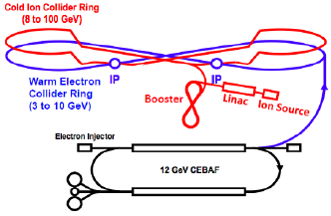

**Figure 1.1:** The JLEIC ion complex.

Using figure-8 ring geometry [11] is an elegant way to preserve and control the polarization of a beam of any particle species during its acceleration and storage at any energy. The ideal lattice of a figure-8 ring is transparent to the spin. The resulting effect of the “strong” arc dipoles on the spin dynamics is reduced to zero over one particle turn. Any spin orientation at any orbital location repeats every turn. In other words, in a figure-8 accelerator, the spin tune is zero, and there is no preferred polarization orientation because the particle is in the zero-integer spin resonance region. To stabilize the beam polarization direction at the interaction point, it is sufficient to use compact insertions for polarization control, which utilize already existing collider magnets and solenoids with small field integrals (“weak” solenoids) [12-15]. The spin tune and the polarization direction are then determined not by the “strong” structural fields of the collider but by the introduced weak solenoids. The weak solenoids do not affect the closed orbit at all and do not essentially change the beam orbital parameters. This property is universal and does not depend on the particle type.   
Figure-8 colliders provide a real opportunity for obtaining intense polarized deuteron beams with energies greater than a few tens of GeV.

Figure 1.2 shows the scheme for polarization preservation in the booster of JLEIC. A weak solenoid stabilizes the polarization in the longitudinal direction in the straight where it is placed. There is no problem with ramping the field of such a solenoid during the acceleration cycle. The required solenoid field integral does not exceed 0.7 T⋅m at the top energy of the booster for both protons and deuterons. It provides sufficient spin tune shifts of 0.01 and 0.003 away from zero for protons and deuterons, respectively.

The beam polarization of any particle (p, d, 3He, …) is controlled in the ion collider ring using universal 3D spin rotators. The 3D rotators are designed using weak solenoids and allow for performance of the following tasks: matching of the polarization direction at injection, polarization preservation during acceleration and storage, measurement of the beam polarization at any orbital location, and spin manipulation at the interaction point during experimental running.

|  |  |
| --- | --- |
| . ion_pol_booster  **Figure 1.2:** Schematic of the polarization control in the booster. | ion_pol_collider  **Figure 1.3:** Spin rotator placement in the ion collider ring. |

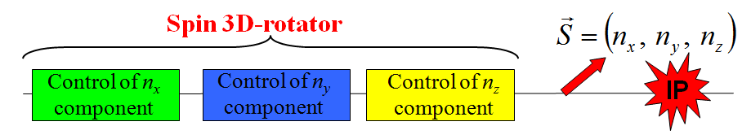

**Figure 1.4:** 3D spin rotator schematic.

Figure 1.4 shows a schematic of the 3D spin rotator [15] for ion polarization control. It is located at the end of the experimental straight. The rotator consists of three modules: those for control of the radial $n_{x}$, vertical $n_{y}$, and longitudinal $n_{z}$ components of the polarization. The placement of the 3D spin rotator in the JLEIC ring is shown schematically in Fig. 1.3.

The spin rotator shifts the proton and deuteron spin tunes away from zero by the amounts of 0.01 and 2.5⋅10-4, respectively. The magnetic fields of the spin rotator solenoids can be changed relatively quickly on the time scale of a few seconds that allows one to use the 3D rotator for spin-flipping.

**1.2 Polarization stability in the JLEIC ion collider ring**

The required weak field integrals are limited by the strength of the zero-integer spin resonance $ω$. For stability of the beam polarization, the spin tune ν induced by the 3D rotator must significantly exceed the strength of the zero-integer spin resonance

$ν≫ω$**.**

The resonance strength is the value of the average spin field determined by deviation of the trajectory from the ideal design orbit. The resonance strength consists of two parts: a coherent part arising due to additional dipole and longitudinal fields on a trajectory deviating from the design orbit and an incoherent part associated with ions’ betatron and synchrotron oscillations (beam emittances)

$$ω=ω_{incoh}+ω_{coh }, ω_{coh }≫ω_{incoh }.$$

The coherent part of the resonance strength is determined by the first order in orbit deviations and lies in the orbital plane. The incoherent part of the resonance strength is determined by the second order in orbit deviations, is directed vertically and is significantly less than the coherent part.

Figures 1.5 and 1.6 show graphs of the incoherent parts of the proton and deuteron resonance strengths as functions of the beam momentum in the ion collider ring. The calculations assumed a normalized vertical beam emittance of $0.07 mm⋅mrad$. The graphs show that, near the beam momentum of 60 GeV/*c*, the incoherent part of the resonance strength has an order of magnitude of ${10}^{-5}$ for protons and ${10}^{-9}$ for deuterons.

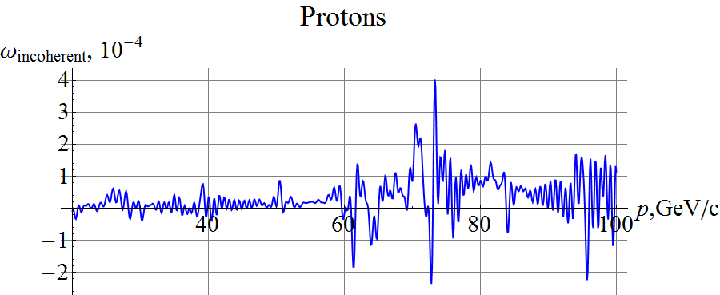

**Figure 1.5:**Incoherent part of the zero-integer spin resonance strength for protons.

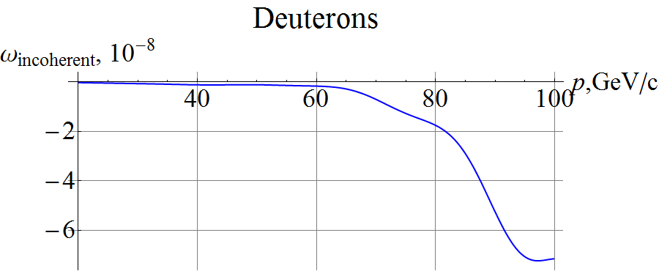

**Figure 1.6:**Incoherent part of the zero-integer spin resonance strength for deuterons.

*Statistical model for calculating the coherent part of the resonance strength*

The coherent part of the zero-integer spin resonance strength due to a perturbing radial field $h_{x}(z)$, can be calculated using a periodic response function $F(z)$:

$$ω_{coh}=γG 〈h_{x}\left(z\right)F\left(z\right)〉 .$$

Perturbing fields may be related to systematic as well as random errors in the manufacturing and alignment of collider elements. Within the statistical model, the contribution to the spin resonance strength of random errors in $Q$ independent elements is proportional to $\sim \sqrt{Q}$ in the absence of correlation between the perturbations from individual lattice elements. It is smaller by the same factor than the contribution of systematic perturbations.

Let us use the statistical model to determine the mean strength of the spin resonance due to $Q$ uncorrelated segments with radial fields $h_{k}≡h_{x}(z_{k})$. The rms strength of the zero-integer spin resonance is determined by the sum of all of the $Q$ uncorrelated segments and equals:

$$\overline{{{|ω}_{coh}|}^{2}}={\left(γG\right)}^{2}\sum_{k=1}^{Q}{η_{k}^{2} \overline{h_{k}^{2}}} {|F_{k}|}^{2},$$

where $η_{k}$ is the fraction of the orbit occupied by element *k*, $\overline{h_{k}^{2}}$ is the rms error in the radial field of element *k*, and $F_{k}≡F(z_{k})$ is the response function at element *k*.

Thus formula allows one to find the rms strength of the zero-integer spin resonance for given manufacturing and alignment precisions of the collider lattice elements.

Perturbing radial fields also lead to vertical excursion of the particle closed orbit. The formula for the rms deviation of the closed orbit at point *z* has the form of:

$$\overline{y^{2}(z)}=\frac{π^{2}β_{y}(z)}{2\sin^{2}{πν_{y}}}\sum_{k=1}^{Q}{η_{k}^{2} \overline{h_{k}^{2}}} β_{k} .$$

Here, $β_{y}(z)$ is the vertical $β$-function of the collider, $β_{k}≡β_{y}(z_{k})$ is the vertical $β$-function at element *k*, and $ν_{y}$ is the vertical betatron tune.

Let us emphasize that the provided formulae are applicable within the statistical model. With special perturbations, one can independently have any values of the vertical closed orbit distortion and zero-integer spin resonance strength. Let us also note that one can substantially reduce the impact of elements giving a significant contribution to the resonance strength. This can be done by choosing a lattice with small response function at those elements.

Figures 1.7 and 1.8 show graphs of the response functions of the JLEIC collider at a momentum of 60 GeV/*c* for proton and deuteron beams, respectively.

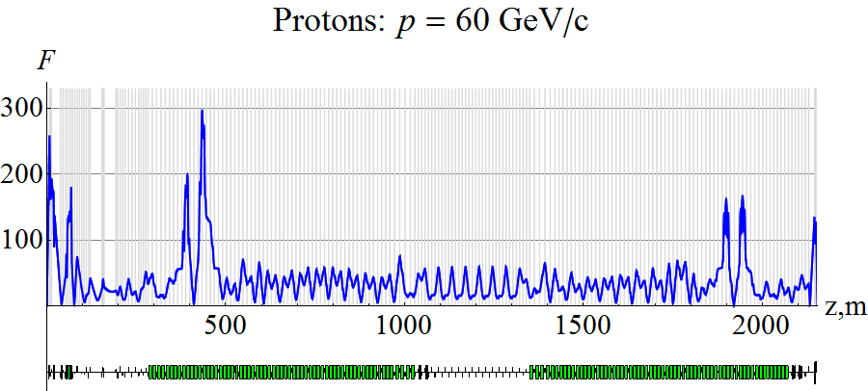

**Figure 1.7:**Response function of the JLEIC collider for a proton beam at 60GeV/*c.*

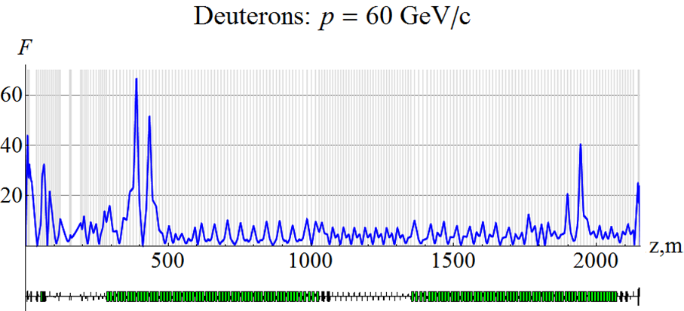

**Figure 1.8:**Response function of the JLEIC collider for a deuteron beam at 60GeV/*c.*

Let us calculate the coherent part of the spin resonance strength using the statistical model with quadrupole vertical misalignments. Figures 1.9 and 1.10 show the calculated dependence of the resonance strength  on the proton and deuteron momenta, respectively, when the orbit excursion in the arcs does not exceed ±0.2 mm for both protons and deuterons. A graph of the rms closed orbit distortion in the collider under the same parameters is shown in Fig. 1.11.

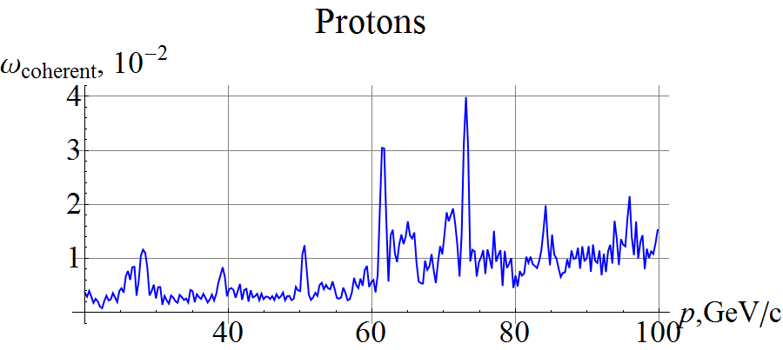

**Figure 1.9:**Coherent part of the zero-integer spin resonance strength for protons.

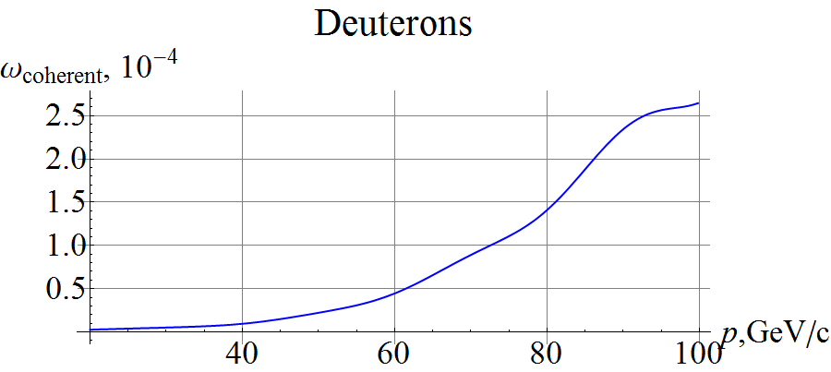

**Figure 1.10:**Coherent part of the zero-integer spin resonance strength for deuterons.

|  |
| --- |
|  |
| **Figure 1.11:**Vertical beam excursion with random misalignment of all quads in the JLEIC collider. |

In the presented examples, the coherent part of the proton resonance strength has an order of magnitude of 10-3-10-2 almost in the whole momentum range, except for two ranges near of 60 and 80 GeV/c with peak values of 3.5⋅10-2 and 4⋅10-3. It is due to the fact that the response function depends on the collider lattice and the spin rotation angle in each arc dipole. One can suppress the peak values down to 10-3-10-4 by means of collider lattice optimization. Besides, it is useful to minimize the response function in the experimental straights to reduce their contribution to the resonance strength.

The coherent part of the deuteron resonance strength has an order of magnitude of 10-5-10-4 in the whole momentum range of the collider.

Our calculations show that the coherent part of the resonance strength significantly exceeds the incoherent one. By itself, the coherent part of the resonance strength does not cause depolarization of the beam. On the contrary, it has a stabilizing effect on the spin along the direction determined by imperfections of the lattice. Only the incoherent part of the resonance strength produces depolarizing effect on the spin.

The resonance strength grows together with the beam momentum and can reach the order of magnitude of the spin tune induced by the control 3D rotator. In this case, control of the beam polarization by a single 3D rotator, although still possible, becomes ineffective. Stronger solenoids are then required, since now one has to simultaneously “compensate” the effect of the coherent part of the resonance strength during polarization control.

A scheme using two 3D spin rotators becomes more suitable. The first one, as before, is used to control the polarization while the second 3D rotator with static fields is used for compensation of the coherent part of the resonance strength. This allows one to significantly reduce the fields of the solenoids in the “control” 3D rotator and, at the same time, to quickly change the fields of the super-conducting solenoids for spin reversals during an experiment. It also generally reduces the impact on the beam orbital characteristics at the interaction point during manipulation of the spin motion.

A real collider with polarized beams then becomes equivalent to an “ideal” collider, which has its magnetic elements aligned exactly on the reference orbit so that the zero-integer resonance strength is determined only by the beam emittances. This allows for polarized beam experiments at a high precision level.

Our analytic calculations show that, after compensation of the coherent part of the resonance strength, polarization can be controlled using 3D rotators, which can induce spin tune values of up to 10-2 for protons and 2.5⋅10-4 for deuterons up to momentum of 100 GeV/*c* in the JLEIC collider.

**2.** **Comparison of figure-8 and racetrack designs in   
the JLEIC Ion Complex**

The figure-8 rings of the JLEIC ion complex completely solve the problem of polarization preservation during acceleration of any ion species including protons and deuterons. A racetrack ring has a smaller circumference, which may reduce its cost and relax the limitation related to space charge. Let us compare the figure-8 and racetrack designs for the JLEIC ion complex.

In contrast to figure-8 rings, due to a small value of the deuteron anomalous magnetic moment, the techniques for preserving proton and deuteron polarizations during beam acceleration in a racetrack are substantially different. Siberian snakes have been shown to work well for preserving the proton polarization. For preserving the deuteron polarization, it is the most optimal to use techniques for preservation of the polarization during each resonance crossing. There are various techniques for crossing of spin resonances: resonance strength compensation, intentional enhancement of the spin resonance strength using specially introduced magnetic fields (a partial Siberian snake), betatron tune jump, spin tune jump [16-19]. References [20-21] proposed and experimentally tested a transparent crossing technique, which, in principle, allows one to eliminate polarization loss during a crossing. The limiting factors for the transparent and fast resonance crossings are effects of the spin and betatron tune spreads in the beam.

*Requirements on placing Siberian snakes in racetrack rings.* Siberian snakes must be used when working with polarized protons in racetrack rings. Snakes allow one to preserve the polarization during proton acceleration in a racetrack, since they eliminate crossing of spin resonances. Besides, identical snakes in a racetrack collider create a “spin transparency” mode that allows one to use the advantages of figure-8 for polarization control.

In the booster, it is the most optimal to use a solenoid snake, which does not distort the closed orbit. In the collider, it is preferable to use a transverse-field snake, whose field integral is practically independent of the momentum and whose closed orbit excursion is already small compared to the snake magnet aperture. Table 2.1 gives the main parameters of Siberian snakes in the JLEIC booster and collider rings for a proton beam.

**Table 2.1**. Siberian snakes for proton beam in racetrack rings.

|  |  |  |  |  |
| --- | --- | --- | --- | --- |
| ring | snake type | number | *BL*, T⋅m | *L*snake, m |
| Booster | solenoidal | 1 | 30 | 10 |
| JLEIC Collider | helical | 2 | 2×25 | 2×10 |

*Saving in arc dipole magnets with a racetrack type structure.* With the same lengths of the main straights, a racetrack ring requires a shorter arc length than a figure-8 one. Table 2.2 shows the total field integrals of the arc dipoles (*BL*) and their total length *L*dip for racetrack and figure-8 boosters with a maximum dipole field of 3 T.

**Table 2.2**. Arc dipoles in racetrack and figure-8 rings.

|  |  |  |  |  |  |  |  |
| --- | --- | --- | --- | --- | --- | --- | --- |
| ring | p, GeV/c | Racetrack | | Figure-8 | | Difference | |
| *BL*, T⋅m | *L*dip, m | *BL*, T⋅m | *L*dip, m | Δ(*BL*), T⋅m | Δ(*L*dip), m |
| Booster | 8 | 167 | 56 | 237 | 79 | 70 | 23 |
| JLEIC Collider | 100 | 2094 | 698 | 3045 | 1015 | 951 | 317 |

Thus, the length occupied by arc dipoles is about 20 m shorter for a racetrack booster and about 300 m shorter for a collider. The lengths occupied by the snakes in the racetracks are about 10 m for the booster and 20 m for the collider.

**2.1 Racetrack vs figure-8 booster**

*Preservation of ion polarization in the booster.* In a figure-8 booster, preserving the polarization during acceleration of any ion species requires introduction of a single weak solenoid with a field integral of ~0.6 Tm. Let us emphasize the universality of this polarization preservation scheme, which does not depend on the field ramp rate of the dipole magnets.

In a racetrack booster, polarization preservation techniques are conceptually different for protons and deuterons. Protons require a solenoidal snake with a maximum field integral of 30 Tm. A solenoidal snake can be used for deuterons as well but this requires a maximum field integral of ~100 Tm. The snake then occupies ~35 m.

For deuterons, it would be more adequate to use acceleration of a vertically polarized beam with consequent crossing of spin resonances. This has to do with the fact that the resonance grid for deuterons is very sparse. A proper choice of the magnetic lattice can eliminate strong linear intrinsic spin resonances owing to correlation of the spin and betatron motions. As a result, in the booster’s momentum range, there will only be linear resonances related to imperfections of the magnetic lattice and higher-order resonances. Polarization loss will depend on the field ramp rate of the utilized magnets. Magnets with a fast ramp rate of ~1 T/s practically guarantee fast crossing of linear resonances as well as of high-order ones. Superconducting magnets with such a field ramp rate are used in Dubna’s Nuclotron [22-24].

When using magnets with a field ramp rate of ~1 T/min (conventional super-ferric magnets), the linear resonances are crossed at an intermediate rate. Thus, one has to use fast quadrupoles to produce a betatron tune jump at the moment of resonance crossing. Fast crossing of a linear resonance still does not guarantee preservation of the polarization in the whole booster momentum range. Higher-order resonances must be analyzed. One also has to carefully optimize the booster lattice and account for subtler effects such as those related to synchrotron energy oscillations, which lead to splitting of a resonance into a series of synchrotron side-band resonances. The betatron tune jump technique was used for protons at ZGS and AGS [16,25].

*Orbital characteristics.* The orbital characteristics of a racetrack booster change depending on the ion species. Moreover, when using magnets with a field ramp rate of ~1 T/min, the orbital characteristics change in the process of a betatron tune jump.

The orbital characteristics of a figure-8 booster do not change when using a weak solenoid. An advantage of figure-8 is that there is no change in the orbital characteristics when running with polarized and unpolarized ion beams.

**2.2 Racetrack vs figure-8 collider**

*Preservation of ion polarization in the collider.* The above discussion about acceleration of polarized ions in a figure-8 booster applies to the collider case as well. A weak solenoid with a field integral of ~8 Tm is sufficient to preserve the polarization in the whole momentum range of the collider.

When running with protons, a racetrack collider is setup in the “spin transparency” mode using two identical helical snakes. Therefore, proton polarization control itself is not conceptually different from the polarization control in a figure-8 collider.

In the collider momentum range, there are strong resonances for deuterons: ~7 integer resonances and ~12 intrinsic resonances. While the series of the integer resonances can be crossed by introducing a partial solenoidal snake, crossing of the 12 intrinsic resonances by betatron tune jumps causes a problem even when using magnets with field ramp rate of ~1 T/s. One has to keep in mind that many higher-order resonances will most likely also have to be crossed with the betatron tune jump technique that will unavoidably lead to a significant polarization loss. Even if polarization is preserved during acceleration, there is no guarantee of sufficient polarization lifetime; in fact, it will most likely be short.

We conclude that running with polarized deuterons in a racetrack collider is not practical.

*Orbital characteristics.* When accelerating protons in a racetrack collider, helical snakes introduce a betatron tune shift proportional to 1/γ2 and change β-functions. Thus, it will require optical correction of changes in the collider’s orbital characteristics, especially at low energies.

In a figure-8 collider, optical characteristics do not change during acceleration of ions and during manipulation of particle spins.

Summing up the above discussion, one can draw the following conclusions:

* a racetrack booster does not give conceptual advantages over a figure-8 booster,
* a racetrack collider for protons allows one to shorten the collider’s circumference by about 15% but then excludes the possibility of experiments with polarized deuterons,
* a figure-8 collider allows one to run with any light ion beams.

**3. CALCULATION OF PROTON AND DEUTERON POLARIZATIONS   
IN RACETRACK AND FIGURE-8 BOOSTERS USING ZGOUBI**

This chapter presents the results of calculating polarization during acceleration of protons and deuterons in the racetrack and figure-8 boosters obtained using spin tracking with Zgoubi [8]. Zgoubi is also used to do a numerical analysis of the effect of booster magnet setup errors on the proton and deuteron beam polarizations.

This study did not consider questions related to stability of the beam orbital motion during crossing of the transition energy. For this reason, the maximum beam momentum in the calculations was limited by the booster’s transition energy. The maximum deuteron momentum was 7.1 GeV/c for the racetrack booster and 8 GeV/c for the figure-8 booster. The maximum proton momentum in the calculations was about 4.5 GeV/c for both the racetrack and figure-8 boosters. This limitation does not affect the demonstration of operability of the proposed schemes of beam polarization preservation in the booster, since there is practically no effect on the beam polarization during crossing of the transition energy in case of stable orbital motion.

The calculations also assumed that booster’s quadrupoles and dipoles have hard edges and do not contain non-linear components of the magnetic field.

**3.1 Racetrack Booster**

**3.1.1 *Orbital characteristics of racetrack booster***

*Lattice of racetrack booster for acceleration of polarized deuterons*

**Figure 3.1.**

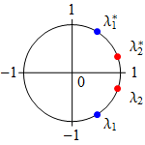

To accelerate polarized deuterons, we choose a racetrack design most similar to the existing figure-8 booster design, i.e. keep the optical beam characteristics in the straight and in one FODO cell period of the booster arc. The superperiodicity of the booster lattice is *N*= 2 and the radial and vertical betatron tunes equal *νx* = 5.95 ${??}_{x}=5.95$ and *νy* = 4.84, respectively. Figure 3.1 shows the eigenvalues $λ_{1,2}=\exp{(2πiν_{1,2})}$ located on a unit circle. Figures 3.2 and 3.3 show the β-functions and dispersion of an unperturbed lattice of a racetrack booster for operation with deuterons.

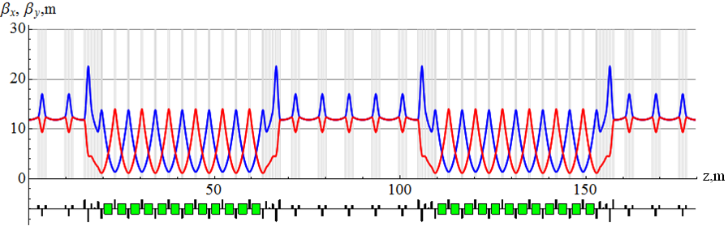

**Figure 3.2:** β-functions of an unperturbed lattice of a racetrack booster.

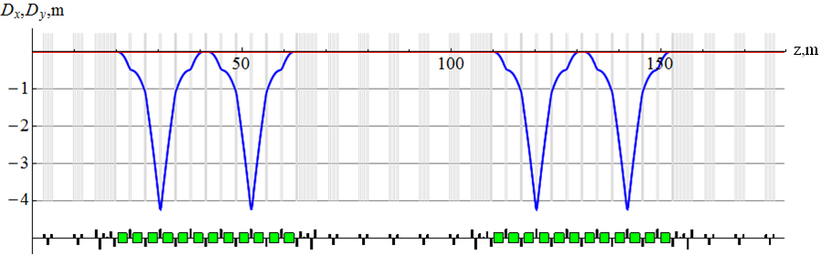

**Figure 3.3:** Dispersion in an unperturbed lattice of a racetrack booster.

*Racetrack booster with solenoidal snake for acceleration of polarized protons*

In a superconducting racetrack booster, it is possible to use a solenoidal snake, which completely eliminates resonant depolarization of a proton beam. To preserve the proton polarization up to 8 GeV/c, the maximum required longitudinal field integral of the snake is 30 Tm. Placement of the snake solenoids in a straight of the booster is shown in Fig. 3.4. For the snake length of 2×4.6 m, the maximum solenoid field is 3.3 T.

**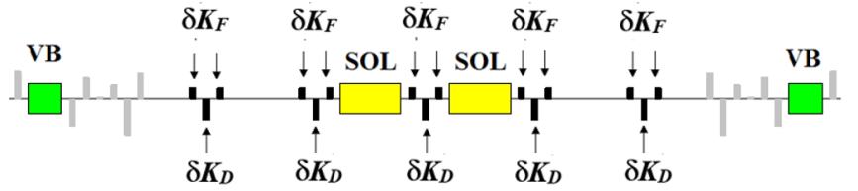**

**Figure 3.4:** Placement of the snake in a booster’s straight.   
SOL are the solenoids, VB are the arc’s vertical-field bending magnets.

The solenoids mainly introduce coupling of the betatron oscillations and shift the betatron tunes. For example, when matching the snake solenoids to the optics of the straight, it is sufficient to correct only the betatron tune shifts and leave the betatron oscillations coupled. The tune shift can be compensated by adjusting the gradients of the two focusing and defocusing quadrupole families in the booster straight’s triplets by small values *δKF* and *δKD*. Figure 3.5 shows a graph of the   
*β*-functions for the case of the booster with a snake with compensation of the betatron tune shifts introduced by the snake. A comparison of the graphs in Figs. 3.2 and 3.5 yields that the change in the *β*-functions in the booster with the snake is quite acceptable. In the presented scheme of solenoidal snake matching, the dispersion remains unchanged.

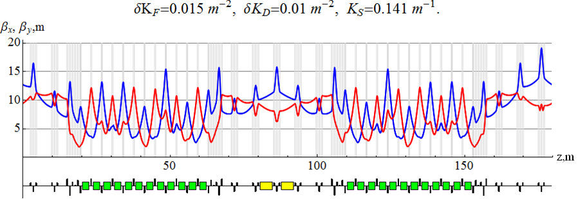

**Figure 3.5:** *β*-functions in the booster with a snake.

**3.1.2 *Spin resonances in racetrack booster***

In a racetrack booster without a snake, the stable polarization points along the vertical axis and the spin tune is proportional to the beam energy *ν* =*γ G* (*G* is the anomalous magnetic moment). This unavoidably leads to crossing of spin resonances during acceleration and, as a consequence, to resonant depolarization of the beam. Table 3.1 gives the numbers of linear resonances along with the conditions for their occurrence in the booster.

|  |  |  |  |  |
| --- | --- | --- | --- | --- |
| **Table 3.1:** Number of linear resonances in a racetrack booster. | | | | |
| **Particles** | **Number of resonances** | | | |
| integer *ν = k* | intrinsic *ν = k N ± νy* | coupling *ν = k N ± νx* | non-super-periodic *ν = k ± νy* (*k ≠ mN*) |
| protons | 16 | 16 | 32 | 16 |
| deuterons | 0 | 0 | 0 | 1 |

Our calculations show that proton resonance strengths lie within the ranges of 10-4-10-3 for integer resonances, 10-4-10-3 for intrinsic resonances, and 10-7-10-5 for coupling and non-super-periodic resonances. The strength of a single deuteron resonance is *w* ~3⋅10-7.

Polarization after crossing of a resonance with a strength *w* is determined by the rate of crossing . A fast crossing  keeps the spin aligned with the field. A slow resonance crossing  flips the spin direction along the field. In an intermediate situation of , the spin orientation significantly deviates from the field direction. In the considered example, the crossing rate can be expressed through the field ramp rate  as:

 for protons,  for deuterons.

At a field ramp rate of 1 T/s, the resonance strengths corresponding to practically complete beam depolarization are $3.8⋅{10}^{-4}$ for protons and $7.6⋅{10}^{-5}$ for deuterons.

Below we use Zgoubi to demonstrate the effect on the proton beam polarization of errors in the setup of the booster lattice elements (lattice imperfections). We analyze the errors having the most significant impact on the beam polarization including random vertical quadrupole shifts, random changes in quadrupole gradients and random quadrupole roll.

*Intrinsic resonances.*

An unperturbed lattice of the racetrack booster can only have a series of intrinsic resonances *ν = k N ± νy*. Intrinsic resonances occur due to correlation of the spin motion with the particle betatron motion.

The graph in Fig. 3.6 shows dependence of the vertical spin component on the energy in units of γ*G* when accelerating protons at a field ramp rate equal 1 T/s in an unperturbed lattice of the racetrack booster.

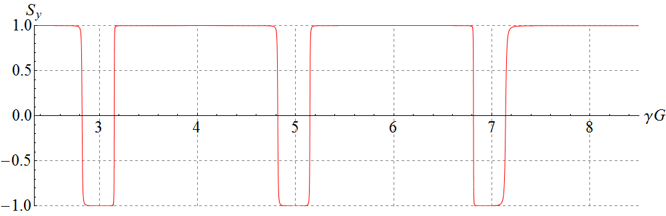

**Figure 3.6:** Proton vertical spin component vs γ*G* in an unperturbed lattice of the racetrack booster. The initial conditions are *x*0 = 10 mm, =0 rad (radial direction), *y*0 = 10 mm, = 0 rad (vertical direction), and Δp/p=0.

One can see from the figure that slow crossings of intrinsic resonances take place. According to the theory, intrinsic resonances should be located at the distances of ±0.836 (fractional part of *νy*) from each even integer value (super-period of *N*=2) or ±0.164 from each odd integer value.

Intrinsic resonances, as all resonances involving betatron tunes, belong to the category of incoherent resonances. The strength of an intrinsic resonance is proportional to the amplitude of betatron oscillations and, therefore, during a slow crossing of the resonance, there could simultaneously be particles having intermediate and fast crossing rates. The fraction of such particles determines the polarization loss in a slow crossing.

Figure 3.7 shows acceleration of three protons with different initial offsets in the transverse plane. As we can see, with a small initial offset *y*0 = 0.1 mm (the green curve), the spin practically does not change, i.e., all resonances are crossed quickly. With an initial offset of *y*0 = 10 mm (the blue curve), the spin flips at each crossing of an intrinsic resonance, i.e. the crossings are slow. An initial offset of *y*0 = 0.5 mm (the red curve) corresponds to intermediate-rate crossings of intrinsic resonances.

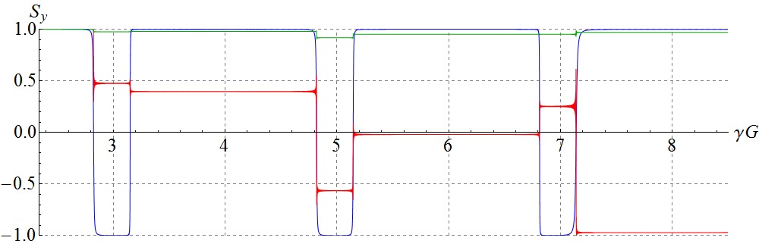

**Figure 3.7:** Proton vertical spin component vs γ*G* in an unperturbed lattice of the racetrack booster for three particles with different vertical offsets: *y*0 = 0.1 mm (the green curve), *y*0 = 0.5 mm (the red curve), and  
*y*0 = 10 mm (the blue curve).

*Imperfection resonances*

a) Random vertical quadrupole shifts give rise to a series of integer resonances *ν = k*.

Figure 3.8 shows a diagram of the random quadrupole shifts, which were used when calculating proton spin motion in the racetrack booster. The sizes of the quadrupole shifts are shown in units of their rms deviation equal 0.01 cm.

Vertical quadrupole shifts also result in a displacement of the closed orbit. Figure 3.9 shows a displacement of the phase-space ellipse of the vertical betatron motion. The center of the ellipse has the coordinates of *y*c = -1.1 mm and *y’*c = -0.402 mrad.

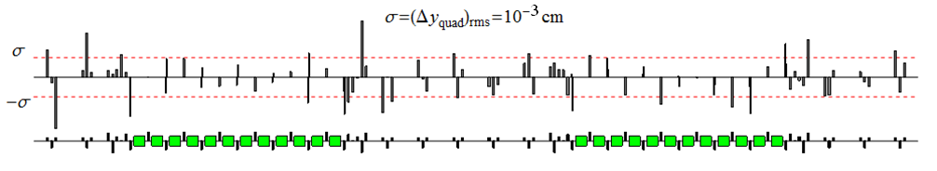

**Figure 3.8:** Diagram of the quadrupole vertical displacement errors in the booster. The errors are distributed normally with an rms deviation of $σ=Δy_{quad}={10}^{-3}cm$.

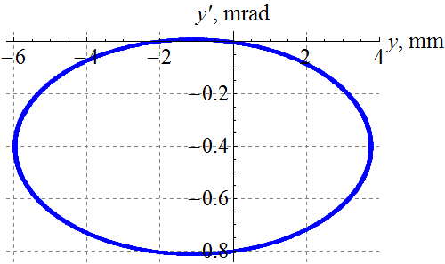

**Figure 3.9:** Displacement of the phase-space ellipse of the vertical   
betatron motion due to random quadrupole shifts.

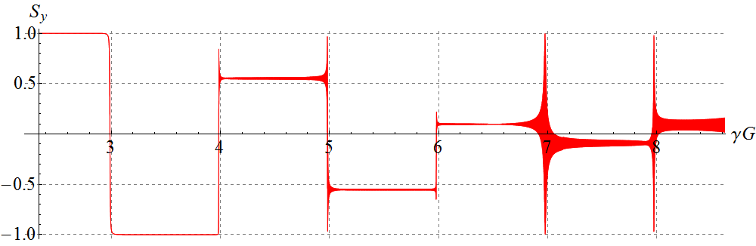

**Figure 3.10:** Proton vertical spin component vs γ*G* for a synchronous particle in the racetrack booster with random quadrupole shifts. The particle is launched along the displaced closed orbit.

The graph in Fig. 3.10 shows the dependence of the vertical spin component on the energy in units of γ*G* when accelerating protons with a field ramp rate equal 1 T/s in the racetrack booster lattice with the random quadrupole shift as per the diagram in Fig. 3.8.

One can see in Fig. 3.10 a series of resonances at integer values of the spin tune γ*G*, which are crossed adiabatically with a spin flip (ν=3), at an intermediate rate (ν=4, ν=5, ν=6) and sufficiently fast (ν=7, ν=8). In contrast to intrinsic resonances, integer resonances are coherent, i.e., they are crossed in the same way by particles with different values of the betatron oscillations amplitudes.

b) random changes in quadrupole gradients give rise to a series of non-super-periodic resonances *ν = k ± νy* (*k ≠ mN*).

Figure 3.11 shows a diagram of the quadrupole gradient errors, which were used when calculating the proton spin motion in the racetrack booster. The relative values of the quadrupole gradient errors are given in units of their rms deviation equal $σ=Δg/g={10}^{-3}$.

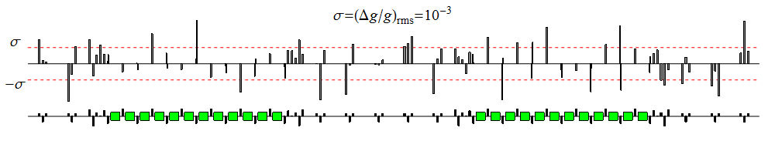

**Figure 3.11:** Diagram of quadrupole gradient errors in the booster lattice. The errors are distributed normally with an rms deviation of $σ=Δg/g={10}^{-3}$.

The graph in Fig. 3.12 shows the dependence of the vertical spin component on the energy in units of γ*G* for the synchronous particle during acceleration of protons with a field ramp rate equal 1 T/s. The racetrack booster lattice contained quadrupole gradient errors according to the diagram in Fig. 3.11.

One can see in Fig. 3.12 that, besides the intrinsic resonances (which are crossed slowly with a spin reversal), there appears a series of non-super-periodic resonances, which are already crossed sufficiently fast and are also located at the distances of ±0.836 (±0.164) from integer values. The strength of the non-super-periodic resonances located “around” the value of γ*G* = 4 is so small that, on the chosen scale, the change in the vertical spin component is practically not visible.

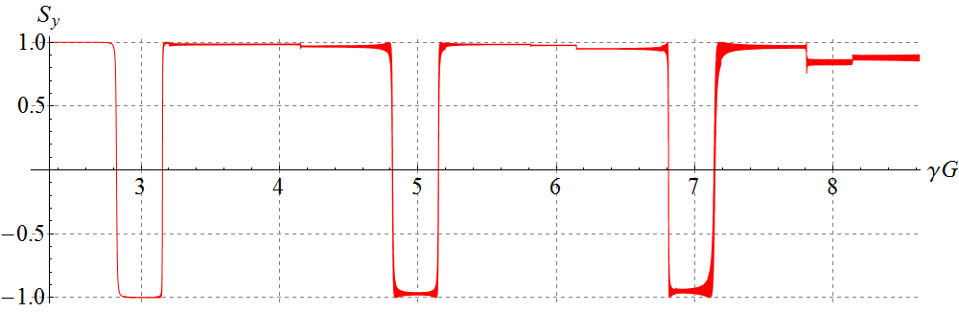

**Figure 3.12:** Proton vertical spin component vs γ*G* in the racetrack booster with quadrupole gradient errors. The initial conditions are: *x*0 = 10 mm, =0 rad, *y*0 = 10 mm, = 0 rad, and Δp/p = 0.

c) random quadrupole rolls give rise to a series of coupling resonances *ν = k ± νx*.

Figure 3.13 shows a diagram of random quadrupole rolls, which were used in calculating the proton spin motion in the racetrack booster. The values of the quadrupole roll errors are given in units of their rms deviation equal 10-3 rad.

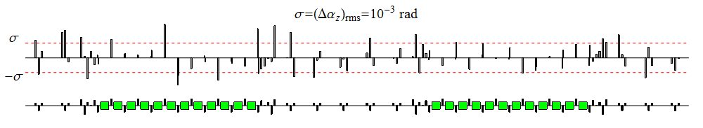

**Figure 3.13:** Diagram of the quadrupole roll errors in the booster. The errors are distributed normally with an rms deviation of $σ=Δα_{quad}={10}^{-3}$ rad.

The graph in Fig. 3.14 shows the dependence of the vertical spin component on the energy in units of γ*G* for the synchronous particle during acceleration of protons with a field ramp rate equal 1 T/s. The racetrack booster lattice contained random quadrupole rolls in accordance with the diagram in Fig. 3.13.

One can see in Fig. 17 a series of coupling resonances, which are crossed sufficiently quickly and are located at the distances of ±0.947 (the fractional part of *νx*) or ±0.053 about integer values of γ*G.*

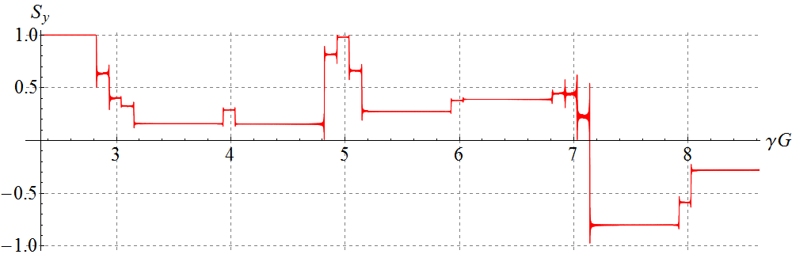

**Figure 3.14:** Proton vertical spin component vs γ*G* in the racetrack booster with random quadrupole rolls. The initial conditions are: *x*0 = 10 mm, =0 rad, *y*0 = 0 mm, = 0 rad, and Δp/p = 0.

**3.1.3 *Taking account of synchrotron energy modulation when crossing spin resonances in racetrack booster***

The effect of synchrotron energy modulation on the beam polarization was discussed at the teleconference of November 3, 2015 [26]. Calculations showed that synchrotron energy modulation leads to splitting of a single resonance into a series of satellite resonances. Their number is determined by an rms spread of the energy-dependent detuning from the resonance $σ_{γ}$ and the value of the synchrotron tune $ν_{γ}$ and equals $σ_{γ}/ν_{γ}$. The distance between the satellites depends on the “average” crossing rate $ε'$ and equals $ν_{γ}/ε'$.

For a fast crossing of a single resonance, account of energy modulation does not change the polarization value after the crossing, since all satellites are also crossed quickly. However, differences in the initial phases of the particles’ synchrotron motion and, at the same time, in their real rates of crossing the satellite resonances result in that the polarization “gets ruffled” after the crossing, i.e. leads to an incoherent mixing of the spins.

Let us demonstrate the effect of spin mixing with the example of accelerating a particle with a vertical spin in the racetrack booster containing all of the aforementioned types of errors, namely: vertical quadrupole shifts with $({Δy{}_{q})}_{rms}=50 μm$, random quadrupole rolls with ${(Δα{}_{q})}_{rms}= 0.1$  
 mrad, and random changes in quadrupole gradients with ${\left(Δg/g\right)}_{rms}={10}^{-3}$. The dependence of the vertical spin component on the energy in units of γ*G* in this case is shown for the synchronous particle (Δp/p=0) in Fig. 3.15.

Figure 3.16 shows a calculation of the vertical spin component during acceleration in the same lattice for three particles including synchrotron modulation (Δp/p=5⋅10-4, the initial phases of synchrotron motion differ by 120°). In Fig. 3.16, one can see that, with the same momentum deviations and the same initial vertical spin component values, the particles have different vertical spin components at the exit.

Note that the orbital motion in the considered example is not stable: as the beam is accelerated, its radial size grows (see Fig. 3.17). The momentum deviation and the equilibrium phase of the synchrotron oscillations also grow as the booster energy approaches the transition value (see Fig. 3.18).

The presented numerical analysis of the error effect on the proton beam polarization in the conventional racetrack booster clearly demonstrates the difficulties arising with preservation of the polarization related to crossing of multiple spin resonances.

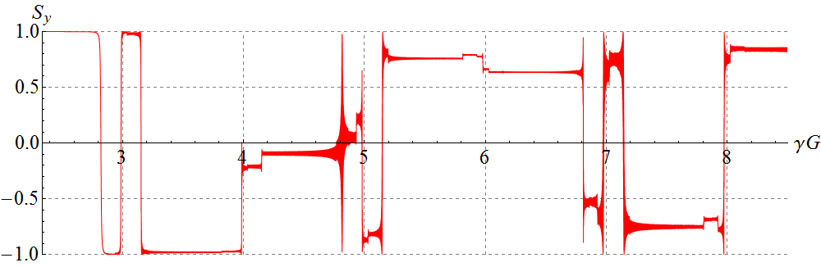

**Figure 3.15:** Proton vertical spin component vs γ*G* in the racetrack booster with three types of errors: ${(Δy{}_{q})}_{rms}=50 μm$, ${(Δα{}_{q})}_{rms}= 0.1$ mrad, and ${\left(Δg/g\right)}_{rms}={10}^{-3}$. The initial conditions are: *x*0 = 10 mm,   
=0 rad, *y*0 = 10 mm, = 0 rad, and Δp/p=0.

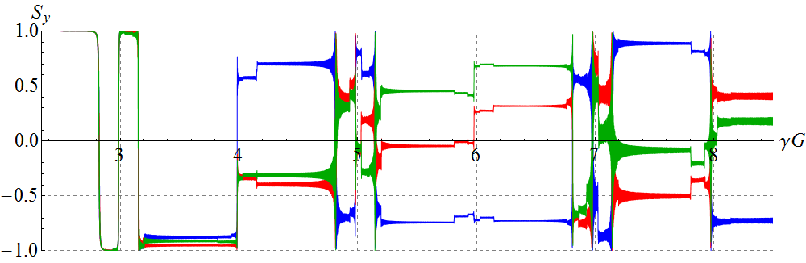

**Figure 3.16:** Proton vertical spin component vs γ*G* in the racetrack booster with the 3 types of errors for 3 particles with Δp/p=5⋅10-4 and with the initial phases of synchrotron motion differing by 120°. The initial conditions for all particles are: *x*0 = 10 mm, =0 rad and *y*0 = 10 mm, = 0 rad.

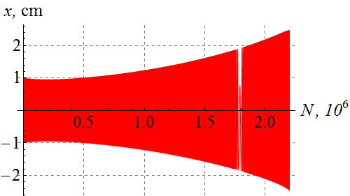**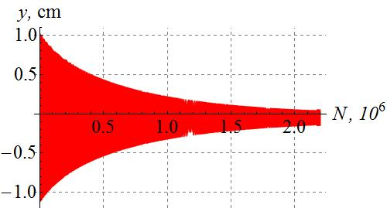**

**Figure 3.17:** Radial and vertical beam sizes as functions of the number of beam turns in the lattice with the three types of errors.

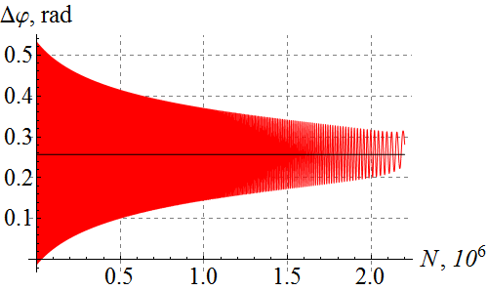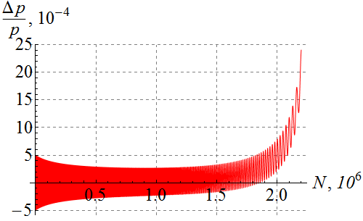

**Figure 3.18:** Dependence of the synchrotron motion phase and momentum deviation on the number of beam turns in the lattice with the three types of errors.

**3.1.4 *Calculation of proton polarization in racetrack booster with solenoidal snake***

All of the resonances described above can be eliminated during acceleration of a proton beam in the racetrack booster by introducing a solenoidal snake whose placement schematic is shown in Fig. 3.4.

A special feature of our scheme for matching the snake solenoids to the booster lattice is absence of compensation of betatron oscillation coupling. Lack of quadrupoles for coupling compensation does not affect the stability of the beam orbital motion. The graphs in Fig. 3.19 show changes in the radial and vertical beam sizes in the unperturbed booster lattice with the solenoidal snake as functions of the number of turns. Graphs of the phase-space motion of the betatron oscillations are presented in Fig. 3.20. A synchronous particle (Δp/p=0) was launched at the entrance with the initial conditions: *x*0 = 10 mm, *=0* rad, *y*0 = 10 mm, and $y_{0}^{'}$ = 0 rad.

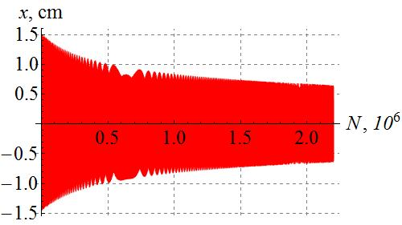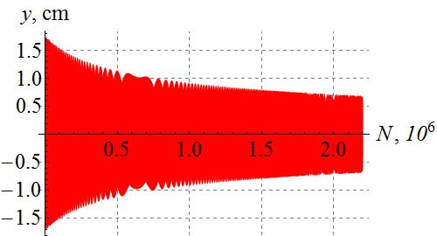

**Figure 3.19:** Radial and vertical beam sizes as functions of the number of turns in the racetrack booster with the solenoidal snake. The initial conditions are: *x*0 = 10 mm, =0 rad, *y*0 = 10 mm, = 0 rad, and Δp/p=0.

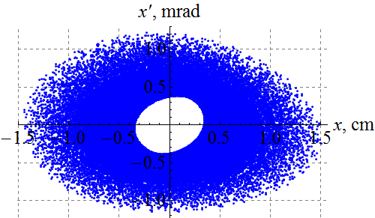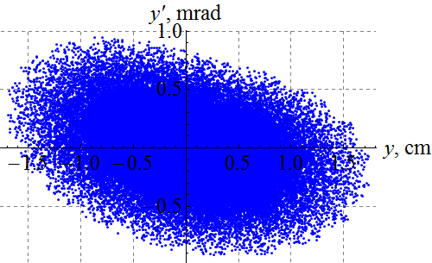

**Figure 3.20:** Phase-space trajectories of the radial and vertical beam betatron oscillations in the racetrack booster with the solenoidal snake.

As we can see from Figs. 3.19 and 3.20, the beam undergoes stable orbital motion. Due to non-zero derivatives of the β-functions at the particle entrance (see Fig. 3.5), the initial sizes of the beam envelope reach about 15 mm for both modes of the betatron oscillations. Note that, due to the presence of coupling, the phase-space trajectory of the vertical betatron oscillations completely fills in its inner area. This is related to the fact that the independent modes of the betatron oscillations in the presence of the solenoidal snake have components in both the vertical and horizontal booster planes.

Figure 3.21 shows the change in the longitudinal spin component as a function of the beam energy in the booster with the snake. The calculation assumed that there were no quadrupole setup errors.

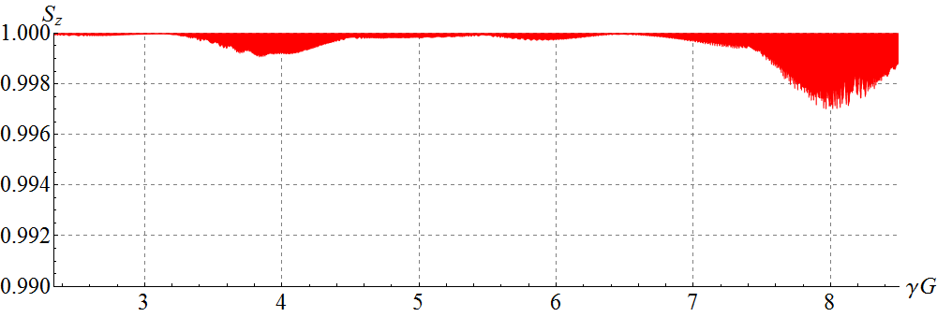

**Figure 3.21:** Proton longitudinal spin component vs γ*G* in the unperturbed lattice of the racetrack booster with the solenoidal snake. The initial conditions are: *x*0 = 10 mm, =0 rad, *y*0 = 10 mm, = 0 rad, and Δp/p=0.

One can see from the graph in Fig. 3.21 that the maximum change in the longitudinal spin component does not exceed 0.3%. The solenoidal snake eliminated beam depolarization related to crossing of strong intrinsic resonances inherent to the unperturbed booster lattice without a snake (compare to Fig. 3.6). Note that the tunes of the racetrack booster were chosen to be the same with and without the snake.

The calculations used a solenoid model with uniform coil winding. It should be noted that, presently, a hard-edge solenoid is not realized in Zgoubi. Taking account of the solenoid edge leads to a jump in the transverse velocities of orbital motion in accordance with the symplecticity conditions [27].

One can minimize the velocity jump by increasing the sizes of the solenoid edge regions to 50 cm (5 aperture sizes). Then the ratio of the solenoid field at the entrance into its edge region to the field at its center is about 10-3. For this reason, to study the effect of element setup error on the polarization in the booster with the *strong* solenoids, one should implement a hard-edge solenoid model in Zgoubi.

**3.1.5 Calculation of deuteron polarization in racetrack booster**

When choosing the betatron tunes of *νx* = 5.95 ${??}_{x}=5.95$ and *νy* = 4.84, there is only one resonance, *ν=νy -*5, in the energy range of the racetrack booster.

Figure 3.22 shows the dependence of the deuteron vertical spin component on the energy in units of γ*G* for a synchronous particle (Δp/p=0) in the racetrack booster containing the same errors as in the proton case: vertical quadrupole shifts with ${(Δy{}_{q})}_{rms}=50 μm$, random quadrupole rolls with ${(Δα{}_{q})}_{rms}= 0.1$ mrad, and random changes in quadrupole gradients with ${(Δg/g)}_{rms}={10}^{-3}$. The field ramp rate is 1 T/s.

Figure 3.23 shows a calculation of the deuteron vertical spin component during acceleration in the same lattice for three particles including their synchrotron modulation (Δp/p=5⋅10-4, the initial phases of synchrotron motion differ by 120°).

The graphs in Figs. 3.22 and 3.23 clearly show crossing of two deuteron resonances. The first resonance located in the γ*|G|* region of about 0.17 correspond to a non-superperiodic resonance of the linear approximation, *ν=νy -*5. The second resonance is separated from the first one by a distance of about 0.05 and corresponds to a resonance of the second-order approximation, *ν= νx* + *νy* -11, which appears because Zgoubi takes into account higher orders in the expansion of the equation of particle motion (nonlinearities were not included in the descriptions of dipole and quadrupole fields).

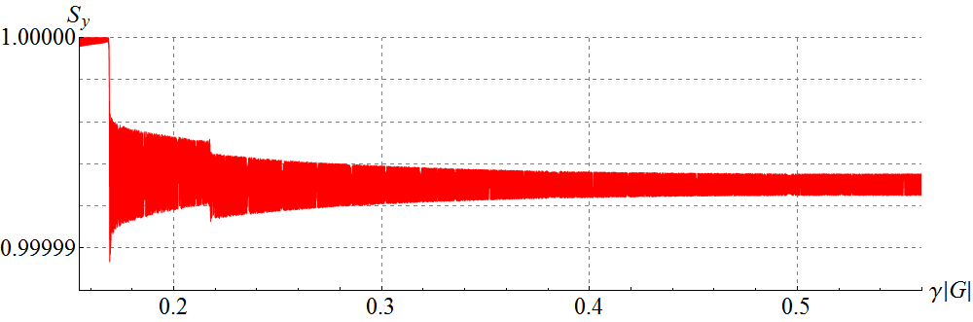

**Figure 3.22:** Deuteron vertical spin component vs γ*G* in the racetrack booster with three types of errors. The initial conditions are: *x*0 =10 mm, =0 rad, *y*0 = 10 mm, = 0 rad, and Δp/p=0.

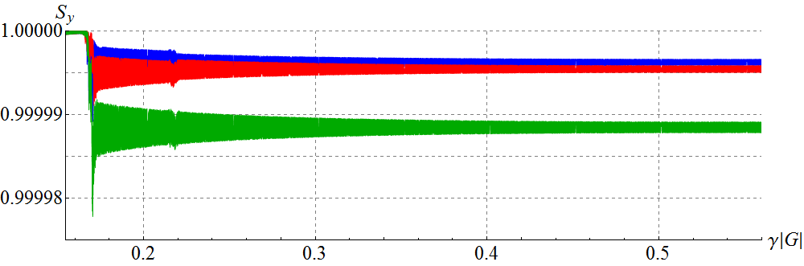

**Figure 3.23:** Deuteron vertical spin component vs γ*G* in the racetrack booster with the three types of errors for three particles with Δp/p=5⋅10-4 and with the initial phases of synchrotron motion different by 120°. The initial conditions for the particles are: *x*0 = 10 mm, =0 rad, *y*0 = 10 mm, and $y_{0}^{'}$ = 0 rad.

The final change in the deuteron vertical polarization does not exceed 2⋅10-5. It should be emphasized that such a result is due to the absence of intrinsic resonances in this particular booster lattice, which are 2-3 orders of magnitude stronger than non-superperiodic ones. Since depolarization is proportional to the square of the resonance strength, in the presence of intrinsic resonances, the polarization may be completely lost even when accelerating with a field ramp rate of 1 T/s.

**3.2. Figure-8 booster**

**3.2.1 *Orbital characteristics of figure-8 booster***

For calculating proton and deuteron polarizations in a figure-8 booster, we chose the prebooster lattice with the tunes *νx* = 7.977 ${??}_{x}=5.95$ and *νy* = 6.793 initially developed for 3 GeV/с momentum. To weaken the sensitivity of orbital parameters to lattice element setup errors, the betatron tunes were adjusted as shown in Fig. 3.24. The tune shifts were done using the two quadrupole families constituting the triplets of the booster’s straight sections. Figures 3.25 and 3.26 show the β-functions and dispersion in an unperturbed lattice of the figure-8 booster. Figures 3.25 and 3.26 also show the location of the solenoid stabilizing the spin motion. The solenoid is indicated by a yellow rectangle.

**Figure 3.24.**

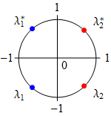

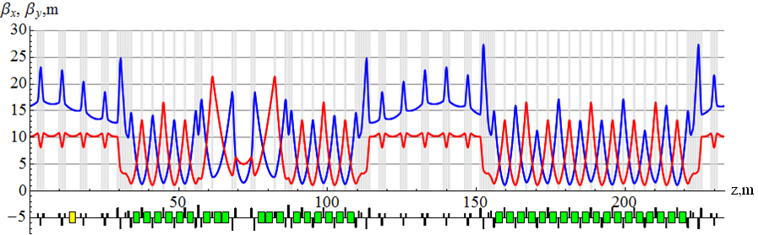

**Figure 3.25:** β functions in an unperturbed lattice of the figure-8 booster.

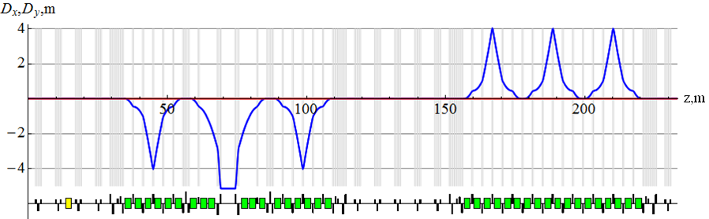

**Figure 3.26:** Dispersion in an unperturbed lattice of the figure-8 booster.

**3.2.2 *Calculation of proton and deuteron polarizations in figure-8 booster***

Let us use Zgoubi to demonstrate the effect of the incoherent and coherent parts of the resonance strength on proton and deuteron polarizations.

**Proton polarization**

*Incoherent part of the proton resonance strength*

To demonstrate the impact of the incoherent resonance component, Figs. 3.27 and 3.28 show changes in the protons vertical and longitudinal spin components as functions of energy in the figure-8 booster in the absence of errors. The filed ramp rate is 1 T/s. The particle makes 1.6⋅106 turns during acceleration.

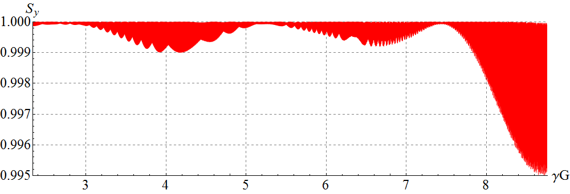

**Figure 3.27:** Proton vertical spin component vs γ*G* in an unperturbed lattice of the figure-8 booster. The initial conditions are: *x*0 = 1 cm, =0 rad, *y*0 = 1 cm, = 0 rad, and Δp/p = 0.

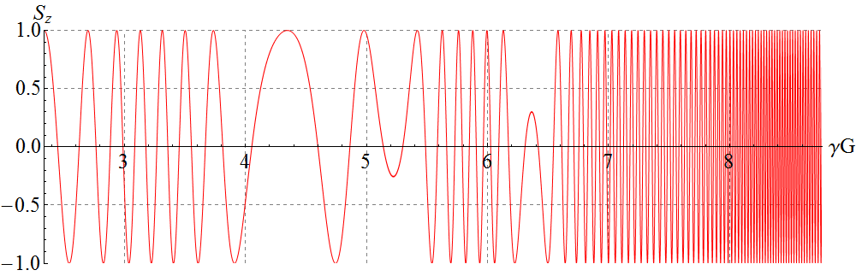

**Figure 3.28:** Proton longitudinal spin component vs γ*G* in an unperturbed lattice of the figure-8 booster. The initial conditions are: *x*0 = 1 cm, =0 rad, *y*0 = 1 cm, = 0 rad, and Δp/p = 0.

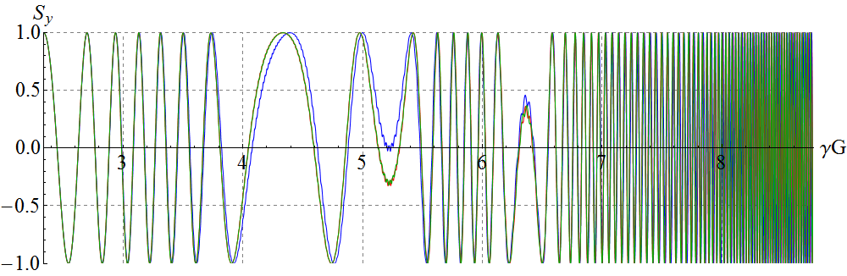

**Figure 3.29:** Proton vertical spin component vs γ*G* in an unperturbed figure-8 booster for three particles with Δp/p=5⋅10-4 and with the initial phases of synchrotron motion differing by 120°. The initial conditions for all particles are: *x*0 = 1 cm, =0 rad, *y*0 = 1 cm, and $y_{0}^{'}$ = 0 rad.

As we can see, the vertical spin component practically does not change during acceleration, while the longitudinal one undergoes oscillations. This means that the incoherent part of the resonance strength ωincoherent is directed vertically. If a particle is launched with longitudinal polarizatoin its spin will complete one revolution after 1/ωincoherent number of turns. Thus, the inverse of the longitudinal polarization oscillation period in an ideal booster lattice determines the incoherent part of the resonance strength.

Figure 3.28 gives that the incoherent part of the resonance strength at the beginning of acceleration is of the order of 10-5 and increases at the end of acceleration.

Figure 3.29 shows a calculation of the deuteron vertical spin component during acceleration in the same lattice for three particles including synchrotron oscillations (Δp/p=5⋅10-4, the initial phases of synchrotron motion differ by 120°). In contrast to the racetrack booster, influence of the synchrotron modulation on the spin motion in the figure-8 booster is not significant.

*Coherent part of the proton resonance strength*

The greatest contribution to the coherent part of the zero-integer resonance strength comes from quadrupole shifts in the plane transverse to the orbit’s one.

Figures 3.30 and 3.31 show diagrams of the random quadrupole shifts that were used when calculating the proton spin motion in the figure-8 booster. The sizes of the quadrupole shifts in the vertical and radial directions are given in the units of their rms deviation equal to 10-3 cm.

The graph in Fig. 3.32 shows the dependence of the proton vertical spin component on the energy in units of γ*G* when accelerating protons with a field ramp rate of 1 T/s in the figure-8 booster with random quadrupole shifts according to the diagrams presented in Figs. 3.30 and 3.31.

In figure-8 accelerators, the coherent part of the resonance strength ωcoherent lies in the plane of the accelerator. If a particle with vertical polarization is launched along the closed orbit, its spin will complete one revolution after 1/ωcoherent number of turns. Thus, the inverse period of oscillations of the vertical polarization will determine the coherent part of the resonance strength, which, as it can be seen from the graph in Fig. 3.32, should have maxima in the regions γ*G* ≈ 4, γ*G* ≈ 7 and γ*G* ≈ 8.5.

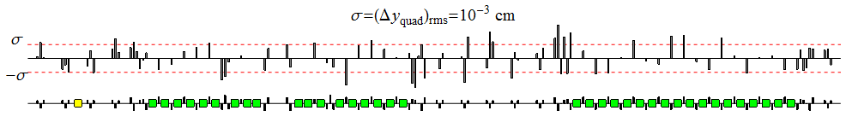

**Figure 3.30:** Diagram of vertical quadrupole misalignments in the booster. The errors are distributed normally with an rms deviation of $σ=Δy_{quad}={10}^{-3}cm$.

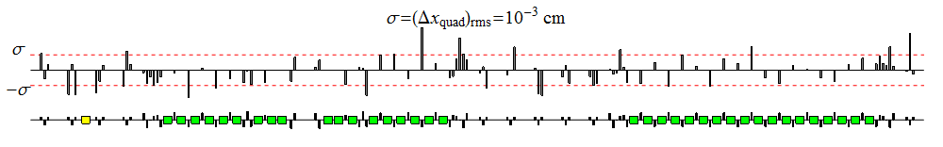

**Figure 3.31:** Diagram of radial quadrupole misalignments in the booster. The errors are distributed normally with an rms deviation of $σ=Δx_{quad}={10}^{-3}cm$.

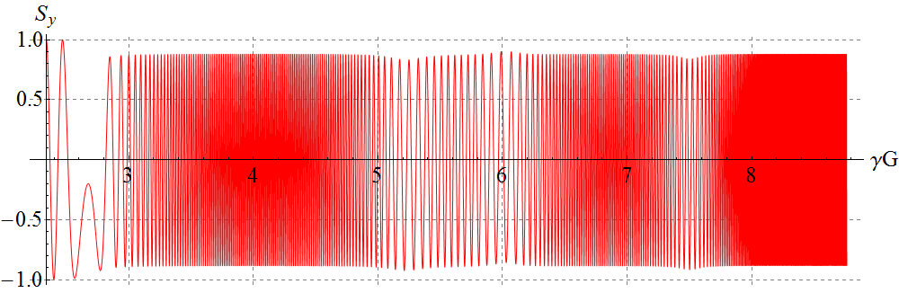

**Figure 3.32:** Proton vertical spin component vs γ*G* for a synchronous particle in the figure-8 booster with random quadrupole shifts. The particle is launched along the distorted closed orbit.

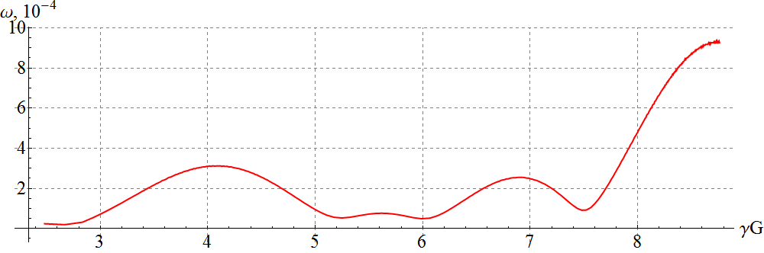

**Figure 3.33:** Coherent part of the resonance strength vs γ*G* in the figure-8 booster.

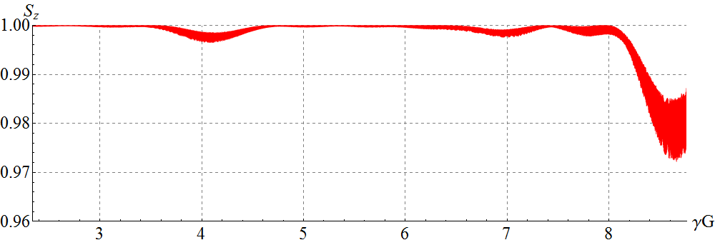

**Figure 3.34:** Proton longitudinal spin component vs γ*G* in the figure-8 booster with random quadrupole shifts and with the spin stabilizing solenoid. The initial values are: *x*0 = 1 cm, =0 rad, *y*0 = 1 cm, and $y_{0}^{'}$ = 0 rad.

The graph in Fig. 3.33 shows the dependence of the coherent part of the resonance strength on the energy in units of γ*G*. The coherent part has a periodic behavior and its maximum value does not exceed 10-3.

To stabilize the longitudinal direction of the proton spin in the whole energy range during acceleration, it is sufficient to introduce a “weak” solenoid inducing a spin tune value significantly greater than the resonance strength.

Figure 3.34 shows the change in the proton longitudinal spin component in the booster with a stabilizing solenoid. Providing a spin tune equal to 5⋅10-3 requires a field integral changing proportionally to momentum with a maximum value of 0.1 Tm. As we can see, the longitudinal polarization is stabilized in the whole energy range with a precision better than 3%. In principle, by choosing an optimal collider injection energy, one can significantly improve the beam polarization. For instance, when extracting the beam at the energy corresponding to a value of γ*G* ≈ 7.5, the change in the proton longitudinal polarization will be less than 0.1% at the same field strength of the solenoid.

***Deuteron polarization***

*Incoherent part of the deuteron resonance strength*

To demonstrate the impact of the incoherent resonance component, Figs. 3.35 and 3.36 show the changes in the deuteron vertical and longitudinal spin components as functions of the energy in the figure-8 booster with a field ramp rate of 1 T/s in the absence of errors. The particle made 3⋅106 turns during acceleration. The graphs give that the incoherent part of the resonance strength, as in the proton case, is directed vertically. The change in the vertical component at the exit from the booster is less than 10-8. The longitudinal component changed by only 5% during the whole acceleration cycle. This allows one to make a rough estimate that the average value of the incoherent part does not exceed 10-8 at the exit from the booster.

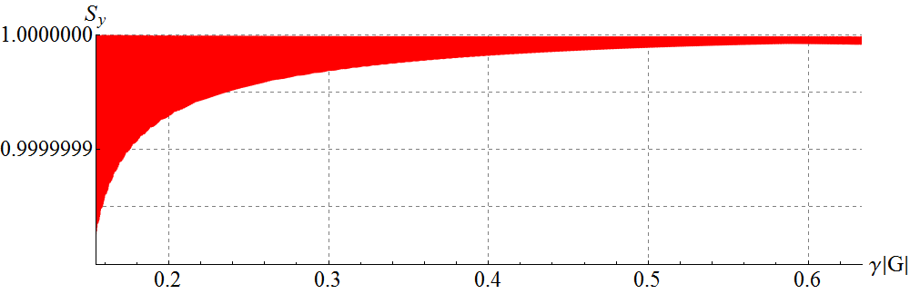

**Figure 3.35:** Deuteron vertical spin component vs γ|*G|* in an unperturbed lattice of the figure-8 booster. The initial conditions are: *x*0 = 1 cm, =0 rad, *y*0 = 1 cm, = 0 rad, and Δp/p = 0.

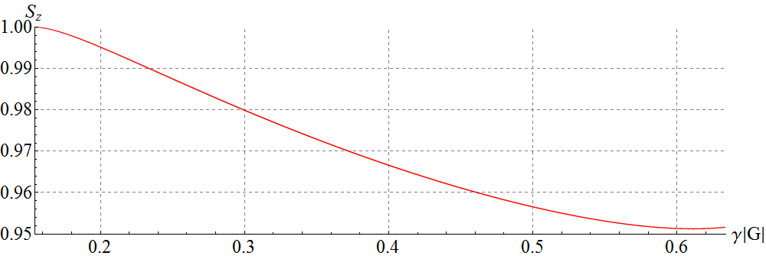

**Figure 3.36:** Deuteron longitudinal spin component vs γ|*G|* in an unperturbed lattice of the figure-8 booster. The initial conditions are: *x*0 = 1 cm, =0 rad, *y*0 = 1 cm, = 0 rad, and Δp/p = 0.

*Coherent part of the deuteron resonance strength*

The graph in Fig. 3.37 shows the dependence of the deuteron vertical spin component on the energy in units of γ|*G|* when accelerating deuterons with a field ramp rate of 1 T/s in the figure-8 booster with random quadrupole shifts according to the diagrams presented in Figs. 3.30 and 3.31. One can make a rough estimate from the graph that the coherent part of the resonance strength has an order of magnitude of 10-7 at the entrance and 10-6 at the exit from the booster.

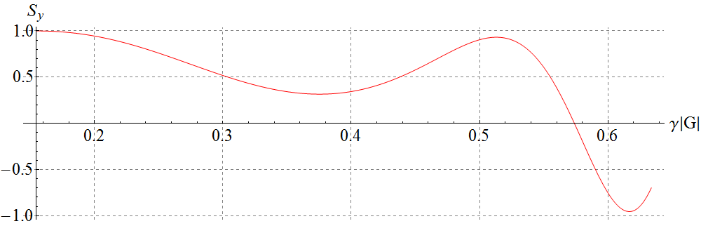

**Figure 3.37:** Deuteron vertical spin component vs γ|*G|* for a synchronous particle in the figure-8 booster with random quadrupole shifts. The particle was launched along the distorted closed orbit.

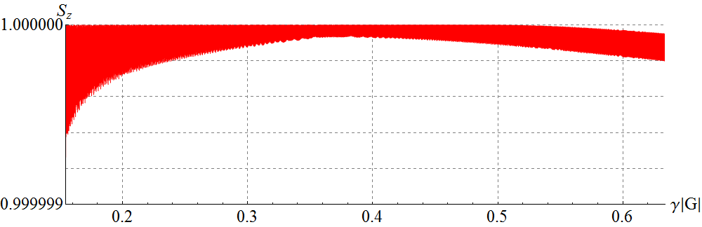

**Figure 3.38:** Deuteron longitudinal spin component vs γ*G* in the figure-8 booster with random quadrupole shifts and with the stabilizing solenoid. The initial conditions are: *x*0 = 1 cm, =0 rad, *y*0 = 1 cm, and $y_{0}^{'}$ = 0 rad.

Figure 3.38 shows the change in the deuteron longitudinal spin component in the booster with a stabilizing solenoid. The same solenoid was used in the calculation as in the proton case. As we can see, the longitudinal polarization is stabilized in the whole energy range with a precision better than 5⋅10-7.

The presented examples show an exceptional stability of the deuteron polarization in the figure-8 booster.

**4.** **Control of proton and deuteron polarizations in   
the JLEIC ion collider ring using 3D spin rotators**

This chapter presents the results of verification of the proton and deuteron polarization control scheme in the JLEIC ion collider ring using the Zgoubi spin tracking code. We first calculate the incoherent component of the resonance strength, which determines the depolarizing effect on the ion beam and sets the necessary requirements on the proton and deuteron spin tune shifts with 3D spin rotators. We then model the spin motion at the beam interaction point when the 3D spin rotators are used to set the transverse and longitudinal orientations of the proton and deuteron polarizations. We next calculate the coherent part of the resonance strength caused by misalignments of the collider quadrupoles. Finally, we demonstrate compensation of the coherent part of the resonance strength by a second 3D spin rotator that allows one to significantly improve the spin characteristics of the beam and to reduce the requirement on the fields of the control solenoids in the 3D spin rotator.

**4.1 Proton and deuteron polarization in an ideal lattice of the JLEIC ion collider ring**

An ideal lattice of the ion collider ring is transparent to the spin, i.e., when a particle moves on a closed figure-8 orbit, its spin repeats itself after every particle turn. This means that the collider does not have a preferred orientation of the $\vec{n}$  axis and the particle is in the region of the zero-integer spin resonance. The indicated degeneracy of the spin motion is removed when a particle deviates from the ideal closed orbit. In that case, the spin motion is determined by the strength of the zero-integer spin resonance, which consists of two parts, namely, the coherent and incoherent parts of the resonance strength.

Figures 4.1a and 4.1b show graphs of the spin components in an ideal lattice of the collider ring for proton and deuteron beams. The beam momentum is 60 GeV/c. The particle was launched along the closed orbit with vertically (Fig. 4.1a) and longitudinally (Fig. 4.1b) oriented spin.

|  |  |
| --- | --- |
|  |  |
| **Figure 4.1a:** Proton spin components in an ideal collider lattice. The initial conditions are: *Sy*=1, *x*0=*y*0=0 μm, ==0 mrad. | **Figure 4.1b:** Deuteron spin components in an ideal collider lattice. The initial conditions are: *Sz*=1, *x*0=*y*0=0 μm,= =0 mrad. |
|  |  |
| **Figure 4.2a:** Proton vertical spin component in an ideal collider lattice when including betatron oscillations (the initial condition is: *Sy* = 1). | **Figure 4.2b:** Proton spin components in an ideal collider lattice when including betatron oscillations (the initial condition is: *Sz* = 1). |

As can be seen from Figs. 4.1a and 4.1b, when a particle is launched along the ideal closed orbit, the spin does not change at all, which means that the coherent part of the spin resonance strength equals zero in an ideal collider lattice.

Figs. 4.2a and 4.2b show calculations of the proton spin dynamics for the transverse beam size at the interaction point of 25×5 μm2. The spin was started in vertical (Fig. 4.2a) and longitudinal (Fig. 4.2b) directions. The graphs in Figs. 4.2a and 4.2b yield that the incoherent resonance strength component is directed vertically and its value for protons is about *w*incoh = 1.8 10-5. Note that, for the particle offset from the closed orbit, the modulation of its vertical spin component occurs at a doubled frequency. This confirms that the average spin field due to betatron oscillations is determined by the second order of the averaging method (compare Figs. 4.2a and 4.2b).

Similar calculations for deuterons show that their incoherent resonance strength component is also directed vertically and its value is about *w*incoh = 0.7 10-9.

*Characteristics and placement of a 3D spin rotator in the ion collider ring*

To control the ion polarization in an ideal lattice of the ion collider ring, it is sufficient to use a single 3D rotator, which consists of three modules for control of the radial, vertical, and longitudinal beam polarization components.

Figure 4.3a shows the module for control of the radial polarization component *nx*, which consists of two pairs of opposite-field solenoids and three vertical-field dipoles producing a fixed orbit bump. The control module for the vertical polarization component *ny* is the same as that for the radial component except that the vertical-field dipoles are replaced with radial-field ones (Fig. 4.3b). To keep the orbit bumps fixed, the fields of the vertical- and radial-field dipoles must be ramped proportionally to the beam momentum. The module for control of the longitudinal polarization component *nz* consists of a single weak solenoid (Fig. 4.3c). There is a substantial flexibility in the placement and arrangement of these modules in the collider.

|  |  |  |
| --- | --- | --- |
|  |  |  |
| **(*a*) *nx* module** | **(*b*) *ny* module** | **(*c*) *nz* module** |

**Figure 4.3:** Modules for control of the radial (*a*), vertical (*b*), and longitudinal (*c*) spin components.

Given below are the formulae for calculation of the spin rotation angles $φ_{zi}$ in the control solenoids for a given polarization direction at the 3D spin rotator location ${\vec{n}=(n}_{x},n_{y},n_{z})$ and a given value of the spin tune ν (linear approximation in ν):

$$n_{x} module: φ_{z1}=πν\frac{n_{x}}{\sin{φ_{y}}}, { φ}_{z10}=\frac{πν}{2}\frac{n_{x}}{\tan{φ_{y}}}, φ_{y}=γGα_{orb} ,$$

$$n_{y} module: φ_{z2}=πν\frac{n_{y}}{\sin{φ_{x}}}, { φ}_{z20}=\frac{πν}{2}\frac{n_{y}}{\tan{φ_{x}}}, φ_{x}=γGα_{orb} ,$$

$$n_{z} module: φ_{z3}=πνn_{z} .$$

The field $B_{zi}$ of a control solenoid of length $L_{zi}$ can be calculated using the formula:

$$B_{zi}=\frac{φ_{zi}}{(1+G)L_{zi}} .$$

Schematic placement of the 3D rotator elements in the collider ring’s experimental straight is shown in Fig. 4.4 [10,15]. The lattice quadrupoles are shown in black, the vertical-field dipoles are green, the radial-field dipoles are blue, and the control solenoids are yellow. With each module’s length of ~7 m, the fixed orbit deviation in the bumps is ~15 mm in the whole momentum range of the collider. The 3D spin rotator can provide any desired polarization orientation at the interaction point. The maximum required dipole and solenoid magnetic field strengths are 3 and 3.6 T, respectively.

Figure 4.5 shows placement of the 3D rotator magnetic elements in the ion collider ring with the following parameters: $L_{x}=L_{y}=0.6 m, L_{zi}=2 m, L_{zi0}=1 m, { α}_{orb}={0.31}^{∘}.$

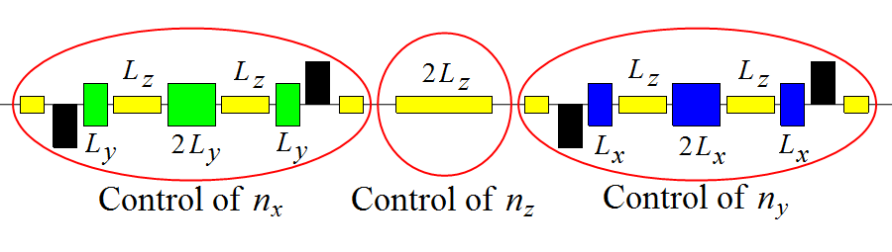

**Figure 4.4:** Schematic placement of the 3D spin rotator elements.

**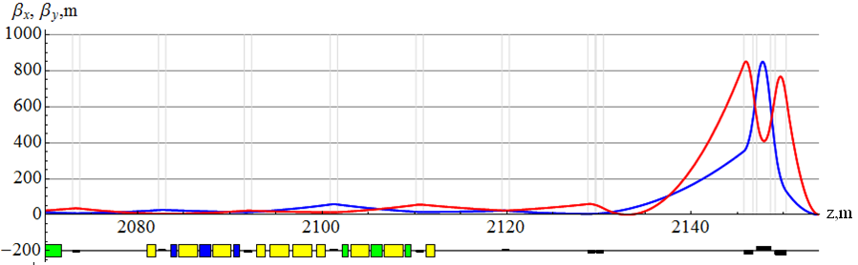**

**Figure 4.5:** Placement of the 3D rotator in the ion collider lattice. The yellow rectangles are the control solenoids, the blue rectangles are the dipoles with radial magnetic field direction, and the green rectangles are the dipoles with vertical magnetic field direction.

Below we consider examples of obtaining transverse and longitudinal polarizations at the collider’s interaction point. To demonstrate the stability of the beam polarization, besides calculating the spin components of a particle launched along the closed orbit, we provide similar calculations for a particle offset from the closed orbit and undergoing betatron oscillations.

*Obtaining transverse polarization at the collider’s interaction point*

As an example let us consider obtaining radial proton polarization at the collider’s interaction point. Figures 4.6a-4.6d show graphs of changes in the spin components in an ideal collider lattice. The 3D rotator parameters are: *nx*=1, νsol=0.01. The beam momentum is 60 GeV/c. The particle is launched along the closed orbit with radial (Fig. 4.6a) and longitudinal (Fig. 4.6b) spin directions. Figures 4.6c and 4.6d show similar calculations for the transverse beam size at the interaction point of 25×5 μm2. As can be seen from Figs. 4.6b and 4.6d, the proton spin tune value induced by the 3D rotator is practically independent of betatron oscillations and remains equal to 10-2.

|  |  |  |
| --- | --- | --- |
|  |  | |
| **Figure 4.6a:** Proton spin components in an ideal collider with a 3D rotator setting of *nx*=1, νsol=0.01. The initial conditions are: *Sx*=1, *x*0=*y*0=0 μm, ==0. | **Figure 4.6b:** Proton spin components in an ideal collider with a 3D spin rotator setting of *nx*=1, νsol=0.01. The initial conditions are: *Sz*=1, *x*0=*y*0=0 μm,== 0. | |
|  |  |
| **Figure 4.6c:** Proton radial spin component in the presence of betatron motion with a 3D rotator setting of *nx*=1, νsol=0.01. The initial conditions are: *Sx*=1, *x*0=25μm, *y*0=5μm,= =0 mrad. | **Figure 4.6d:** Proton spin components in the presence of betatron motion with a 3D rotator setting of *nx*=1, νsol=0.01. The initial conditions are: *Sz*=1, *x*0=25μm, *y*0=5μm,= =0 mrad |

Our calculations show that, when setting vertical polarization at the collider’s interaction point, the spin dynamics is similar to the case of the radial polarization setting considered above.

*Obtaining longitudinal polarization at the collider’s interaction point*

As an example, let us consider obtaining longitudinal deuteron polarization at the collider’s interaction point. Graphs of change in the spin components in an ideal collider lattice are shown in Figs. 4.7a-4.7d. Parameters of the 3D rotator are: *nz*=1, νsol=10-4. The beam momentum is 60 GeV/c. The particle is launched along the closed orbit with longitudinal (Fig. 4.7a) and vertical (Fig. 4.7b) spin directions. Similar calculations for the transverse beam size at the interaction point of 25×5 μm2 are shown in Fig. 4.7c and 4.7d. As can be seen from Figs. 4.7b and 4.7d, the deuteron spin tune value induced by the 3D rotator is practically independent of betatron oscillations and remains equal to 10-4.

Note the exceptional stability of deuterons in regard to the incoherent spin resonance strength: the longitudinal component changed by only 10-6 in the presence of betatron oscillations.

The presented calculations confirm the stability of polarization in the ion collider ring when using a 3D spin rotator, which provides the spin tune values of 10-2 for protons and 10-4 for deuterons.

|  |  |
| --- | --- |
|  |  |
| **Figure 4.7a:** Deuteron spin vector in an ideal collider with a 3D rotator setting of *nz*=1, νsol=10-4. The initial conditions are: *Sz*=1, *x*0=*y*0=0 μm, = = 0. | **Figure 4.7b:** Deuteron spin vector in an ideal 3D collider with a 3D rotator setting of *nz*=1, νsol=10-4. The initial conditions are: *Sy*=1, *x*0=*y*0=0 μm,= = 0. |

|  |  |
| --- | --- |
|  |  |
| **Figure 4.7c:** Deuteron longitudinal spin component in the presence of betatron motion with a 3D rotator setting of *nz*=1, νsol=10-4. The initial conditions are: *Sy*=1, *x*0=25μm, *y*0=5μm,= =0 mrad. | **Figure 4.7d:** Deuteron spin components in the presence of betatron motion with a 3D rotator setting of *nz*=1, νsol=10-4. The initial conditions are: *Sy*=1, *x*0=25μm, *y*0=5μm,= =0 mrad. |

**4.2 Impact of lattice imperfections on polarization in the JLEIC ion collider ring**

In real conditions, there are always errors in the manufacture of collider magnetic lattice elements as well as errors in alignment of these elements along the collider’s design orbit. These lattice imperfections lead to a change in the collider’s closed orbit. As a result, particle spins experience additional coherent rotations caused by perturbing magnetic field when the particles are moving along the distorted periodic closed orbit. The combined effect of these magnetic fields on the spin determines the coherent part of the resonance strength.

*Coherent component of the resonance strength in a non-ideal collider lattice*

One of the main reasons for appearance of the coherent resonance strength component are random quadrupole shifts resulting in a change in the collider’s closed orbit.

Figures 4.8 and 4.9 show diagrams of random quadrupole shifts, which are used in calculations of the proton spin motion in the collider. The sizes of the quadrupole shifts in the vertical and radial directions are given in units of their rms deviation equal to 5 µm. The diagrams also indicate the locations of the control 3D rotator (1st 3D-rotator) and of the compensating 3D rotator (2nd 3D-rotator). The indicated quadrupole alignment errors result in a closed orbit distortion in the arcs of a few hundred µm (see Fig. 4.10).

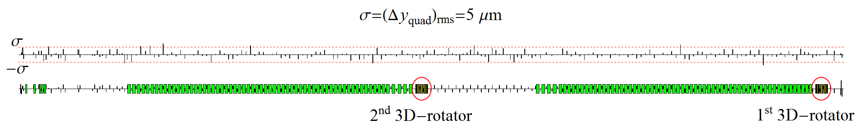

**Figure 4.8:** Diagram of vertical quadrupole alignment errors in the collider ring distributed normally with $σ_{rms}= Δy_{quad}=5 μm$.

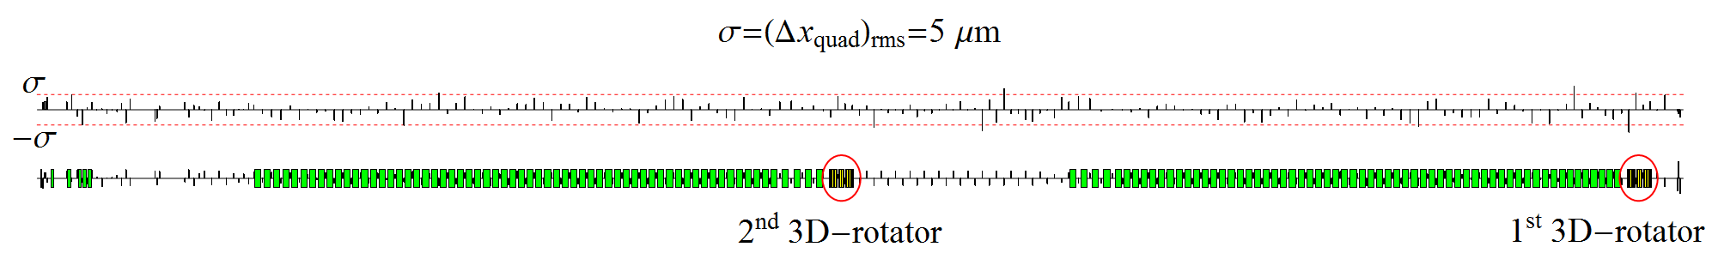

**Figure 4.9:** Diagram of radial quadrupole alignment errors in the collider ring distributed normally with $σ_{rsm}=Δx_{quad}=5 μm$ 
.

|  |  |
| --- | --- |
|  |  |

**Figure 4.10:**Radial and vertical orbit excursions with random misalignments of all quadrupoles in the collider ring.

|  |  |
| --- | --- |
|  |  |
| **Figure 4.11a:** Proton spin components at the interaction point in an non-ideal collider lattice with the 3D rotators off. | **Figure 4.11b:** Deuteron spin components at the interaction point in an non-ideal collider lattice with the 3D rotators off. |

To determine the coherent part of the resonance strength, Fig. 4.11 demonstrates graphs of the proton and deuteron spin components versus the number of particle turns in the collider with the random quadrupole shifts as per the diagrams in Figs. 4.8 and 4.9. The particle is launched from the beam interaction point along the closed orbit with longitudinal spin.

The proton spin completes 2 oscillations in 793 particle turns. The coherent part of the resonance strength is then about $w_{coh}^{prot}≈2.52⋅{10}^{-3}$. The deuteron spin completes 1 oscillation in 87550 particles turns, which gives the coherent part of the resonance strength equal to about $w_{coh}^{deut}≈1.14⋅{10}^{-5}$  
.

As noted above, the coherent part of the resonance strength itself does not cause beam depolarization. On the contrary, by finding the unknown direction of the coherent part, which is determined by random quadrupole misalignments, one can stabilize the particle’s spin.

To find the direction of the precession axis $\vec{n}$ induced by the coherent part of the resonance strength, one can also use the graphs in Fig. 4.11. Since the spin component along the $\vec{n}$ axis is an invariant of the spin motion, the average spin value $〈\vec{S}〉$ is directed along the $\vec{n}$ axis:

$$〈\vec{S}〉=S_{n} \vec{n} .$$

Thus, by calculating the average spin components as half sums of the maximum and minimum values of the corresponding spin components:

$$〈S_{x}〉=\frac{{{(S}_{x})}_{min}+⁡{{(S}_{x})}_{max}}{2} , 〈S_{y}〉=\frac{{{(S}_{y})}_{min}+⁡{{(S}_{y})}_{max}}{2} , 〈S_{z}〉=\frac{{{(S}_{z})}_{min}+⁡{{(S}_{z})}_{max}}{2} ,$$

we get the  axis components:

$$n_{x}=±\frac{〈S_{x}〉}{S_{n}} , n_{y}=±\frac{〈S_{y}〉}{S_{n}} , n_{z}=±\frac{〈S_{z}〉}{S_{n}} , S_{n}=\sqrt{{〈S_{x}〉}^{2}+{〈S_{y}〉}^{2}+{〈S_{z}〉}^{2}} .$$

The sign of the $\vec{n}$ vector is determined from the condition that the spin vector rotates about $\vec{n}$ counterclockwise. Calculations of the proton and deuteron precession axes at the interaction point give:

$${\vec{n}}_{IP}^{prot}=\left( -0.665 , 0.011,-0.746 \right), {\vec{n}}_{IP}^{deut}=\left( 0.939, 0.001,0.343\right).$$

If a particle is launched along the closed orbit with its initial spin direction being along ${\vec{n}}_{IP}$ at the interaction point, then the polarization will be stable from turn to turn of the particle, which is completely confirmed by the calculations presented in Fig. 4.12.

|  |  |
| --- | --- |
|  |  |
| **Figure 4.12a:** Stable proton polarization at the interaction point in a non-ideal collider lattice with the 3D rotators off. | **Figure 4.12b:** Stable deuteron polarization at the interaction point in a non-ideal collider lattice with the 3D rotators off. |

*Compensation of the depolarization caused by imperfections*

Below we consider compensation of the coherent part of the resonance strength using protons as example. The deuteron case can be considered similarly.

The calculation of the coherent part of the resonance strength in the collider ring shows that its value for protons is $ω_{coh}^{prot}≈2.5⋅{10}^{-3}$. This means that using a 3D rotator with a spin tune of 10-2 to control the proton polarization already becomes, at least, inconvenient, since, during a spin manipulation process, one should always make a “correction” of the spin field for the coherent part of the resonance strength. Besides, the coherent part grows with increase in energy along with the fields required for its compensation. Nevertheless, the solenoid fields of the control 3D rotator can be left at the same level if one compensates the coherent part of the resonance strength using a second 3D rotator with static field located in the opposite straight (see Fig. 4.8).

To determine the direction of the precession axis induced by the coherent part of the resonance strength near the 2nd 3D rotator, Fig. 4.13a shows graphs of the proton spin components versus the number of particle turns in the collider ring with the random quadrupole shifts according to the diagrams presented in Fig. 4.8 and 4.9. The particle is launched from the interaction point along the closed orbit with longitudinal spin. The spin is observed near the 2nd 3D rotator in a section opposite to the interaction point. The graph yields that the direction of the spin precession axis ${\vec{n}}_{2}$ near the second 3D rotator is

$${\vec{n}}_{2}=\left( 0.887, -0.002, 0.463\right).$$

|  |  |
| --- | --- |
|  |  |
| **(a)** | **(b)** |
| **Figure 4.13:** Proton spin components in a section opposite to the interaction point in a non-ideal collider lattice with the 3D rotators off before **(a)** and after **(b)** compensation of the coherent part of the resonance strength. | |

Figure 4.13b shows the spin components after compensation of the coherent part of the resonance strength. The parameters of the compensating 3D rotator were chosen as

$${\vec{n}}_{comp}={\vec{n}}_{2}=\left( 0.887, -0.002, 0.463\right), ν_{comp}=-ω_{coh}=-2.52 {10}^{-3}.$$

The graph in Fig. 4.13b yields that, after compensation, the coherent part of the resonance strength, became $2.7⋅{10}^{-5}$, i.e. decreased practically to the value of the incoherent part of the resonance strength.

Since we set the 3D rotator parameters using formulae derived in the linear approximation in the spin tune $ν$, the accuracy of compensation in an ideal collider lattice is determined by the square of the spin tune $ν^{2}\sim 5⋅{10}^{-6}$. One can further improve the compensation by specifying the 3D rotator parameters up to the second order including the non-commutativity of the spin rotations about the different axes in the 3D rotator modules. One should also analyze the effect on the 3D rotator of additional fields arising inside the rotator due to random quadrupole misalignments.

Figure 4.14a shows a graph of the spin component evolution in a non-deal collider lattice when setting vertical proton polarization at the interaction point with compensation of the coherent part of the resonance strength. The parameters of the control 3D rotator are: *ny*=1, νsol=0.01. The beam momentum is 60 GeV/c. The particle is launched along the closed orbit with vertical spin. For comparison, Fig. 4.14b shows a similar graph without compensation of the coherent part of the resonance strength.

|  |  |
| --- | --- |
|  |  |
| **(a)** | **(b)** |
| **Figure 4.14:** Setting vertical polarization in a non-ideal collider lattice with **(a)** and without **(b)** compensation of the coherent part of the resonance strength. | |

The provided example shows that a non-ideal collider with compensation of the coherent part of the spin resonance strength becomes equivalent to an ideal one in terms of polarization control.

**4.3** **Spin flipping in the ion collider ring**

A 3D spin rotator allows one to make reversals of the particle spins during an experiment by slowly (adiabatically) changing the solenoid fields of the 3D spin rotator to rearrange the spin motion [28]. To preserve the polarization degree, one must meet the condition of adiabatic change in the spin direction, which has the following form for the number of particle turns $N_{flip}$ necessary to flip the spin:

$$N_{flip}≫\frac{1}{ν} .$$

We get a limit on the number of turns for a spin flip of $N_{flip}^{prot}≫{10}^{2}$ for protons and $N_{flip}^{deut}≫{10}^{4}$  
 for deuterons, which, in terms of the flip time, means $τ_{flip}^{prot}≫1 ms$ for protons and $τ_{flip}^{deut}≫0.1 s$ for deuterons. In practice, the adiabaticity condition is automatically satisfied, since the spin reversal time is limited by the field ramp rate in the super-conducting solenoids.

Let us provide the results of our calculation of the proton spin reversals in the vertical (*yz*) plane of the collider. The pattern of spin field change with the number of turns when making spin reversals is shown in Fig. 4.15. The number of turns is indicated in units of $N_{0}$, which is the number of turns for rotation of the spin from vertical to longitudinal direction. The vertical *hy* (green line) and longitudinal *hz* (red line) components of the spin field are set using the solenoids of the vertical *ny*- and longitudinal *nz*-modules of the 3D spin rotator. The magnitude of the spin field sets the spin tune value. Change in the spin tune in units of the maximum field $h_{max}$ is shown in Fig. 4.16.

Figure 4.17 shows the change in the proton spin components as a function of the number of turns for the indicated change in the spin field using the 3D rotator. Rotation from vertical to longitudinal direction and back is done in 50 thousand turns. The maximum spin tune value is 10-2. The spin components then follow the shape of the spin filed pattern practically everywhere, as it should be in case of adiabatic motion. Exceptions are small regions where the spin field has sharp breaks, in which the adiabaticity condition is violated. The spin is directed vertically up. Then a spin rotation takes place in 50 thousand turns. As we can see, the spin undergoes sequential rotations from the vertical-up direction to the longitudinal direction along the particle velocity, then to the vertical-down direction and finally to the longitudinal direction opposite to the particle velocity.

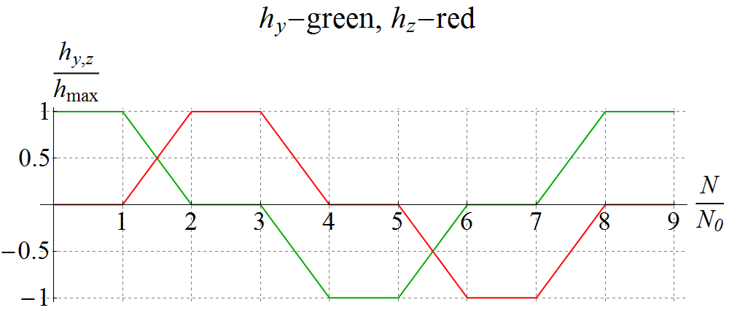

**Figure 4.15:** Pattern of change in the vertical *hy* and longitudinal *hz* spin field components when making spin reversals in the collider ring.

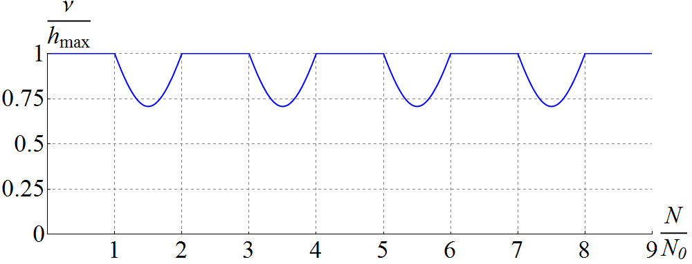

**Figure 4.16:** Change in the spin tune in units of the maximum spin field *h*max when producing rotations of the spin in the collider.

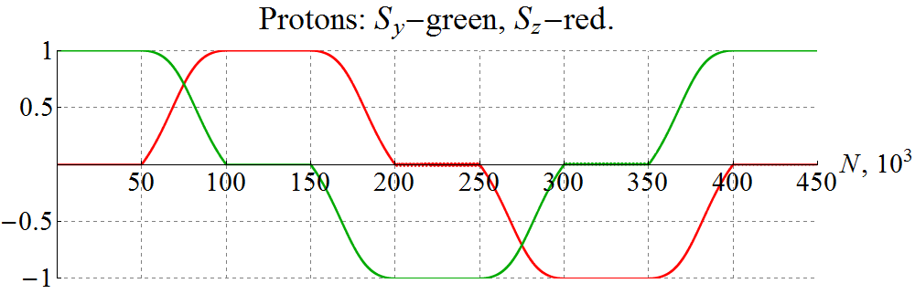

**Figure 4.17:** Producing rotations of the proton spin in an ideal collider lattice.

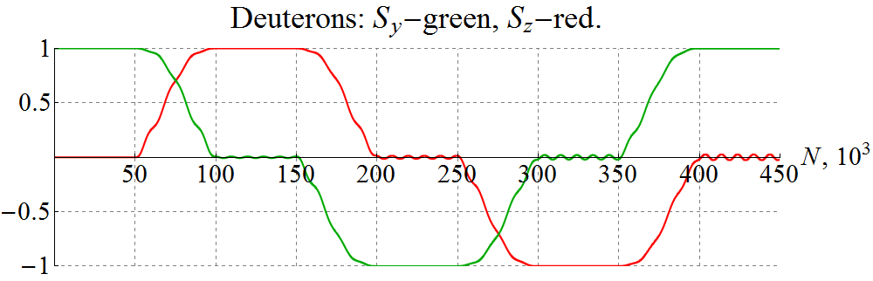

**Figure 4.18:** Producing rotations of the deuteron spin in an ideal collider lattice with violation of the adiabaticity condition of the spin motion.

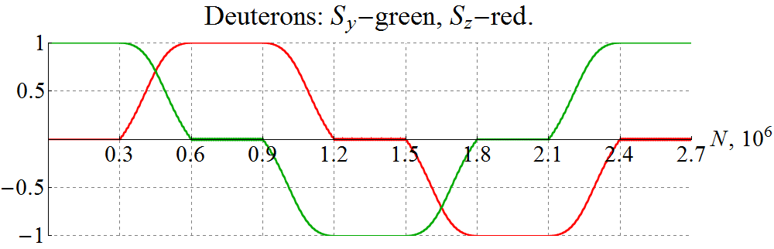

**Figure 4.19:** Producing rotations of the deuteron spin in an ideal collider lattice with the adiabatic condition of the spin motion satisfied.

To demonstrate a violation of the adiabatic condition of the spin motion during its rotations, Fig. 4.18 shows a similar graph for a deuteron when rotation from vertical to longitudinal direction is done in 50 thousand turns with a maximum spin tune value of 10-4. As we can see from the graphs, there appears an additional modulation of the spin components at the spin frequency, which gradually grows with increase in the number of turns.

To meet the adiabatic condition of the spin motion at the spin tune of 10-4, it is sufficient to complete the rotation from vertical to longitudinal direction in 300 thousand turns. A graph of the spin components when making deuteron spin rotations in this case are shown in Fig. 4.19. As we can see, now, as in the proton case, the spin practically everywhere follows the spin field according to the pattern in Fig. 4.15.

The presented calculations demonstrate the capability of implementing a spin-flipping system using a 3D rotator. Thus, the figure-8 JLEIC ion collider provides a unique capability of doing high-precision experiments with polarized ion beams.

**5.** **ConclusionS**

Let us summarize the main results presented in this report.

Comparison of the figure-8 and racetrack designs for the JLEIC ion rings led us to draw the following conclusions:

* a racetrack booster does not provide conceptual advantages over a figure-8 booster,
* a racetrack collider allows one to shorten the collider’s circumference by about 15% for protons but then excludes the possibility of experiments with polarized deuterons,
* a figure-8 collider allows one to run with any light ion beams.

We tracked proton and deuteron spins in the racetrack and figure-8 booster designs using Zgoubi to

* numerically analyze the impact of quadrupole manufacturing and setup errors on the proton polarization in the racetrack booster,
* show stability of the proton orbital motion and polarization in the racetrack booster with a solenoidal snake without compensation of betatron coupling,
* show stability of the deuteron polarization in the racetrack booster with a field ramp rate of 1 Т/s at an optimal choice of the betatron tunes,
* show stability of the proton and deuteron polarizations in the figure-8 booster,
* demonstrate that the degree of deuteron beam depolarization in a figure-8 booster is a few orders of magnitude smaller than in a racetrack one for any choice of the betatron tunes and the ramp rate of the superconducting field.

We used Zgoubi for spin tracking simulations of the ion polarization control in the JLEIC ion collider ring by means of 3D spin rotators. We were able to

* verify the ability of a 3D spin rotator to control the ion polarization in the JLEIC energy range,
* calculate the incoherent part of the resonance strength in the JLEIC ion collider ring for protons and deuterons, which sets a lower limit on the spin tune induced by a 3D rotator,
* calculate the coherent part of the resonance strength in the JLEIC ion collider ring for protons and deuterons within the statistical model of quadrupole alignment errors,
* numerically demonstrate compensation of the coherent part of the resonance strength, which significantly reduces the requirements on the strengths of the control solenoids in a 3D rotator,
* numerically modeled a spin flipping system implemented using a 3D rotator for protons and deuterons.

The results of this work have been presented at DSPIN’15 [1], IPAC’16 [2], and discussed at an accelerator seminar at Jefferson Lab on March 28, 2016. The results of our spin tracking simulations of the JLEIC ion collider ring will be presented at the SPIN’2016 and NAPAC’2016 conferences. The obtained results were regularly discussed at teleconferences with JLab’s CASA staff.

**Acknowledgements**

This work was supported by Jefferson Science Associates, LLC under U.S. DOE Contracts No. DE-AC05-06OR23177 and DE-AC02-06CH11357. The U.S. Government retains a non-exclusive, paid-up, irrevocable, world-wide license to publish or reproduce this manuscript for U.S. Government purposes.

**REFERENCES**

[1] V.S. Morozov, Y.S. Derbenev, F. Lin, Y. Zhang, Y. Filatov, A.M. Kondratenko, and M.A. Kondratenko, “Superconducting Racetrack Booster for the Ion Complex of MEIC”, proceeding of DSPIN2015.

[2] A.M. Kondratenko et al., “Ion Beam Polarization Dynamics in the 8 GeV Booster of the JLEIC Project at JLAB”, IPAC’16, WEPMW017, 2460-2462.

[3] Quarterly report “Superconducting racetrack booster for the ion complex of MEIC”, July 10, 2015

[4] Quarterly report “Comparison of figure-8 and racetrack designs in the MEIC Ion Complex”, October 12, 2015.

[5] Report “Calculation of proton and deuteron polarizations in racetrack and figure-8 boosters using Zgoubi”, March 07, 2016.

[6] Quarterly report “Verification of schemes for preservation of proton and deuteron polarizations in figure-8 and racetrack boosters using spin tracking simulations”, January 19, 2016.

[7] Quarterly report “Stability of proton polarization in the collider ring of JLEIC”, April 26, 2016.

[8] F. Méot, The ray-tracing code Zgoubi, NIM-A 427 (1999) 353-356; http://sourceforge.net/projects/zgoubi/

[9] Close out report “Ion Polarization Scheme for MEIC”, June 12, 2015.

[10] V.S. Morozov, Y.S. Derbenev, F. Lin, Y. Zhang, Y. Filatov, A.M. Kondratenko, and M.A. Kondratenko, “Baseline Scheme for Polarization Preservation and Control in the MEIC Ion Complex”, IPAC’15, TUPWI029.

[11] Ya.S. Derbenev, University of Michigan report UM HE 96-05 (1996).

[12] Ya.S. Derbenev, F. Lin, V.S. Morozov, Y. Zhang, A.M. Kondratenko, M.A. Kondratenko, and Yu.N. Filatov, “Ion polarization control in MEIC rings using small magnetic field integrals”, PoS (PSTP 2013) 026.

[13] A.M. Kondratenko, Ya.S. Derbenev, Yu.N. Filatov, M.A. Kondratenko, F. Lin, V.S. Morozov and Y. Zhang, “Ion Polarization Control in Figure-8 Rings Using Small Magnetic Field Integrals”, The Inter. Workshop EIC14, March 17-21, 2014, JLab, Newport News, VA, MOCAUD3.

[14] Ya.S. Derbenev, F. Lin, V.S. Morozov, Y. Zhang, A.M. Kondratenko, M.A. Kondratenko, Yu. Filatov, “Polarized Ion Beams in Figure-8 Rings of JLab’s MEIC”, IPAC’14, MOPRO004, p. 68.

[15] Ya.S. Derbenev, V.S. Morozov, F. Lin, Y. Zhang, A.M. Kondratenko, M.A. Kondratenko, and Yu.N. Filatov, “Polarization preservation and control in a figure-8 ring”, International Journal of Modern Physics: Conference Series, The 21st International Symposium on Spin Physics (SPIN2014), Beijing, China, 20-24 October 2014, to be published.

[16] E.D. Courant and R.D. Ruth, BNL 51270 (1980).

[17] L.G. Ratner, High Energy Spin Physics-1982, BNL, AIP Conference Proceedings 95, Particles and Fields Subseries 28, p.412 (1982).

[18] F.Z. Khiari et al., Phys. Rev. D 39 , 45-85 (1989).

[19] N.I. Golubeva, A.M. Kondratenko and Yu.N. Filatov, “A Jump in Spin Precession Frequency as a Method to Pass Spin Resonance”, Proc. of the Int. Workshop “Deuteron-93” (1994), p. 374.

[20] A.M. Kondratenko, M.A. Kondratenko and Yu.N. Filatov, “Compensation for particle beam depolarization of spin resonance intersection at accelerators”, PEPAN Lett. 1 5 (2004), pp 266-69.

[21] V.S. Morozov et al., “Experimental test of a new technique to overcome spin-depolarizing resonances”, Phys. Rev. Lett. 102, 244801 (2009).

[22] A.A. Smirnov et al., Le journal de Physique (1984).

[23] N.N. Agapov et al., 7th EPAC, MOP3A17.

[24] A.D. Kovalenko et al, EUCAS’2009, J. Phys. Conf. Ser. 234 (2010), pp.32-33.

[25] T. Khoe et al., “The Acceleration of Polarized Protons to 8.5 GeV/c”, Part. Accel. 6, 213 (1975).

[26] Report “Calculation of spin resonance crossing including synchrotron oscillations using Zgoubi”, teleconference JLab, November 3, 2015.

[27] E. Courant and H. Snyder, “Theory of the Alternating-Gradient Synchrotron”; Annals of Physics 3, 1-48 (1958).

[28] Quarterly report “Manipulation of the proton and deuteron polarizations in the MEIC ion collider and spin-flipping systems”, October 13, 2014.