ion beam polarization dynamics in the 8 GeV
booster of the jleic project at JLAB*
A.M. Kondratenko, M.A. Kondratenko, Science and Technique Laboratory Zaryad, Novosibirsk
Yu.N. Filatov, MIPT, Dolgoprudny, Moscow Region
Ya.S. Derbenev, F. Lin, V.S. Morozov, Y. Zhang, Jefferson Lab, Newport News, VA 23606, USA

Abstract
In the Jefferson Lab’s Electron-Ion Collider (JLEIC) project, an injector of polarized ions into the collider ring is a superconducting 8 GeV booster. Both figure-8 and racetrack booster versions were considered. Our analysis showed that the figure-8 ring configuration allows one to preserve the polarization of any ion species during beam acceleration using only small longitudinal field with an integral less than 0.5 Tm. In the racetrack booster, to preserve the polarization of ions with the exception of deuterons, it suffices to use a solenoidal Siberian snake with a maximum field integral of 30 Tm. To preserve deuteron polarization, we propose to use arc magnets for the racetrack booster structure with a field ramp rate of the order of 1 T/s. We calculate deuteron and proton beam polarizations in both the figure-8 and racetrack boosters including alignment errors of their magnetic elements using the Zgoubi code.

proton and deuteron polarizationS in racetrack booster
Proton spin resonances
Schemes for preservation of proton and deuteron polarizations during acceleration in figure-8 and racetrack boosters were presented at IPAC’15 and DSPIN2015 [1,2]. We choose a racetrack design most similar to the existing figure-8 booster design, i.e. keep the optical beam characteristics in the straights and in one FODO cell period of the booster arc [1]. The super-periodicity of the booster lattice is N = 2 and the radial and vertical betatron tunes equal ν_{x} = 5.95 and ν_{y} = 4.84, respectively.

* Authored by Jefferson Science Associates, LLC under U.S. DOE
Contracts No. DE-AC05-06OR23177 and DE-AC02-06CH11357.
The U.S. Government retains a non-exclusive, paid-up, irrevocable, world-wide license to publish or reproduce this manuscript for
U.S. Government purposes.
In a racetrack booster without a snake, the stable polarization points along the vertical axis and the spin tune is proportional to the beam energy ν = γ G (G is the anomalous part of the gyromagnetic ratio). This leads to crossing of spin resonances during acceleration and, as a consequence, to resonant depolarization of the beam.
The strongest effects on the spin come from intrinsic resonances (ν = k N ± ν_{y}) arising due to correlation of the spin with the betatron motion and from integer resonances (ν = k) related to closed orbit excursion. Effects on the spin of coupling resonances (ν = k ± ν_{x}) and non-super-periodic resonances ν = k ± ν_{y} (k ≠ mN) are significantly weaker.
Besides that, a strong influence on the ion polarization can also be caused by synchrotron energy modulation, which leads to splitting of a single resonance into a series of satellite resonances. For a fast crossing of a single resonance, account of energy modulation does not change the polarization value after the crossing, since all satellites are also crossed quickly. However, differences in the initial phases of the particles’ synchrotron motion and, at the same time, in their real rates of crossing of the satellite resonances result in the polarization “getting ruffled” after the crossing, i.e. leads to an incoherent mixing of the spins.
Below we use Zgoubi [3] to demonstrate the effect on the proton beam polarization of errors in the setup of the booster lattice elements (lattice imperfections), as well as of synchrotron energy modulation. We analyze the errors having the most significant impact on the beam polarization including random vertical quadrupole shifts causing an rms closed orbit excursion of a few hundred μm, random changes in quadrupole gradients with an rms value of 10⁻³ and random quadrupole roll with an rms value of 0.1 mrad. We track three particles including synchrotron modulation. Figure 1 shows the dependence of their vertical spin components on the energy in units of γG. The calculations here and in the rest of the text assume that the initial conditions for all particles are: x₀ = 10 mm, x’₀ = 0 rad and y₀ = 10 mm, y’₀ = 0 rad. Оne can see that, with the same momentum deviations and the same initial vertical spin components, the particles have different vertical spin components at the exit. Note that the particles are tracked only up to the transition energy of about 4 GeV, which poses no problem to the spin stability but requires a special treatment of the orbital dynamics.
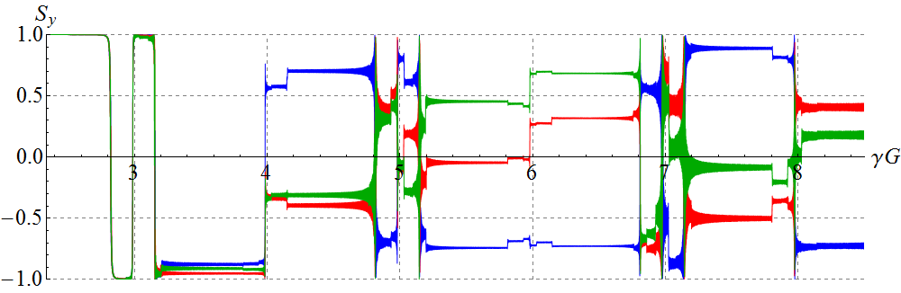
Figure 1: Proton vertical spin component vs γG in the racetrack booster for 3 particles with Δp/p=5⋅10⁻⁴ and with the initial synchrotron phases differing by 120°.
The presented calculation of the error and synchrotron modulation effects on the proton beam polarization in the conventional racetrack booster clearly demonstrates the difficulties arising with preservation of the polarization related to crossing of multiple spin resonances.
Proton polarization in racetrack booster
To avoid resonant depolarization during proton acceleration in a racetrack booster, one uses a solenoidal snake without compensation of betatron coupling. Figure 2 shows graphs demonstrating orbital stability in the racetrack booster with a strong betatron coupling.
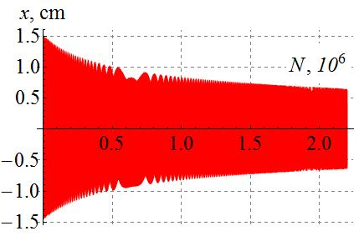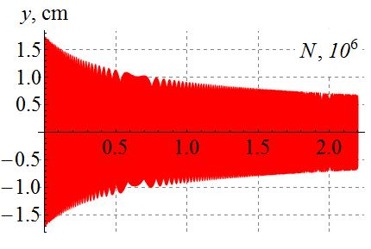
Figure 2: Radial and vertical beam sizes versus the number of turns in a racetrack booster with a solenoidal snake generating strong coupling of betatron oscillations.
The snake substantially rearranges the spin motion in the booster – the stable polarization in the straight opposite to the snake is directed along the beam. Figure 3 shows the longitudinal spin component as a function of the beam energy in the unperturbed lattice of the racetrack booster with the snake. The maximum change in the longitudinal spin component does not exceed 0.3%. The solenoidal snake eliminated beam depolarization related to crossing of strong intrinsic resonances inherent to the unperturbed booster lattice without a snake. Note that the snake also suppresses the beam depolarization caused by synchrotron energy modulation.
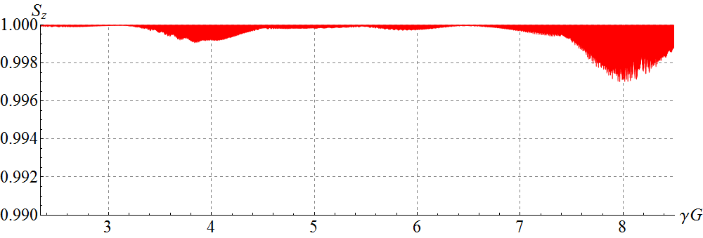
Figure 3: Proton longitudinal spin component vs γG in the unperturbed lattice of the racetrack booster with the solenoidal snake.
Deuteron polarization in racetrack booster
Deuteron vertical polarization is preserved in the conventional way. When choosing the betatron tunes at ν_{x} = 5.95 and ν_{y} = 4.84, the energy range of the racetrack booster contains only one spin resonance γ G =ν_{y} - 5, which is crossed quickly during acceleration using a field ramp rate of 1 T/s. Calculation of the deuteron vertical polarization included the following errors of the magnetic lattice: rms relative quadrupole strength error of 10⁻³, rms quadrupole roll error of 0.1 mrad, and random transverse quadrupole alignment error giving in an rms closed orbit excursion of a few hundred μm. The result is presented in Fig. 4. The effective alignment and roll errors were relatively small because there was no orbit correction.
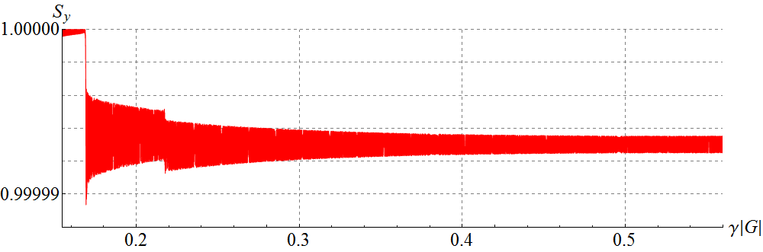
Figure 4: Vertical spin projection of deuterons vs γG in the figure-8 booster.
The calculation showed that change in the deuteron vertical polarization does not exceed 10⁻⁵. It should be emphasized that such a result is due to the absence of intrinsic resonances in this particular booster lattice, which are 2-3 orders of magnitude stronger than non-super-periodic ones. Since depolarization is proportional to the square of the resonance strength, in the presence of intrinsic resonances, the polarization may be completely lost even when accelerating with a field ramp rate of 1 T/s.

proton AND deuteron polarizations in figure-8 booster
Strength of the zero-integer spin resonance
The spin motion in figure-8 accelerators is determined by the strength of the zero-integer spin resonance, which consists of coherent and incoherent parts [4]. The coherent part of the resonance strength is mainly determined by errors leading to closed orbit distortion. In an ideal lattice, the incoherent part of the resonance strength is directed vertically and is determined by the emittances of betatron oscillations. Usually, the incoherent part is significantly smaller than the coherent part of the oscillations.
The greatest contribution to the coherent part of the zero-integer resonance strength comes from quadrupole shifts in the plane transverse to the orbit’s one. To demonstrate the impact of the coherent resonance part ω_{coherent}, it is enough to calculate the motion of a particle launched along the closed orbit with a vertical spin. Then its spin will complete one revolution after 1/ω_{coherent} number of turns. Thus, the inverse period of oscillations of the vertical polarization will determine the coherent part of the resonance strength. Figure 5 shows the dependence of the proton vertical spin component on the energy in units of γG when accelerating protons with a field ramp rate equal 1 T/s in the figure-8 booster with random quadrupole shifts with an rms value of 10⁻³ cm.
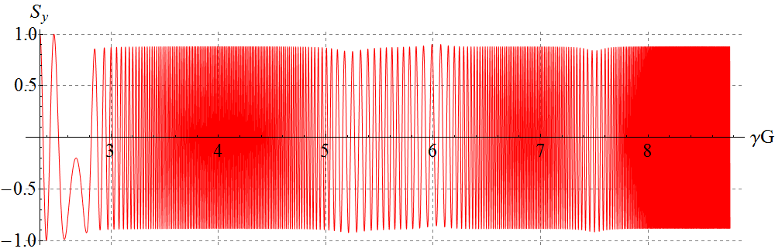
Figure 5: Proton vertical spin component vs γG for a synchronous particle in the figure-8 booster with random quadrupole shifts. The particle is launched along the distorted closed orbit.
The graph in Fig. 6 shows the dependence of the coherent part of the resonance strength on the energy in units of γG. The coherent part has a periodic behavior and its maximum value does not exceed 10⁻³. Similar calculations for deuterons show that their coherent part does not exceed a value of 10⁻⁵.
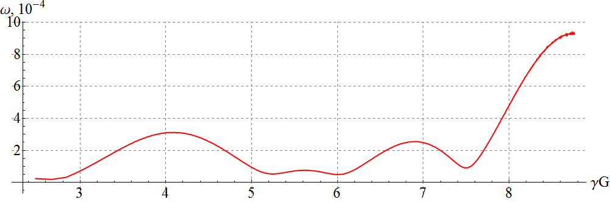
Figure 6: The coherent part of the proton resonance strength vs γG in the figure-8 booster.
Our calculations show that the incoherent part of the resonance strength is indeed vertical and does not exceed values of 10⁻⁵ for protons and 10⁻⁸ for deuterons.
Preservation of proton and deuteron polarizations in figure-8 booster
To stabilize both proton and deuteron longitudinal polarizations during acceleration in a figure-8 booster, it is sufficient to introduce a “weak” solenoid inducing a spin tune value significantly greater than the strength of the zero-integer spin resonance, which was generated by random quadrupole misalignments causing an rms closed orbit excursion of a few hundred μm. Figure 7 shows changes in the longitudinal polarization of protons and deuterons in the booster with the stabilizing solenoid. In calculating the proton and deuteron polarizations, we used the same solenoid with a maximum field integral of 0.1 Tm. As we can see, the longitudinal polarization is stabilized in the whole energy range with a precision better than 0.03 for protons and 2⋅10⁻⁷ for deuterons. The presented examples show an exceptional stability of the deuteron polarization in the figure-8 booster.
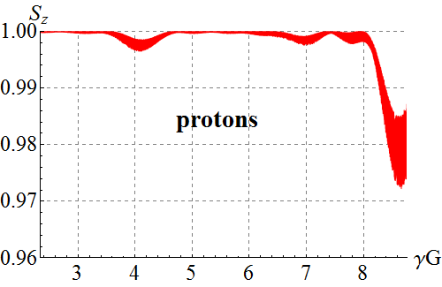
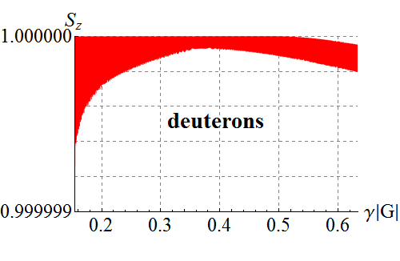
Figure 7: Longitudinal polarization of protons and deuterons vs γG in the figure-8 booster with the randomly misaligned quadrupoles and weak solenoid.
CONCLUSION
Let us briefly summarize the main conclusions obtained in the spin tracking of protons and deuterons in the racetrack and figure-8 boosters using Zgoubi.
- We numerically analyzed the impact of quadrupole manufacturing and setup errors and of synchrotron energy modulation on the proton polarization in the racetrack booster.
- We showed stability of the proton orbital motion and polarization in the racetrack booster with a solenoidal snake without compensation of betatron coupling.
- We showed stability of the deuteron polarization in the racetrack booster with a field ramp rate of 1 Т/s at an optimal choice of the betatron tunes.
- We showed stability of the proton and deuteron polarizations in the figure-8 booster.
- The degree of deuteron beam depolarization in the figure-8 booster is a few orders of magnitude smaller than in the racetrack booster for any choice of the betatron tunes and the ramp rate of superconducting field.
References
[1] A.M. Kondratenko et al., IPAC’15, TUPWI029.
[2] Yu.N. Filatov et al., J. Phys.: Conf. Ser 678 (2016) 012015 (XVI Workshop on HESP D-SPIN2015).
[3] F. Méot, The ray-tracing code Zgoubi, NIM-A 427 (1999) 353-356.
[4] A.M. Kondratenko et al., arXiv:1604.05632 [phys-ics.acc-ph] (2016).

