**Stability of proton polarization in the collider ring of JLEIC**

Numerical simulations of the ion polarization using Zgoubi [1] confirmed stability of the proton and deuteron polarizations in the figure-8 booster [2]. They demonstrated exceptional stability of the deuteron polarization. This tendency is preserved in the JLEIC collider ring as well: tolerances to errors and misalignments of collider’s magnetic elements and therefore the field integrals of the control solenoids are, first of all, determined by requirements of the proton beam polarization stability.

The proton polarization control scheme based on the use of weak solenoids is described in [3]. We used analytic methods to show that, to control the protons polarization, it is sufficient to use solenoids inducing a spin tune of 0.01 if the coherent part of the resonance strength is compensated. Below we present results of numerical analysis of proton polarization stability in the JLEIC collider ring at 60 GeV.

***Strength of the zero-integer spin resonance in the JLEIC collider ring***

The strength of the spin resonance is determined by the average values of the spin field components along the particle trajectories and consists of a coherent part related to optical lattice implementation errors and an incoherent part determined by emittances of the betatron and synchrotron oscillations: .

In an ideal lattice, the strength  is mainly related to vertical betatron oscillations in the collider’s arcs. It is calculated in the second order of the method of averaging the spin perturbation. It is proportional to the emittance of vertical oscillations and has vertical direction.

The strength  is related to errors of optical lattice implementation. It is determined by the fields along the perturbed closed orbit. It is calculated in the linear approximation of the averaging method and lies in the plane of the orbit.

In practice, the coherent part of the resonance strength significantly exceeds the incoherent part: . This means that depolarization of the beam in a figure-8 collider is vanishingly small. Even in the absence of the control solenoids, the polarization is stabilized by the coherent part of the resonance strength. Then the polarization direction is not controlled and is determined by errors of the collider lattice implementation.

***The incoherent part of the resonance strength.***

To calculate the incoherent part of the resonance strength, Fig. 1 shows changes in the proton vertical and longitudinal spin components as functions of the number of particle turns in the JLEIC collider in the absence of errors. The calculations assume that the proton beam size at the collider’s interaction point is 25х5 μm2 at 60 GeV. As we can see, the vertical spin component practically does not change, while the longitudinal one undergoes oscillations. This means that the incoherent part of the resonance strength ωincoherent is directed vertically. If a particle is launched with longitudinal polarization its spin will complete one revolution after 1/ωincoherent turns. Thus, the incoherent part of the spin resonance strength is about 2⋅10-5. The beam depolarization degree related to the vertical emittance in an ideal collider does not exceed 0.2%.

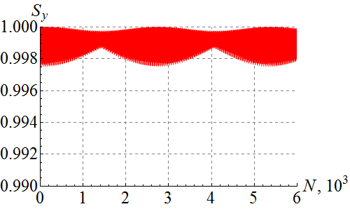 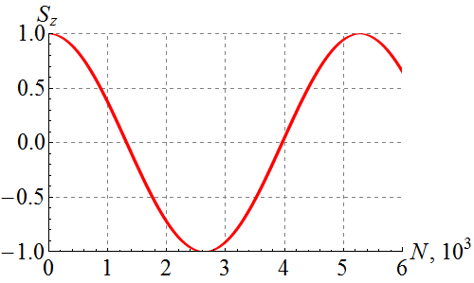

**Figure 1.** Proton vertical and longitudinal spin component vs the number of particle turns in an unperturbed lattice of the collider. The initial conditions at IP are: *x*0 = 25 μm, *x’*0 = 0 rad, *y*0 = 5 μm, *y’*0 = 0 rad.

***The coherent part of the resonance strength.***

The largest contribution to the coherent part of the spin resonance comes from errors of quadrupole alignment in the direction transverse to the plane of the beam orbit. In the model with random shifts of the quadrupoles in the collider’s arcs, the coherent part of the spin resonance is proportional to the shift of the closed orbit. As it follows from the Zgoubi calculations presented in Fig. 2, with the rms shift of the closed orbit in the arcs of 200 μm, the coherent part of the resonance strength is  exceeding the incoherent part of the resonance strength by about an order of magnitude.

|  |  |
| --- | --- |
|  |  |
| **Figure 2.** Proton spin components vs the number of turns in the collider with random quadrupole shifts. The particle is launched along the distorted closed orbit with vertical spin direction. | **Figure 3.** Spin component along the *n*-axis vs the number of turns in the collider with random quadrupole shifts. The initial conditions at IP are: *x*0 = 25 μm, *x’*0 = 0 rad, *y*0 = 5 μm, *y’*0 = 0 rad. |

Figure 2 shows that the spin rotates about an -axis lying in the plane of the collider and making an angle of ~65° with the beam direction. Figure 3 shows the spin component along the -axis in the collider with random quadrupole shifts. The calculations assumed that the initial spin direction is along the  axis and the beam size related to betatron oscillations is again 25x5 μm2 at the collider’s interaction point. This example demonstrates stabilization of the spin direction by the coherent part of the resonance strength. The depolarization degree related to the vertical beam emittance is about an order of magnitude lower than in an unperturbed collider lattice for a beam with the same emittance (compare to Fig. 1).

***Manipulation of the polarization direction in the JLEIC collider***

The spin direction is manipulated using control solenoids with small field integrals. The spin tune induced by the control solenoids must significantly exceed the spin resonance strength: . Compensation of the coherent part of the resonance strength using additional small static fields allows for a significant reduction of the field integrals of the control solenoids. The polarization stability condition in this case takes the form: .

Figure 4 shows an example of setting longitudinal polarization at the interaction point in an unperturbed lattice of the collider using a stabilizing solenoid. The field integral of the solenoid at 60 GeV/c is 4.5 T⋅m and the corresponding shift of the spin tune equals *ν* = 0.01. As we can see from the figure, the beam depolarization degree does not exceed 0.5% and vertical polarization completes a full revolution in 100 particle turns in the collider.

**(a) 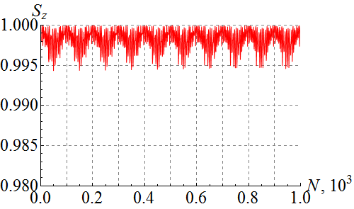 (b)** 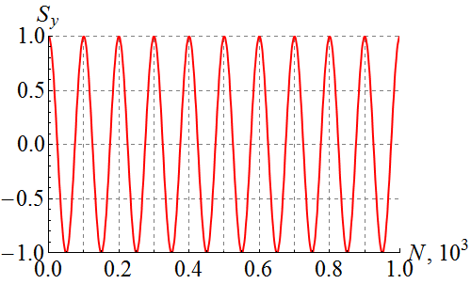

**Figure 4.** Polarization of protons vs the number of turns in an unperturbed lattice of the JLEIC collider with a stabilizing solenoid. The particle is launched with longitudinal (a) and vertical (b) spin directions.

***Conclusions***

The completed numerical analysis using Zgoubi confirms the validity of the chosen proton polarization control scheme in the JLab’s project.

***References***

[1] F. Méot, The ray-tracing code Zgoubi, NIM-A 427 (1999) 353-356; http://sourceforge.net/projects/zgoubi/

[2] A.M. Kondratenko et al., “Calculation of proton and deuteron polarizations in racetrack and figure-8 boosters using Zgoubi”, JLab Report, March 7, 2016.

[3] V.S. Morozov, et al. “Baseline Scheme for Polarization Preservation and Control in the MEIC Ion Complex”, IPAC’15, TUPWI029.