Work plan items addressed:

First and Second quarters:

* Systematic comparison of figure-8 and racetrack designs
* Development of efficient numerical techniques for spin calculations
* Spin tracking simulations

Third and Forth quarters:

* Study of spin dynamics and compensation of the depolarization caused by imperfections and non-linear fields

**Verification of schemes for preservation of proton and deuteron polarizations in figure-8 and racetrack boosters using spin tracking simulations**

A.M. Kondratenko1, M.A. Kondratenko1, and Yu.N. Filatov2,3

*1Science and Technique Laboratory “Zaryad”, Novosibirsk 630090, Russia*

*2Moscow Institute of Physics and Technology, Dolgoprudny 141700, Russia*

*3Joint Institute for Nuclear Research, Dubna 141980, Russia*

Brief conclusions of comparing figure-8 and racetrack ring configuration options for operation of the MEIC ion complex with polarized protons and deuterons are as follows [1]:

* a racetrack booster does not give conceptual advantages over a figure-8 booster,
* a racetrack collider for protons allows one to shorten the collider’s circumference by about 15% but then excludes the possibility of experiments with polarized deuterons,
* a figure-8 collider allows one to run with any light ion beams.

Schemes for preservation of proton and deuteron polarizations during acceleration in figure-8 and racetrack boosters were presented at IPAC15 and DSPIN 2015 [2,3]. This report presents the results of spin tracking using the code Zgoubi [4].

**1. Preservation of proton polarization in racetrack booster**

To avoid resonant depolarization during proton acceleration in a racetrack booster, one uses a solenoidal snake without compensation of coupling of betatron oscillations. Figure 1 shows graphs demonstrating orbital stability in the racetrack booster with a strong coupling of betatron oscillations.

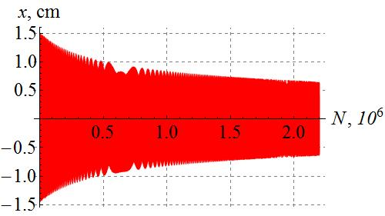 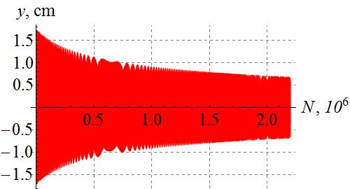

**Figure 1.** Radial and vertical beam sizes as functions of the number of turns in a racetrack booster with a solenoidal snake. The initial conditions are: *y*0 = 10 mm, *y’*0 = 0 rad; *x*0 = 10 mm, *x’*0 = 0 rad, Δp/p = 0.

Figure 2 demonstrates preservation of the longitudinal polarization of protons during their acceleration in the booster with the snake (γ is the relativistic factor, *G* is the anomalous magnetic moment)*.* Change in the polarization does not exceed 2×10-3. The calculations assumed that there were no quadrupole errors. In the absence of the snake, the energy range of the calculation includes six strong intrinsic spin resonances completely depolarizing the proton beam.

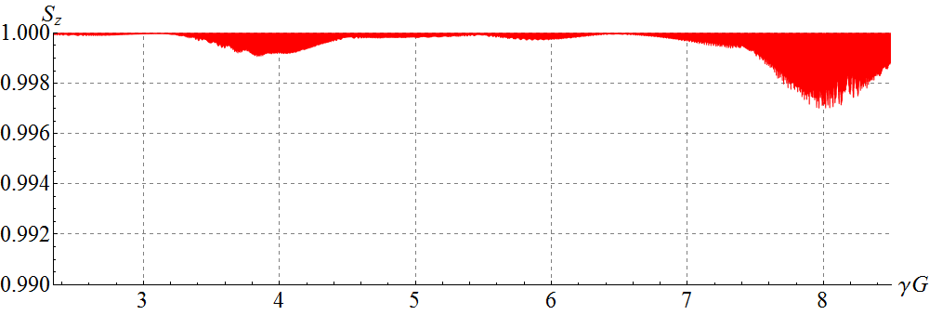

**Figure 2.** Proton longitudinal spin component vs γ*G* in an ideal lattice of the racetrack booster with the solenoidal snake. The initial conditions are: *y*0 = 10 mm, *y’*0 = 0 rad; *x*0 = 10 mm, *x’*0 = 0 rad, Δp/p = 0.

**2. Preservation of deuteron polarization in racetrack booster**

Deuteron vertical polarization is preserved in the conventional way. When choosing the betatron tunes at *νx* = 5.95 ${??}_{x}=5.95$ and *νy* = 4.84, the energy range of the racetrack booster contains only one spin resonance *γ G=νy -* 5, which is crossed quickly during acceleration using a field ramp rate of 1 T/s. Calculation of the deuteron vertical polarization included the following errors of the magnetic lattice: random quadrupole transverse alignment error with an rms value of 10 μm, rms quadrupole roll error of 0.1 mrad, rms relative quadrupole strength error of 10-3. The effective alignment and roll errors are small because there was no orbit correction. The calculation showed that change in the deuteron vertical polarization does not exceed 10-5.

**3. Preservation of proton and deuteron polarizations in figure-8 booster**

To stabilize both proton and deuteron longitudinal polarizations during acceleration in a figure-8 booster, it is sufficient to introduce a “weak” solenoid inducing a spin tune value significantly greater than the strength of the zero-integer spin resonance, which was generated by random quadrupole misalignments with an rms value of 10 μm. Figure 3 shows changes in the longitudinal polarization of protons and deuterons in the booster with the stabilizing solenoid. In calculating the proton and deuteron polarizations, we used the same solenoid with a maximum field integral of 0.1 Tm. As we can see, the longitudinal polarization is stabilized in the whole energy range with a precision better than 0.03 for protons and 2×10-7 for deuterons. The presented examples show an exceptional stabillity of the deuteron polarizatoin in the figure-8 booster.

**(a) 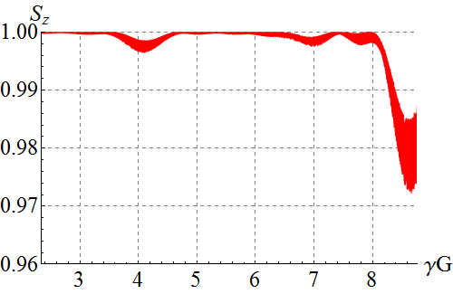 (b)** 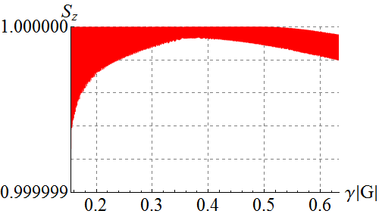

**Figure 3.** Longitudinal polarization of protons (a) and deuterons (b) vs γ*G* in the figure-8 booster with the randomly misaligned quadrupoles and weak solenoid. The initial conditions are: *y*0 = *x*0 = 10 mm, *y’*0 = *x’*0 = 0 rad.

**Conclusions**

* We showed stability of the proton orbital motion and polarization in the racetrack booster with a solenoidal snake without compensation of betatron coupling.
* We showed stability of the deuteron polarization in the racetrack booster with a field ramp rate of 1 Т/s at an optimal choice of the betatron tunes.
* We showed stability of the proton and deuteron polarizations in the figure-8 booster.
* The degree of deuteron beam depolarization in the figure-8 booster is a few orders of magnitude smaller than in the racetrack booster.

**References**

[1] Quarterly report “Comparison of figure-8 and racetrack designs in the MEIC Ion Complex”, October 12, 2015

[2] V.S. Morozov, Y.S. Derbenev, F. Lin, Y. Zhang, Y. Filatov, A.M. Kondratenko, and M.A. Kondratenko, “Baseline Scheme for Polarization Preservation and Control in the MEIC Ion Complex”, IPAC’15, TUPWI029.

[3] V.S. Morozov, Y.S. Derbenev, F. Lin, Y. Zhang, Y. Filatov, A.M. Kondratenko, and M.A. Kondratenko, “Superconducting Racetrack Booster for the Ion Complex of MEIC”, proceeding of DSPIN2015.

[4] F. Méot, The ray-tracing code Zgoubi, NIM-A 427 (1999) 353-356; http://sourceforge.net/projects/zgoubi/