**Calculation of spin resonance crossings including synchrotron oscillations using Zgoubi**

A.M. Kondratenko1, M.A. Kondratenko1, and Yu.N. Filatov2,3

*1Science and Technique Laboratory “Zaryad”, Novosibirsk 630090, Russia*

*2Moscow Institute of Physics and Technology, Dolgoprudny 141700, Russia*

*3Joint Institute for Nuclear Research, Dubna 141980, Russia*

Translated by V.S. Morozov, *Jefferson Lab*

November 3, 2015

In the absense of synchrotron oscillaitons, change of the vertical spin component for fast crossing of an isolated resonance of strength  at a constant rate  is described by

 (1)

where we introduced an auxiliary function

 (2)

Its graph is shown in Fig. 1. The main change in function  happens in a region near zero  (resonance region) and, after exiting the resonance region, the function undergoes damping oscillations about unity. Therefor, function  can be interpreted as a trigger, which marks the resonance crossing moment.

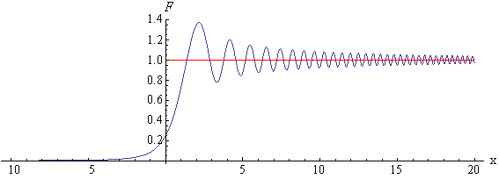

**Fig. 1** Graph of function  (resonance “trigger”).  
(*theoretical calculation using Eq. (2)*)

Figure 2 shows behavior of the vertical spin component during crossing of a deuteron resonance **=*y* - 5 in a racetrack booster at a field ramp rate of *dB/dt* =1 T/s calculated using ZGOUBI. The corresponding rate of change of detuning from the resonance in this case equals . The non-super-periodic resonance **=*y* −5 was created by random changes in quadrupole gradients. By the change of the vertical spin component before and after the resonance in this graph, one can calculate the resonance strength:

. (3)

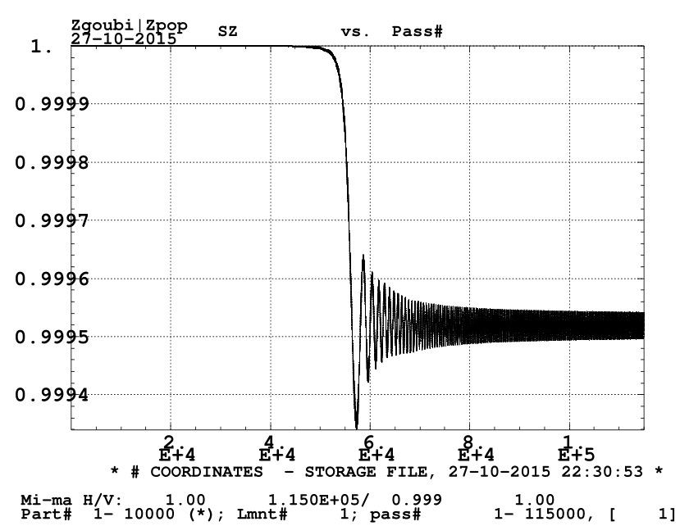

**Fig. 2** Crossing of the deuteron ***y *− resonance at the field ramp rate of *dB/dt* =1 T/s  
(*simulation in ZGOUBI*, SZ is the vertical spin component)

Including synchrotron energy modulation drastically changes characteristic behavior of the spin motion during resonance crossing. Instead of a single isolated resonance, the resonance spectrum now contains a series of equidistant sideband resonances with strengths , which are separated from each other by the distance .

 (4)

where  and  are the amplitude and tune of the synchrotron oscillations of resonance detuning:

 (5)

The spin of an individual particle is now determined not only by the magnitudes of the sideband resonance strengths  but by their interference and the initial phase of the synchrotron oscillations $Ψ_{0}$ as well.

 (6)

Figures 3 (ZGOUBI) and 4 (theoretical calculation using Eq. (6)) show changes in the vertical spin components of 16 particles whose initial phases are multiples of ${ΔΨ}_{0}=π/8$, during crossing of the =y-5 deuteron resonance at the field ramp rate of *dB/dt* = 1 T/s with energy modulation included. The crossing parameters in the calculations have the following values:

 (7)

For deuterons, due to their small anomalous gyromagnetic ratio, the amplitude of synchrotron detuning oscillations  is mainly determined by chromaticity of the betatron tune.

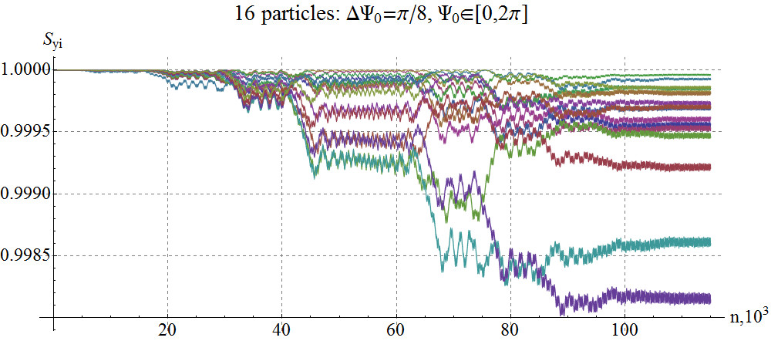

**Fig. 3** Crossing of the ***y *− resonance with synchrotron energy modulation included  
for 16 different values of the initial phase of synchrotron oscillations  
(*ZGOUBI calculation*).

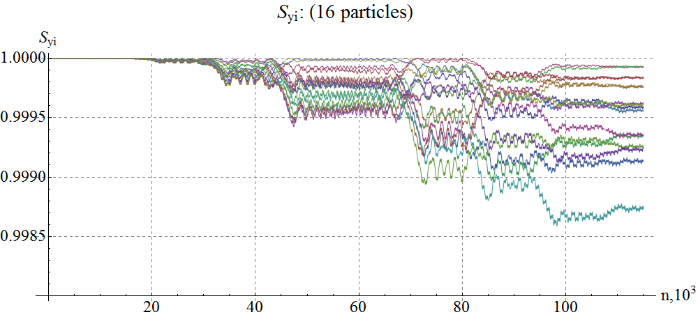

**Fig. 4** Crossing of the ***y *− resonance with synchrotron energy modulation included  
for 16 different values of the initial phase of synchrotron oscillations  
(*theoretical calculation using Eq. (6)*).

From Figs. 3 and 4 one can see the final value of the vertical spin component strongly depends on the initial phase of synchrotron oscillations. Therefore, when tracking a single particle, one cannot use the Froissart-Stora formula, Eq. (3) to calculate the resonance strength. One must consider correlation of the initial phase of synchrotron oscillation with the phases of sideband resonance crossings.

In a real case, when calculating beam polarization, one must average it over the initial phases and amplitudes of synchrotron motion, whose distribution function looks like:

 (8)

The rms amplitude value is connected to the rms detuning value by the relationship , since .

After averaging Eq. (6) over the initial phases $Ψ_{0}$, only the cross terms with the same values of indices  and  are left. The formula for the vertical spin component takes a simple form:

 (9)

which represents consecutive crossing of isolated sideband resonance with effective resonance strengths . After each crossing, the vertical polarization changes by the value of .

It is easy to confirm that, in the considered model of fast crossing, inclusion of energy modulation does not change the final result of crossing of an isolated resonance:

 (10)

After averaging Eq. (9) over the amplitudes , the shape of Eq. (9) remains the same with  replaced by its rms value 

 (11)

A graph of the vertical spin component averaged over the initial phases of 16 particles (see Fig. 3) is shown in Fig. 5. A graph of the vertical spin component averaged over the initial phases of all beam particles calculated using Eq. (9) is shown in Fig. 6. We can see that, in both cases, the final value of the vertical spin component comes to the same value as in the case of resonance crossing without accounting for synchrotron energy modulation (see Fig. 2). Thus, graphs averaged over the initial phases of synchrotron oscillations from ZGOUBI can be used to calculate the strength of an isolated resonance using Eq. (3).

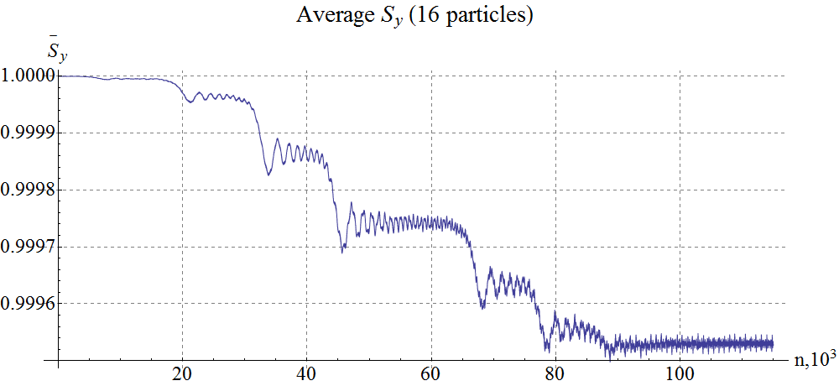

**Fig. 5** Average value of the vertical spin component for the calculated 16 particles  
(*ZGOUBI calculation*)

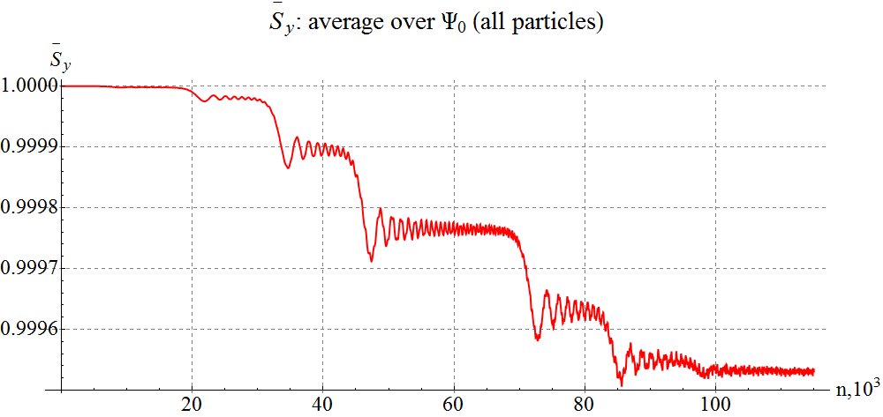

**Fig. 6** Vertical spin component averaged over the initial phases Ψ0 during crossing of a spin resonance with synchrotron energy modulation included  
(*theoretical calculation using Eq. (9)*).

To calculate beam polarization during resonance crossing using ZGOUBI, one must model its averaging over synchrotron oscillation amplitudes. A graph including such averaging over all beam particles calculated using Eq. (11) is shown in Fig. 7.

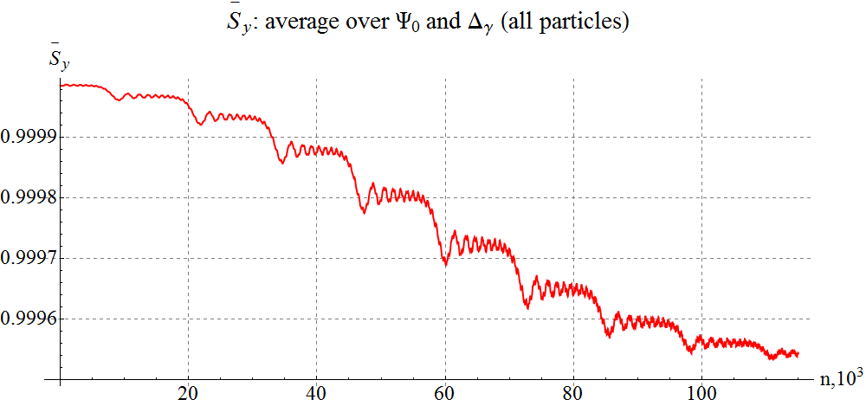

**Fig. 7** Vertical spin component averaged over the initial phases Ψ0 and amplitudes Δγ during crossing of a spin resonance with synchrotron energy modulation included  
(*theoretical calculation using Eq. (11)*).

In a real case, a sharp step during crossing of sideband resonances is observed only at the location of the “central” (original) resonance. The other steps are “smeared” due to synchrotron tune spread. The prominence of the central resonance allows for high-precision measurements of polarized particle parameters [1].

In summary, one can draw the following conclusion:

theoretical calculations of spin resonance crossing including synchrotron oscillations agree with calculations performed using the ZGOUBI code.

[1] A.M. Kondratenko, M.A. Kondratenko and Yu.N. Filatov “*High-precision measurement of the polarized hadron beam energy in circular accelerator*”, Journal of Physics: Conference Series (JPCS) 295,012137, the 19th International Symposium on Spin Physics (SPIN2010), (2011).