Preliminary demonstration of the MEIC baseline ion polarization scheme by numerical simulations
A.M. Kondratenko¹, M.A. Kondratenko¹, and Yu.N. Filatov^{2,3}
¹Science and Technique Laboratory “Zaryad”, Novosibirsk 630090, Russia
²Moscow Institute of Physics and Technology, Dolgoprudny 141700, Russia
³Joint Institute for Nuclear Research, Dubna 141980, Russia
Translated by V.S. Morozov, Jefferson Lab

MEIC ion polarization control scheme was reported in “Complete baseline scheme for ion polarization preservation and control in the MEIC ion complex including the prebooster, large booster and collider ring” (January 2015). Here we present numerical analysis of the baseline scheme for ion polarization control in the MEIC collider. We calculate effect of control solenoids in 3D rotators on the collider’s orbital properties. We compute proton and deuteron beam polarizations along the collider’s orbit. We present calculations of the coherent and incoherent parts of the resonance strength in the MEIC ion collider ring for proton and deuteron beams. We analyze the possibility of compensating the coherent part of the resonance strength using static small solenoids, which will allow one to substantially improve the polarization properties as well as to significantly reduce the fields of the control solenoids.
Ion polarization control with 3D rotators in MEIC collider
The figure-8 shaped MEIC ion collider ring is “transparent” to the spin. In MEIC, effect on the spin of one arc is compensated by the other arc. Thus, effect of “strong” arc fields on the spin is reduced to zero. Any spin direction repeats after a particle turn, i.e. the collider has no preferred spin direction. This means that the particles are in the region of a zero-integer spin resonance and the spin tune is zero ν=0. Colliders transparent to the spin offer a unique opportunity to efficiently control the ion polarization using small magnetic field integrals. In such a collider, any small perturbation has a strong effect on the beam polarization.
In the ion collider ring of MEIC, the spin tune and stable polarization direction of any particle species (p, d, 3He, …) are determined by a universal 3D spin rotator designed using solenoids with small field integrals (weak solenoids) [1-3]. The weak solenoids do not change the reference orbit and allow one to control the beam polarization essentially without affecting parameters of the orbital motion. The rotator consists of three modules: those for control of the radial n_{x}, vertical n_{y}, and longitudinal n_{z} polarization components (see Fig. 1).

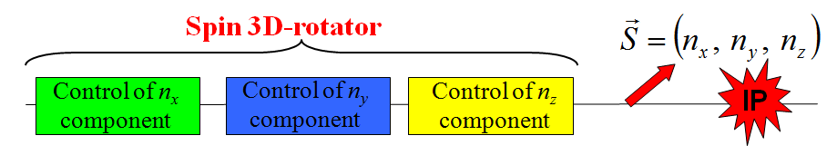
Figure 1: 3D spin rotator schematic.
Figure 2a shows the module for control of the radial polarization component n_{x}, which consists of two pairs of opposite-field solenoids and three vertical-field dipoles producing a fixed orbit bump. The control module for the vertical polarization component n_{y} is the same as that for the radial component except that the vertical-field dipoles are replaced with radial-field ones (Fig. 2b). To keep the orbit bumps fixed, the fields of the vertical- and radial-field dipoles must be ramped proportionally to the beam momentum. The module for control of the longitudinal polarization component n_{z} consists of a single weak solenoid (Fig. 2c). There is a substantial flexibility in the placement and arrangement of these modules in the collider. For instance, to free up the space in the experimental straight, the module for control of the vertical polarization component can be installed anywhere in the arc.
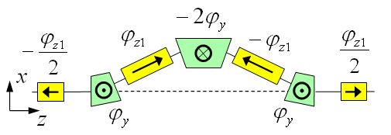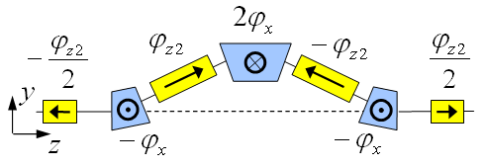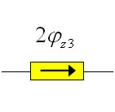
(a) (b) (c)
Figure 2: Modules for control of the radial (a), vertical (b), and longitudinal (c) spin components.
Schematic placement of the 3D rotator elements in the collider ring’s experimental straight is shown in Fig. 3. The lattice quadrupoles are shown in black, the vertical-field dipoles are green, the radial-field dipoles are blue, and the control solenoids are yellow. With each module’s length of ~8 m (L_{x}= L_{y} =0.6 m, L_{z} = 2 m), the fixed orbit deviation in the bumps is ~16 mm in the whole momentum range of the collider. Placement of each bump between lattice quadrupoles keeps the experimental straight dispersion-free.
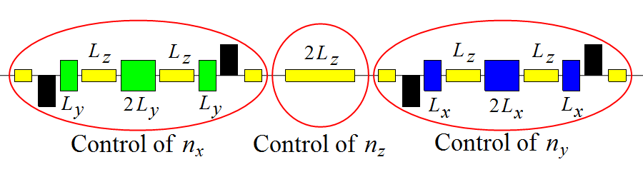
Figure 3: Placement of the 3D spin rotator elements.
The maximum required dipole and solenoid magnetic field strengths are 3 and 2 T, respectively. The spin rotator shifts the proton and deuteron spin tunes from zero by sufficient amounts of 0.01 and 10⁻⁴, respectively.
Figure 4 shows dependencies of the solenoid fields in the 3D rotator on the deuteron and proton beam momenta for radial, vertical and longitudinal polarizations in MEIC.
The universal 3D spin rotator can be used to arrange a spin-flipping system in MEIC, which provides multiple beam polarization reversals at the interaction point during an experiment. To reverse the polarization, the fields of the control solenoids in the n_{x}, n_{y}, and n_{z} modules must change signs. To preserve the polarization when switching the fields of the control solenoids, one must keep the spin tune fixed and change only the polarization direction. This then eliminates resonant depolarization of the beam due to crossing of spin resonances. To preserve the polarization, one must then only satisfy the adiabaticity condition. This means that the characteristic spin reversal times in the indicated examples should not be shorter than 0.1 ms for protons and 1 ms for deuterons. Thus, using solenoids with a field ramp rate of 2 T/s, polarization can be flipped in a second [4].
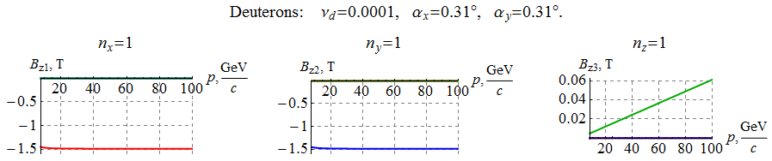
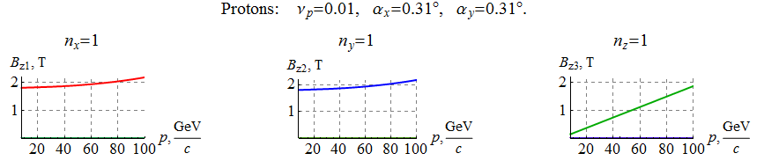
Figure 4: Dependencies of the solenoid fields on the deuteron and proton beam momentum in MEIC for the cases of radial, vertical and longitudinal polarizations at the exit from the 3D rotator.
EFFECT OF 3D SPIN ROTATOR ON THE ORBITAL
BEAM PARAMETERS IN MEIC
Effect of the 3D spin rotator is calculated for multiple reversals of the beam polarization in the vertical plane (yz) of the detector during an experiment (spin flipping). Figures 5 and 6 show graphs of the solenoid fields in the n_{y} and n_{z} modules of the 3D rotator versus the angle Ψ between the spin and the beam direction for deuterons and protons, respectively.
With such a synchronous change of the solenoid fields, the spin tune remains constant while the polarization direction changes in the (y,z) plane and is given by the angle Ψ:
n_{x} = 0, n_{y} = sin Ψ, n_{z} = cos Ψ.
The stability of the reversals is provided by keeping the spin tune fixed while changing the spin direction, which eliminates the possibility of crossing spin resonances.
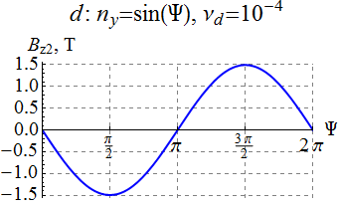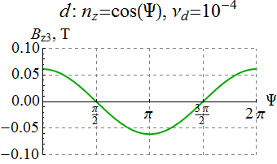
Figure 5: : Solenoid fields in the n_{y} and n_{z} modules versus the polarization angle Ψ for the deuteron beam.
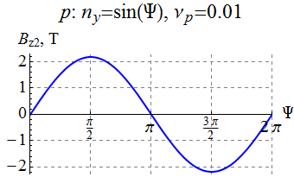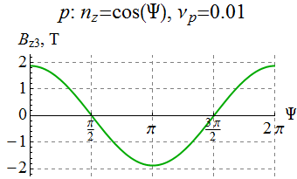
Figure 6: Solenoid fields in the n_{y} and n_{z} modules versus the polarization angle Ψ for the proton beam.
Figure 7 shows a part of the collider’s experimental straight with the 3D spin rotator and interaction point (IP) locations indicated. The figure shows graphs of the horizontal and vertical β-functions. With the 3D rotator off, the betatron tunes and the β-function values at the IP are:
ν_{x} = 24.38, ν_{y} = 24.28, β_{x} = 10 cm, β_{y} = 2 cm.
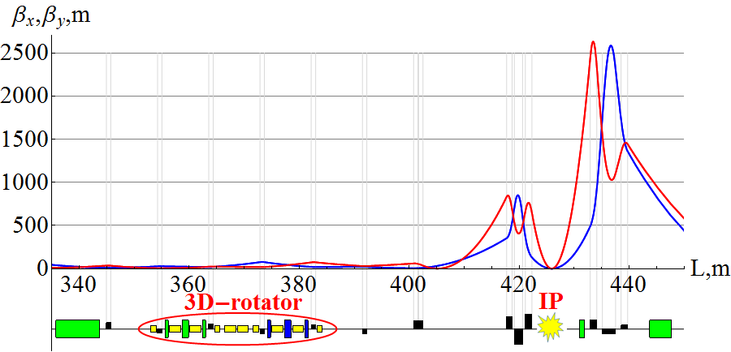
Figure 7: β-functions and 3D rotator placement in the experimental straight of MEIC.
Figure 8 shows change in the β functions at the IP for deuterons and protons when changing the spin direction in the vertical plane of the detector during an experiment. As one can see, the maximum change of the β functions does not exceed 60 and 200 μm for deuterons and protons, respectively, i.e. the beam size remains virtually the same. Similarly, Fig. 9 shows change in the betatron tunes. One can see that the betatron tune shifts at 100 GeV/c do not exceed 10⁻⁴ for deuterons and 2×10⁻⁴ for protons.
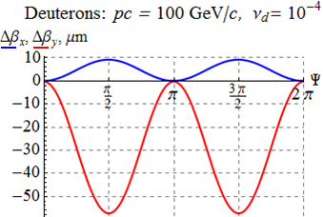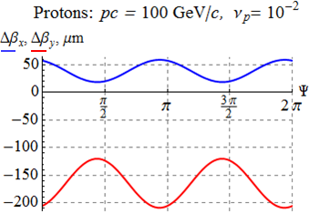
Figure 8: Change in the β functions at the IP versus the polarization angle.
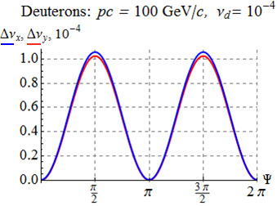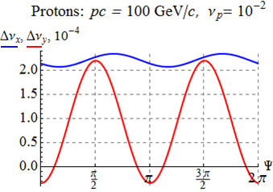
Figure 9: Change in the betatron tunes versus the polarization angle.
Calculations show that change in the dispersion due to the 3D rotator is also negligibly small. Figure 10 shows change in the dispersion function at the IP when changing the spin direction in the vertical plane of the detector for deuterons and protons. The control solenoids induce vertical dispersion in the collider ring, which, at 100 GeV/c, does not exceed 50 and 70 μm for deuterons and protons, respectively.
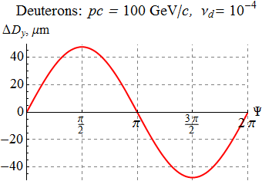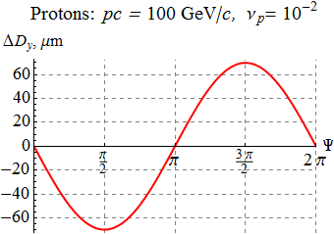
Figure 10: Change in the dispersion function at the IP versus the polarization angle for protons and deuterons.
Our numerical calculations confirm that the 3D spin rotator does not affect the orbital beam parameters of the MEIC ion collider ring.
Calculation of the Beam Polarization in MEIC
Let us present calculations of the proton and deuteron beam polarizations in the MEIC ion collider ring with a single 3D rotator determining the equilibrium polarization at the interaction point.
As an example, in Fig. 11, for an ideal collider structure, the equilibrium polarization components of a 100 GeV/c deuteron beam are shown as functions of the orbital length z around the ring for the case of longitudinal (n_{z}(z_{IP}) = 1) polarization at the interaction point. The blue, red, and green curves show the radial, longitudinal, and vertical polarization components, respectively. Note that the vertical polarization component is zero around the whole ring.
In Fig. 12, for an ideal collider structure, the equilibrium polarization components of a 100 GeV/c proton beam are shown as functions of the orbital length z along the experimental straight for the case of radial polarization at the interaction point. In contrast to the deuteron beam, the radial and longitudinal components of the proton polarization change significantly at each bending magnet of the lattice. The horizontal polarization component undergoes about 127 turns in each arc and is rotated significantly by the vertical-field dipoles located near the interaction point.
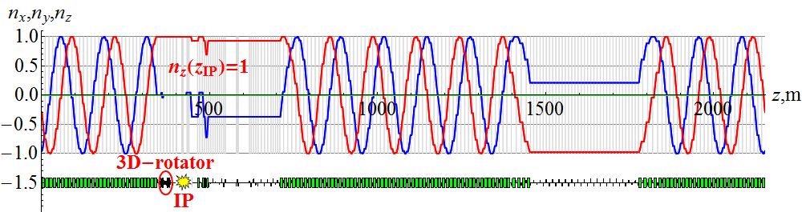
Figure 11: Deuteron beam’s polarization around the ion collider ring with n_{z}(z_{IP}) = 1.
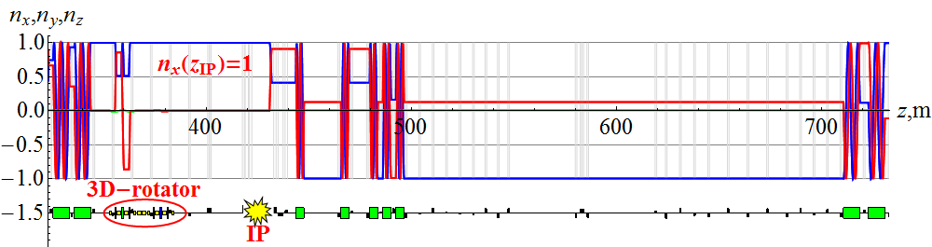
Figure 12: Proton beam’s polarization in the experimental straight of the ion collider ring with n_{x}(z_{IP}) = 1.
POLARIZATION STABILITY AND RESONANCE STRENGTH
The spin motion in MEIC is governed by the Thomas-BMT equation. In accelerator reference frame with basis unit vectors tied to the beam design orbit (see Fig. 13), this equation has the form
Here is the generalized azimuthal angle (normalized distance along reference orbit), is curvature of the design orbit.
The spin perturbation contains two parts. The first part of the perturbation arises due to deviations of particles for the ideal design orbit. Orbit deviations are related to errors of the magnetic lattice as well as to beam emittances. The second part of the spin perturbation has to do with effect of control solenoids stabilizing the spin motion in MEIC.
Components of the spin perturbation can be written in the accelerator reference frame. In the linear approximation (γG>>1), they are equal to  ,  where vector specifies the velocity direction of a beam particle, is its derivative with respect to the generalized azimuthal angle, and is the normalized strength of the control solenoids setting the polarization direction and the spin tune ν. | 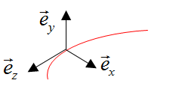  Figure 13: Basis unit vectors of the accelerator reference frame.
For stability of the polarization in the collider, the spin tune ν induced by the control solenoids must significantly exceed the strength of the zero-integer spin resonance:
The resonance strength is determined by the spin perturbation component transverse to
Spin Field without Control Solenoids
Spin field components in the spin reference frame
Let us find spin field components for the case when the control solenoids in the 3D rotator are turned off. This problem can be solved in the accelerator reference frame. However, the spin field components have simpler form in the spin reference frame.
The basis unit vectors of the spin reference frame rotate in the collider arcs together with the spin of a particle moving along the design orbit. Therefore, the spin components of such a particle remain constant in the spin reference frame.
The relation between the basis unit vectors of the accelerator and spin reference frames is given by the following expressions:
where is the spin rotation angle in the collider’s bending dipoles.
In the linear approximation, averaging the spin perturbation gives the following spin field components in the spin reference frame:
where brackets <…> denote averaging over the particle’s azimuthal angle. The vertical component of the spin field in the linear approximation turns into zero. The spin field vector lies in the orbital plane and is determined primarily by vertical excursions of particle orbits.
Coherent part of the spin field
The most substantial contribution to the spin field in colliders transparent to the spin comes from imperfections of a real magnetic lattice introducing radial perturbing fields. Such fields arise, for example, due to dipole roll errors, vertical quadrupole misalignments, etc. They result in vertical closed orbit distortion, are periodic and determine the coherent part of the spin field. The spin field induced by perturbing radial field h_{x}(θ), can be calculated using a periodic response function F(θ):
.
For a flat figure-8 design orbit, the response function is expressed through the Floke function of vertical betatron oscillations f_{y}(θ) possessing the property :
Figures 14 and 15 show graphs of the response function in the ion collider ring of MEIC for proton and deuteron beams, respectively, at 100 GeV/c.
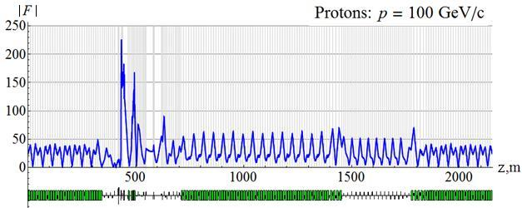
Figure 14: Response function for a proton beam at 100 GeV/c.
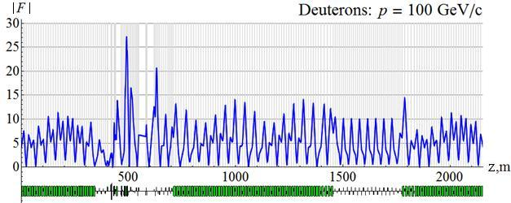
Figure 15: Response function for a deuteron beam at 100 GeV/c.
Let us calculate the spin field using a statistical model of quadrupole misalignments in vertical direction. Figures 16 and 17 show calculated dependence of the coherent part of the spin resonance strength on the proton and deuteron momenta, respectively, when the orbit excursion in the arcs does not exceed ±100 μm. A graph of an rms closed orbit distortion in the collider under the same parameters is shown in Fig. 18.
The greatest contribution to the spin resonance strength and rms orbit excursion comes from misalignment of strong quadrupoles near the interaction point. In the considered model, with the same distributions of alignment errors for all quadrupoles, contribution of these quadrupoles is an order of magnitude greater than that of the arc quadrupoles. Magnetic lattice in the experimental straight requires careful implementation and alignment. In principle, one can eliminate the effect of the strong quadrupoles in the experimental straight on the coherent part of the spin field. All that is needed is to make the response function zero near the interaction point by an appropriate choice of lattice structure.
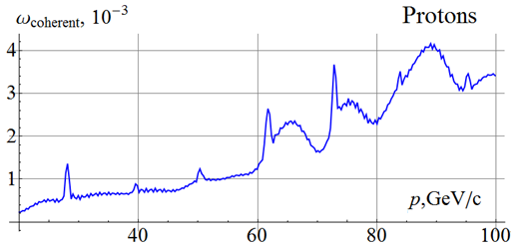
Figure 16: Coherent part of the spin field for a proton beam with random misalignment of all quadrupoles in the MEIC ion collider ring. The orbit excursion in the arcs does not exceed ±100 μm.
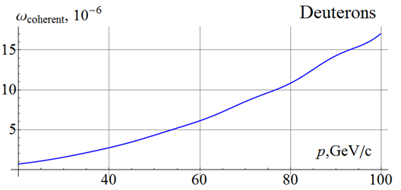
Figure 17: Coherent part of the spin field for a deuteron beam with random misalignment of all quadrupoles in the MEIC ion collider ring. The orbit excursion in the arcs does not exceed ±100 μm.
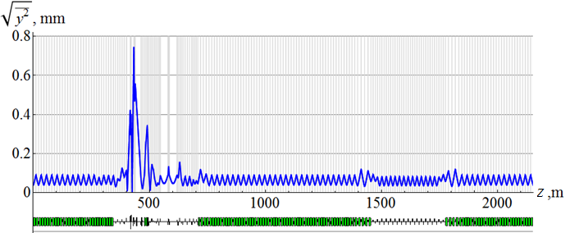
Figure 18: rms vertical beam excursion with random misalignment of all quadrupoles in the ion collider ring.
Compensation of the coherent part of the spin field
The coherent part of the spin field is determined by three parameters and can be compensated by a 3D spin rotator with constant fields. Schematic of 3D rotators’ placement in the MEIC ion collider ring is shown in Fig. 19.
Figure 19: Schematic of 3D rotators’ placement in the MEIC ion collider ring.
The first 3D rotator is located in the straight containing the interaction point and directly controls the polarization. The second 3D rotator with constant solenoid fields is located in the other straight and is used to compensate the coherent part of the zero-integer spin resonance strength. This allows one to significantly improve the polarized beam parameters as well as to greatly reduce the field integrals of the solenoids used for polarization control in the first rotator. In particular, the spin reversal time of the spin-flipping system of the MEIC ion collider ring will be on the order of 1 ms instead of 1 s.
The incoherent part of the spin field
In the linear approximation, the incoherent part of the spin field is determined by the beam energy spread:
where D_{y} is the vertical dispersion in dipole magnets. The condition of absence of synchrotron modulation of the spin field means that . In an ideal MEIC lattice, there is no vertical dispersion D_{y} and this condition is automatically satisfied. Thus, in a figure-8 collider with conventional arcs (without radial-field magnets), the incoherent part of the resonance strength is calculated in the next-order approximation. In the second-order approximation, the spin field is directed vertically and is given by
.
The spin perturbation in the arcs is determined by vertical betatron oscillations and can be written through the vertical Floke function f(θ). Using and expressing vertical betatron oscillation amplitude C through the beam emittance (), we get a formula for the incoherent part of the spin field:
Figures 20 and 21 show graphs of the incoherent parts of the proton and deuteron resonance strengths versus momentum for a normalized beam emittance of 0.07 μm⋅rad. The incoherent part of the spin resonance strength is related to asymmetry in the collider’s magnetic lattice.
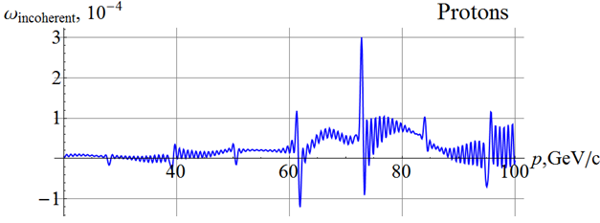
Figure 20: Incoherent part of the resonance strength for a proton beam.
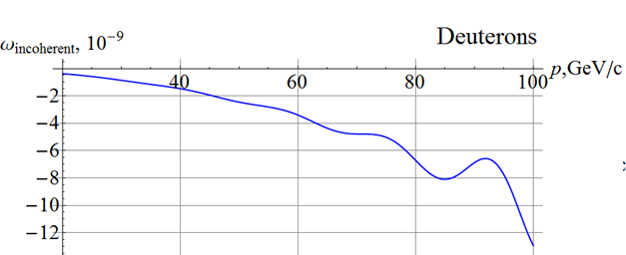
Figure 21: Incoherent part of the resonance strength for a deuteron beam.
Conclusion
Let us briefly summarize the main conclusions obtained in the numerical analysis of proton and deuteron polarization stability in the ion collider ring of MEIC.
- The polarization control insertion does not affect the orbital beam parameters of the MEIC ion collider ring.
- For stability of ion polarization in MEIC, the spin tune induced by the 3D spin rotator must significantly exceed the strength of the zero-integer spin resonance.
- Calculations of the resonance strength for MEIC show that its coherent part related to closed orbit distortion is a few orders of magnitude greater than its incoherent part related to beam emittances.
- 3D rotators with 2 T solenoids provide control of proton and deuteron polarizations in MEIC.
- Polarized beam quality can be additionally significantly improved and the field strengths of the control solenoids in the 3D rotator can be significantly reduced by compensating the coherent part of the resonance strength.
The results of this work have been presented at IPAC’15 and discussed at an accelerator seminar at Jefferson Lab on May 14, 2015.
REFERENCES
[1] A.M. Kondratenko et al., PoS (PSTP 2013) 026.
[2] A.M. Kondratenko et al., EIC’14, to be published.
[3] A.M. Kondratenko et al., SPIN’14, to be published.
[4] A.D. Kovalenko et al., IPAC’14, TUPRO004, pp. 1000 (2014).

