Numerical calculation of the ion polarization in MEIC*
Ya.S. Derbenev, F. Lin, V.S. Morozov, Y. Zhang, JLab, Newport News, VA 23606
A.M. Kondratenko, M.A. Kondratenko, Sci. & Tech. Laboratory Zaryad, Novosibirsk, Russia
Yu.N. Filatov , MIPT, Dolgoprudny, Moscow Region, Russia

Abstract
Ion polarization in the Medium-energy Electron-Ion Collider (MEIC) is controlled by means of universal 3D spin rotators designed on the basis of “weak” solenoids. We use numerical calculations to demonstrate that the 3D rotators have negligible effect on the orbital properties of the ring. We present calculations of the polarization dynamics along the collider’s orbit for both longitudinal and transverse polarization directions at a beam interaction point. We calculate the degree of depolarization due to the longitudinal and transverse beam emittances in case when the zero-integer spin resonance is compensated.

introduction
Jefferson Lab presently considers an updated scheme of the MEIC electron-ion collider project with the main changes related to a switch to 3 T super-ferric magnets and an increase of the collider ring circumference to ~2.2 km [1]. The ion collider ring retains a figure-8 shape, remains transparent to the spin and, as before, allows for an efficient control of polarization of any ion species by “small” solenoids rotating the particle spins by small angles. The main element of the polarization control system is a universal 3D spin rotator designed using “weak” solenoids [2]. Below we present numerical calculations demonstrating operability of the 3D rotator in the new lattice of the MEIC ion collider ring.

3D spin rotator in meic collider
A universal 3D spin rotator consists of three modules for control of the n_{x}, n_{y}, and n_{z} polarization components (see Fig. 1) [2, 3].
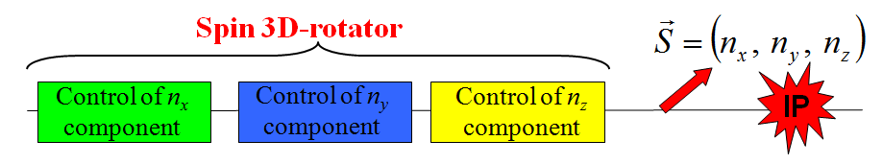
Figure 1: 3D spin rotator schematic.
Figure 2 shows the module for control of the radial polarization component , which consists of two pairs of opposite-field solenoids and three vertical-field dipoles producing a fixed orbit bump. The control module for the vertical polarization component is the same as that for the radial component except that the vertical-field dipoles are replaced with radial-field ones. To keep the orbit bumps fixed, the fields of the vertical- and radial-field dipoles must be ramped proportionally to the beam momentum. The module for control of the longitudinal polarization component consists of a single weak solenoid.
(a) 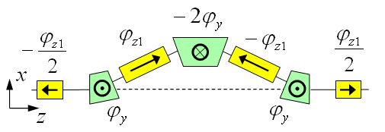 (b) 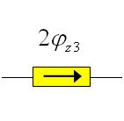
Figure 2: Modules for control of the radial n_{x} (a) and longitudinal n_{z} (b) polarization components.
Figure 3 shows schematically placement of the radial (green) and vertical (blue) dipoles as well as of the weak control solenoids (yellow) between the lattice magnets (black) of a collider’s straight.
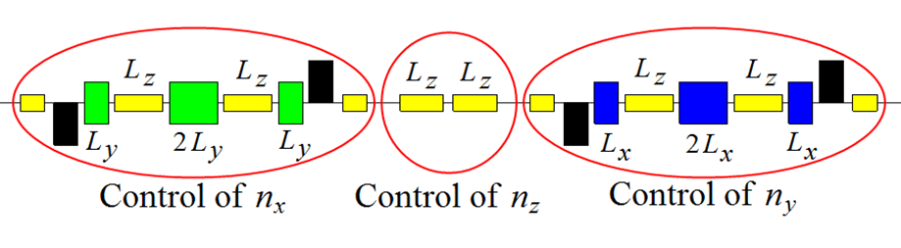
Figure 3: Placement of the 3D spin rotator elements.
The dipole and solenoid lengths are L_{x} = L_{y} = 0.6 m and L_{z} = 2 m, respectively. In the modules for control of the transverse polarization components, the dipoles produce a fixed orbit bump of ~18 mm in the whole momentum range. The maximum dipole field is 3 T while the field of the control solenoids does not exceed 2 T. This allows one to set the spin tune to ν_{p} = 0.01 for protons and ν_{d} = 10⁻⁴ for deuterons and also to stabilize any polarization direction at any location in the collider during an experiment essentially with no perturbation to the collider’s orbital properties.
Effect of 3D spin rotator on the orbital beam parameters in meic
Effect of the 3D spin rotator is calculated for multiple reversals of the beam polarization in the vertical plane (yz) of the detector during an experiment (spin flipping). Figures 4 and 5 show graphs of the solenoid fields in the n_{y} and n_{z} modules of the 3D rotator versus the angle Ψ between the spin and the beam direction for deuterons and protons. Superconducting pulsed solenoid field of 2 T can be ramped in about 1 second [4].

* Authored by Jefferson Science Associates, LLC under U.S. DOE Contracts No. DE-AC05-06OR23177 and DE-AC02-06CH11357.
The U.S. Government retains a non-exclusive, paid-up, irrevocable, world-wide license to publish or reproduce this manuscript for U.S. Government purposes.
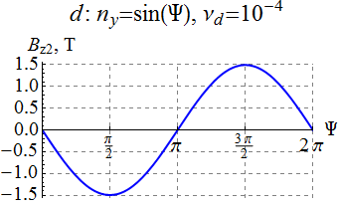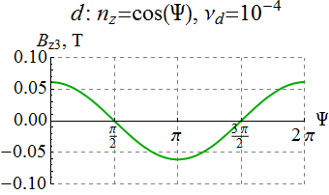
Figure 4: Solenoid fields in the n_{y} and n_{z} modules versus the polarization angle Ψ for the deuteron beam.
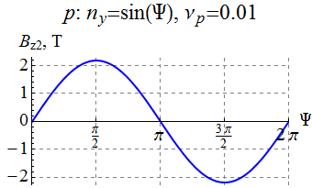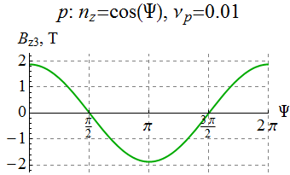
Figure 5: Solenoid fields in the n_{y} and n_{z} modules versus the polarization angle Ψ for the proton beam.
With such a synchronous change of the solenoid fields, the spin tune remains constant while the polarization direction changes in the (y,z) plane and is given by the angle Ψ: n_{x} = 0, n_{y} = sin Ψ, n_{z} = cos Ψ. The stability of the reversals is provided by keeping the spin tune fixed while changing the spin direction, which eliminates the possibility of crossing spin resonances.
Figure 6 shows a part of the collider’s experimental straight with the 3D spin rotator and interaction point (IP) locations indicated. The figure shows graphs of the horizontal and vertical β-functions. With the 3D rotator off, the betatron tunes and the β-function values at the IP are: ν_{x} = 24.38, ν_{y} = 24.28, β_{x} = 10 cm, β_{y} = 2 cm.
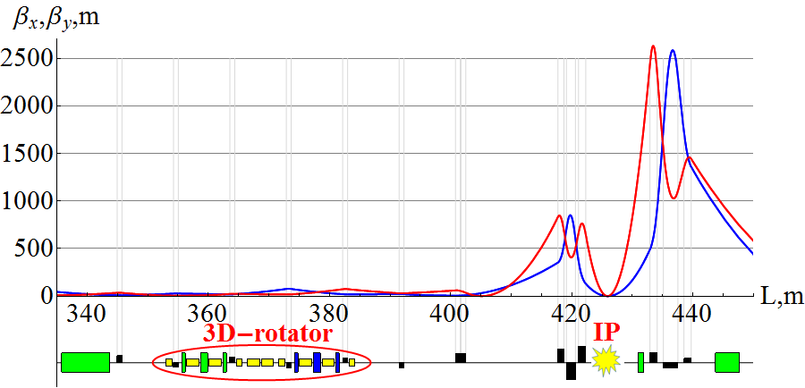
Figure 6: β-functions and 3D rotator placement in the experimental straight of MEIC.
Figure 7 shows change in the β functions at the IP when changing the spin direction in the vertical plane of the detector during an experiment for deuterons and protons. As one can see, the maximum change of the β functions does not exceed 60 and 200 μm for deuterons and protons, respectively, i.e. the beam size remains virtually the same. Similarly, Fig. 8 shows change in the betatron tunes. One can see that the betatron tune shifts at 100 GeV/c do not exceed 10⁻⁴ for deuterons and 2×10⁻⁴ for protons.
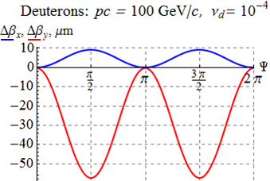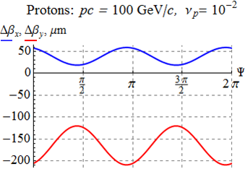
Figure 7: Change in the β functions at the IP versus the polarization angle.
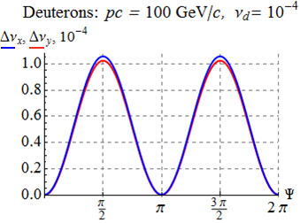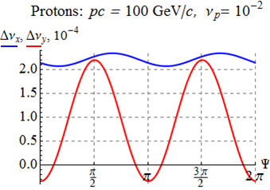
Figure 8: Change in the betatron tunes versus the polarization angle.
Calculations show that change in the dispersion due to the 3D rotator is also negligibly small. Figure 9 shows change in the dispersion function at the IP when changing the spin direction in the vertical plane of the detector for deuterons and protons. The control solenoids induce vertical dispersion in the collider ring, which, at 100 GeV/c, does not exceed 50 and 70 μm for deuterons and protons, respectively.
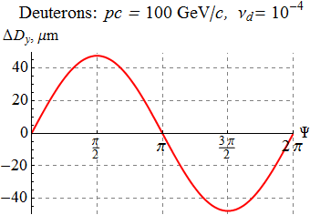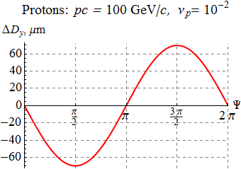
Figure 9: Change in the dispersion function at the IP versus the polarization angle for protons and deuterons.
Our numerical calculations confirm that the 3D spin rotator does not affect the orbital beam parameters of the MEIC ion collider ring.
Calculation of the Beam
Polarization in MEIC
Let us present calculations of the proton and deuteron beam polarizations in the MEIC ion collider ring with a single 3D rotator determining the equilibrium polarization at the interaction point.
As an example, in Fig. 10, for an ideal collider structure, the equilibrium polarization components of a 100 GeV/c deuteron beam are shown as functions of the orbital length around the ring for the case of longitudinal (n_{z}(z_{IP}) = 1) polarization at the interaction point. The blue, red, and green curves show the radial, longitudinal, and vertical polarization components, respectively. Note that the vertical polarization component is zero around the whole ring.
In Fig. 11, for an ideal collider structure, the equilibrium polarization components of a 100 GeV/c proton beam are shown as functions of the orbital length z along the experimental straight for the case of radial polarization at the interaction point. In contrast to the deuteron beam, the radial and longitudinal components of the proton polarization change significantly at each bending magnet of the lattice. The horizontal polarization component undergoes about 127 turns in each arc and is rotated significantly by the vertical-field dipoles located near the interaction point.

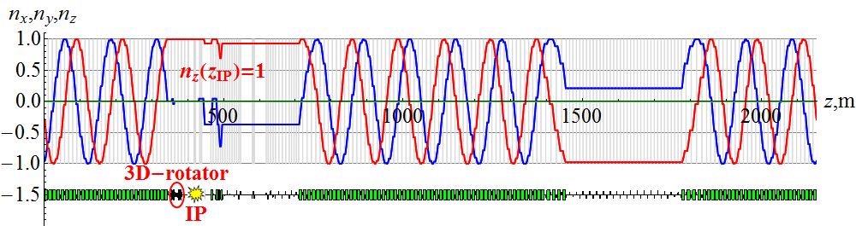
Figure 10: Deuteron beam’s polarization around the ion collider ring with n_{z}(z_{IP}) = 1.
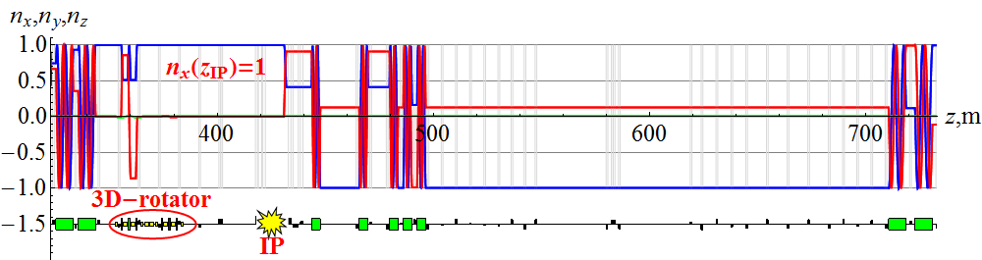
Figure 11: Proton beam’s polarization in the experimental straight of the ion collider ring with n_{x}(z_{IP}) = 1.

Calculation the Zero-Integer Spin Resonance Strength
The spin tune ν set by the 3D spin rotator must significantly exceed the strength of the zero-integer spin resonance w₀: ν >> w₀. The zero-integer resonance strength is determined by the spin field arising when particles deviate from the design orbit. Orbit deviations are related to lattice implementation errors as well as to the beam emittances. The coherent part of the spin field caused by errors in implementation of the collider’s lattice is periodic and can be compensated. Compensation of this part of the spin field greatly reduces the required field integral of the control solenoids. This can be done using a second stationary 3D spin rotator. A fundamental limitation may come from the spin field related to the beam emittances. In an ideal collider structure, there is no synchrotron modulation of the spin field and the incoherent part of the spin resonance strength is determined by emittances of the beam betatron oscillations. Our numerical calculations show that, in the present collider lattice, the zero-integer spin resonance strength in the momentum range up to 100 GeV/c does not exceed 10⁻⁴ for protons and 10⁻⁶ for deuterons.
CONCLUSION
Our numerical analysis confirms that the polarization control insertion does not affect the orbital beam parameters of the MEIC ion collider ring. The spin tune values of ν_{p} = 0.01 for protons and ν_{d} = 10⁻⁴ for deuterons as set by the control solenoids are adequate for polarization control in the ion collider ring. Compensation of the coherent part of the zero-integer spin resonance strength using a second 3D spin rotator will allow one to further reduce the field integrals of the control solenoids by, at least, an order of magnitude. This will result in a substantial reduction of time required to readjust the spin motions in experiments with polarized beams.
References
[1] S. Abeyratne et al., “MEIC Design Summary”,
edited by G.A. Krafft, JLab report, January (2015).
[2] A.M. Kondratenko at al., Proc. EIC14, MOCAUD3, JLab, Newport News, VA (2014).
[3] V.S. Morozov et al., “Polarization preservation and control in a figure-8 ring”, Proc. SPIN2014, Beijing, China (2014), to be published.
[4] A.D. Kovalenko et al., Proc. IPAC2014, TUPRO004, p. 1000 (2014).

