Baseline Scheme for Polarization Preservation and
Control in the MEIC Ion Complex*
Ya.S. Derbenev, F. Lin, V.S. Morozov, Y. Zhang, JLab, Newport News, Virginia
A.M. Kondratenko, M.A. Kondratenko, Science and Technique Laboratory Zaryad, Novosibirsk
Yu.N. Filatov, MIPT, Dolgoprudny, Moscow Region

Abstract
The scheme for preservation and control of the ion polarization in the Medium-energy Electron-Ion Collider (MEIC) has been under active development in recent years. The figure-8 configuration of the ion rings provides a unique capability to control the polarization of any ion species including deuterons by means of “weak” solenoids rotating the particle spins by small angles. Insertion of “weak” solenoids into the magnetic lattices of the booster and collider rings solves the problem of polarization preservation during acceleration of the ion beam. Universal 3D spin rotators designed on the basis of “weak” solenoids allow one to obtain any polarization orientation at an interaction point of MEIC. This paper presents the baseline scheme for polarization preservation and control in the MEIC ion complex.

introduction
Colliders “transparent to the spin”
Colliders with a figure-8 topology are natural representatives of colliders “transparent to the spin”. In such colliders, effect on the spin of one arc is compensated by the other arc. Thus, effect of “strong” arc fields on the spin is reduced to zero. Any spin direction repeats after a particle turn, i.e. the collider has no preferred spin direction. This means that the particles are in the region of a zero-integer spin resonance and the spin tune is zero ν=0.

* Authored by Jefferson Science Associates, LLC under U.S. DOE
Contracts No. DE-AC05-06OR23177 and DE-AC02-06CH11357.
The U.S. Government retains a non-exclusive, paid-up, irrevocable, world-wide license to publish or reproduce this manuscript for U.S. Government purposes.
Colliders transparent to the spin offer a unique opportunity to efficiently control the ion polarization using small magnetic field integrals. In such a collider, any small perturbation has a strong effect on the beam polarization. To stabilize the spin direction, one must introduce additional fields into the collider’s lattice, which “shift” the spin tune by a small value ($ν\text{<<}1$) and set the necessary orientation of the polarization. “Weak” fields have essentially no effect on the beam’s orbital characteristics. What especially stands out is the possibility of using weak solenoids, which do not impact the closed orbit at all. In the collider’s energy range of up to 100 GeV, the field integrals of these solenoids are approximately two orders of magnitude lower than the field integrals of the spin rotators with strong fields. There is no problem with changing the fields of such solenoids during adjustment of the beam polarization direction. It becomes possible to reverse the spin in less than a second allowing for polarized beam experiments at a new precision level.
Strength of the zero-integer spin resonance
The required weak field integrals are limited by the strength of the zero-integer spin resonance $w_{0}$: $ν\text{>>}w_{0}$. The resonance strength is the value of the average spin field, which is determined by deviation of the trajectory from the ideal design orbit. The resonance strength consists of two parts: a coherent part arising due to additional dipole and longitudinal fields on a trajectory deviating from the design orbit and an incoherent part associated with the ions’ betatron and synchrotron oscillations (beam emittances). The coherent part of the spin field is determined by linear effects and lies in the orbital plane. The incoherent part of the spin field is not present to first order in orbit deviations due to the non-resonant nature of the oscillations about the closed orbit. The coherent part of the spin field providing the main contribution to the resonance strength can be compensated by a pair of solenoids, which can be used to set any orientation and magnitude of the spin field in the collider’s plane. Compensation of the coherent part of the resonance strength allows one to greatly reduce the field integrals of the control solenoids. The technique for compensation of integer resonance harmonics is well known and has been successfully utilized, for example, at the AGS [1]. Thus, figure-8 colliders allow one to take polarized beam experiments to a conceptually higher precision level.
Let us demonstrate the main advantages of spin-transparent figure-8 colliders by applying this concept to the tasks of polarization preservation and spin manipulation during experiments in the ion complex of MEIC.

Ion polarization in the MEIC
accelerator complex
In the new design, the MEIC ion complex consists of sources for polarized light ions and non-polarized light to heavy ions, a 280 MeV pulsed SRF ion linac, an 8 GeV booster, and a medium-energy collider ring [2]. The ion collider ring is stacked vertically above the electron collider ring, and takes a vertical excursion to the plane of the electron ring for a horizontal crossing. Two interaction points of the electron and ion beams lie in the plane of the electron ring.
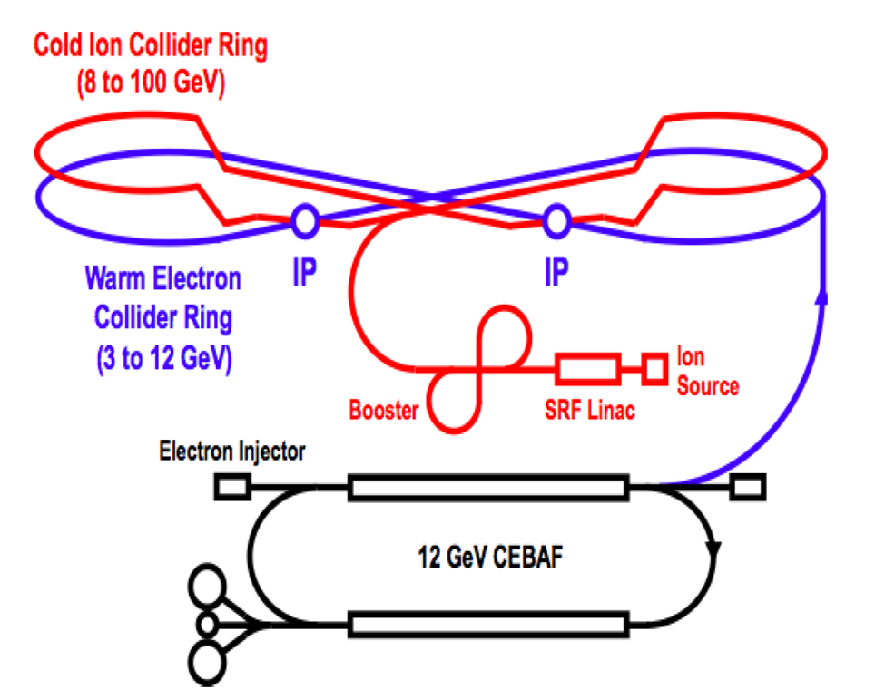
Figure 1: Schematic layout of the MEIC complex.
For experiments with polarized ion beams in the MEIC complex, one must solve the problem of preserving the polarization at all stages of ion beam acceleration including the sources of polarized light ions, SRF ion linac, booster, and collider ring. One must also solve the problem of ion polarization control at the collider’s interaction points.

Preservation of the ion polarization in the booster
In figure-8 accelerators, the spin tune is zero and is independent of energy. A figure-8 accelerator eliminates the possibility itself of crossing spin resonances during an energy ramp. To preserve the beam polarization during acceleration, it is sufficient to stabilize the spin motion in the zero-integer spin resonance region using one weak solenoid. Figure 2 shows a schematic of polarization preservation in the booster of the MEIC complex [3].
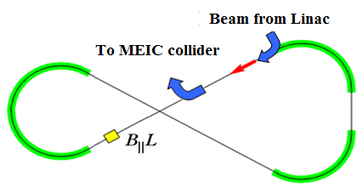
Figure 2: Acceleration and spin matching in the booster.
A solenoid stabilizes the longitudinal polarization direction in the straight where it is installed. Injection and extraction of the beam take place in the same accelerator straight. Polarization must then be matched to the longitudinal direction at injection of the ion beam from the linac into the booster and at extraction from the booster into the collider ring. The spin tune value set by the weak solenoid must greatly exceed the strength of the zero-integer spin resonance. To stabilize the spin and orbital motions, the solenoid field must change proportionally to the beam momentum. The required solenoid field integral does not exceed 1 T⋅m at the top energy of the booster. There is no problem with ramping up the fields of such solenoids during the acceleration cycle.

Ion polarization control in the collider ring
In the ion collider ring of MEIC, the spin tune and stable polarization direction of any particle species (p, d, 3He, …) are determined by a universal 3D spin rotator designed on the basis of solenoids with small field integrals (weak solenoids) [3-6]. The weak solenoids do not change the reference orbit and allow one to control the beam polarization essentially without affecting parameters of the orbital motion. The rotator consists of three modules: those for control of the radial n_{x}, vertical n_{y}, and longitudinal n_{z} polarization components (see Fig. 3).
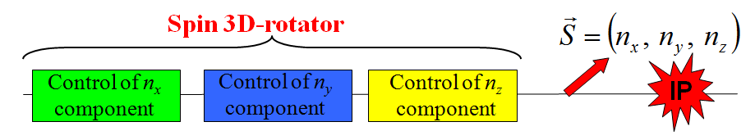
Figure 3: 3D spin rotator schematic.
Figure 4a shows the module for control of the radial polarization component n_{x}, which consists of two pairs of opposite-field solenoids and three vertical-field dipoles producing a fixed orbit bump. The control module for the vertical polarization component n_{y} is the same as that for the radial component except that the vertical-field dipoles are replaced with radial-field ones (Fig. 4b). To keep the orbit bumps fixed, the fields of the vertical- and radial-field dipoles must be ramped proportionally to the beam momentum. The module for control of the longitudinal polarization component n_{z} consists of a single weak solenoid (Fig. 4c). There is a substantial flexibility in the placement and arrangement of these modules in the collider. For instance, to free up the space in the experimental straight, the module for control of the vertical polarization component can be installed anywhere in the arc.

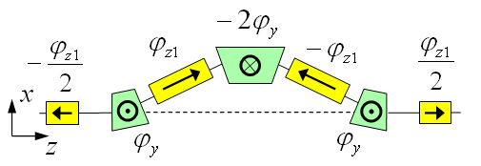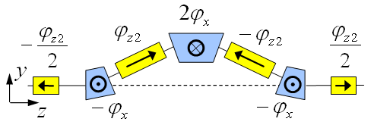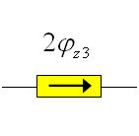
(a) (b) (c)
Figure 4: Modules for control of the radial (a), vertical (b), and longitudinal (c) spin components.

We plan to control the ion polarization using two 3D spin rotators located in both experimental straights of the collider as shown in Fig. 5. The 1st 3D rotator located in the straight containing the interaction point directly controls the polarization direction. The 2nd 3D rotator is located in the other straight and is used to compensate the coherent part of the zero-integer spin resonance strength. This allows one to significantly improve the polarized beam parameters as well as to greatly reduce the field integrals of the solenoids used for polarization control in the first rotator.
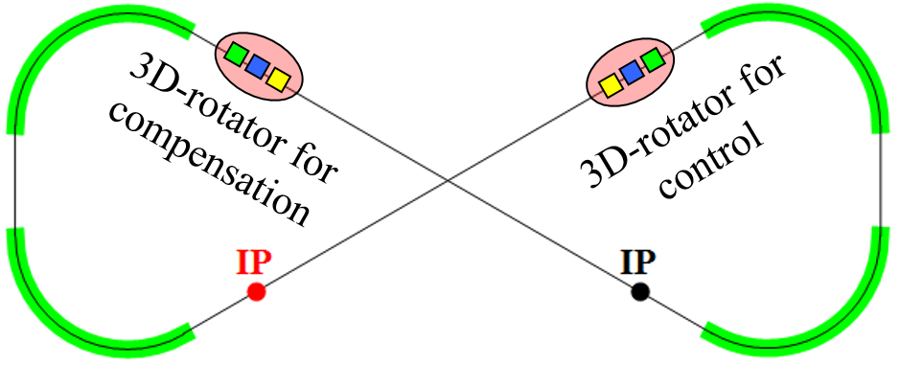
Figure 5: Placement of the spin rotators in the ion collider.
Schematic placement of the 3D rotator elements in the collider ring’s experimental straight is shown in Fig. 6. The lattice quadrupoles are shown in black, the vertical-field dipoles are green, the radial-field dipoles are blue, and the control solenoids are yellow. With each module’s length of ~8 m ( L_{x}= L_{y} =0.6 m, L_{z} = 2 m), the fixed orbit deviation in the bumps is ~16 mm in the whole momentum range of the collider. Placement of each bump between lattice quadrupoles keeps the experimental straight dispersion-free.
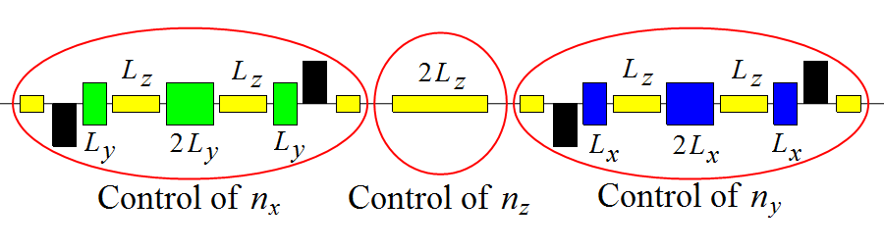
Figure 6: Placement of the 3D spin rotator elements.
The maximum required dipole and solenoid magnetic field strengths are 3 and 2 T, respectively. The spin rotator shifts the proton and deuteron spin tunes from zero by sufficient amounts of 0.01 and 10⁻⁴, respectively.
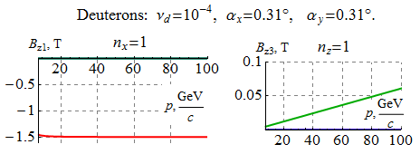
Figure 7: Dependencies of the solenoid fields on the deuteron beam momentum in MEIC for the cases of radial and longitudinal polarizations at the exit from the 3D rotator.
As an example, Fig. 7 shows dependencies of the solenoid fields in the 3D rotator on the deuteron beam momentum for radial and longitudinal polarization in MEIC.
SPin-flipping system in meic
The universal 3D spin rotator can be used to arrange a spin-flipping system in MEIC, which provides multiple beam polarization reversals at the interaction point during an experiment. To reverse the polarization, the fields of the control solenoids in the n_{x}, n_{y}, and n_{z} modules must change signs. To preserve the polarization when switching the fields of the control solenoids, one must keep the spin tune fixed and change only the polarization direction. This then eliminates resonant depolarization of the beam due to crossing of spin resonances. To preserve the polarization, one must then only satisfy the adiabaticity condition. This means that the characteristic spin reversal times in the indicated examples should not be shorter than 0.1 ms for protons and 1 ms for deuterons. Thus, using solenoids with a field ramp rate of 2 T/s, polarization can be flipped in a second [6].
CONCLUSION
Let us briefly summarize the main polarization features of the MEIC design that uses universal 3D spin rotators. Such a design allows for:
- polarization control at high energies of any particle type including deuterons;
- elimination of the resonant depolarization at all stages of the beam acceleration from the linac to the collider ring;
- adjustment of any polarization orientation at any orbital location (polarization matching at the beam transfers between the components of the accelerator complex, polarimetry, spin-flipping systems);
- manipulation of the particle spin during an experiment without affecting the beam orbital properties, which provides a capability of carrying out polarized beam experiments at a new precision level;
- compensation of manufacturing and alignment errors of lattice magnetic elements, which additionally substantially enhances the precision of polarized beam experiments;
- an easy adjustment of the spin dynamics to meet any experimental requirements, which may arise in the future.
References
[1] F.Z. Khiari et al., Phys. Rev. D 39, 45 (1989).
[2] S. Abeyratne et al., “MEIC Design Summary”,
edited by G.A. Krafft, JLab report, January 2015.
[3] A.M. Kondratenko et al., PoS (PSTP 2013) 026.
[4] A.M. Kondratenko et al., EIC’14, to be published.
[5] A.M. Kondratenko et al., SPIN’14, to be published.
[6] A.D. Kovalenko et al., IPAC’14, TUPRO004,
pp. 1000 (2014).

