Effect of 3D spin rotator on the orbital beam parameters in MEIC
We numerically calculate β functions and betatron tunes of the MEIC ion collider ring with a 3D spin rotator using its latest design based on 3 T arc magnets [1]. Figure 1 shows a part of the collider’s experimental straight with the 3D spin rotator and interaction point (IP) locations indicated. The figure shows graphs of the horizontal and vertical β functions. With the 3D rotator off, the betatron tunes and the β function values at the IP are: ν_{x} = 24.38, ν_{y} = 24.28, β _{x} = 10 cm, β _{y} = 2 cm.
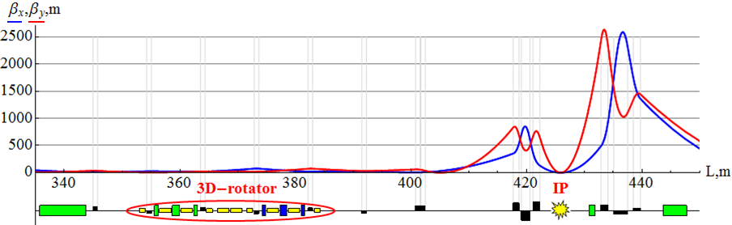
Fig. 1. β functions and 3D rotator placement in the experimental straight of MEIC.
Figure 2 shows schematic of the 3D spin rotator [2,3]. The calculations assume the lengths of L_{x} = L_{y} = 0.6 m for dipoles and of L_{z} = 2 m for solenoids.
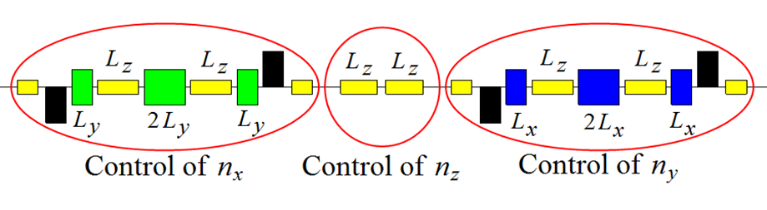
Fig. 2: Schematic placement of the 3D spin rotator elements.
Effect of the 3D spin rotator is calculated for multiple reversals of the beam polarization in the vertical plane (yz) of the detector during an experiment (spin flipping). Figures 3 and 4 show graphs of the solenoid fields in the n_{y} and n_{z} modules of the 3D rotator versus the angle Ψ between the spin and the beam direction for deuterons and protons.
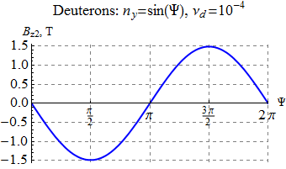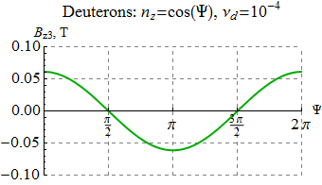
Fig. 3. Solenoid fields in the n_{y} and n_{z} modules versus the polarization angle Ψ for the deuteron beam.
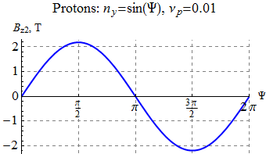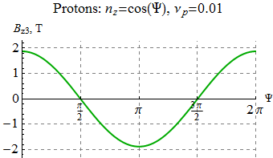
Fig. 4. Solenoid fields in the n_{y} and n_{z} modules versus the polarization angle Ψ for the proton beam.
With such a synchronous change of the solenoid fields, the spin tune remains constant while the polarization direction changes in the (y,z) plane and is given by the angle Ψ:
n_{x} = 0, n_{y} = sin Ψ, n_{z} = cos Ψ.
The stability of the reversals is provided by keeping the spin tune fixed while changing the spin direction, which eliminates the possibility of crossing spin resonances.
Figure 5 shows change in the β functions at the IP when changing the spin direction in the vertical plane of the detector during an experiment for deuterons and protons. As one can see, the maximum change of the β functions does not exceed 60 and 200 μm for deuterons and protons, respectively, i.e. the beam size remains virtually the same. Similarly, Fig. 6 shows change in the betatron tunes. One can see that the betatron tune shifts at 100 GeV/c do not exceed 10⁻⁴ for deuterons and 2×10⁻⁴ for protons.
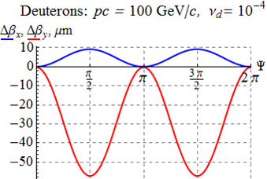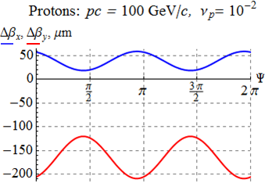
Fig. 5. Change in the β functions at the IP versus the polarization angle.
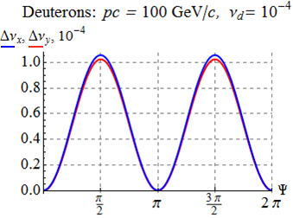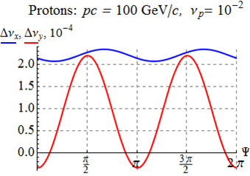
Fig. 6. Change in the betatron tunes versus the polarization angle.
Calculations show that change in the dispersion due to the 3D rotator is also negligibly small.
Our numerical analysis confirms that the polarization control insertion does not affect the orbital beam parameters of the MEIC ion collider ring.
[1] S. Abeyratne et al., MEIC Design Summary, January 20, 2015.
[2] A.M. Kondratenko, M.A. Kondratenko, and Yu.N. Filatov. “Complete baseline scheme for ion polarization preservation and control in the MEIC ion complex including the prebooster, large booster and collider ring”, the report on a complete MEIC ion polarization scheme, March 20, 2015.
[3] “Universal 3D spin rotator for control of the ion polarization in the ion collider ring of MEIC”, QUARTERLY REPORT: FY2012 R&D for Next Generation Nuclear Physics Accelerator Facilities projects, February 10, 2015.

