Complete baseline scheme for ion polarization preservation and control
in the MEIC ion complex including the prebooster, large booster and collider ring

A.M. Kondratenko¹, M.A. Kondratenko¹, and Yu.N. Filatov^{2,3}

¹Science and Technique Laboratory “Zaryad”, Novosibirsk 630090, Russia
²Moscow Institute of Physics and Technology, Dolgoprudny 141700, Russia
³Joint Institute for Nuclear Research, Dubna 141980, Russia

Translated by V.S. Morozov, Jefferson Lab

Introduction
The design requirements for the ion beam polarization in MEIC are:
- High polarization (over 70%) for protons or light ions (d, ³He⁺⁺, and possibly ⁶Li⁺⁺⁺)
- Both longitudinal and transverse polarization at all interaction points
- Sufficiently long polarization lifetime
- Spin flipping at a high frequency
The choice of a figure 8 shape for the prebooster, large booster and collider rings of MEIC opens wide possibilities for preservation of the ion polarization during beam acceleration as well as for control of the polarization at the collider’s interaction points [1-5]. As in the case of accelerators with Siberian snakes, the spin tune is energy independent but is equal to zero instead of one half. The figure-8 topology eliminates the effect of arcs on the spin motion. There appears a unique opportunity to control the polarization of any particle species including deuterons, using longitudinal fields of small integrated strength (weak solenoids). Contrary to existing schemes, using weak solenoids in figure-8 colliders, one can control the polarization at the interaction points without essentially any effect on the beam’s orbital characteristics. A universal scheme for control of the polarization using weak solenoids provides an elegant solution to the problem of ion acceleration completely eliminating resonant beam depolarization. It allows one to easily adjust the polarization in any direction at any orbital location, which becomes necessary when transferring the beam from one ring into another or when measuring the polarization by polarimeters. It also allows for an easy manipulation of the spin direction at an interaction point during an experiment. The latter feature allows one to set up a spin-flipping system with a spin reversal time of less than a second. By compensating the coherent part of the zero-integer spin resonance strength, which arises due to errors in alignment of the magnetic element of the lattice, one can reduce the field integrals of the control solenoids by a few orders of magnitude.
The above advantages of a figure-8 collider with weak spin control solenoids allow polarized beam studies in MEIC at an unprecedented precision level.
Below we will first discuss the main characteristic features of the spin behavior in figure-8 colliders and will then describe the baseline for ion polarization control in the accelerator complex of MEIC.

Colliders with “preferred spin axis” and “transparent to the spin”
Describing the polarization dynamics of ion beams in colliders (cyclic accelerators, storage rings) is in many respects similar to describing their orbital motion. An analog of the closed orbit, along which the particle velocity vector is periodic, is the periodic spin precession axis . When a particle is moving along the closed orbit, its spin initially directed along the axis will restore its orientation every particle turn. Thus, the effect of magnetic fields along the closed orbit on the spin represents a rotation about the axis by some angle , which determines the spin tune . When the particle trajectory deviates from the closed orbit, the spin precession axis as well as the spin tune also experience deviations. The beam polarization is stable just along the collider’s axis. The particle spins transverse to the axis get completely disordered in a few hundred particle turns due to the spin tune spread leading to beam depolarization.
From the spin dynamics point of view, all colliders can be generally categorized into two types, namely, colliders “with preferred spin direction” and colliders “transparent to the spin”.
In colliders “with preferred spin direction”, the periodic spin motion along the closed orbit is unique, i.e. the static magnetic lattice determines a single stable orientation of the beam polarization. The fractional part of the spin tune differs from zero.
Let us give examples of colliders (accelerators) with preferred spin direction.
1. Conventional accelerator. Conventional accelerators include accelerators consisting of arcs and straight sections. The stable polarization direction is vertical while the spin tune is proportional to the beam energy, which unavoidably leads to crossing of many spin resonances during acceleration and, consequently, to resonant depolarization of the beam.
2. Collider with a Siberian snake. Introduction of Siberian snakes opens wide opportunities for obtaining of intense polarized beams at high energies. Insertion of one Siberian snake into a collider ring completely rearranges the spin dynamics. Instead of being vertical, polarization becomes stable in the collider’s plane while the spin tune does not depend on the energy at all and is equal to one half. A Siberian snake eliminates crossing of spin resonances and completely solves the problem of polarization preservation during beam acceleration [1].
3. Collider with two Siberian snakes. Insertion of two Siberian snakes into opposite straights of a collider allows one to keep the polarization vertical in the arcs. The spin tune is then also independent of energy, is determined by the angle between the snakes’ spin rotation axes, and can vary in the range from zero to one half. In a conventional scheme with two Siberian snakes, the angle between the snakes’ rotation axes is equal to 90° and the spin tune is equal to one half, the same as in the case of a collider with one snake (RHIC, BNL) [6,7].
In colliders “transparent to the spin”, any spin direction repeats every particle turn along the closed orbit, i.e. the accelerator’s magnetic lattice is transparent to the spin. The fractional part of the spin tune is equal to zero.
Let us give examples of colliders (accelerators) transparent to the spin.
1. Conventional accelerator (resonant case). As noted above, conventional accelerators belong to the type of accelerators “with preferred spin direction” everywhere except narrow energy bands in the regions of integer resonances , i.e. when the combined effect of arcs on the spin results in an integer number of rotations about the vertical axis.
2. Collider with two identical Siberian snakes. When using two identical snakes with the angle between their rotation axes equal to zero or 180°, the fractional part of the spin tune becomes equal to zero. A project of a collider with two solenoidal snakes has been proposed at Dubna (NICA, JINR) [8].
3. Collider in the shape of a figure 8. The most natural representative of a collider “transparent to the spin” is an accelerator in the shape of a figure 8 (MEIC, JLAB) [1,9]. The resulting effect of the arc magnets on the spin dynamics over a particle turn reduces to zero and the ring becomes “transparent” to the spin: the spin first rotates about the vertical field in the first arc and then its rotation is compensated by an opposite field in the second arc. Any spin direction at any orbital location repeats every turn. The spin tune is zero. The particles are in the region of a zero-integer spin resonance .
From the above examples, we see that a collider of one type can be easily transformed into a collider of the other type. For instance, insertion of a Siberian snake into a spin-transparent collider converts it into a collider with preferred spin direction. Inversely, addition of a second identical snake to a single-snake collider with preferred spin direction converts it into a spin-transparent collider.
Colliders transparent to the spin offer a unique opportunity to efficiently control the ion polarization using small magnetic field integrals. In such a collider, any small perturbation has a strong effect on the beam polarization. To stabilize the spin direction, one must introduce additional fields into the collider’s lattice, which “shift” the spin tune by a small value (ν << 1) and set the necessary orientation of the axis. The required field integrals (weak fields) are significantly lower than the field integrals used in Siberian snakes (strong fields) and are limited by the strength of the zero-integer spin resonance :
ν >>.
For example, for a collider transparent to the spin with a maximum energy of 100 GeV, it is sufficient to introduce a solenoid with a field integral of about 10 T⋅m to stabilize the polarization in the longitudinal direction at the solenoid insertion place. Besides, such a scheme is universal for all particle species including both protons and deuterons. In RHIC, longitudinal proton polarization is obtained using two helical snakes and two spin rotators with a combined transverse field integral of T⋅m. For deuterons, due to the small value of their anomalous magnetic moment, the total transverse field integral in RHIC would have to be about 2500 T⋅m. In a collider with one solenoidal snake, obtaining longitudinal polarization of protons and deuterons would require longitudinal field integrals of about 360 and 1000 T⋅m, respectively. These examples demonstrate that obtaining longitudinal deuteron polarization in colliders with preferred spin direction presents a serious problem.
In colliders, a crucial task is not only preservation of the polarization during the energy ramp but also its control at the interaction points during experiments.
Traditionally, in colliders with preferred spin direction, polarization is controlled using a pair of spin rotators with “strong” fields, which provide the required spin orientation at an interaction point and then return the spin to its original direction. This process changes not only the polarization direction but the trajectories of the beam particles as well. This causes a change in the orbital characteristics of the beam. There are betatron tune shifts, changes in dispersion, beta-functions, luminosity, etc. Accounting for the changes in the beam orbital characteristics becomes a problem when doing experiments with polarized beams in colliders.
In colliders with spin transparency, ion polarization can be efficiently controlled using “weak” fields, which have essentially no effect on the beam’s orbital characteristics. What especially stands out is the possibility of using weak solenoids, which do not impact the closed orbit at all. In the collider’s energy range of up to 100 GeV, the field integrals of these solenoids are approximately two orders of magnitude lower than the field integrals of the spin rotators with strong fields. There is no problem with changing the field of such solenoids during adjustment of the beam polarization direction. It becomes possible to reverse the spin in less than a second that allows for polarized beam experiments at a new precision level.

Strength of the zero-integer spin resonance in a figure-8 collider
When using figure-8 colliders in the spin transparent mode, polarization of the ion beam is controlled in the region of the zero-integer resonance and its strength determines polarization stability. The resonance strength is the value of the average spin field, which is determined by deviation of the trajectory from the ideal design orbit.
The symmetry of a figure-8 ring singles out the vertical polarization direction because vertical polarization does not change when ions are moving along the design orbit while horizontal polarization component rotates in the collider’s arcs first in one direction and then in the other. Due to periodic nature of the spin motions with a zero tune, the frequency spectrum of the spin motion consists of integer-multiple harmonics of the particle revolution frequency in the collider.
The resonance strength consists of two parts: a coherent part arising due to additional dipole and longitudinal fields on a trajectory deviating from the design orbit and an incoherent part associated with ions’ betatron and synchrotron oscillations (beam emittances).
The coherent part of the spin field is determined by linear effects and lies in the orbit plane. The incoherent part of the spin field is not present in the linear approximation in orbit deviations due to the non-resonant nature of the oscillations about the closed orbit. This part of the field is mainly related to a large number of precessions in the arcs and is directed along the vertical. The coherent part of the spin field, which provides the main contribution to the resonance strength, can be compensated by a pair of solenoids, which can be used to set any orientation and size of the spin field in the collider’s plane. Compensation of the coherent part of the resonance strength allows one to greatly reduce the field integrals of the control solenoids. The compensation technique of integer resonance harmonics is well known and has been successfully utilized, for example, at the AGS [10]. Thus, figure-8 colliders allow one to take polarized beam experiments to a conceptually higher precision level.
Let us demonstrate the main advantages of spin transparent figure-8 colliders when solving the problems of polarization preservation and spin manipulation during experiments in the ion complex of MEIC.

Ion polarization in the MEIC accelerator complex
In the present design, the MEIC ion complex consists of sources for polarized light ions and non-polarized light to heavy ions, a 280 MeV pulsed SRF ion linac, a 3 GeV pre-booster ring, a 20 GeV large booster, and a medium-energy collider ring [9]. All of the above energy parameters are for the proton beam; they must be scaled appropriately for ion beams using the mass-to-charge ratio for the same magnetic rigidity. The large booster is currently designed with its footprint matching the collider rings as shown in Figure 1 and thus will be housed in the same tunnel. The large booster is placed above the medium-energy ion collider ring while the electron ring is below it. Two interaction points of the electron and ion beams lie in the plane of the electron ring.
For experiments with polarized ion beams in the MEIC complex, one must solve the problem of preserving the polarization at all stages of ion beam acceleration including the sources of polarized light ions, SRF ion linac, pre-booster, large booster, and collider ring. One must also solve the problem of ion polarization control at the collider’s interaction points.
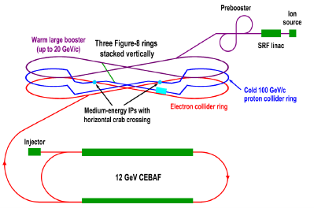
Figure 1: The MEIC electron and ion collider rings and the large ion booster ring are stacked vertically and housed in the same tunnel.
Preservation of the ion polarization in the prebooster and large booster
In figure-8 accelerators, the spin tune is zero and is independent of energy. Similar to an accelerator with a Siberian snake, a figure-8 accelerator eliminates the possibility itself of crossing spin resonances during an energy ramp. To preserve the beam polarization during acceleration, it is sufficient to stabilize the spin motion in the zero-integer spin resonance region using one weak solenoid. Figure 8 shows schematics of polarization preservation in the prebooster and large booster of the MEIC complex [3-4]. A solenoid stabilizes the longitudinal polarization direction in the straight where it is installed. Injection and extraction of the beam take place in the same accelerator straight. Polarization must then be matched to the longitudinal direction at injection of the ion beam from the linac into the prebooster and at extraction from the large booster into the collider ring.
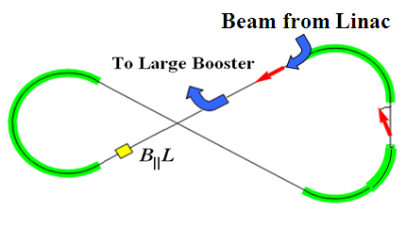 | 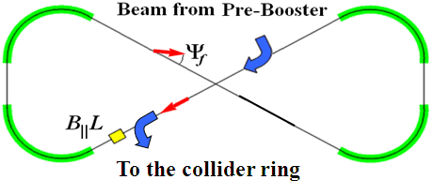
Figure 2: Acceleration and spin matching in the prebooster and large booster.
The spin tune value set by the weak solenoid must greatly exceed the strength of the zero-integer spin resonance. To stabilize the spin and orbital motions, the solenoid field must change proportionally to the beam momentum. Table 1 shows parameters of the solenoids providing preservation of the proton and deuteron polarizations in the whole energy ranges of the accelerators.

 | , GeV/c | , T⋅m | , cm
Prebooster | 0.785/3.83 | 0.06/0.28 | 60 | 0.003/0.01
Large booster | 3.83/25 | 0.28/1.9 | 120 | 0.003/0.01
Table 1. Parameters of the solenoids preserving the polarization in the prebooster and large booster.

The required solenoid field integral does not exceed 2 T⋅m at the top energy of the large booster. There is no problem with ramping up the fields of such solenoids during the acceleration cycle. To avoid crossing of spin resonances up to the energies of 20 GeV, accelerators with Siberian snakes require a solenoidal snake with a field integral of about 75 T⋅m for protons and about 250 T⋅m for deuterons. Note the universality of the polarization preservation scheme with regard to the particle species. Figure-8 colliders allow one to easily preserve the deuteron polarization up to the maximum energy of the complex.
As pointed out above, weak solenoids essentially do not change the orbital parameters of the ring. As an example, Fig. 3 shows graphs of the -functions and vertical dispersion in the prebooster for the cases without (top) and with (bottom) insertion of the solenoid. The insertion location is circled in red.
We can see that, when the solenoid is placed at an orbital location with a small radial dispersion , the vertical dispersion is essentially not excited ( m). The dispersion is only excited when the solenoid is placed at locations with nonzero and can be of the order of 0.1 m in the prebooster.
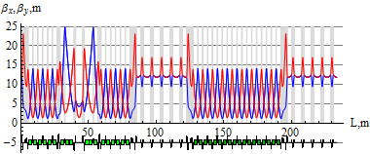 | 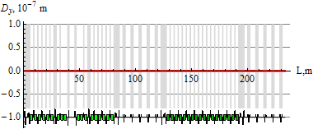
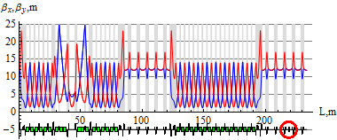 | 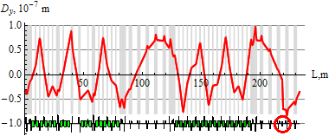
Figure 3: β-functions and vertical dispersion D_{y} for the cases without (top) and with (bottom) insertion of the solenoid in the prebooster.
The radial and vertical betatron tunes of the prebooster without the solenoid are and , respectively. The solenoid causes betatron tune shifts, which are independent of energy. In the approximation of a short solenoid (L||<<β), the shifts of the radial and vertical betatron tunes can be estimated using the formula
.
For the maximum solenoid field integral of 0.3 T⋅m at the prebooster’s maximum rigidity of T⋅m and for m, the betatron tune shift is about .
The considered example shows that the influence of a weak solenoid on the orbital parameters of the prebooster is negligibly small despite even the fact that one of the betatron tunes is near an integer, i.e. when parameters of the orbital motion are particularly sensitive to small orbit perturbations.
Ion polarization control in the collider ring
The advantages of using weak solenoids in figure-8 colliders stand out most prominently when manipulating the particle spin at the interaction points during an experiment.
As already noted, in a collider transparent to the spin, the spin tune and stable polarization direction are determined not by the structural arc magnets but by small solenoids introduced into the collider’s lattice. The small solenoids do not change the design orbit and allow for control of the beam polarization without essentially any effect on the parameters of the orbital motion.
Weak solenoid and dipole inserts can be used to construct a universal 3D spin rotator, which allows for adjustment of any polarization direction of any particle species (p, d, ³He, …) in the collider.
Figure 4 shows a schematic of the 3D spin rotator [5] for ion polarization control located at the end of the experimental straight. The rotator consists of three modules: those for control of the radial , vertical , and longitudinal components of the polarization (see Fig. 4a). The 3D spin rotator placement in the MEIC ring is shown schematically in Fig. 4b.
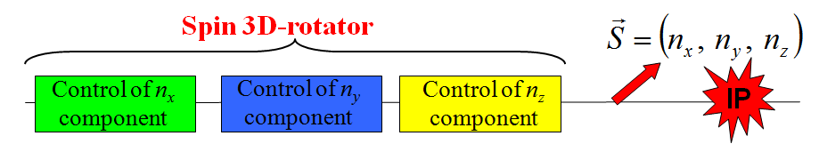 | 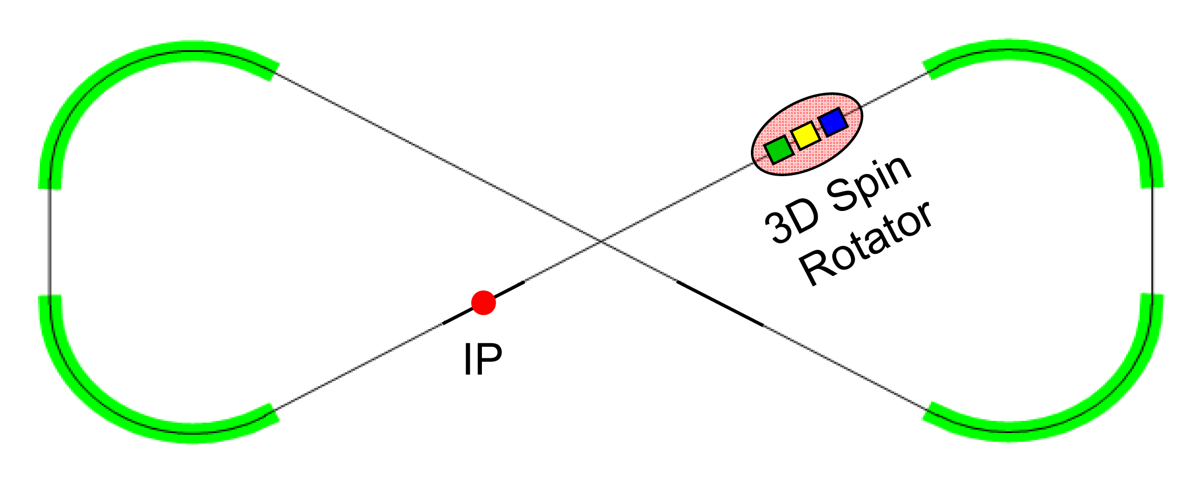
(a) | (b)
Figure 4: (a) 3D spin rotator schematic. (b) Spin rotator placement in the ion collider ring.

Figure 5a shows the module for control of the radial polarization component , which consists of two pairs of opposite-field solenoids and three vertical-field dipoles producing a fixed orbit bump. The control module for the vertical polarization component is the same as that for the radial component except that the vertical-field dipoles are replaced with radial-field ones (Fig. 5b). To keep the orbit bumps fixed, the fields of the vertical- and radial-field dipoles must be ramped proportionally to the beam momentum. The module for control of the longitudinal polarization component consists of a single weak solenoid (Fig. 5c). There is a substantial flexibility in the placement and arrangement of these modules in the collider. For instance, to free up the space in the experimental straight, the module for control of the vertical polarization component can be installed anywhere in the arc.

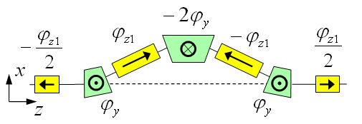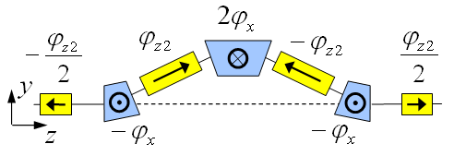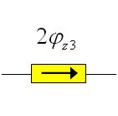
(a) (b) (c)

Figure 5: Modules for control of the radial (a), vertical (b), and longitudinal (c) spin components.

Under the approximation of a small spin tune, the required spin rotation angles of the solenoids are determined by the following equations ():
where , , and are the radial, vertical, and longitudinal polarization components, respectively, at the rotator’s exit, and are the spin rotation angles of the aforementioned radial- and vertical-field dipoles, respectively, and and are the respective orbit bending angles of these dipoles. The calculation assumes that, with the solenoids off, the spin tune in the collider is zero.
Figure 6 shows dependencies of the required solenoid field integrals on the beam momentum for the radial, vertical, and longitudinal deuteron polarizations in MEIC at the exit from the 3D rotator. Here, $(B_{||}L)_{i}=ϕ_{\text{zi}}Bρ/(1+G)$ is the solenoid field integral and is the magnetic rigidity. We assume bending angles of for the radial and vertical-field dipoles and a spin tune of .

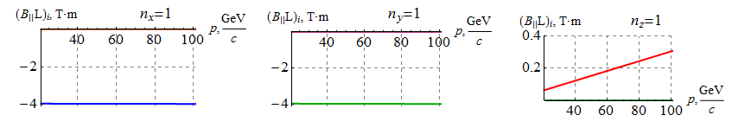
(a) (b) (c)
Figure 6: Dependencies of the solenoid field integrals on the deuteron beam momentum in MEIC for the cases of radial (a), vertical (b), and longitudinal (c) polarizations at the exit from the 3D rotator.

Note that, for the transverse polarization directions, the solenoid fields remain constant at about
-4 T⋅m in the whole momentum range of the deuteron beam. For the longitudinal polarization, the solenoid field is proportional to the deuteron momentum and is about an order of magnitude lower than the solenoid fields required for the transverse polarization.
The same insertion can be used to control the proton polarization. Figure 7 shows dependencies of the required solenoid field integrals on the beam momentum for the radial, vertical, and longitudinal proton polarizations in MEIC at the exit from the 3D rotator. We assume a spin tune of . Thus, when manipulating the proton spin during an experiment, the solenoid field does not exceed 4 T in the whole momentum range as for the deuteron beam.

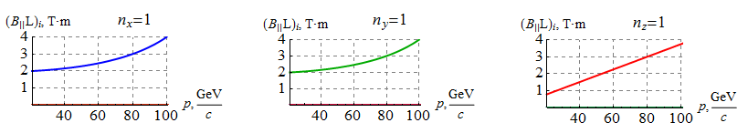
(a) (b) (c)
Figure 7: Dependencies of the solenoid field integrals on the proton beam momentum in MEIC for the cases of radial (a), vertical (b), and longitudinal (c) polarizations at the exit from the 3D rotator.

Schematic placement of the 3D rotator elements in the collider ring’s experimental straight is shown in Fig. 8 [5]. The structural quadrupoles are shown in black, the vertical-field dipoles are green, the radial-field dipoles are blue, and the control solenoids are yellow. With each module’s length of ~6 m ( m, m), the fixed orbit deviation in the bumps is ~12 mm in the whole momentum range of the collider. Arranging each bump between the structural quadrupoles allows one to keep the experimental straight dispersion free.
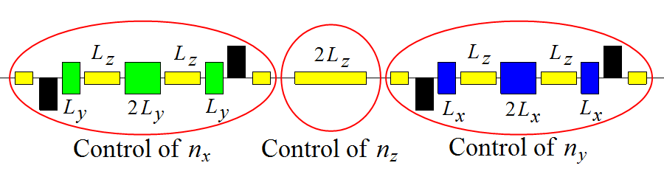
Figure 8: Schematic placement of the 3D spin rotator elements.

The 3D spin rotator can provide any desired polarization orientation at the interaction point. The maximum required dipole and solenoid magnetic field strengths are 3 and 3.6 T, respectively. The spin rotator shifts the proton and deuteron spin tunes from zero by sufficient amounts of 0.01 and 2.5⋅10⁻⁴, respectively. The magnetic fields of the spin rotator solenoids can be changed relatively quickly on the time scale of a few seconds allowing one to use the 3D rotator for spin-flipping.
The 3D rotators are designed using weak solenoids and allow performance of the following tasks: matching of the polarization direction at injection, polarization preservation during acceleration and storage, measurement of the beam polarization at any orbital location, and spin manipulation at the interaction point during experimental running.

Calculation of the ion polarization in the collider’s experimental straight
The interaction point of the electron and ion beams is located in the plane of the electron ring. The ion beam is brought from the plane of the ion arcs to the electron plane in the experimental straight using two two-step dogleg sections. Each section consists of two pairs of opposite-field but otherwise identical radial-field dipoles, which first lower the ion beam down to the plane of the electron ring and then bring it back up. Also, in the experimental straight, there are six vertical-field dipoles, which bring the beams together at the interaction point. The first dipole is located prior to the interaction point (IP) and provides crossing of the electron and ion beams creating an angle of 50 mrad between the beam directions. The remaining five dipoles located after the interaction point adjust the ion beam direction to be parallel to the direction of the electron beam. Figure 9 shows a schematic of the placement of the radial-field (blue) and vertical-field (green) dipoles that bring the electron and ion beams to collision at the interaction point.
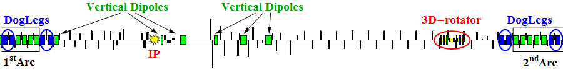
Figure 9: Schematic placement of the radial and vertical-field dipoles bringing the electron and ion beams together at the interaction point.

Without the indicated dipoles that arrange the beam crossing, the beam polarization in the experimental straight would not be changing at all and would coincide with the polarization direction set by the 3D rotator. Due to their presence, the polarization direction at the interaction point must be coordinated with that set at the 3D rotator location, i.e. one must account for an addition polarization rotation by the vertical-field dipoles by a net angle, which is times greater than the 50 mrad orbital angle. While, for deuterons, at the top energy, this angle is not large and is equal to about 20 degrees, for protons, this angle is not small and is equal to about one and a half turns.
In Fig. 10, the equilibrium polarization components in the MEIC’s ion collider ring are shown for an ideal collider structure as functions of the orbital length z for a 100 GeV/c deuteron beam for the cases of radial , vertical , and longitudinal polarizations at the interaction point. The blue, green, and red curves show the radial, vertical, and longitudinal polarization components, respectively.
Figure 10 shows that the vertical polarization changes only at the location of the radial-field dipoles of the dogleg sections. The polarization component lying in the plane of the ring does not change significantly in the experimental straights and makes about 5 turns about the vertical direction in each arc.

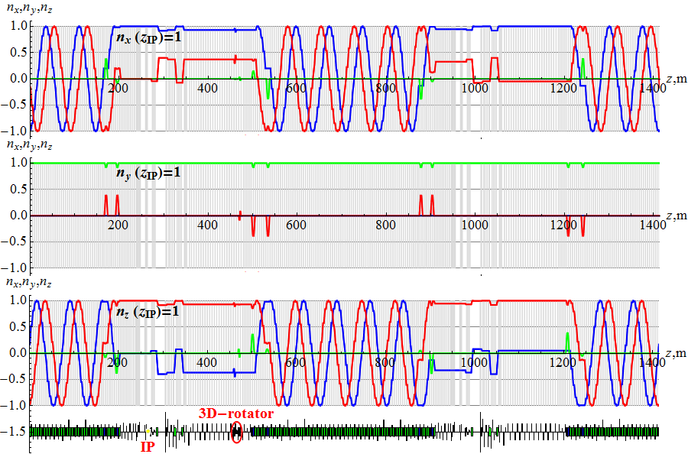
Figure 10: Deuteron polarization components in the ion collider ring for the cases of radial (a), vertical (b) and longitudinal (c) polarizations at the interaction point.

In contrast to the deuteron beam, the transverse proton polarization changes significantly at each magnet of the lattice. The polarization component of a 100 GeV/c proton beam lying in the ring plane makes about 125 turns in each arc and rotates considerably inside the magnets with vertical and radial fields that bring the beams together at the interaction point. The vertical polarization, similarly to deuterons, remains unchanged in both experimental straights. In Fig. 11, for an ideal collider structure, the equilibrium polarization components in the MEIC’s experimental straight are shown as functions of the orbital length for a 100 GeV/c proton beam for the cases of radial, vertical, and longitudinal polarizations at the interaction point.
The presented examples demonstrate the flexibility in control of the ion polarization when using a universal 3D spin rotator. The 3D spin rotator allows for a simple adjustment of the spin motion in the collider when modifying the magnetic lattice of the interaction region or introducing additional magnets into the lattice in the future. The only requirement on the introduced fields is that the accelerator remains transparent to the spin.

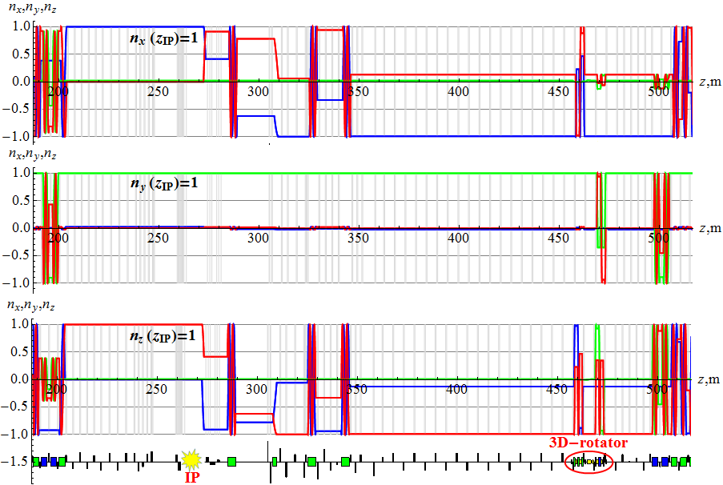
Figure 11: Proton polarization in the MEIC’s experimental straight.

Spin flipping in the ion collider ring
The universal 3D spin rotator can be used to arrange a spin-flipping system in MEIC, which provides multiple beam polarization reversals at the interaction point during an experiment.
At 100 GeV/c, longitudinal polarization is obtained at the interaction point with the following field integrals of the 3D rotator solenoids in the [], [], and [] modules, respectively:
for protons,
for deuterons.
The calculations used the spin tune values of for protons and for deuterons. Running the indicated rotator solenoids sets the longitudinal direction of the beam polarization at the interaction point. When moving along the collider’s orbit, the polarization direction then makes about 250 turns for a proton beam and about 10 turns for a deuteron one.
To reverse the longitudinal polarization, the fields of the control solenoids in the and modules must change signs. To preserve the polarization when switching the fields of the control solenoids, one must keep the spin tune fixed and change only the polarization direction. To achieve this, the change of field of the control solenoids in the module must be accompanied by a coordinated change of the solenoid field in the module. Figure 12 shows the dependencies of the field integrals on the field integral when reversing the longitudinal polarization at the interaction point. When changing the solenoid fields along the indicated ellipse, from the blue point to the green one, the longitudinal polarization undergoes a reversal at a fixed spin tune. This then eliminates resonant depolarization of the beam due to crossing of spin resonances.

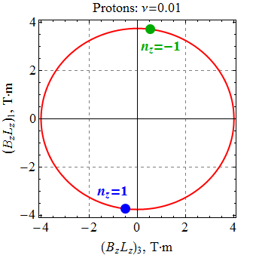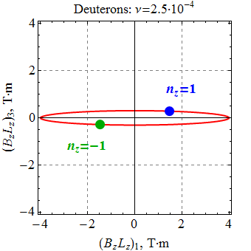
Figure 12: Relation of the solenoid field integrals in the and modules when changing the polarization direction (). Shown on the left is the ellipse for the proton beam, on the right is that for the deuteron one. The blue dot marks the solenoid field integrals, for which . The green dot marks those, for which .
To preserve the polarization, one then only has to satisfy the condition of adiabatic change of the polarization direction by the control solenoids :
$\left|\frac{d\vec{n}}{\text{dt}}\right|\text{<<}Ω_{\text{spin} }, Ω_{\text{spin}}=ν Ω_{c}=\text{const},$
where is the particle revolution frequency in the collider. This condition means that the characteristic spin reversal time in the given examples is limited by 0.1 ms for protons and 3 ms for deuterons.
An advantageous feature of the chosen polarization manipulation scheme is the absence of resonant depolarization occurring in spin resonance crossings. Dynamic depolarization is determined by the strength of the zero-integer spin resonance, which contains a coherent part related to errors in the collider’s magnetic structure and an incoherent part associated with the beam emittances. The dynamic depolarization can be significantly reduced by compensating the coherent part of the zero-integer spin resonance strength. The strength of the zero-integer spin resonance can be compensated using similar 3D spin rotators located in the experimental straight. Compensation of the spin resonance strength allows one to greatly reduce the spin tune in the collider and manipulate the spin orientation using ultimately small field integrals of the control solenoids.

Conclusions
Let us briefly summarize the main features of the figure-8 design. Such a design allows for:
- use of weak solenoids for polarization control at high energies of any particle species including deuterons;
- seamless integration of the spin control elements into the collider lattice with fixed closed orbit and no optics distortion;
- elimination of the resonant depolarization at all stages of the beam acceleration from the linac to the collider ring;
- adjustment of any polarization orientation at any orbital location (spin matching at injection into the different accelerator complex components, polarimetry, spin flipping);
- manipulation of the particle spin during an experiment without affecting the beam orbital properties, which provides a capability of carrying out polarized beam experiments at a new precision level;
- compensation of manufacturing and alignment errors of the lattice magnetic elements, which additionally substantially enhances the precision of polarized beam experiments;
- ease of adjusting the spin dynamics to meet any experimental requirements, which may arise in the future.
References
[1] Ya.S. Derbenev, University of Michigan report UM HE 96-05 (1996).
[2] A.M. Kondratenko et al., PoS (PSTP 2013) 026.
[3] A.M. Kondratenko et al., EIC’14, to be published.
[4] A.M. Kondratenko et al., IPAC’14, MOPRO004, p. 68.
[5] A.M. Kondratenko et al., SPIN’14, to be published.
[6] V.Ptitsin and Y.Shatunov, NIM A398, 126 (1997).
[7] E.Willen et al., in Proc. PAC99, NY, 3161 (1999).
[8] A.D. Kovalenko et al, Pepan, 2014, Vol. 45, No. 1, pp. 321–322.
[9] S. Abeyratne et al., “Science requirements and conceptual design for a polarized medium energy electron-ion collider at Jefferson lab”, edited by Y. Zhang and J. Bisognano, arXiv:1209.0757 [physics.acc-ph] (2012).
[10] Khiari F.Z. et al. “Acceleration of polarized protons to 22GeV and the measurement of spin-spin effects in p-up + p-up -> p + p” Phys. Rev. D 39:45 (1989)

