Universal 3D spin rotator for control of the ion polarization
in the ion collider ring of MEIC

In the ion collider ring of MEIC, the spin tune and stable polarization direction of any particle species (p, d, ³He, …) are determined by a universal 3D spin rotator designed on the basis of solenoids with small field integrals (weak solenoids) [1-3]. The weak solenoids do not change the reference orbit and allow one to control the beam polarization essentially without affecting parameters of the orbital motion. The rotator consists of three modules: those for control of the radial , vertical , and longitudinal polarization components (see Fig. 1a).
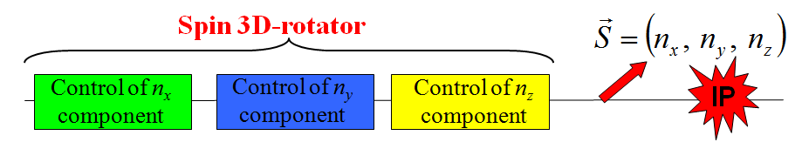 | 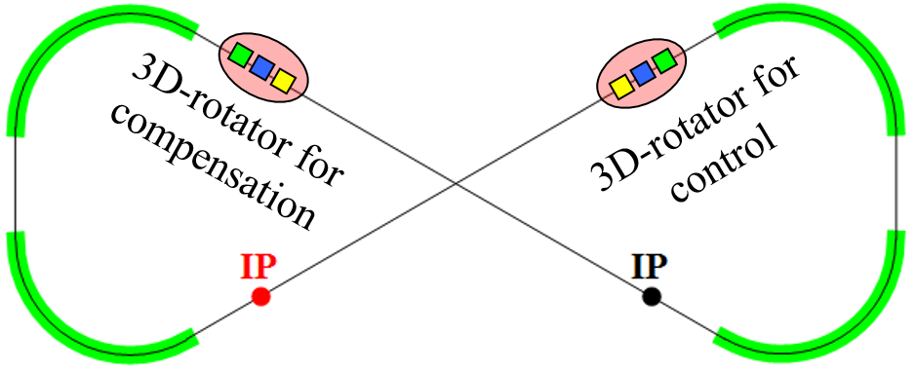
(a) | (b)
Figure 1: (a) 3D spin rotator schematic. (b) Placement of the spin rotators in the ion collider ring.

We plan to control the ion polarization using two 3D spin rotators located in both experimental straights of the collider as shown in Fig. 1b. The first 3D rotator located in the straight containing the interaction point directly controls the polarization. The second 3D rotator is located in the other straight and is used to compensate the coherent part of the zero-integer spin resonance strength. This allows one to significantly improve the polarized beam parameters as well as to greatly reduce the field integrals of the solenoids used for polarization control in the first rotator.
Schematic placement of the 3D rotator elements in the collider ring’s experimental straight is shown in Fig. 2 [3]. The lattice quadrupoles are shown in black, the vertical-field dipoles are green, the radial-field dipoles are blue, and the control solenoids are yellow. With each module’s length of ~6 m ( m, m), the fixed orbit deviation in the bumps is ~12 mm in the whole momentum range of the collider. Placement of each bump between lattice quadrupoles keeps the experimental straight dispersion-free.
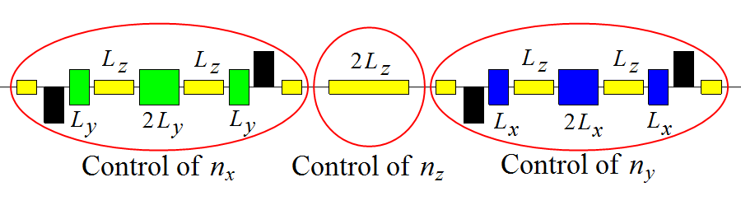
Figure 2: Schematic placement of the 3D spin rotator elements.
The maximum required dipole and solenoid magnetic field strengths are 3 and 3.6 T, respectively. The spin rotator shifts the proton and deuteron spin tunes from zero by sufficient amounts of 0.01 and 2.5⋅10⁻⁴, respectively. The magnetic fields of the spin rotator solenoids can be changed relatively quickly on the time scale of a few seconds allowing use of the 3D rotator for spin-flipping.
The universal 3D spin rotators in the ion collider of MEIC allow for
- manipulation of any particle’s spin at the interaction point during experimental running without affecting the beam orbital properties, which provides a capability of carrying out polarized beam experiments at a new precision level;
- polarization preservation during acceleration and storage;
- adjustment of any polarization orientation at any orbital location (spin matching at injection into the different accelerator complex components, polarimetry, spin flipping);
- compensation of the manufacturing and alignment errors of the lattice magnetic elements, which additionally substantially enhances the precision of polarized beam experiments;
- ease of adjustment of the spin dynamics to meet any experimental requirements, which may arise in the future.
References
[1] A.M. Kondratenko et al., EIC’14, to be published.
[2] A.M. Kondratenko et al., IPAC’14, MOPRO004, p. 68.
[3] A.M. Kondratenko et al., SPIN’14, to be published.

