**Manipulation of the proton and deuteron polarizations in the MEIC ion collider and spin-flipping systems**

Universal 3D spin rotators are used in the MEIC ion collider to control the beam polarization of any particle species (p, d, He3, …). The 3D rotators are designed using weak solenoids. A rotator consists of three modules including the modules for control of the radial , vertical , and longitudinal  components of the polarization (see Fig. 1). The lattice’s structural quadrupoles are shown in black, the vertical-field dipoles are green, the radial-field dipoles are blue, and the control solenoids are yellow. With lengths of $L_{x}=L_{y}=0.5$ m and $L_{z}=1.0$ m, the fixed orbit displacement in the bumps is ~1.8 cm in the whole beam momentum range of the collider. The 3D spin rotator placement in the MEIC ion collider ring is shown schematically in Fig. 2.

|  |  |
| --- | --- |
|  |  |
| Fig. 1: Schematic placement of the 3D spin rotator elements. | Fig. 2: Placement of the 3D spin rotator in the MEIC ion collider. |

Let us present calculations of the proton and deuteron beam polarizations in the MEIC ion collider with a single 3D spin rotator determining the polarization at the interaction point (IP). Figures 3 and 4 show examples of how the proton and deuteron polarization components change along the collider’s orbit for the case of longitudinal polarization at the IP.

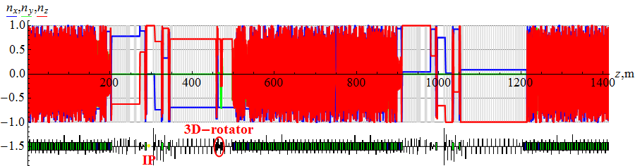

Fig. 3: Proton beam’s polarization in the MEIC ion collider ring for the case of longitudinal polarization at the IP (*n*z=1).

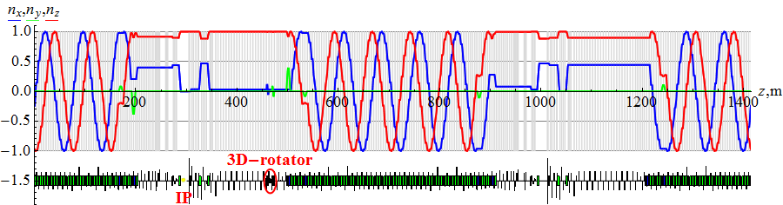

Fig. 4: Deuteron beam’s polarization in the MEIC ion collider ring for the case of longitudinal polarization at the IP (*n*z=1).

For the longitudinal polarization at the IP, the field integrals of the 3D rotator solenoids in the *n*x (Bz Lz)1, *n*y (Bz Lz)2, and *n*z (Bz Lz)3 modules have the following values at 100 GeV/c:

(Bz Lz)1= -2.775 (Bz Lz)2 = 0 (Bz Lz)3= 2.706 for protons,  
(Bz Lz)1= -0.146 (Bz Lz)2 = 0 (Bz Lz)3= 0.366 for deuterons.

The calculations used the spin tune values of νspin=0.01 for protons and νspin=0.0003 for deuterons. The rotator solenoids set the beam’s longitudinal polarization orientation at the IP. At the same time, during one beam turn around the collider, the polarization vector precesses about 250 times in case of protons and about 10 times in case of deuterons.

The longitudinal polarization can be flipped by reversing the fields of the control solenoids in the nx and nz modules. To preserve the polarization when changing its direction, the spin tune νspin must remain constant during the solenoid field change. The field change of the control solenoids in the nx module must be accompanied by an appropriate field change of the solenoid in the nz module. Figure 5 shows the dependence of the field integral (Bz Lz)3 on the field integral (Bz Lz)1 during reversal of the longitudinal polarization at the IP. When changing the solenoid fields along the indicated ellipse from the blue dot to the green dot, the longitudinal polarization reversal takes place at a constant spin tune. This eliminates the possibility of resonant beam depolarization due to crossing of spin resonances.

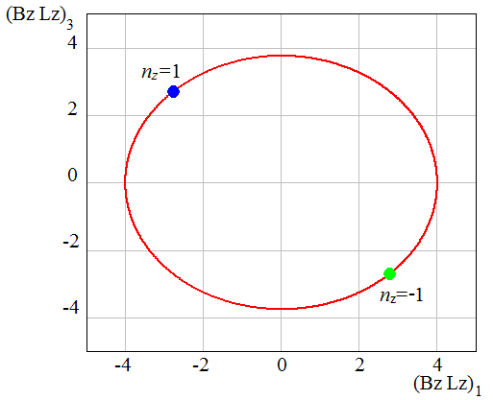 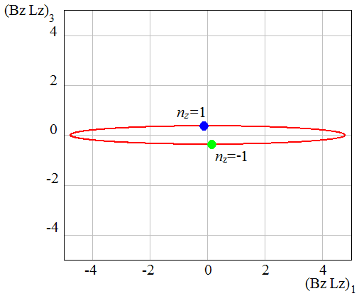

Fig. 5: Relation between the field integrals of the solenoids in the nx and nz modules during the change of polarization orientation with νspin=const. The left and right figures show ellipses for proton and deuteron beams, respectively. The blue dots indicate the solenoid field integrals corresponding to nz=1 while the green dots indicate those corresponding to nz=-1.

To preserve the polarization, one must then only satisfy the adiabaticity condition for the rate of change of the polarization direction $\vec{n}\left(B_{zi}\right)=\left(n_{x},n_{y},n_{z}\right)$ by the control solenoids $B_{zi}$:

$\left|\frac{d\vec{n}}{dt}\right|≪Ω_{\text{spin}}$, $Ω_{\text{spin}}=ν_{\text{spin}} Ω_{c}=\text{const}$,

where $Ω_{c}$ is the particle revolution frequency in the collider. This condition means that the characteristic spin reversal time in the indicated examples should not be shorter than 0.1 ms for protons and 1 ms for deuterons.

An important feature of this polarization manipulation scheme is the absence of resonant depolarization arising when crossing spin resonances. Dynamic depolarization is determined by the zero-harmonic spin resonance strength, which includes a coherent part associated with imperfections of the collider’s magnetic lattice, and an incoherent part associated with the beam emittance. The dynamic depolarization can be substantially reduced by compensating the coherent part of the zero-harmonic spin resonance strength. This part of the resonance strength can be compensated using similar 3D spin rotators placed in the experimental straight. Compensation of the spin resonance strength will allow one to significantly reduce the spin tune in the collider and to manipulate the spin orientation using the smallest possible field integrals of the control solenoids.