Injection Optics for the JLEIC Ion Collider Ring*

* Authored by Jefferson Science Associates, LLC under U.S. DOE Contracts No. DE-AC05-06OR23177 and DE-AC02-06CH11357. The U.S. Government retains a non-exclusive, paid-up, irrevocable, world-wide license to publish or reproduce this manuscript for U.S. Government purposes. Work supported in part by the US DOE Contract No. DE-AC02-76SF00515.
# morozov@jlab.org
V.S. Morozov#, Ya.S. Derbenev, F. Lin, F.C. Pilat, G.H. Wei, Y. Zhang,
Jefferson Lab, Newport News, VA 23606, USA
Y.M. Nosochkov, Y. Cai, M.K. Sullivan, M.-H. Wang, SLAC, Menlo Park, CA 94025, USA

Abstract
The Jefferson Lab Electron-Ion Collider (JLEIC) will accelerate protons and ions from 8 GeV to 100 GeV. A very low beta function at the Interaction Point (IP) is needed to achieve the required luminosity. One consequence of the low beta optics is that the beta function in the final focusing (FF) quadrupoles is extremely high. This leads to a large beam size in these magnets as well as strong sensitivity to errors which limits the dynamic aperture. These effects are stronger at injection energy where the beam size is maximum, and therefore very large aperture FF magnets are required to allow a large dynamic aperture. A standard solution is a relaxed injection optics with IP beta function large enough to provide a reasonable FF aperture. This also reduces the effects of FF errors resulting in a larger dynamic aperture at injection. We describe the ion ring injection optics design as well as a beta-squeeze transition from the injection to collision optics.

INTRODUcTION
The collision optics of the JLEIC ion collider ring is shown in Fig. 1 [1, 2, 3] with IP x and y beta-star values of 10 and 2 cm, respectively. Such small beta-star values in combination with about 11 m detector space lead to maximum x and y beta functions of about 2500 m. The horizontal emittance is typically larger than the vertical one due to the difference in the horizontal and vertical intra-beam scattering rates. Depending on electron cooling performance, the normalized rms horizontal emittance is expected to be as low as 0.35 mm⋅mrad. Even with such a low emittance, the maximum rms beam size inside the FF quadrupoles reaches about 3 mm at 100 GeV/c. The normalized rms emittance at the injection momentum of 8 GeV/c is expected to be about 1 mm⋅mrad. There is a factor of 32 difference between the geometric emittances at 8 and 100 GeV/c.
The beam can clearly not be injected in the collision optics setup. At injection, the maximum beta functions in the FF quadrupoles have to be brought down ideally by a factor of 32 to keep the maximum beam size manageable. This can only be done by increasing the beta-star values at injection by about the same factor. Once the beam is electron-cooled and accelerated to the experimental energy, the beta-star sizes are reduced to the design values through the beta squeeze procedure commonly used in hadron colliders [4, 5]. During a beta squeeze, the betatron tunes must remain constant to avoid crossing of betatron resonances, the phase advance between the FF quadrupoles and the local chromatic sextupoles (see Fig. 1) should stay fixed, and the dispersion, particularly in the interaction region (IR), should remain suppressed.
In the remainder of this paper, we discuss two approaches to beta squeeze. The first is based on a beta-wave method. It involves only a small number of quadrupoles but has a limited beta squeeze range in the JLEIC’s ion collider ring due to certain features of the ring’s design. The second approach is modular. Beta squeeze is done in large-beta sections independently while maintaining the necessary phase advance between them using connecting sections as trombones. This technique involves a much larger number of quadrupoles than the first one but it can provide the required range of beta squeeze in the ion collider ring.

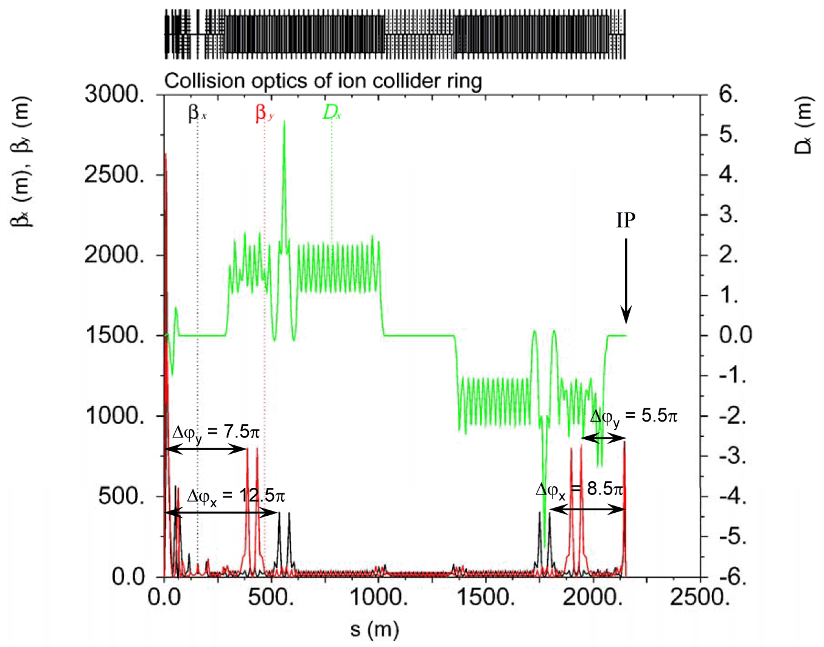
Figure 1: Collision optics of the JLEIC ion collider ring showing phase advance from the local sextupoles to IP.

beta-wave method
A simple method to reduce peak beta functions in the FF quadrupoles while preserving the non-linear chromaticity correction is based on a local beta-wave created within the IR and the non-linear chromaticity correction blocks (CCB). In the case of the ion collider ring, it works as follows. Six quadrupoles just upstream of the first CCB are used to create a beta perturbation Δβ/β. This beta-wave freely propagates with twice the betatron frequency all the way to the CCB on the other side of the IP, after which it is cancelled with another set of six quadrupoles. The six quadrupoles are required in order to match to the desired IP beta functions (β_{x}* and β_{y}*=β_{x}*/5) while keeping the IP alpha functions and dispersion equal to zero (α_{x}*=α_{y}*=0, η_{x}*=η′_{x}*=0). Since the magnet strengths within the beta-wave region are not changed, all the transfer matrices and dispersion inside this region are preserved. A proper adjustment of the above matching quadrupole strengths allows us to increase the β* and therefore decrease the peak beta functions in the FF quadrupoles (∼1/β*) for beam injection without affecting the rest of the ring optics.
Since the transfer matrix between the FF quadrupoles and the CCB sextupoles is not changed by the beta-wave, and due to the nominal nπ phase advance between them, it is evident that the sextupole beta functions (β_{s}) change at the same rate with the FF beta functions (β_{FF}). This can be seen by inspecting, for example, the R₁₁ and R₁₂ terms of the matrix from the sextupoles to the FF. Since the R₁₂=(β_{s}β_{FF})^{1/2}sin(μ) is zero, hence the μ=nπ regardless of the beta wave setting. With this phase advance, the ratio of beta functions is also a constant, namely β_{FF}/β_{s}=R₁₁². Since the dispersion at the sextupoles is not changed with β*, the chromaticity generated by the FF quadrupoles and the CCB sextupoles change at the same rate with β*. Therefore the condition for the FF non-linear chromaticity compensation is always preserved for the same sextupole strengths. Figure 2 shows an example of the beta functions within the IR and the two CCBs where the β* is increased by a factor of 5 relative to the collision setting. Figure 3 shows a smooth dependence of the 6 matching quadrupole strengths as a function of β_{x}*.

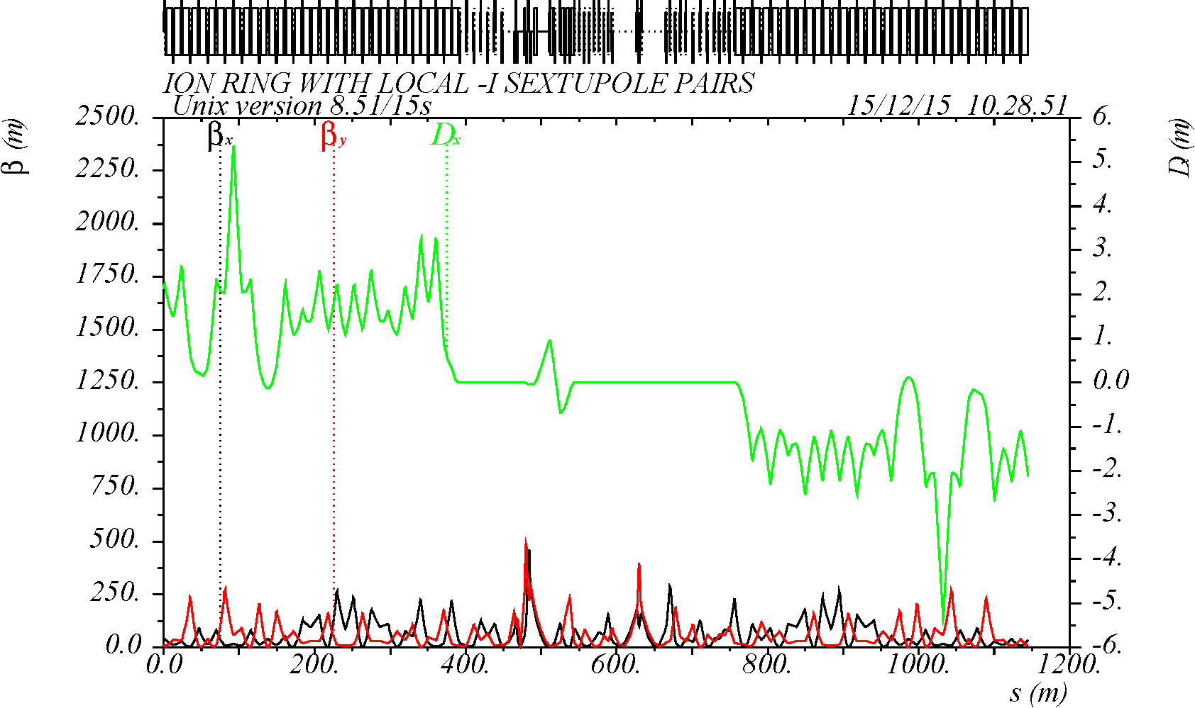
Figure 2: IR and CCB optics at β* = 0.5/0.1 m.

This method however poses a practical limit to the range of the β* because the generated Δβ/β is a sinusoidal wave, and therefore the beta functions are decreased at the quadrupoles which are in phase with the FF, but increased at the quadrupoles in phase with the IP. The latter limits how much β* can be increased. Due to the complexity of the ion ring IR design, the practical range of β* increase is limited in this method to less than a factor of 5. Finally, there may be a small change of the ring betatron tune and linear chromaticity when using this method which can be corrected using global correction systems.

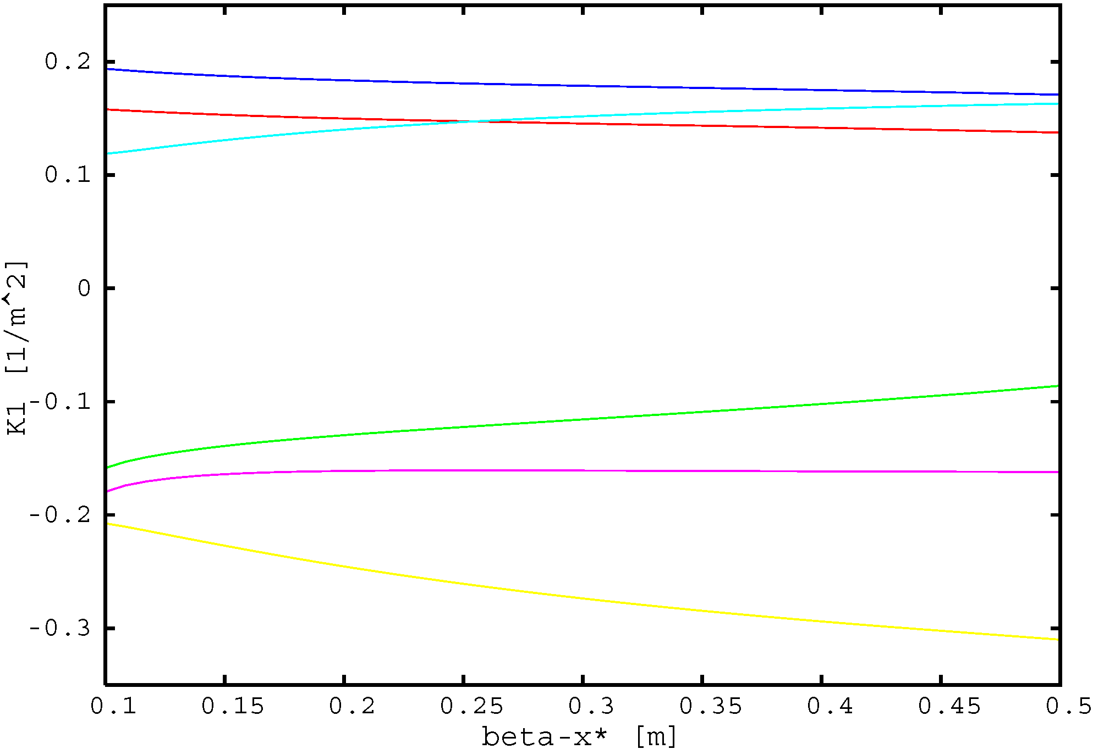
Figure 3: Normalized quadrupole strengths vs. β*.

modular method
The large-beta sections of the ion collider ring are the IR and CCBs (see Fig. 1). In the modular approach, the maximum beta functions in these sections are independently reduced at injection resulting in relaxed beta star values. At the final energy, the beta-star sizes are gradually squeezed to the collision values increasing the maximum beta functions in the IR. The beta functions at the locations of the local chromatic sextupoles in the CCBs are increased synchronously with the IR maintaining the local chromatic compensation of the FF quadrupoles throughout the beta-squeeze process. Maintaining the chromatic compensation requires that the phase advances between the local sextupoles and the FFQs are maintained as well. This is done by using the matching sections between the IR and CCBs as tune trombones. Finally, the global betatron tunes are kept constant by a dedicated global tune trombone to avoid crossing of betatron resonances. The optical matching of each section participating in beta squeeze is kept fixed decoupling it from the rest of the ring. Thus, beta squeeze is done by simultaneously ramping quadrupoles in several independent sections making this a modular approach.
Figure 4 shows IR optics for three different settings of β* including injection, intermediate and collision values of 3.0/0.5, 0.5/0.1 and 0.1/0.02 m, respectively. Note that the optics remains fixed at the start and end points. Scaling of the upstream IR quadrupoles during the beta squeeze is illustrated in Fig. 5. A relatively large number of quadrupoles is needed to maintain the optical match and adjust the phase advance to the chromatic sextupoles. However, the ranges of quadrupole strength variation are limited and there are enough knobs to optimize the scaling pattern and simplify the practical implementation. The fully relaxed injection optics of the complete ion collider ring is shown in Fig. 6. Compared to Fig. 1, the maximum beta function values are reduced by a factor of more than 25.
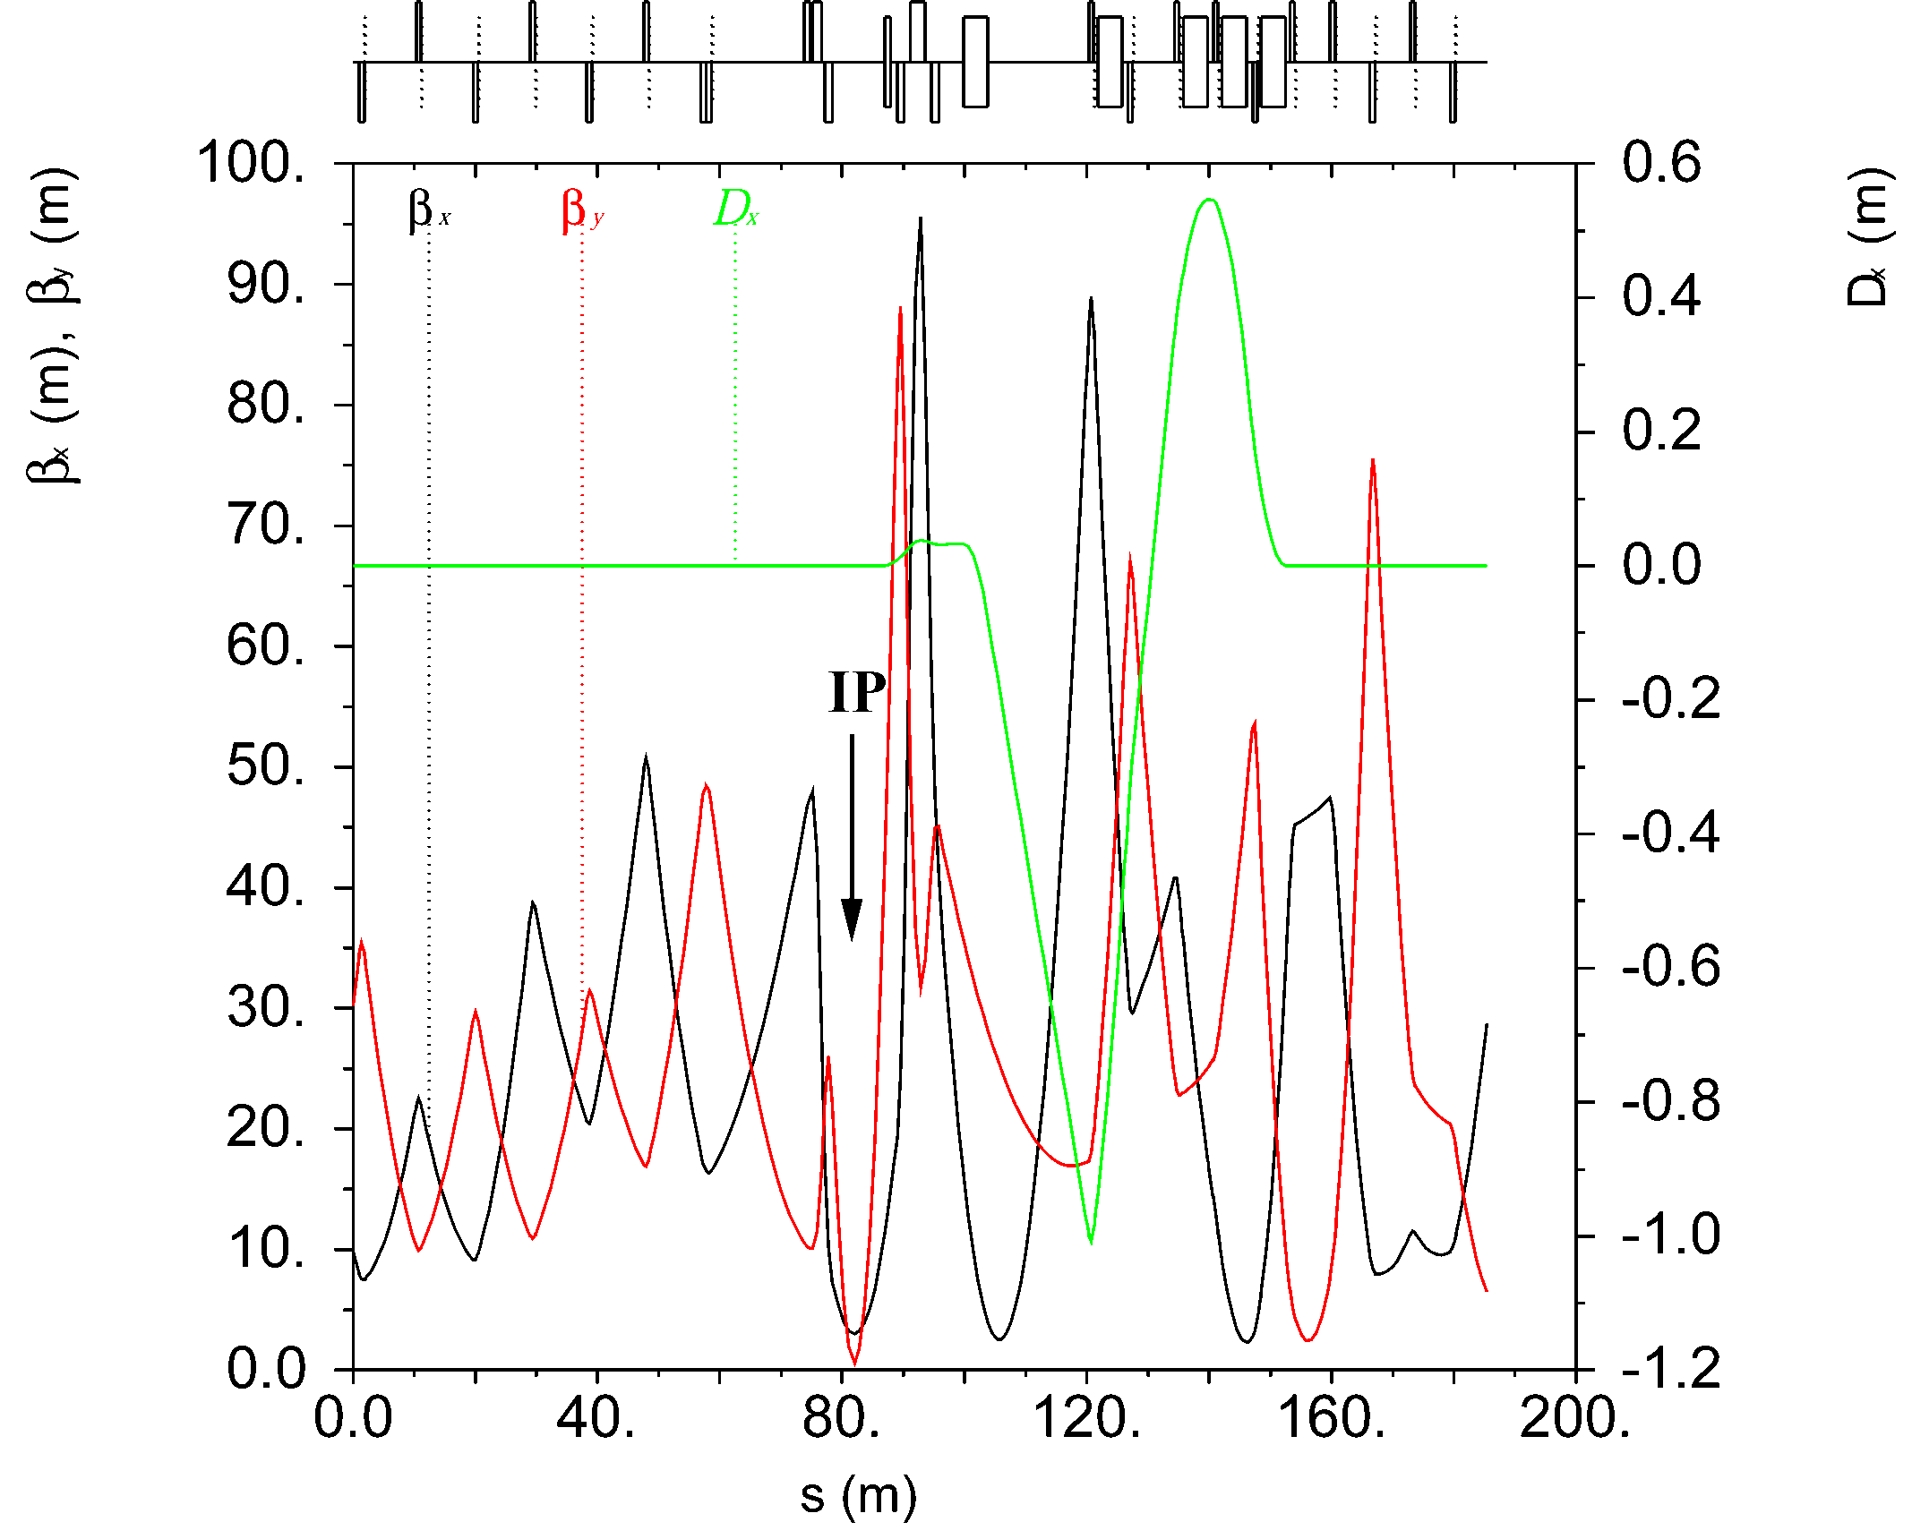
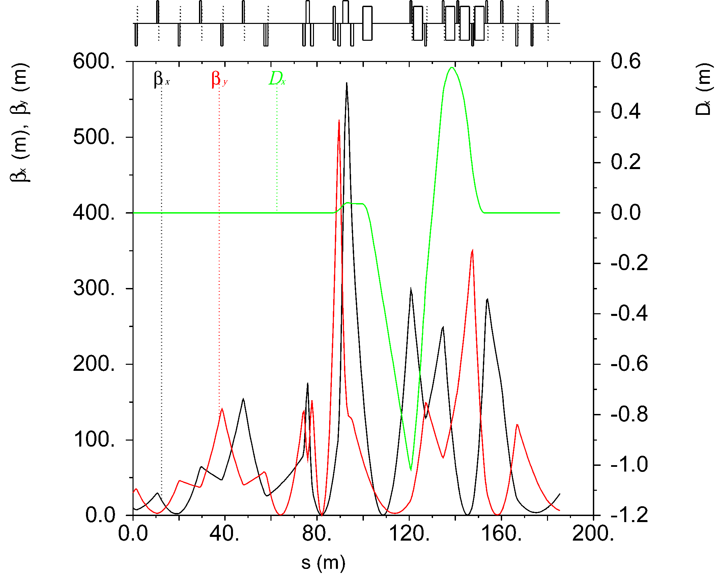
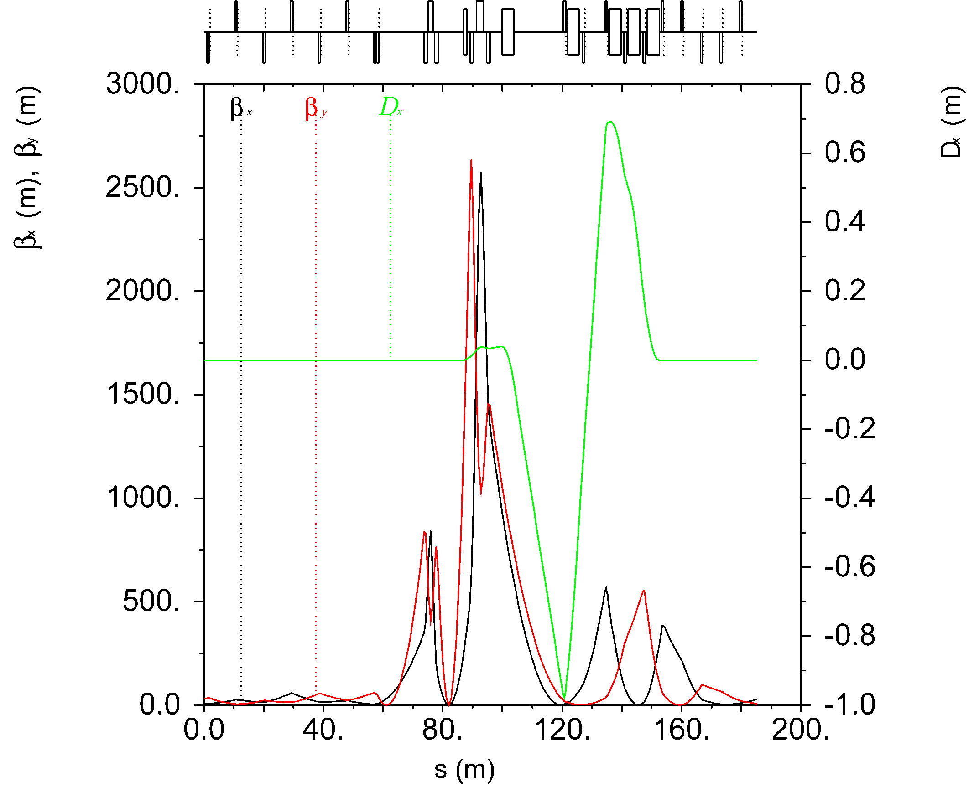
Figure 4: IR optics with β* = 3.0/0.6 m (top), 0.5/0.1 m (middle), and 0.1/0.02 m (bottom).

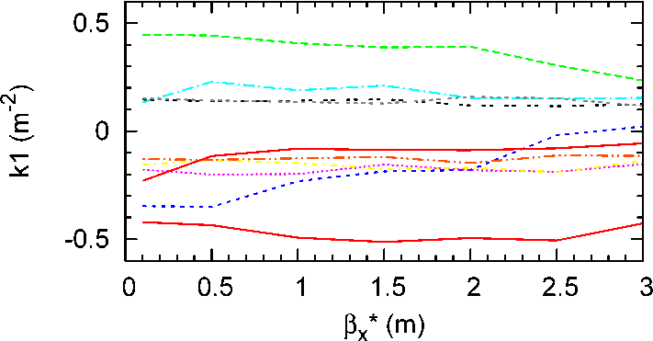
Figure 5: Strengths of the upstream IR quadrupoles vs. β*.

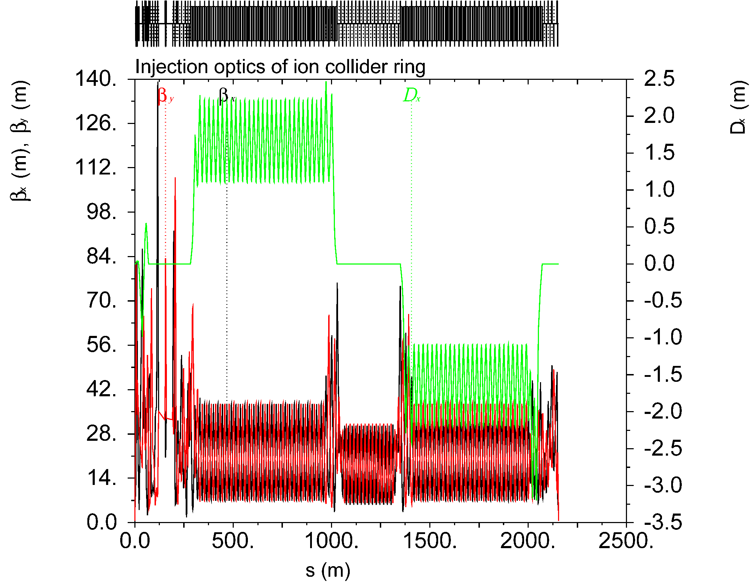
Figure 6: Injection optics of the complete collider ring starting from the IP.

Finally, we investigate the nonlinear dynamics in the injection lattice. Figure 7 shows the dynamic aperture (DA) at the IP of the bare lattice for different values of the momentum offset. Since the natural chromaticity of the injection lattice is much lower than that in the collision mode, the dependence of the DA on the momentum offset is quite weak. The DA in Fig. 7 exceeds ±20σ in both x and y. Figure 8 shows the DA frequency map and tune footprint.
In conclusion, we developed a beta squeeze procedure for the JLEIC ion collider ring with a large range of variation of maximum beta functions necessary for injection. We also confirmed that the non-linear properties of the injection lattice are adequate.

Figure 7: Dynamic aperture of the bare lattice for different momentum offsets.

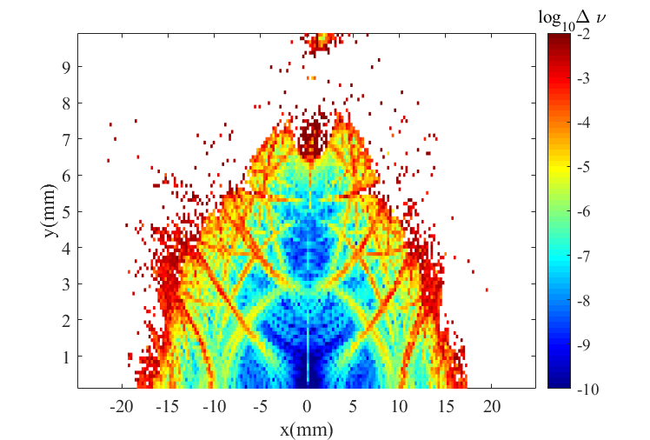
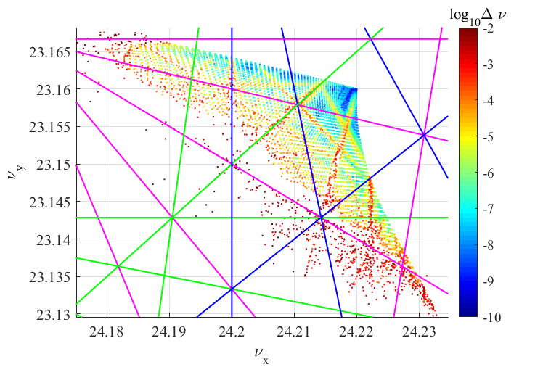
Figure 8: DA frequency map (top) and tune footprint (bottom).
References
[1] S. Abeyratne et al., arXiv:1504.07961 [physics.acc-ph] (2015).
[2] V.S. Morozov et al., IPAC’15, TUPWI031.
[3] Y.M. Nosochkov et al., IPAC’15, TUPWI032.
[4] Y.M. Nosochkov et al., SSCL-Preprint-550 (1994).
[5] S. Redaelli et al., IPAC’13, TUPFI038.

