**error CORRECTION for THE JLEIC ion collider ring**

G.H. Wei†, V.S. Morozov, F. Lin, Y. Zhang, F. Pilat,   
Jefferson Lab, Newport News, VA 23606, USA  
Y. M. Nosochkov, M.-H. Wang, SLAC, Menlo Park, CA 94025, USA

### Abstract

The sensitivity to misalignment, magnet strength error, and BPM noise is investigated in order to specify design tolerances for the ion collider ring of the Jefferson Lab Electron Ion Collider (JLEIC) project. Those errors, including horizontal, vertical, and longitudinal displacement, roll error in transverse plane, strength error of main magnets (dipole, quadrupole, and sextupole), BPM noise, and strength jitter of correctors, cause closed orbit distortion, tune change, beta-beat, coupling, chromaticity problem, etc. These effects generally reduce the beam dynamic aperture. Following the real commissioning experiences in other machines, closed orbit correction, tune matching, beta-beat correction, decoupling, and chromaticity correction have been included in the study. Finally, we find that the dynamic aperture with the implemented corrections is restored to an acceptable level.

## introduction

Error correction is a common issue in any synchrotron and especially a collider. For the Jefferson Lab Electron Ion Collider (JLEIC) project, to get a luminosity level of a few 1033 cm-2sec-1, error study should be done to investigate error tolerances for magnets, BPMs, and RF system. Here we focus on the errors in BPM and magnets, in order to find acceptable tolerances for the project design.

## lattice of ion collider ring

The JLEIC ion collider ring accelerates protons from 8 to up to 100 GeV/c or ions in the equivalent momentum range [1]. An overall lattice and collision optics of the ion collider ring is shown in Fig. 1. The ring consists of two 261.7° arcs connected by two straight sections intersecting at an 81.7° angle. The total circumference of the ion collider ring is 2153.89 m.

The JLEIC ion collider ring has 343 main magnets including 133 dipoles, 205 quadrupoles, and 75 sextupoles. The dynamic aperture attained with the bare lattice is shown in Fig. 2. Considering a normalized emittance of 0.35/0.07 mm-mrad (H/V) with strong cooling, dynamic aperture is about 50 σ of the beam size. Even for a normalized emittance of 1.2/1.2 mm-mrad (H/V) with weak cooling, dynamic aperture is about 38 σ of the beam size.

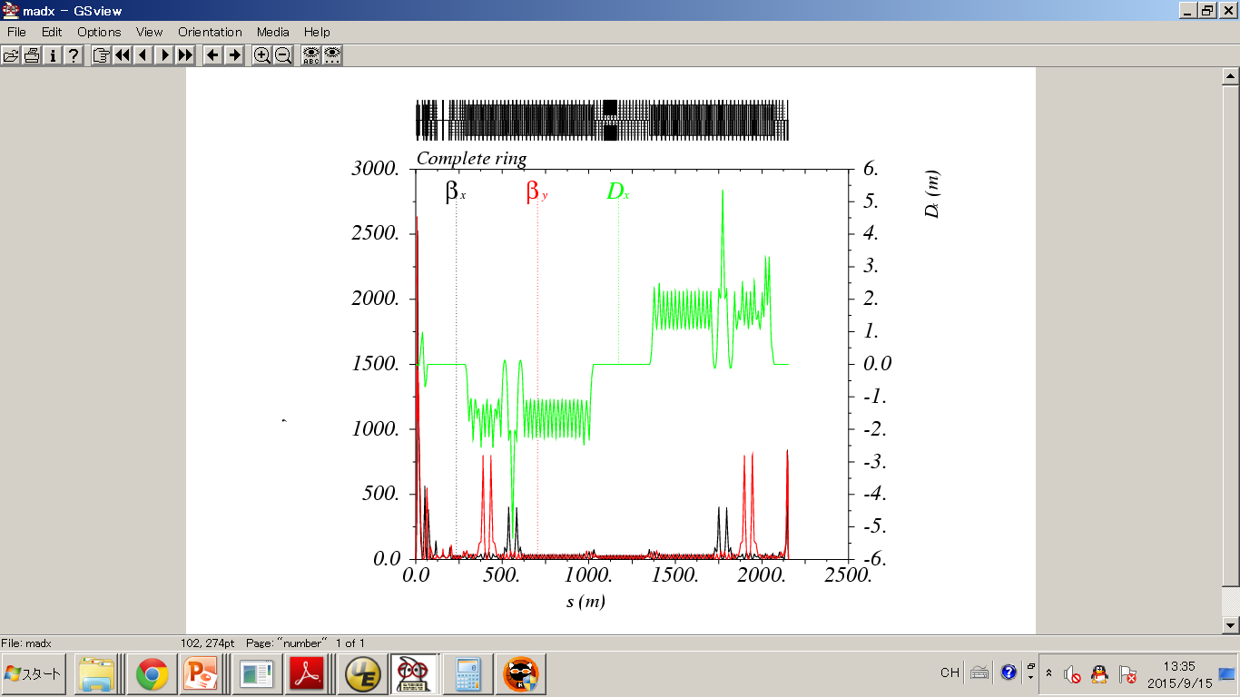

Figure 1: Lattice and optics of the JLEIC ion collider ring starting from IP.

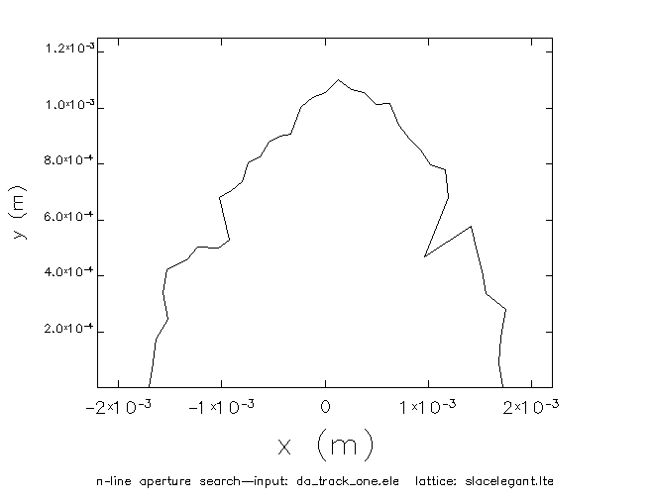

Figure 2: Dynamic aperture of the bare lattice of the JLEIC ion collider ring at IP.

## Machine element errors

Here we mainly consider errors in all magnets and BPMs as shown in Table 1. The errors can be divided into two types, namely, static errors and dynamic errors [2].

• Static error: this type of error is independent of time. It includes displacement and roll errors and effective lengths of all magnets, including dipoles, quadrupoles, sextupoles and correctors. Offset of the BPMs is also this type of error, but it can be determined by beam-based alignment, so we do not consider it in our simulations. One important static error is multipole fields of the main magnets, including dipoles, quadrupoles, and sextupoles. These multipole fields have a dominant influence on the dynamic aperture, especially for the magnets in the interaction region. This topic is discussed in another paper [3] in this conference.

[† gwei@jlab.org](mailto:†%20gwei@jlab.org)

• Dynamic error: this type of error depends on time. It contains noise signal of the BPMs, field jitter of the magnets, etc. The noise signal level depends not only on the BPM itself but also on the beam energy, beam current, etc. Field jitter of the magnets is usually less than 0.1% of the nominal setting value.

Table 1: Errors assumed in simulations

(σ Value, Gaussian distribution)

|  |  |  |  |
| --- | --- | --- | --- |
|  | **x/y/s\***  **disp.[mm]** | **tilt**  **[mrad]** | **strength**  **error [%]** |
| dipole | 0.3/0.3/0.1 | 0.3 | 0.1 |
| quadrupole | 0.3/0.3/0.3 | 0.3 | 0.2 |
| FFQ** | 0.03/0.03/0.03 | 0.05 | 0.03 |
| sextupole | 0.3/0.3/0.3 | 0.3 | 0.2 |
| BPM | 0.05/0.05*** | - | - |
| corrector | - | 0.1 | 0.1 |

*: disp. = displacement;

**: FFQ = Final Focus Quadrupole;

***: Horizontal/Vertical BPM noise;

## Error sensitivity and correction considerations

Since the full errors in Table 1 without orbit correction will give no stable closed orbit in a simulation, 50% of the errors are used to perform the sensitivity study with MAD-X [4] and Elegant [5]. Correction is considered according to analysis results and machine commissioning practices.

### Error sensitivity of the closed orbit distortion

Error sensitivity of the closed orbit distortion is analysed for each error type shown in Fig. 3. In the simulation, no orbit correction or other correction is considered.

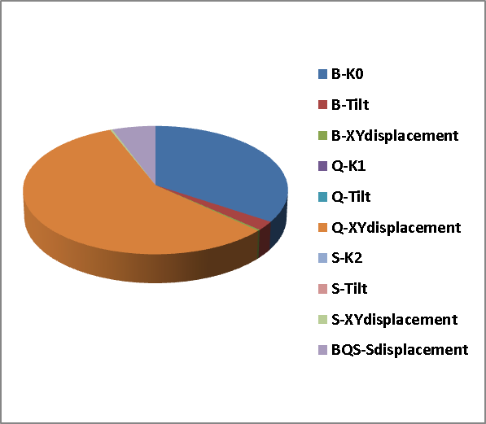

Figure 3: Pie chart of the impact of individual error types on the closed orbit distortion.

Figure 3 compares the impacts of different error types. The main impact comes from the transverse displacements of quadrupoles and the strength error of dipoles. The transverse displacements of quadrupoles contribute 57% of the total effect while the strength errors of dipole contribute 34%.

### Error sensitivity of the dynamic aperture

Error sensitivity of the dynamic aperture at the Interaction Point (IP) is analysed with respect to each error type shown in Fig. 4.

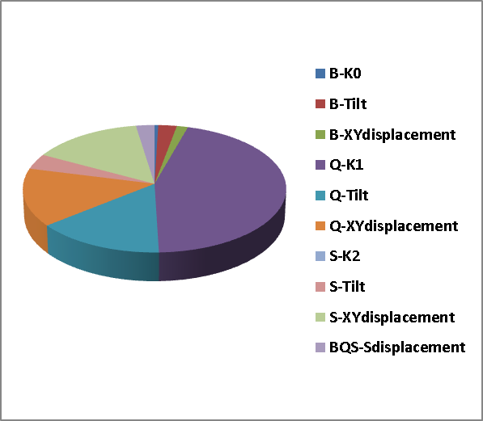

Figure 4: Pie chart of the impact of individual error types on the dynamic aperture.

Impacts of the different error types can be seen in Fig. 4. The main effects are due to the strength error, tilt error, transverse displacements of quadrupoles and sextupoles. The strength error of quadrupoles gives 45% of the total effect. And the tilt error, transverse displacements of quadrupoles and sextupoles produce similar impacts of about 15 %.

Therefore, besides the orbit correction, dynamics changes due to the transverse displacements and strength errors of quadrupoles and sextupoles and the tilt errors of quadrupole should be corrected for the machine commissioning.

### Correction considerations

The sensitivities analyses suggest the following correction items using parameters of existing machine commissioning experience.

* Closed orbit correction, especially at the IP;
* Tune correction, considering the tune measurement accuracy, the tune correction is considered in the range of ±0.1 % of the design tune;

• Beta-beat correction, considering the beta function measurement accuracy, the beta correction is considered in the range of ±5% at all magnets with beta less than 500 m; beta correction is considered in the range of ±1% at all magnets with beta larger than 500 m and IP;

* Decoupling, the optimal skew quadrupole locations [6] in terms of the horizontal and vertical betatron phase advance from the IP (μx, µy): (/2, 0), ( $π$/2, $π$/2), (0, 0), and (0, $π$/2) (mod $π$). Since it is usually difficult to find quadrupoles with those exact phase advances and one also has to consider global decoupling, a larger number of skew quadrupoles is used.

• Chromaticity correction, considering linear chromaticity correction and W function for the first-order chromatic beta function correction. This type of correction is a part of our future work.

## Simulation results with errors and corrections

We simulated the errors listed in Table 1 and their correction using CODE ELEGANT. We calculated the dynamic aperture for 60-GeV proton beam in tracking simulations with 1000 turns, and 41 lines in the x-y phase space. First, the closed orbit distortion was corrected as shown in Fig. 5. One BPM and one corrector are installed next to each of the 205 quadrupoles. The vertical closed orbit is finally corrected to < ± 10 µm globally and < ± 1 µm at the IP. The horizontal closed orbit is corrected to < ± 0.7 mm globally and < ± 3 µm at the IP. With inclusion of more correctors in the IR triplet area, the horizontal orbit will be improved but even the current orbit after correction is acceptable.

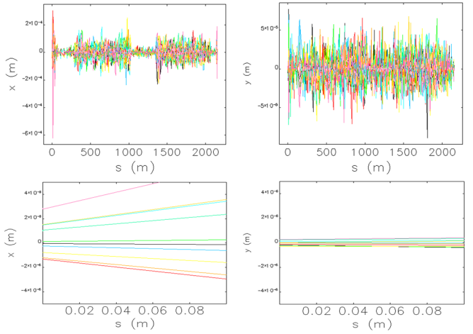

Figure 5: Closed orbit distortion after correction (upper: global x/y closed orbit; lower: x/y closed orbit in 0.1 m after the IP, the IP is at 0 m).

After correcting the closed orbit distortion, we implement beta-beat correction, decoupling, tune correction, and linear chromaticity correction in the simulation. The resulting dynamic aperture at the IP is shown in Fig. 6. The dynamic aperture includes all corrections and is shown for 10 seeds of random errors. Considering the weak cooling emittance of 1.2/1.2 mm-mrad (H/V), the dynamic aperture is larger than 27 σ of the beam size, which is acceptable.

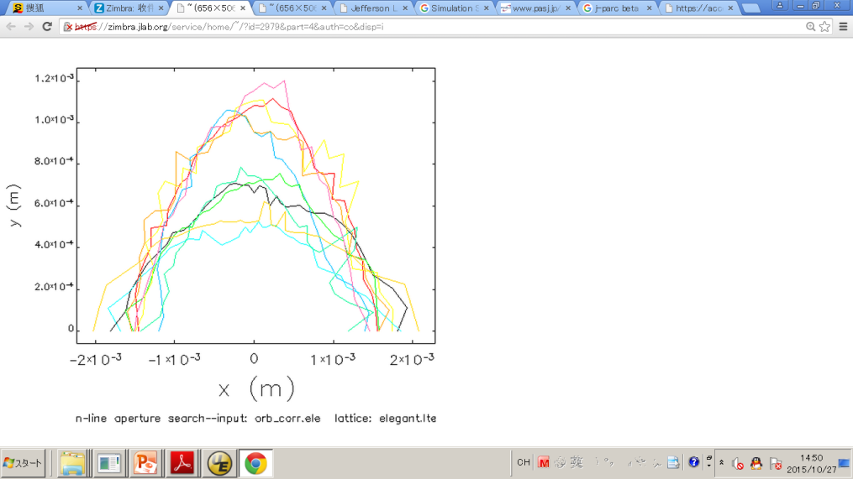

Figure 6: Dynamic aperture with errors and corrections (after applying corrections for 10 seeds of random errors).

## Summary

Sensitivity to magnets and BPM errors is studied in the JLEIC ion collider ring. Transverse quadrupole displacements and dipole strength errors are the main factors affecting the closed orbit. The main impact on the dynamic aperture comes from the strength errors, quadrupole tilt errors and transverse quadrupole and sextupole displacements.

The dynamic aperture at the IP is studied after suitable closed orbit correction, beta-beat correction, tune correction, decoupling, and linear chromaticity correction. Assuming a weak cooling emittance of 1.2 mm-mrad in both the horizontal and vertical planes, the dynamic aperture is larger than 27 σ of the beam size with errors and corrections.

The closed orbit correction can be improved in the interaction region using more correctors. This will be the next step of the study.

## acknowledgment

This manuscript has been authored by Jefferson Science Associates, LLC under U.S. DOE Contracts No. DE-AC05-06OR23177 and DE-AC02-06CH11357. Work supported also by the U.S. DOE Contract DE-AC02-76SF00515. The United States Government retains a non- exclusive, paid-up, irrevocable, world-wide license to publish or reproduce the published form of this manuscript, or allow others to do so, for United States Government purposes.

## References

[1] S. Abeyratne et al., arXiv:1504.07961 [physics.acc-ph].

[2] G. Wei et al., PASJ7, WEPS046, p. 453 (2010).

[3] G.H. Wei, V. S. Morozov, F. lin, Y. M. Nosochkov, M.-H Wang, IPAC’16, Busan, Korea, May 2016, paper THPMR053, this conference.

[4] http://mad.web.cern.ch/mad

[5] M. Borland, *"elegant: A Flexible SDDS-Compliant Code for Accelerator Simulation,"* Advanced Photon Source LS-287, September 2000.

[6] V. S. Morozov, USPAS Lecture on Coupled Motion (2015)