# Influence of magnet multipole field components on beam dynamics in JLEIC ion collider ring

G.H. Wei†, V.S. Morozov, F. Lin, Y. Zhang, F. Pilat,  
Jefferson Lab, Newport News, VA 23606, USA  
Y.M. Nosochkov, M.-H. Wang, SLAC, Menlo Park, CA 94025, USA

### Abstract

Multipole field components of magnets and especially those of the magnets in the interaction region are the primary cause of dynamic aperture limitation in a collider. For the Jefferson Lab Electron Ion Collider (JLEIC) project, having a large enough dynamic aperture (at least ±10σ of the rms beam size) is important to get a luminosity level of a few 1033 cm-2s-1 with low beam loss. Depending on the dynamic aperture requirements, limiting multipole field components of magnets are surveyed to find a possible compromise between the requirements and what can be realistically achieved by a magnet manufacturer. Dependence of the dynamic aperture on beam emittance and magnetic field imperfections is also analysed by numerical simulations.

## introduction

To get a luminosity level above 1033 cm-2s-1 at all design points of the Jefferson Lab Electron Ion Collider (JLEIC) project, small β* values in both horizontal and vertical planes are necessary at the Interaction Point (IP) in the ion collider ring. This also means large β in the final focus area, chromaticity correction sections, etc. which sets a constraint on the field quality of magnets in these large beta areas necessary to ensure a large enough dynamic aperture (DA). In this context, limiting multipole field components of the magnets are surveyed to find a possible compromise between the requirements and what can be realistically achieved by a magnet manufacturer. This paper describes that work.

## lattice and emittance of the Jleic ion collider ring

The JLEIC ion collider ring accelerates protons from 8 to up to 100 GeV/c or ions in the equivalent momentum range and is designed to provide luminosity above 1033 cm-2s-1 [1, 2]. The overall collision lattice of the ion collider ring is shown in Fig. 1. The ring consists of two 261.7 ° arcs connected by two straight sections intersecting at an 81.7° angle. The total circumference of the ion collider ring is 2153.89 m.

The beam emittance in ion ring is determined by a balance of the intra beam scattering (IBS) and electron cooling. With strong cooling, the normalized rms emittances of 0.35/0.07 mm-mrad (H/V) are considered. With initial weak cooling, larger values of 1.2/1.2 mm-mrad (H/V) are assumed.

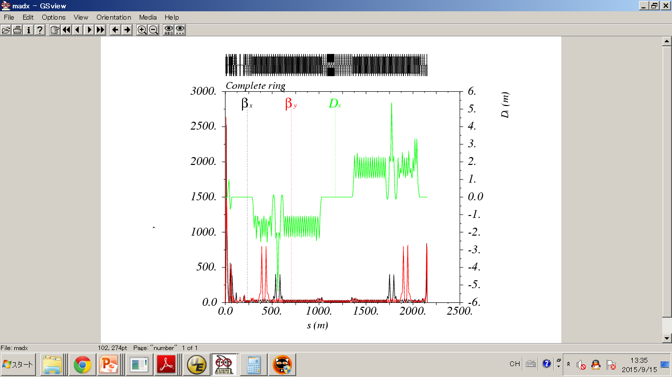

Figure 1: Linear optics of the JLEIC ion collider ring starting from IP.

The JLEIC ion collider ring has 343 main magnets including 133 dipoles, 205 quadrupoles, and 75 sextupoles, which are shown in Table 1. In the interaction region (IR), there are 2 dipoles and 6 final focus quadrupoles whose multipole components are a common bottleneck for the dynamic aperture.

Table 1: Magnets in the JLEIC ion collider ring

|  |  |  |  |
| --- | --- | --- | --- |
|  | **Dipole** | **Quadrupole** | **Sextupole** |
| All | 133 | 205 | 75 |
| IR | 2 | 6 | 0 |
| With β >200 m | 21 | 19 | 8 |

## RefereNce raDius and magnet Field quality

The non-linear magnetic field of magnets can be defined by the following expansion using the US multipole convention [3].

 (1)

where the an and bn coefficients are the relative values of the skew and normal multipole field determined at a reference radius r0 in units of 10-4, and BN is the main field at r0. Furthermore, each an and bn is composed of the systematic and random terms, where the random values are randomly generated based on their Gaussian distributions.

For a superconducting magnet, r0 is usually set at 1/3 of the coil aperture, as an edge of the good field region of the magnet. The multipole terms an and bn scale with the reference radius r0 and the coil diameter dc by the expressions in Eqs. (2) and (3) [3]. Furthermore, to keep their contribution to the non-linear resonance driving terms constant, the effects of an and bn scale with βmax according to Eq. (4) [4].

† gwei@jlab.org

 (2)

 (3)

 (4)

Thus, the reference radius is an important parameter for characterizing magnet field quality. It is reasonable to make it 1/3 of the coil aperture or proportional to the beam size. For example, for the IR triplets in the JLEIC ion ring, the three upstream final focus quadrupoles have their reference radii defined considering the 1/3 rule and are roughly proportional to the beam size. According to the full acceptance requirement [5], the physical apertures of the three downstream final focus quadrupoles are designed to provide a large acceptance in the forward direction.

Table 2: Physical apertures and reference radii of the two IR triplets in the JLEIC ion collider ring

|  |  |  |  |
| --- | --- | --- | --- |
|  | **Physical**  **Aperture[mm]** | **Beta_max**  **x/y[m]** | **Reference**  **Radius[mm]** |
| Qffb3_us | 80 | 538/- * | 30 |
| Qffb2_us | 80 | 847/- | 30 |
| Qffb1_us | 60 | 369/766.7 | 22 |
| Qffb1 | 180 | 931/2640 | 60 |
| Qffb2 | 314 | 2574/- | 90 |
| Qffb3 | 340 | 1724/- | 90 |

* the beam size is dominated by beta-x for the cases of both 1.2/1.2 mm-mrad emittance with weak cooling and 0.35/0.07 mm-mrad emittance with strong cooling.

## Dynamic aperture with multipole fiELds of Arc dipoles

Using the multipole field data of the arc dipoles provided by magnet designers [6], a dynamic aperture study was performed in Elegant. The simulations were done for 60-GeV protons, 1000 turns and 41 lines in the x-y phase space. The resulting dynamic aperture is shown in Fig. 2.

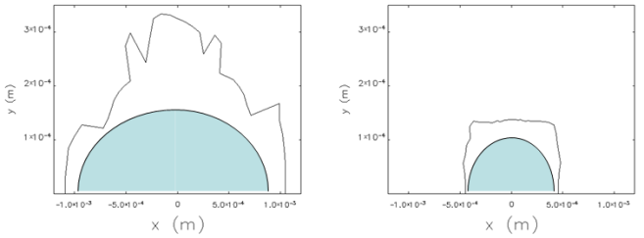

Figure 2: Dynamic apertures with multipole fields of the arc dipoles (left: errors in arc dipoles with β < 200 m; right: errors in all arc dipoles).

Here we simulated two multipole field setups. First, multipoles are applied to all arc dipoles. Second, only the arc dipoles with beta less than 200 m have multipoles. The results show that, even for the weak cooling emittance of 1.2/1.2 mm-mrad (H/V), the dynamic aperture is about 27 σ of the beam size for the case when only the arc dipoles with beta less than 200 m are considered. For the case when all arc dipoles include multipole fields, the dynamic aperture is about 10.8 σ for the weak cooling situation. Since only the normal (bn) multipole field data are available so far, a more detailed study is needed in the case of all arc dipole with multipole fields. Generally speaking, the present magnet model is adequate for the arc dipoles with beta less than 200 m and may be acceptable for the arc dipoles with beta larger than 200 m.

## Dynamic aperture with multipole fieLds of IR triplets

In comparison to the arc magnets, multipole fields of the IR triplets have a dominating effect on the dynamic aperture. Hence their influence is studied in detail. First, the multipole field data of the LHC IR triplets are used with the JLEIC ion collider ring lattice to find the dynamic aperture. Second, a survey of DA limiting multipoles is performed in the JLEIC ion collider ring. Third, preliminary multipole data for the IR triplet is applied to the JLEIC ion collider ring. Finally, the multipoles are optimized to get a suitable dynamic aperture, taking into account the LHC data and the limiting multipole survey.

### Dynamic Aperture with Multipole Fields of the LHC IR Triplets in the JLEIC Ion Collider Ring

Figure 3 shows the dynamic aperture at the IP attained by applying the multipole field data of the LHC IR triplets [7] to the JLEIC ion collider ring triplets. Considering the strong cooling emittance of 0.35/0.07 mm-mrad (H/V), the dynamic aperture is about 16 sigma of beam size; it is 8.6 sigma of the beam size for the weak cooling emittance of 1.2/1.2 mm-mrad (H/V).

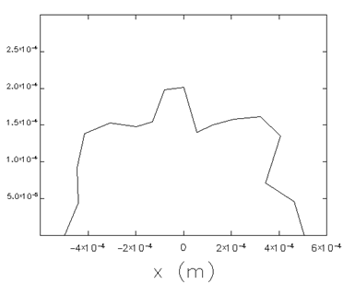

Figure 3: Dynamic aperture of the JLEIC ion ring where the LHC triplets multipole field is applied to the JLEIC triplets.

### Multipole Field Survey of the IR Triplets of the JLEIC Ion Collider Ring

After applying the multipole field data of the LHC IR triplets, a multipole field survey was done for the JLEIC ion collider ring. Here we consider the lattice shown in Fig. 1 and the reference radii listed in Table 2. First, we find the upper limit on each single multipole term for a specified dynamic aperture of about 20 sigma for each of the multipole order (2-13). Second, a combination of all multipoles with their limits is used to find a dynamic aperture of ±10 sigma of the beam size.

For the different emittances, the most dominant multipoles are different as shown in Fig. 4. In case of the 1.2/1.2 mm-mrad emittance with weak cooling the higher order multipoles have stronger effect than in the case of 0.35/0.07 mm-mrad with strong cooling. For an intermediate emittance value of 0.9/0.9 mm-mrad, the DA is ±10 sigma with the limiting multipole values just above the LHC multipole field values.

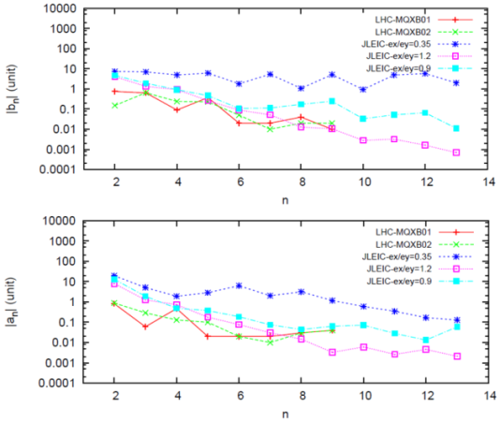

Figure 4: Survey of limiting multipole field coefficients in the JLEIC ion collider ring.

### Dynamic Aperture with Preliminary Multipole Field Data for the IR Triplets

We estimated the dynamic aperture using the preliminary multipole field data of the IR triplets. The simulations were performed for 60-GeV protons, 1000 turns, and 41 lines in the x-y phase space. The data and the results are shown in Figs. 5 and 6.

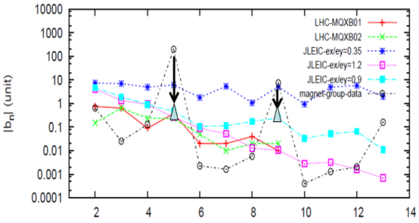

Figure 5: Preliminary multipole field data (black dash) and the modification of b5 and b9 (arrow and triangle).

With the original multipole field data, a dynamic aperture of only 4σ is attained for the case with weak cooling and of 7.3σ for the case with strong cooling. An adjustment was made to the b5 and b9 terms according to the LHC data and the limiting multipole survey (assuming the results for 0.9/0.9 mm-mrad emittance as shown in Fig. 4). With this modification, a large dynamic aperture is obtained meeting the JLEIC ion collider ring requirements.

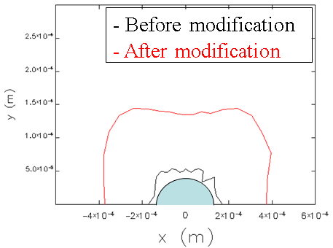

Figure 6: Dynamic apertures with the multipole fields of the IR triplets (black: original data; red: modified data).

## Summary

A dynamic aperture study including magnet multipole fields was done for the JLEIC ion collider ring. With the multipole field data for the arc dipoles provided by magnet designers, simulation results show that the dynamic aperture is sufficiently large in case of strong cooling. In case of weak cooling, a more detailed study should be done for the arc dipoles with beta larger than 200 m.

A comprehensive study was done for the multipole fields of the IR triplets. We obtained upper limits for the multipole coefficients for both the strong and weak cooling cases. We compared them to the multipole data of the LHC IR triplets. For the field quality comparable to the LHC data, an emittance of 0.9/0.9 mm-mrad is desirable for sufficiently large dynamic aperture with the current ion ring lattice and IP beta.

The multipole field data of the preliminary IR triplet design was also studied. After a modification of b5 and b9, we obtained a suitable dynamic aperture meeting the requirement.

## acknowledgment

This manuscript has been authored by Jefferson Science Associates, LLC under U.S. DOE Contracts No. DE-AC05-06OR23177 and DE-AC02-06CH11357. Work supported also by the U.S. DOE Contract DE-AC02-76SF00515. The United States Government retains a non- exclusive, paid-up, irrevocable, world-wide license to publish or reproduce the published form.

## References

[1] S. Abeyratne et al., arXiv:1504.07961 [physics.acc-ph].

[2] V.S. Morozov et al., IPAC’14, MOPRO005, p. 71 (2014).

[3] B. Bellesia et al., Phys.Rev.ST-AB, 10, 062401(2007).

[4] S. Fartoukh, sLHC Project Report 0038.

[5] V. S. Morozov et al., IPAC’12, TUPPR080 (2012).

[6] P. McIntyre and J. Gerity, JLab report.

[7] G.V. Velev et al., FERMILAB-Conf-03/109-E June 2003.